FOUNDATIONS OF ELECTRONICS
Electrical Engineering
Book 1 of the Electrical Engineering Series
The physics, the mathematics, and the circuit theory that everything else is built on.

Foundations of Electronics
Book 1 of the Electrical Engineering Series
Copyright © 2026 Lothar J. Musiol
All rights reserved.
No part of this publication may be reproduced, distributed, or transmitted in any form or by any means without the prior written permission of the copyright holder.

Preface — How to Use This Book
This is the first book in a series that walks through electrical engineering from the ground up, and it is the longest, because it carries the largest load. Everything in every later volume — devices, radio, power, control, signal processing — rests on the three subjects gathered here.
The book is in three parts, meant to be read in order. Part I covers the physics: charge, fields, potential, current, magnetism, and induction. Part II covers the mathematical language that physics is written in, from SI units and dimensional analysis through logarithms, trigonometry, complex numbers, phasors, and first-order calculus. Part III brings the two together into circuit theory, DC and AC, ending with resonance, frequency response, and a first look at the Smith chart and impedance matching.
You need not read all of it before moving on. A reader comfortable with secondary-school physics can skim Part I; a reader already fluent with complex numbers can skim Part II. But the parts are cross-referenced throughout, and a chapter reference anywhere in this book points to a chapter in this book — the numbering runs continuously from 1 to 38 across all three parts.
Each chapter follows the same shape. It opens with the question the chapter answers, builds the picture in words first, then introduces the mathematics needed to make that picture precise, and closes with worked examples and practice problems. Three kinds of boxed panel appear throughout. "Key Idea" panels flag the handful of facts in each chapter worth memorizing outright. "Worked Example" panels take a representative problem all the way to a number, showing the reasoning at each step rather than only the arithmetic. "Common Misconception" panels address specific wrong turns that show up reliably among people meeting the material for the first time, before those wrong turns calcify.
Almost every chapter ends with a short set of practice problems — usually four, sometimes three, five, or six — and full worked solutions to all 156 of them are collected in Appendix B. The bridging chapters that close Parts I and III (12 and 38) carry review questions instead, and Chapter 25, which closes Part II, has none. The solutions are worth more than the answers, so resist looking until you have made a real attempt: the value of a worked solution lies almost entirely in comparing it against your own reasoning and noticing where the two diverged. The lab notes and project examples use a small kit of parts, introduced once in The Reader Lab, after About This Series.
A note on units and notation. SI units are used exclusively — no cgs, no mixed systems. Vectors are written in bold and their magnitudes in italics. The imaginary unit is written j rather than i, because i denotes current; Part II explains this properly when the time comes.

How This Book Is Organized

Part I — The Physics of Electricity and Magnetism (Chapters 1-12)
Begins with charge and Coulomb's law, builds the electric field and Gauss's law, then potential, capacitance, current, and resistance. The second half turns to magnetism: the magnetic field, its sources, and electromagnetic induction, closing with a first look at Maxwell's equations. No prior physics coursework is assumed, and calculus is used sparingly and explained in place.

Part II — Mathematics and Measurement (Chapters 13-25)
The mathematical toolkit, in the order an engineer needs it: SI units and dimensional analysis, engineering notation, measurement uncertainty, the algebra of circuit formulas, linear systems, graph reading, exponentials and decibels, trigonometry and the sinusoid, complex numbers, Euler's formula, phasors and impedance, and first-order calculus. This is the part you will return to most often, and Appendices A and C are built for that.

Part III — DC and AC Circuit Theory (Chapters 26-38)
Kirchhoff's laws, equivalent resistance and dividers, nodal and mesh analysis, Thevenin and Norton equivalents, superposition, then capacitors and inductors as circuit elements and the first-order transients they produce. The remainder is sinusoidal steady state: phasor analysis, AC power and power factor, resonance, frequency response, and transformers, and finally the Smith chart, impedance matching, and bias networks.
Key Idea
Chapter numbering is continuous across the three parts. A reference to "Chapter 20" means Chapter 20 of this book, which happens to sit in Part II. The part boundaries fall between chapters 12 and 13, and between 25 and 26.

About This Series
This book is the first of nine, covering the foundations on which the rest of the Electrical Engineering Series builds. Each volume gathers one tier of the master topic list into a single book and assumes only the books before it, never those that follow.
The series runs from foundations through circuits, semiconductor devices, RF, communications, power, and embedded software, then into the physical product: packaging, layout, electromagnetic compatibility, and test. The full list:
Book - Covers
1. Foundations (this book) - Physics, mathematics, and circuit theory
2. Circuits, Components, and Control - Analog and digital, op-amps, passives, the classical loop
3. Semiconductor Physics and Devices - Diodes, BJTs, MOSFETs, FinFET, compound semiconductors
4. RF, Microwave, and Transceivers - Lines, matching, antennas, PAs, receivers, PLLs, radar
5. Communications, Wireless, and SDR - Modulation, band plans, DSP and software radio
6. Power and Energy - Regulators, magnetics, the grid, the rack
7. Packaging, Layout, EMC, and Test - Boards, packages, cooling, emissions, the accredited lab, robots
8. Firmware and Software for Electronics - Embedded firmware, software tools, and code-driven electronics
9. Test and Measurement Instruments - Oscilloscopes, analyzers, calibration, and device characterization
Key Idea
You do not need the other eight books to use this one. Each volume stands on its own with its stated prerequisites, which are almost always limited to earlier books in the list. Treat the table as a map of where you have been and where a later interest can take you, not as a syllabus you must complete in order.

The Reader Lab
Electronics is learned with the hands as much as the head, so this series asks you to build things. Every book uses the same small kit, the reader lab, and this is the one place it is introduced; the later books refer back here. Nothing in this book requires it: every worked example stands on paper. But a divider you have measured, or an LED you have burned out, stays learned in a way a formula alone does not.
The kit uses ten commonly available modules and components. Many sensor and display modules come with breadboard-compatible headers; the camera and battery assembly may use board-specific or holder connections, so check each pinout and logic voltage before wiring. Prices and connectors vary by supplier; budget separately for the controller, camera board, and protected battery assembly.
- An ESP32-S3 development board: the controller. Two processor cores at up to 240 MHz, 2.4 GHz Wi-Fi and Bluetooth LE 5, a 12-bit analog-to-digital converter, and 3.3 V input and output pins. It is the brain of every project.
- A 0.96-inch OLED display (128 × 64 pixels, I²C or SPI): the face, where the projects show what they measure.
- An HC-SR04 ultrasonic ranger: the bat's sense. It times a 40 kHz echo and measures 2 cm to 4 m. The classic version runs from 5 V and returns a 5 V pulse, which Chapter 27 brings down safely to 3.3 V.
- A PIR (passive infrared) motion sensor: the sense of warmth at a distance, the same sensor that switches porch lights.
- A BME280 environmental sensor: temperature, humidity, and air pressure, the skin and inner ear of the kit, read over I²C.
- A GPS receiver module: the sense of place, sending position and time over a serial line once a second.
- A LoRa radio module in the locally permitted sub-GHz band (often 868 or 915 MHz): the voice. With a suitable antenna and a favorable link budget, a low data rate and clear path can support links over several kilometers; actual range and lawful transmit power depend on local conditions and regional rules.
- A small hobby servo: the muscle. It turns to an angle set by a pulse about 1 to 2 ms long, repeated every 20 ms.
- An 18650 lithium-ion cell in a holder with a protection module: the stomach. A typical cell has a nominal voltage of 3.6 to 3.7 V and charges to 4.2 V; capacity depends on the cell model (about 3000 mAh is a representative example, not a guaranteed value). Use a charger specified for the cell.
- A camera module (an OV2640 or OV5640 on an ESP32-S3 camera board, or a camera that plugs into the main board): the eye.
Add a breadboard, jumper wires, a handful of resistors, capacitors, LEDs, and push buttons, a few thermistors and light-dependent resistors, and a multimeter, and you have everything this book's lab notes use. Figure L.1 shows the kit as a body: each part stands in for a sense or an organ, and each connects to the controller over one of a few kinds of wire.
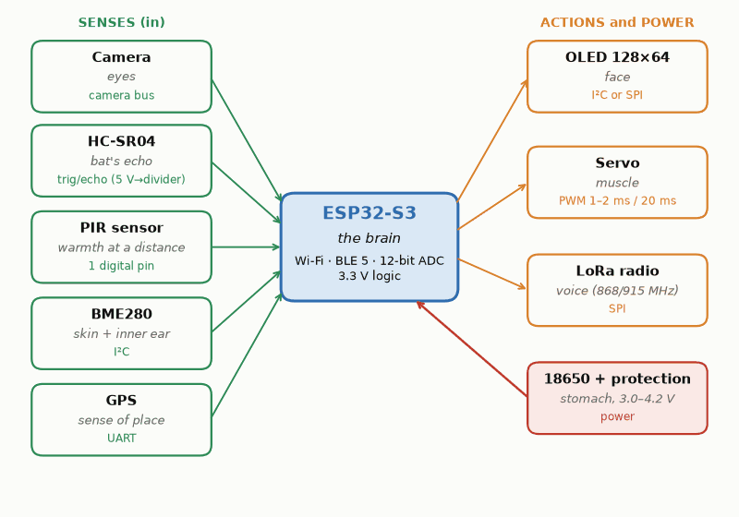
Figure L.1 — The reader lab as a body. The ESP32-S3 is the brain; the sensors are its senses, the servo its muscle, the OLED its face, the LoRa radio its voice, and the 18650 cell its stomach. Link labels name interface types; this is a kit map, not a complete wiring diagram.
If you buy only one controller, buy an ESP32-S3 board. It has the wireless radios the later books need, enough analog inputs for the sensing chapters, and enough speed for the camera. An Arduino Uno R4 or a Raspberry Pi Pico 2 W will also do most of the projects; where a difference matters, such as the Uno's 5 V pins against the ESP32-S3's 3.3 V pins, the text says so.
Analog first is a teaching order, not a ban on digital tools. Build the simplest analog version when the question is about a threshold, a divider, an RC time, or how a circuit behaves at one point; a few parts make the physics visible. Use the ESP32-S3 when the measurement needs repeated sampling, calibrated conversion, timing, computation, logging, a digital bus such as I²C, radio, or a display. Its ADC has finite range, calibration error, and sampling limits, so code does not make a measurement accurate by itself. Compare the analog and digital versions when both can answer the same question. Real products combine analog signal conditioning with digital control.
In this book the lab appears in Chapter 8 (an LED and a light sensor), Chapter 15 (what an ADC reading is worth, and an ultrasonic range corrected for temperature), Chapter 18 (a pressure trend), Chapter 27 (thermistors, bridges, a load cell, and safe 5 V to 3.3 V connections), Chapter 33 (a debounced button and the I²C bus), and Chapter 35 (an energy dashboard). Three small projects run through those chapters: a Smart Weather Station, a Home Energy Dashboard, and a Smart Refrigerator Monitor. The camera, GPS, LoRa radio, and servo wait for the later books, and Book 7 closes its own volume with a robot that draws on the series; Books 8 and 9 then take the reader into firmware and measurement. These six activities also form an optional build-first route; follow them in chapter order and return to any earlier explanation when a term or equation is new.
Key Idea
Treat the 18650 cell with respect. A shorted lithium-ion cell can deliver tens of amperes and start a fire. Use a holder with a protection module, never solder directly to a cell, never charge one without a charger made for lithium-ion, and keep its wires covered.

Table of Contents
Preface — How to Use This Book
How This Book Is Organized
About This Series
The Reader Lab

Part I — The Physics of Electricity and Magnetism
Chapter 1 — Electric Charge
Chapter 2 — Coulomb's Law and the Electric Force
Chapter 3 — The Electric Field
Chapter 4 — Electric Flux and Gauss's Law
Chapter 5 — Electric Potential Energy and Voltage
Chapter 6 — Conductors, Capacitance, and Dielectrics
Chapter 7 — Electric Current and Resistance
Chapter 8 — Ohm's Law and a First Look at Circuits
Chapter 9 — Magnetism and the Magnetic Field
Chapter 10 — Sources of the Magnetic Field
Chapter 11 — Electromagnetic Induction
Chapter 12 — Toward Maxwell's Equations and the Rest of This Series

Part II — Mathematics and Measurement
Chapter 13 — Quantities, Units, and the SI System
Chapter 14 — Prefixes, Scientific Notation, and Engineering Notation
Chapter 15 — Precision, Significant Figures, and Uncertainty
Chapter 16 — Algebra for Circuit Analysis
Chapter 17 — Systems of Linear Equations
Chapter 18 — Functions, Graphs, and Limiting Behavior
Chapter 19 — Exponentials, Logarithms, and the Decibel
Chapter 20 — Trigonometry and the Sinusoid
Chapter 21 — Complex Numbers
Chapter 22 — Euler's Formula and the Complex Exponential
Chapter 23 — Phasors and Impedance
Chapter 24 — Calculus for Electrical Engineering
Chapter 25 — Where This Book Leads Next

Part III — DC and AC Circuit Theory
Chapter 26 — Circuit Elements and Kirchhoff's Laws
Chapter 27 — Equivalent Resistance and Dividers
Chapter 28 — Nodal Analysis
Chapter 29 — Mesh Analysis
Chapter 30 — Thevenin and Norton Equivalents
Chapter 31 — Superposition and Linearity
Chapter 32 — Capacitors and Inductors as Circuit Elements
Chapter 33 — First-Order Transients: RC and RL Circuits
Chapter 34 — Sinusoidal Steady-State Analysis
Chapter 35 — AC Power and Power Factor
Chapter 36 — Resonance, Frequency Response, and Transformers
Chapter 37 — The Smith Chart, Impedance Matching, and Bias Networks
Chapter 38 — Where This Series Goes Next
Appendix A — Formula Reference
Appendix B — Practice Problem Solutions
Appendix C — Glossary
Appendix D — Chapter Summaries
Appendix E — A Practical Circuit-Analysis Checklist
Appendix F — Further Reading
About the Author
Also by Lothar J. Musiol

Part I — The Physics of Electricity and Magnetism

Chapter 1 — Electric Charge
Shuffle across a carpet on a dry winter day, reach for a door handle, and you get a small lesson in this chapter: around a microcoulomb of charge, several thousand volts, and a spark you can feel. The charge is tiny. The voltage is not, which is why the same spark can quietly kill a chip.
Where you meet this: ESD wrist straps and anti-static bags, touchscreens that sense the charge on your finger, laser printers, and every battery capacity figure, since milliampere-hours are a unit of charge.

1.1 What Charge Is
Electric charge is one of a small number of properties, alongside mass, that a particle can carry without that property being made of anything more fundamental. You cannot explain charge in terms of something simpler; you can only describe what it does. What it does is this: particles with charge exert forces on other particles with charge, and those forces are enormously stronger than gravity. Two protons separated by a meter repel each other with a force about 10³⁶ times stronger than they attract each other gravitationally. Electromagnetism, not gravity, is the force that dominates chemistry, materials, and — for our purposes — every circuit ever built.
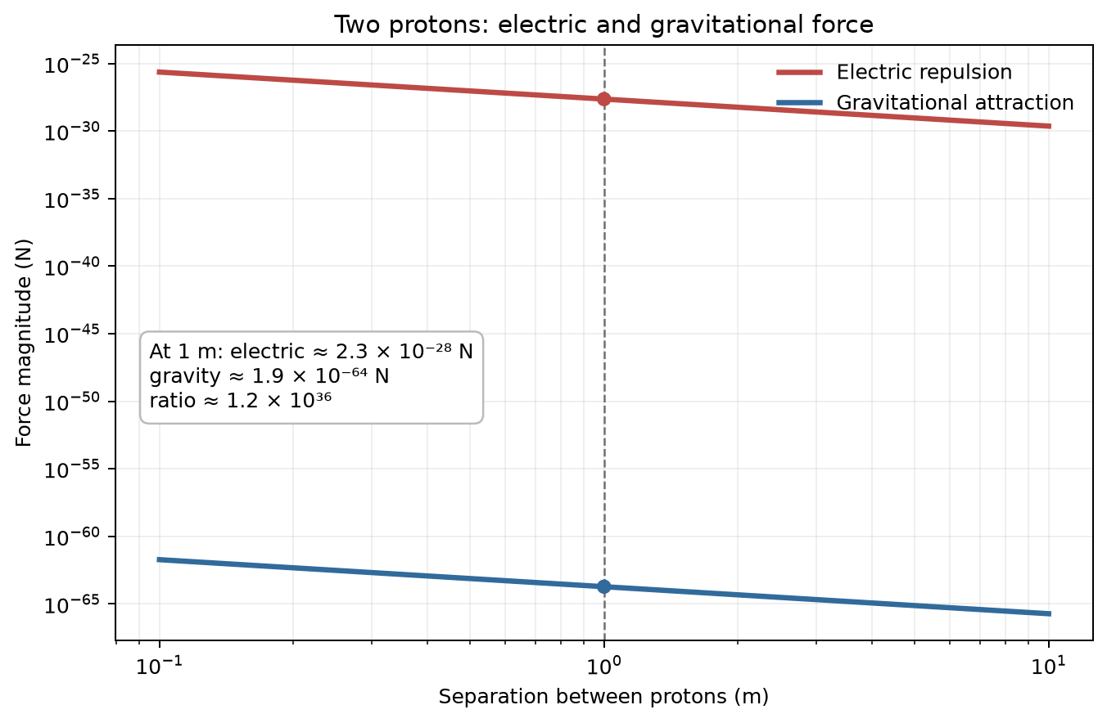
Figure 1.2 — Force between two protons versus separation. Both forces follow an inverse-square law; at 1 m the electric repulsion is about 1.2 × 10³⁶ times the gravitational attraction.
It is worth pausing on just how strange this is. Gravity is the interaction most people build their physical intuition around because its long-range effects are obvious in daily life. Electromagnetism dominates contact forces, chemistry, and materials, but at distances larger than atomic scales the positive and negative charges in ordinary matter nearly cancel. Gravity, weak as it is, has no comparable positive-negative cancellation, so it dominates the large-scale structure of planets, stars, and galaxies. Of the four fundamental interactions, gravity is by far the weakest between individual particles.
Get that cancellation even slightly wrong — charge a balloon by rubbing it on your hair — and the electric force wins over gravity by such a wide margin that the balloon sticks to the ceiling, plainly overpowering the gravitational pull of an entire planet.
Charge comes in two kinds, arbitrarily labeled positive and negative by Benjamin Franklin in the 1740s, before anyone knew what was actually moving inside a wire. Franklin guessed wrong about which kind of charge does the moving in metals — conventional current, the direction we still use in circuit diagrams today, points the opposite way electrons actually travel — but the labels stuck, and the sign convention is now so deeply embedded in circuit theory that no one has seriously proposed fixing it. You will get used to the fact that current “flows” one way while the electrons carrying it move the other.

1.2 The Elementary Charge and Quantization
Charge is quantized in units of the elementary charge, denoted e. Every free particle you will meet in circuit-level physics carries a charge that is a whole-number multiple of e. Quarks carry fractional multiples of e, but they are confined inside composite particles and do not appear as isolated free particles.
e = 1.602 × 10⁻¹⁹ C
The proton carries charge +e; the electron carries charge −e. A neutral atom has equal numbers of each and so carries no net charge. When we talk about a material becoming “charged,” we mean it has acquired a surplus or deficit of electrons relative to protons — the protons themselves are locked in the nucleus and essentially never move in ordinary electrical processes.
Key Idea
Charge is conserved. The total charge in an isolated system never changes. Charge can move from one object to another, and positive and negative charge can be created or destroyed together in equal amounts (as happens in particle physics), but the net total is always constant. This single fact underlies Kirchhoff's current law, which you will meet in Part III of this book (Chapter 26).

1.3 The Coulomb
The SI unit of charge is the coulomb (C), defined operationally through electric current: one coulomb is the charge transported past a point by a steady current of one ampere — informally, roughly the current a bright flashlight bulb draws; the formal definition waits until Chapter 7 — flowing for one second. Since the 2019 revision of the SI, the elementary charge is fixed at exactly e = 1.602176634 × 10⁻¹⁹ C, and the ampere is defined from it, so one coulomb is the charge of about 6.24 × 10¹⁸ elementary charges. Before 2019 the ampere was defined through the force between two current-carrying wires, which is why older books describe the coulomb as a unit derived from the ampere rather than from counting charges.
At circuit scale, a coulomb is substantial: a typical LED drawing 20 mA moves only 0.02 C each second. This gives the unit a practical scale before Chapter 7 explains current as charge flow.
Worked Example 1.1
Problem: A balloon rubbed on hair acquires a charge of − 8.0 nC. How many excess electrons does it carry, and what fraction is this of the roughly 10²³ atoms in a typical balloon's rubber?
Solution: n = Q/e = (8.0×10⁻⁹)/(1.602×10⁻¹⁹) ≈ 5.0×10¹⁰ excess electrons. Comparing to the ~10²³ atoms making up the balloon's rubber, this is a fraction of roughly 5×10¹⁰/10²³ ≈ 5×10⁻¹³ — equivalent, if that excess were spread evenly, to one extra electron per roughly two trillion atoms. A charge easily strong enough to stick a balloon to the ceiling involves rearranging only a vanishingly small fraction of the material's total electrons — the same “spectacular margin” theme from Section 1.1: it takes only the tiniest imaginable imbalance for the electric force to overwhelm gravity entirely.

1.4 Charging by Friction, Contact, and Induction
Objects acquire net charge through several everyday mechanisms, all of which amount to moving electrons from one material to another.
- Friction (triboelectric charging): rubbing two different insulating materials together strips electrons from one surface and deposits them on the other. A balloon rubbed on hair becomes negatively charged because it pulls electrons off the hair more readily than the hair pulls them back.
- Contact charging: touching a charged conductor to a neutral one allows charge to redistribute across both until they reach a common electric potential (a concept formalized in Chapter 5).
- Charging by induction: bringing a charged object near a neutral conductor, without touching it, causes the conductor's own free electrons to redistribute — piling up on the near side if the inducing charge is positive, leaving a net positive region on the far side. Grounding the far side — connecting it by a wire to the earth, or to any large neutral body, giving surplus electrons somewhere to drain to or be drawn from — while the inducing charge is still present, then removing the ground and finally the inducing charge, leaves the conductor with a net charge opposite in sign to the one that induced it.
These three mechanisms look different in practice but share a single underlying idea: nothing is ever created or destroyed, only moved. It is worth checking, for each of the three, that you could point to exactly where the electrons involved came from and where they ended up — an exercise that pays dividends once Kirchhoff's current law asks you to do the same bookkeeping, far more precisely, for entire circuit networks.

1.5 Conductors and Insulators, Revisited at the Charge Level
The difference between a conductor and an insulator is mainly how many charge carriers are available to move and how freely they can move. In a metal such as copper or aluminum, some electrons are delocalized across the material and respond readily even to a small electric field. In an insulator such as glass, rubber, or most plastics, electrons are much more tightly bound, so far fewer mobile carriers are available under ordinary conditions. Real insulators still have leakage current; temperature, impurities, moisture, geometry, and applied field all matter, and a sufficiently high field can cause dielectric breakdown. The “sea of electrons” and “bound electrons” pictures are useful first models, not complete accounts of conduction.
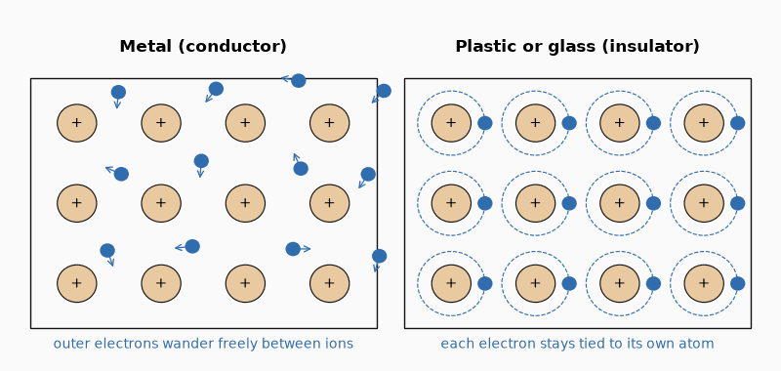
Figure 1.1 — Why copper conducts and glass doesn’t: in a metal the outer electrons roam freely between the ions; in an insulator each one stays tied to its own atom.
Semiconductors sit between these extremes, and the entire discipline of solid-state electronics exists because that middle ground can be controlled precisely through doping — a subject taken up in full in the semiconductor-devices volume of this series.
Common Misconception
It is tempting to think of a “fully charged” insulator as somehow saturated, unable to hold any more charge. In reality, an insulator's inability to conduct has nothing to do with how much charge it is holding — it is about whether the charge it already has is free to redistribute. A heavily charged insulating rod holds its charge in whatever pattern it was deposited in (often quite unevenly), precisely because the charge cannot move to spread out, unlike on a conductor, where excess charge always redistributes itself until it reaches electrostatic equilibrium (Chapter 6).
From the Bench
Treat every bare circuit board as something you can destroy by touching it. The human-body model used in ESD testing is 100 pF behind 1.5 kΩ, and a sensitive MOSFET gate can be damaged by a discharge well below the roughly 3 kV it takes for you to feel one. Wear a grounded wrist strap, keep boards in shielding bags, and remember that a part which worked yesterday and is dead today may have been zapped rather than born defective.

15.7 Reading an Instrument Specification as an Error Budget
Use the actual instrument specification rather than a generic number of trusted digits. For example, the Fluke 117 specifies DC-voltage accuracy as ±(0.5% of reading + 2 counts). On its 6.000 V range, a 4.732 V reading with 1 mV resolution therefore has a stated limit of about ±(0.005 × 4.732 V + 0.002 V) = ±0.026 V, under the conditions and calibration interval in its manual. The display resolution is 1 mV; the accuracy bound is about 26 mV.
A probe belongs in the same budget. A 10× passive oscilloscope probe may present roughly 10 MΩ in parallel with several picofarads; the exact values depend on the probe and scope. The resistance can load a high-impedance DC node, while the capacitance can slow a fast edge or detune a small resonant circuit. Check attenuation, compensation, bandwidth, input resistance, and capacitance in the specific probe manual. For the ESP32-S3, the ±50 mV calibrated ADC total-error figure over 0–2.9 V is measured with a 100 nF input capacitor, DC input, Wi-Fi disabled, and 25 °C ambient; the divider and board add their own errors. Later measurement examples should state their own instrument and setup limits rather than borrowing one universal tolerance from this chapter.

Practice Problems
- A charged rod carries a charge of −8.0 nC. How many excess electrons does it carry?
- Two identical small conducting spheres carry charges of +6.0 nC and −2.0 nC. They are touched together and separated. What charge does each sphere carry afterward?
- Estimate how many elementary charges pass through a wire in one minute if the wire carries a steady current of 2.0 A.
- A third identical, initially neutral sphere is touched first to a sphere carrying +9.0 nC, then separated, then touched to a different sphere carrying −3.0 nC. Find the final charge on all three spheres.

What You’ll Actually Use
Everyday working tools
- Charge as current × time: 1 mAh = 3.6 C, so a 3,000 mAh phone battery holds about 10,800 C.
- Conductor-versus-insulator thinking for enclosures, layout and ESD protection.
- Charge conservation: what flows in must flow out, the seed of Kirchhoff's current law.
Mostly for exams and deeper study
- Counting electrons with e = 1.602 × 10⁻¹⁹ C.
- The step-by-step bookkeeping of charging by induction.

Chapter 2 — Coulomb's Law and the Electric Force
Why doesn't your hand sink into the table? Atoms are mostly empty space, after all. Two things stop it. The electrons in your skin and in the table repel each other with the force in this chapter, and a rule of quantum mechanics, the Pauli exclusion principle, forbids those electrons from crowding into the same states. At atomic distances both effects are enormous.
Where you meet this: Electrostatic spray painting and dust precipitators, MEMS electrostatic actuators, and the forces that hold every molecule, and therefore every solder joint, together.

2.1 Stating the Law
The charged balloon from Chapter 1 does more than stick to the ceiling. Bring a second charged balloon near it and, depending on how each one was charged, they either swing apart or pull together — the same electric force that stuck the first balloon to the ceiling, now acting between two balloons instead of one. Move the two balloons further apart and the push, or pull, visibly weakens; bring them closer and it visibly strengthens.
By how much, though? Twice the distance — is the push half as strong, a quarter, an eighth? Nothing about rubbing two balloons and feeling them push apart tells you the answer. A feel for “weaker further away” is not the same as a number that lets you predict a force you have not yet measured, and predicting exact forces, not only their direction, is what makes a chapter like this one worth having.
The honest obstacle is that answering this needs an actual measurement, and the force between two everyday charged objects is far too small to feel by hand or register on any ordinary scale. You cannot rest two charged balloons against a bathroom scale and read off the push in newtons; whatever is pushing them apart is real, but it sits far below what your hands or an ordinary instrument can detect directly.
The way round it is to trade a force too small to feel for a twist too small to miss. Hang a light rod from one end of a long, thin fiber, so that even a very gentle sideways push on the far end of the rod visibly twists the fiber — the thinner and longer the fiber, the more even a tiny force winds it. Fix a charged object to that end of the rod, bring a second charged object near it without touching, and the amount of twist, converted back into a force through how stiff the fiber is separately known to be, gives a real number for a push far too small to feel by hand.
Do this carefully at several separations, with the same two charges each time, and a clean pattern falls out. Two charges of +1.0 µC, 10 cm apart, push each other with a force of about 0.90 N. Move them to 20 cm apart — twice the separation — and the force drops to about 0.22 N, roughly a quarter of what it was. Move them to 30 cm — three times the original separation — and the force drops further, to about 0.10 N, roughly a ninth of the original.
Notice what the numbers never do: they never fall in proportion to the distance itself. Doubling the separation quarters the force; tripling it cuts the force to a ninth — the force is falling as the square of the distance, not the distance itself. Charles-Augustin de Coulomb measured exactly this relationship in 1785, using precisely the twisting-fiber trick above, sensitive enough to catch forces far smaller than the weight of the charged spheres producing them. The result is Coulomb's law: the electric force between two point charges is proportional to the product of the charges and inversely proportional to the square of the distance between them:
F = k q₁q₂ / r²
where q₁ and q₂ are the magnitudes of the two charges, r is the distance between them, and k is the Coulomb constant:
k = 8.99 × 10⁹ N·m²/C²
The force is directed along the line connecting the two charges. If the charges have the same sign, the force is repulsive; if opposite, attractive. This is a vector equation in disguise — vector, meaning a quantity carrying both a size and a direction, unlike the plain numbers used so far — writing it as a magnitude is convenient, but you must always track direction separately, especially once more than two charges are involved.
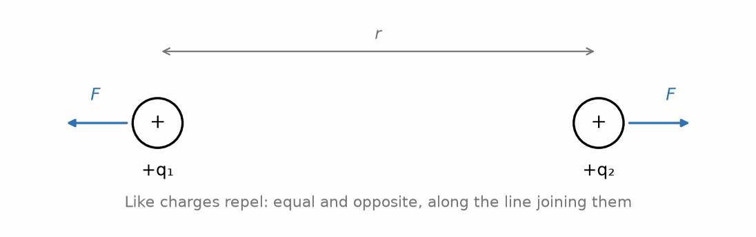
Figure 2.1 — Coulomb's law: like charges repel, with equal and opposite forces along the line joining them.
The Coulomb constant is often written in terms of a more fundamental quantity, the permittivity of free space, ε₀:
k = 1 / (4πε₀) , ε₀ = 8.85 × 10⁻¹² C²/(N·m²)
This looks like an unnecessary complication when you are only dealing with two point charges, but the 4π factor is there so that later results — Gauss's law in particular — come out clean. You will see the payoff in Chapter 4.

2.2 The Inverse-Square Behavior
The 1/r² dependence is the same functional form that governs Newton's law of gravitation, and for the same underlying geometric reason: both forces are carried by something spreading outward from a point source over the surface of an ever-expanding sphere, and the surface area of a sphere grows as r², so the intensity of anything spread evenly over that surface falls as 1/r². This geometric argument is made precise in Chapter 4 and is one of the most useful pieces of physical intuition you will carry into the rest of this series — the same 1/r² falloff will reappear when you study radiation from antennas.
Key Idea
Doubling the distance between two charges cuts the force to one quarter. Tripling the distance cuts it to one ninth. This scaling, not the specific value of k, is the fact worth internalizing.

2.3 Superposition
When more than two charges are present, the net force on any one of them is the vector sum of the Coulomb forces exerted by every other charge individually, as if each pair existed alone. This is the principle of superposition, and it holds because Coulomb's law is linear in each charge — nothing about the presence of a third charge alters the force law between the first two.
Superposition sounds almost too obvious to state, until you notice how much it is quietly assumed. It is not, in fact, a logical necessity — one could imagine a universe where three charges interact through some genuinely three-body force that cannot be decomposed into pairwise contributions, and such three-body effects do arise in more exotic physical settings. That electromagnetism happens not to work that way is an experimental fact, not a mathematical inevitability, and it is one of the reasons circuit analysis is tractable at all: without superposition, adding a second component to a circuit could, in principle, change how every existing component behaved with every other, rather than adding its own well-defined contribution.
Worked Example 2.1
Problem: Charges of +3.0 µC and +5.0 µC sit on the x-axis at x = 0 and x = 4.0 cm. Find the net force on a +2.0 µC charge placed at x = 2.0 cm.
Solution: The test charge is 2.0 cm from each source charge. The force from the +3.0 µC charge is repulsive, pushing the test charge in the +x direction: F₁ = k(3.0×10⁻⁶)(2.0×10⁻⁶)/(0.020)² ≈ 135 N. The force from the +5.0 µC charge is repulsive as well, pushing in the −x direction: F₂ = k(5.0×10⁻⁶)(2.0×10⁻⁶)/(0.020)² ≈ 225 N. These act along the same line in opposite directions, so the net force is 225 − 135 = 90 N, directed toward x = 0 (the test charge is pushed harder by the larger, 5.0 µC charge, so the net push is toward the smaller charge's side, i.e., toward x = 0).
Worked Example 2.2
Problem: Three identical charges of +4.0 µC sit at the corners of an equilateral triangle with sides of 10 cm. Find the magnitude of the net force on any one of the charges.
Solution: By symmetry, the force from each of the other two charges has the same magnitude: F = kq²/r² = (8.99×10⁹)(4.0×10⁻⁶)²/(0.10)² ≈ 14.4 N. These two forces act along the two sides of the triangle meeting at the corner in question, separated by the triangle's interior angle of 60°. Adding them as vectors (using the law of cosines, or equivalently resolving into components), the net force magnitude works out to 2F cos(30°) ≈ 2(14.4)(0.866) ≈ 24.9 N, directed straight out along the triangle's line of symmetry through that corner, away from the triangle's center.

2.4 When Coulomb's Law Stops Being Enough
Coulomb's law as stated applies to point charges (or, outside the sphere, spherically symmetric charge distributions) in an electrostatic situation, with the charges fixed in the chosen reference frame. Charges in motion also produce magnetic fields, so Coulomb's law alone is not the complete force law. Real charge distributions — a charged rod, a charged disk, the electron cloud of an atom — must be handled by dividing the distribution into infinitesimal point charges and integrating. That machinery is exactly what Gauss's law, introduced in Chapter 4, is built to avoid having to do by brute force whenever the charge distribution has enough symmetry.
Common Misconception
Students frequently write Coulomb's law with the separation r substituted as if it were always measured from a fixed origin, rather than the actual distance between the two charges in question. Once you move beyond a single pair of charges arranged conveniently on an axis, r for any given pair is always the straight-line distance between that specific pair, recomputed freshly for each pair under consideration — not a coordinate borrowed from somewhere else in the problem.
From the Bench
Check the exponent before you question the physics. With k ≈ 9 × 10⁹ N·m²/C², two 1 nC charges a millimeter apart push with about 9 mN. If your answer for small charges comes out in kilonewtons, a nano or micro went missing somewhere, which is by far the most common mistake in this chapter.

Practice Problems
- Two point charges of +4.0 µC and −6.0 µC are separated by 30 cm. Find the magnitude and direction of the force each exerts on the other.
- At what separation would two identical charges of +1.0 µC repel each other with a force of exactly 1.0 N?
- Three charges lie on a line: +2.0 µC at x = 0, −3.0 µC at x = 10 cm, and +1.0 µC at x = 20 cm. Find the net force on the middle charge.
- Two identical small spheres, each of mass 1.0 g, hang from strings 50 cm long attached to the same point. They carry equal charges q and repel each other until each string makes an angle of 10° with the vertical. Identify every force acting on one sphere, then find q.

What You’ll Actually Use
Everyday working tools
- Inverse-square scaling: double the distance, quarter the force.
- Sign bookkeeping: like charges repel, unlike attract.
Mostly for exams and deeper study
- Vector sums of forces from several charges, by components.
- Working with ε₀ to several significant figures.

Chapter 3 — The Electric Field
A thundercloud a kilometer overhead can make the hair on your arms stand up. Nothing touches you; the cloud reaches you through its electric field. Engineers worry about the same thing on a far smaller scale, such as the field across a transistor's gate insulator, only a few nanometers thick.
Where you meet this: Capacitive touchscreens, the voltage rating of every capacitor, creepage and clearance spacing on mains boards, and the rounded edges on high-voltage hardware.

3.1 Why Introduce a Field at All
Rub a balloon on your hair, as in Chapter 1, and bring it near a second balloon charged the same way: they push apart, and Coulomb's law from Chapter 2 says exactly how hard. Bring in a third balloon. A fourth. Coulomb's law still handles every pair, one at a time — but nothing in it describes the empty patch of air in the middle of the room, the spot where no balloon happens to be floating yet. Ask what force acts there and the question has no subject: a force is something one charged object exerts on another, and an empty point in space is not an object.
So the question has to change. Not “what force acts on this balloon,” which only makes sense once a balloon is actually there, but “what is the condition of that empty spot, ready and waiting, before any balloon arrives to feel it?” Coulomb's law cannot answer that on its own terms: it names two charges and falls silent about everywhere else. Whatever answer works has to live at points that, for the moment, hold no charge at all.
The way around it looks almost too simple to be the whole story, and turns out to be exactly that. Stop asking the empty point to supply a force on its own. Ask it instead for a readiness — a number saying how hard a charge would be pushed if one were placed there, without yet committing to how big that charge is. Bring a small test charge to the point, measure the force it feels, and divide the force by the size of the charge.
Try it with an ever-smaller test charge, near a fixed source charge of +8.0 nC, 5.0 cm away. Shrink the test charge by a factor of ten at each step — 1.0 nC, then 0.10 nC, then 0.010 nC, then 0.0010 nC — and the force it feels shrinks by that same factor of ten each time: about 2.9×10⁻⁵ N, then 2.9×10⁻⁶ N, then 2.9×10⁻⁷ N, then 2.9×10⁻⁸ N. Divide each force by its own test charge, though, and the factor of ten cancels every time: all four pairs give the same quotient, about 2.9×10⁴ N/C.
Notice what that quotient never does: it never depends on which test charge produced it. Whatever fixes that number is a property of the point itself — 5.0 cm from that particular source charge — a readiness sitting there whether or not a test charge happens to be at that point to notice it.
This is more than philosophical tidiness. The field concept is what lets electromagnetism handle radiation, time delay, and energy storage in empty space — none of which fit comfortably into an “action at a distance” picture. If a source charge is suddenly moved, a distant test charge does not respond instantaneously; the change in the field propagates outward at the speed of light (Chapter 12), and until it arrives, the test charge continues to respond to where the source charge used to be. Coulomb's law alone, treated as a direct force between two charges, has no room in it for this kind of delay; the field, treated as a physically real thing occupying the space between them, does. By the time you reach the RF and antenna volumes of this series, the field will have become the primary object of study, with charges relegated to being merely its sources.

3.2 Defining the Electric Field
That readiness has a name: the electric field. It is exactly what the previous section's quotient was already computing, defined operationally: place a small positive “test charge” q₀ at a point, measure the force F on it, and divide by q₀.
E = F / q₀
The field is a vector, pointing in the direction of the force that would be felt by a positive test charge. Its units are newtons per coulomb (N/C), equivalently volts per meter (V/m) once potential is introduced in Chapter 5. The test charge is taken to be small enough that it does not itself disturb the charge distribution being measured — a limiting idealization, since strictly any nonzero q₀ will push the source charges around a little if they are free to move.
From Coulomb's law, the field of a single point charge q at distance r is:
E = kq / r²
directed radially outward from a positive source charge, and radially inward toward a negative one.

3.3 Superposition of Fields
Just as forces from multiple charges add as vectors, so do the fields they produce. The net field at any point is the vector sum of the fields each source charge would produce there individually. This is the field-picture restatement of the same superposition principle from Chapter 2, and it is what makes the field concept practically useful: once you know how to add vectors, you can find the field of any charge distribution, however complicated, by summing (or integrating) the contributions of its pieces.

3.4 Field Lines
Field lines are a visualization tool, not a physical object: a diagram of curves drawn so that the tangent to the curve at any point gives the field direction there, and the density of lines (how close together they are drawn) represents field strength. Field lines originate on positive charges and terminate on negative charges (or run off to infinity if there is a net charge imbalance in the region). They never cross, because the field at any point has one and only one direction.
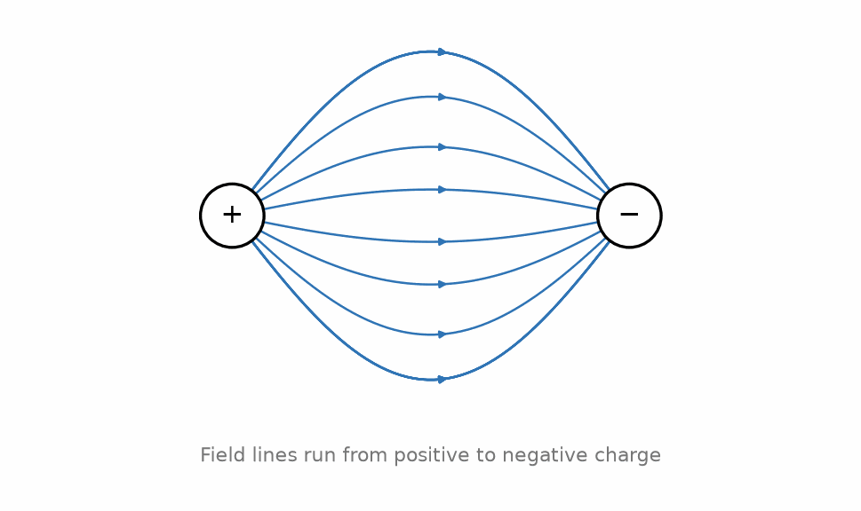
Figure 3.1 — Electric field lines run from positive charge to negative charge.
Key Idea
Field line density encodes field strength. Wherever field lines bunch closer together, the field is stronger; wherever they spread apart, it is weaker. This is exactly the intuition Gauss's law makes quantitative in the next chapter.

3.5 The Field of a Dipole
An electric dipole — two equal and opposite charges +q and −q separated by a small distance d — is worth working through explicitly because dipole fields reappear constantly: in molecular physics, in antenna theory, and as the building block for understanding how insulating (dielectric) materials respond to fields, which matters directly for capacitors in Chapter 6. The dipole is characterized by its dipole moment, a vector p of magnitude p = qd, pointing from the negative charge to the positive one. Far from the dipole (at distances much larger than d), the field falls off as 1/r³ rather than 1/r² — faster than a single point charge, because the +q and −q fields nearly cancel except for the small asymmetry due to their separation.
A dipole placed in an external, uniform electric field feels no net force (the forces on +q and −q are equal and opposite, since both charges sit in the same external field), but it does feel a net torque, which acts to rotate the dipole until p aligns with the external field. This torque-without-net-force behavior is exactly how a compass needle responds to Earth's magnetic field, and it is the mechanism by which an external field polarizes and aligns the molecular dipoles inside a dielectric material — the microscopic picture behind the macroscopic dielectric constant introduced in Chapter 6.
Worked Example 3.1
Problem: Find the electric field 5.0 cm from a point charge of +8.0 nC.
Solution: E = kq/r² = (8.99×10⁹)(8.0×10⁻⁹)/(0.050)² ≈ 2.9 × 10⁴ N/C, directed radially away from the charge.
Worked Example 3.2
Problem: A +4.0 nC charge sits at the origin and a −4.0 nC charge sits at x = 6.0 cm. Find the net electric field at the point x = 3.0 cm (the midpoint between them).
Solution: Field from the +4.0 nC charge, 3.0 cm away, points in the +x direction (away from a positive charge): E₁ = kq/r² = (8.99×10⁹)(4.0×10⁻⁹)/(0.030)² ≈ 3.996×10⁴ N/C. Field from the −4.0 nC charge, also 3.0 cm away, points in the +x direction as well (toward a negative charge, and the negative charge is further along +x, so the field at the midpoint points toward it): E₂ ≈ 3.996×10⁴ N/C, same direction. Because the two fields point the same way at the midpoint of a dipole (this is a general feature of dipole fields directly between the charges), they add rather than cancel: E_net ≈ 7.99×10⁴ N/C in the +x direction.
Common Misconception
It is a common first guess that the field exactly midway between a +q and a −q charge of equal magnitude should be zero, by some vague appeal to symmetry. The worked example above shows this is exactly backward for points between the charges: the two fields point the same direction there and add. The field never actually vanishes anywhere off to the sides, for an ideal dipole of exactly equal and opposite charge: the two individual field vectors on the perpendicular bisector never point in exactly opposite directions, so they never cancel at any finite distance — the field there only grows weaker, approaching zero as the distance grows without bound.
From the Bench
Dry air breaks down at roughly 3 kV per millimeter between smooth electrodes, and at much less near sharp points, where the field crowds together. On a mains or high-voltage board, solder spikes and pointed copper corners are where arcing starts. Space conductors to the safety standard's creepage and clearance values, never to your own estimate, and remember that dirt and humidity eat into the margin.

Practice Problems
- Find the electric field at a point 10 cm from a −12 nC point charge.
- Two point charges, +5.0 nC and −5.0 nC, are 4.0 cm apart. Find the field at the midpoint between them.
- A uniform field of 500 N/C points in the +x direction. Find the force on an electron placed in this field, and state its direction.
- A small dipole with dipole moment 2.0 × 10⁻²⁹ C·m is placed in a uniform external field of 3.0 × 10⁵ N/C, oriented perpendicular to the field. Find the magnitude of the torque on the dipole (torque on a dipole in a uniform field has magnitude τ = pE sinθ, where θ is the angle between p and E).

What You’ll Actually Use
Everyday working tools
- E = V/d for parallel plates, quoted in V/m or kV/mm.
- Field-line sketches as a quick picture: crowded lines mean a strong field.
Mostly for exams and deeper study
- Fields of continuous charge distributions by integration.
- The far field of a dipole.

Chapter 4 — Electric Flux and Gauss's Law
Why does a car protect you from lightning? Largely because of a consequence of Gauss's law: excess charge on a conductor sits on its outer surface, and the static field inside a closed conducting shell is zero. Your phone losing signal in a steel elevator is the radio-frequency cousin of the same idea.
Where you meet this: Metal enclosures and shielded cables, coaxial cable (whose field Gauss's law gives in one line), and the fact that a capacitor's charge sits on the facing surfaces of its plates.

4.1 Electric Flux
Hold a window screen out in falling rain, facing the rain squarely, and count how many drops pass through it in a few seconds. Now tilt the same screen, in the same rain, so it faces more sideways: fewer drops get through, even though the rain itself has not changed at all — only how squarely the screen meets it has. Tilt the screen far enough, edge-on to the rain, and essentially no drops pass through it, however heavy the actual rainfall.
So a useful measure of “how much rain gets through” cannot be only the rain’s intensity, or only the screen’s size — it has to combine how heavy the rain is, how large the screen is, and how squarely the screen faces it. Electric field lines behave exactly the same way: a surface sitting in a field has no way around dealing with its own tilt, once the field is actually there to pass through it.
Electric flux is exactly that combined measure: how much field passes through a given surface, once the surface’s own orientation is accounted for. A flat surface facing squarely into a field gets the full effect; the same surface tilted gets less, scaled down by the same cosine factor a tilted rain-screen would use.
A uniform field of 100 N/C passing through a flat surface of area 0.50 m², facing the field squarely, carries a flux of 50 N·m²/C. Tilt that same surface to 60° from facing the field, and the flux drops to 25 N·m²/C — exactly half. Tilt it all the way to 90°, edge-on to the field, and the flux drops to zero, however strong the field actually is.
That combined quantity — field strength times area times the cosine of the tilt angle — is the electric flux through the surface, the field-line-counting intuition from Chapter 3 made precise. For a flat surface of area A in a uniform field E, with the surface oriented so its normal (the perpendicular direction) makes angle θ with the field, the flux is:
Φ_{E} = E A cosθ
Flux is maximized when the field is perpendicular to the surface (θ = 0) and zero when the field runs parallel to the surface (θ = 90°), since in that case no field lines pierce through it at all. For a curved surface or a nonuniform field, this generalizes to a surface integral, E·dA integrated over the surface — but for this book's purposes, the cases that matter are the ones with enough symmetry that the integral becomes trivial, which is exactly the point of Gauss's law.

4.2 Gauss's Law
Here is the genuinely surprising payoff of building flux this carefully: wrap any closed surface, any shape at all, entirely around a charge, and add up the flux through every part of it — bulges, dents, and all — and the total depends on nothing except how much charge is trapped inside. Move the charge around inside the surface, and the total is unchanged. Change the surface's shape while keeping the same charge inside, and the total is unchanged again. Gauss's law states this precisely: the total electric flux through any closed surface is proportional to the net charge enclosed by that surface:
Φ_{E} = Q_{enc} / ε₀
This is one of the four Maxwell equations (met formally in Chapter 12) and it is exactly equivalent to Coulomb's law — nothing new physically is being added — but it is often dramatically easier to use. The closed surface in question, called a Gaussian surface, is entirely a mathematical construction you get to choose; it does not need to correspond to any physical boundary, and it does not need to contain any actual material at all.
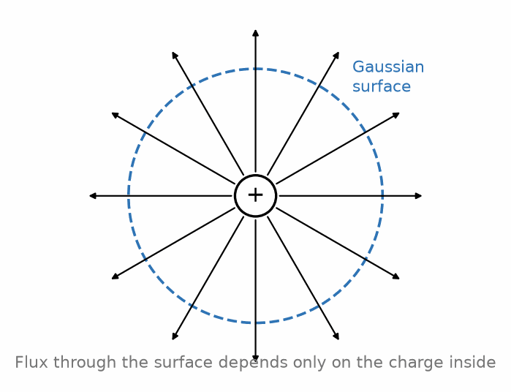
Figure 4.1 — A Gaussian surface enclosing a point charge: the flux through it depends only on the enclosed charge.
Key Idea
Choose a Gaussian surface that matches the symmetry of the charge distribution. For a point charge or any spherically symmetric distribution, use a sphere. For an infinite line or cylinder of charge, use a coaxial cylinder. For an infinite sheet of charge, use a “pillbox” straddling the sheet. Get the shape right, and the field comes out of the surface integral as a constant that can be pulled outside it, turning the integral into simple algebra.

4.3 Deriving Coulomb's Law from Gauss's Law
As a consistency check, and as the cleanest illustration of the method, take a single point charge q and surround it with an imaginary sphere of radius r centered on the charge. By symmetry, the field must point radially and have the same magnitude E everywhere on the sphere's surface — there is no direction along the sphere that is special, so the field cannot depend on where on the sphere you look. The flux integral therefore reduces to E multiplied by the sphere's total surface area, 4πr²:
E (4πr²) = q / ε₀
E = q / (4πε₀r²) = kq / r²
which is exactly the point-charge field from Chapter 3 — and this is precisely why the 4π was folded into the definition of k back in Chapter 2. Choosing ε₀ that way makes Gauss's law come out with no stray factors of 4π in it, at the cost of Coulomb's law carrying that factor instead. Physicists made that trade deliberately because Gauss's law, not Coulomb's law, is the one that generalizes to Maxwell's equations.

4.4 The Field of an Infinite Charged Sheet, a Line Charge, and a Charged Conductor
Three results from this method are used constantly in circuit-adjacent physics and are worth having on hand. First, an infinite sheet of charge with uniform surface charge density σ (charge per unit area) produces a field of constant magnitude on either side, independent of distance from the sheet:
E = σ / (2ε₀)
Second, an infinite line of charge with uniform linear charge density λ (charge per unit length), found using a coaxial cylindrical Gaussian surface of radius r, produces a field:
E = λ / (2πε₀r)
falling off as 1/r rather than the 1/r² of a point source — a direct consequence of the source being an infinite line rather than a point, so that the “surface” over which the field spreads out grows only as the cylinder's circumference (proportional to r), not as a sphere's full surface area (proportional to r²).
Third — and this result underlies why charge sits on the outer surface of a conductor and why the interior of a conductor in electrostatic equilibrium has exactly zero field — a Gaussian surface drawn entirely inside a conducting material, where charge is free to move, must enclose zero net charge, because if there were any field inside the conductor, its free electrons would still be accelerating, contradicting the assumption of equilibrium. All excess charge on a charged conductor therefore resides entirely on its outer surface, a fact this book will use again in Chapter 6 when introducing capacitors.
Worked Example 4.1
Problem: A solid conducting sphere carries a total charge of +6.0 µC. Find the electric field at a point 20 cm from the center, given the sphere's radius is 5.0 cm.
Solution: Since 20 cm is outside the sphere, and the sphere is spherically symmetric, Gauss's law gives exactly the point-charge result with all the charge treated as concentrated at the center: E = kq/r² = (8.99×10⁹)(6.0×10⁻⁶)/(0.20)² ≈ 1.35 × 10⁶ N/C. Note that the field outside a uniformly charged sphere is identical to that of a point charge of the same total charge — the sphere's actual radius plays no role once you are outside it.
Worked Example 4.2
Problem: An infinite sheet carries a uniform surface charge density of +2.0 µC/m². Find the field 1.0 cm and 10 cm from the sheet, and comment on what you find.
Solution: E = σ/(2ε₀) = (2.0×10⁻⁶)/[2(8.85×10⁻¹²)] ≈ 1.13 × 10⁵ N/C — at both distances, since the field of an ideal infinite sheet does not depend on distance from the sheet at all. This is a genuinely surprising result on first encounter (compare it against the point-charge and line-charge results, which both fall off with distance), and it follows directly from the field-line picture in Chapter 3: for a truly infinite sheet, the field lines run straight out perpendicular to the sheet and never spread apart, so their density — and hence the field strength — never decreases with distance. Real, finite sheets only approximate this behavior close to the sheet, well away from its edges.
Common Misconception
The infinite-sheet result E = σ/(2ε₀) is sometimes misapplied to a conductor's surface, where the correct result is instead E = σ/ε₀ — twice as large, with no factor of 2 in the denominator. The difference is not an error in either formula; it reflects a genuinely different physical situation. An isolated charged sheet (with vacuum or a symmetric environment on both sides) splits its flux evenly, half going each way, which is where the factor of 2 in the sheet result comes from. A conductor's outer surface, by contrast, has zero field on its interior side (Chapter 6) by definition of electrostatic equilibrium, so all of the flux is forced out through the exterior side alone, doubling the field there relative to the two-sided sheet case for the same σ.
From the Bench
A shield only shields if it is closed and connected. Seams and slots leak once their length is a sizable fraction of a wavelength, and a cable shield whose drain wire was never actually bonded to the chassis does little at all. Both are common reasons a 'shielded' design fails its emissions test; Book 7 returns to the subject.

Practice Problems
- A Gaussian sphere of radius 3.0 cm encloses a net charge of +2.0 nC. What is the total electric flux through the sphere?
- An infinite sheet carries a uniform surface charge density of +4.0 µC/m². Find the field 2.0 cm from the sheet.
- Explain, using Gauss's law, why the electric field immediately outside the surface of a charged conductor is always perpendicular to that surface.
- An infinitely long straight wire carries a uniform linear charge density of +5.0 nC/m. Find the electric field at a perpendicular distance of 4.0 cm from the wire.

What You’ll Actually Use
Everyday working tools
- Charge lives on outer surfaces and static fields vanish inside closed conductors: the intuition behind shielding.
- The field around a long line or a coax falls off as 1/r.
Mostly for exams and deeper study
- Choosing Gaussian surfaces and evaluating flux integrals.
- The field inside and outside a uniformly charged sphere.

Chapter 5 — Electric Potential Energy and Voltage
A bird can perch on a 10,000-volt power line and stay perfectly calm. What matters is not how many volts something sits at but the difference in volts between two points. The bird's feet are at almost the same potential, so almost no current flows through it.
Where you meet this: Every multimeter reading (always between two probes), battery voltages, logic levels (a 3.3 V signal is 3.3 V relative to ground), and the electron-volt in Book 3.

5.1 From Force to Energy
Every conservative force has an associated potential energy, and the electric force is conservative — the work done moving a charge between two points does not depend on the path taken, only on the endpoints. This mirrors gravitational potential energy exactly, and the analogy is worth leaning on: as an object gains gravitational potential energy when lifted against gravity, a positive charge gains electric potential energy when pushed toward another positive charge, against the repulsive force between them.
For two point charges q and Q separated by distance r, the electric potential energy of the pair is:
U = kqQ / r
Notice the missing square on r, compared to Coulomb's law's force expression — potential energy for a 1/r² force always goes as 1/r, the same relationship gravitational potential energy (U = −GMm/r) has to gravitational force. U is positive for like charges (energy is stored by pushing them together, against their mutual repulsion) and negative for unlike charges (they attract, so energy is released as they come together, and you must supply energy to pull them apart).

5.2 Electric Potential (Voltage)
Every battery has a number printed on it — 1.5 V for an AA cell, 9 V for the boxy rectangular kind, 12 V for a car battery. That number gets used constantly without most people ever asking what it actually measures. It cannot be a raw measure of how much energy the battery can deliver in total: a 12 V car battery and a toy's pack of eight AA cells are both labeled 12 V, yet the car battery can do far more total work before it runs flat.
Total capacity, then, is not what that number on the label measures. What it captures instead is something else: for each individual bit of charge the battery pushes around a circuit, how hard is that particular push? A raw quantity like total stored energy tangles together two separate things — how much charge got moved, and how hard each unit of it was pushed — and there is no way to pull those two apart merely by looking at one lump energy figure.
The way to separate them is the same move Chapter 3 made for force: stop asking for the total, and divide by however much charge is actually involved. Take the energy a battery delivers while moving some amount of charge around a circuit, and divide that energy by the charge that moved.
A 9 V battery moving 1.0 C of charge around a circuit does 9.0 J of work — checkable straight from the definition, since 9 V literally means 9 joules per coulomb. Move only 0.10 C instead, and the work drops to 0.90 J: ten times less charge, ten times less energy. Divide the work by the charge moved in each case, though, and both give back 9.0 J/C. Move 0.010 C, and the work drops again, to 0.090 J — but divide, and the quotient is still 9.0 J/C.
That fixed quotient — energy delivered per unit charge moved — is the electric potential, more commonly called voltage, and it is a property of the battery (or, more precisely, of the two points it connects), not of however much charge happens to pass through it on a given occasion. Written as a general definition, electric potential is the potential energy per unit charge:
V = U / q₀
Potential is a scalar, not a vector — a considerable practical simplification over working with fields directly, since scalars add algebraically with no direction bookkeeping. Its SI unit is the volt (V), equal to one joule per coulomb, and it is this quantity — not the field, and not the potential energy — that a voltmeter measures and that appears on every component datasheet and circuit diagram you will encounter for the rest of this series.
The potential due to a single point charge q, at distance r, taking the zero of potential to be at infinity (the conventional choice), is:
V = kq / r
Key Idea
Only differences in potential are ever physically meaningful. The choice of where V = 0 is a convention, not a physical fact — exactly like choosing sea level as the zero of height. What every circuit actually cares about is potential difference, the voltage between two points, which is why circuit diagrams always show voltage across a component, never a component's voltage in some absolute sense.

5.3 Relating Potential and Field
Potential and field are two descriptions of the same underlying physics, related by the fact that the field points in the direction potential decreases most steeply, and its magnitude is the rate of that decrease. In one dimension:
E = −dV/dx
For the simplest and most important practical case — a uniform field between two parallel plates separated by distance d, with potential difference ΔV between them — this reduces to:
E = ΔV / d
This equation is the workhorse relation for parallel-plate capacitors, taken up in the next chapter, and it is also the reason the field's units, newtons per coulomb, are numerically identical to volts per meter — both are legitimate units for E, and V/m is the one you will see far more often in practice.

5.4 Equipotential Surfaces
An equipotential surface is a surface on which every point has the same potential. Because moving a charge along an equipotential requires no work (there is no change in potential energy), electric field lines must always cross equipotential surfaces at right angles — if a field had any component along an equipotential surface, moving a charge along that direction would change its potential energy at constant potential, a contradiction. For a point charge, the equipotentials are concentric spheres; for a uniform field, they are flat planes perpendicular to the field.
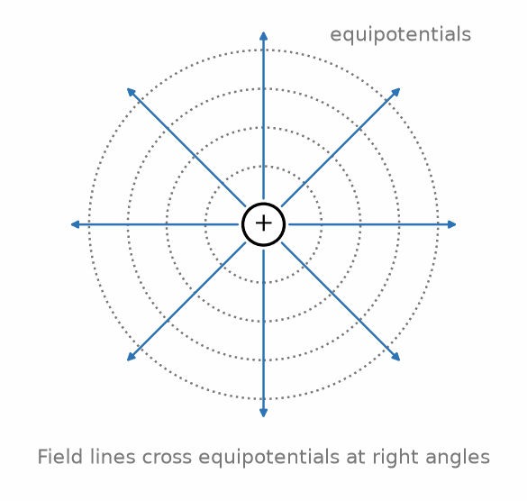
Figure 5.1 — Field lines cross equipotential surfaces at right angles.
This right-angle relationship is a genuinely useful sketching tool: given a diagram of field lines for some charge distribution, you can sketch a reasonable set of equipotential contours by drawing curves everywhere perpendicular to the field lines you already have, and vice versa. Topographic maps use exactly this relationship, incidentally, with contour lines of constant elevation (the gravitational analog of equipotentials) always running perpendicular to the direction water would actually flow downhill.

5.5 Energy Stored in the Electric Field
It is natural, and correct, to think of the potential energy U = kqQ/r as belonging jointly to the pair of charges, rather than to either charge individually — after all, U depends on both charges and vanishes if either one is removed. A more modern and, for this series' purposes, more useful way to think about that same energy is that it is stored in the electric field occupying the space around the charges, at an energy density (energy per unit volume) proportional to E². This field-centered accounting becomes indispensable once fields exist without any nearby charge to “belong” to — as in an electromagnetic wave, where energy propagates through empty space with no charges present at all. Chapter 6 develops the field-energy picture concretely for the case of a capacitor, where it becomes possible to compute a definite, measurable quantity: the total energy stored between two charged plates.
Worked Example 5.1
Problem: Two parallel plates 2.0 mm apart are held at a potential difference of 100 V. Find the electric field between them, and the potential energy change of an electron moved from the negative plate to the positive plate.
Solution: The field magnitude is E = ΔV/d = 100 V / 0.0020 m = 5.0 × 10⁴ V/m. Moving an electron (charge −e) from the negative plate to the positive plate means moving it against the field's push on a positive charge — but the electron is negative, so the field actually assists this motion, and the electron's potential energy decreases. Numerically, ΔU = qΔV = (−1.60×10⁻¹⁹ C)(100 V) = −1.60×10⁻¹⁷ J: the electron loses 1.60×10⁻¹⁷ J of potential energy, which reappears as kinetic energy — exactly the mechanism that accelerates electrons in a cathode-ray tube or a particle accelerator.
Worked Example 5.2
Problem: Find the electric potential at a point midway between a +6.0 nC charge and a −6.0 nC charge, separated by 8.0 cm.
Solution: Potential is a scalar, so it adds algebraically (no vectors needed) — a considerable simplification compared to the equivalent field calculation. Each charge is 4.0 cm from the midpoint. V₁ = kq/r = (8.99×10⁹)(6.0×10⁻⁹)/(0.040) ≈ 1348 V (from the positive charge). V₂ = kq/r = (8.99×10⁹)(−6.0×10⁻⁹)/(0.040) ≈ −1348 V (from the negative charge). Net potential: V₁ + V₂ = 0 V. Contrast this with Worked Example 3.2, which found a nonzero field at the same midpoint of an equal-and-opposite dipole — potential and field do not have to vanish (or fail to vanish) at the same locations, since one is a scalar sum and the other a vector sum, and this particular symmetric case happens to make the potential exactly zero everywhere on the entire perpendicular bisector plane, not only at the midpoint.
From the Bench
Voltage is always between two points, so always know where your black lead is. An ordinary oscilloscope's ground clip is tied to mains earth through its power cord. Clip it onto a node that isn't at earth potential, such as the high side of a half-bridge or anywhere in a non-isolated supply, and you short that node to earth, sometimes spectacularly. Use a differential probe or an isolated measurement instead.

Practice Problems
- Find the electric potential 15 cm from a point charge of +3.0 nC.
- How much work is required to bring a +2.0 nC charge from infinity to a point 10 cm from a fixed +5.0 nC charge?
- A uniform field of 2.0 × 10⁴ V/m exists between two plates 5.0 mm apart. Find the potential difference between the plates.
- An electron is accelerated from rest through a potential difference of 500 V. Find its final kinetic energy in joules, and its final speed (electron mass 9.11×10⁻³¹ kg).

What You’ll Actually Use
Everyday working tools
- Voltage as a difference from a chosen reference, usually called ground.
- Energy equals charge times voltage: W = QV.
Mostly for exams and deeper study
- Potentials of point-charge arrangements from the field integral.
- Equipotential surfaces and the gradient relation in full.

Chapter 6 — Conductors, Capacitance, and Dielectrics
A camera flash takes a few seconds to recharge and then empties itself in a thousandth of a second or less. A capacitor is what makes that possible: it collects charge slowly from a small battery and gives it back all at once. This chapter shows how two plates and an insulator store energy, and why the insulator matters as much as the plates.
Where you meet this: Decoupling capacitors beside every chip, the sensing layer of a touchscreen, camera flashes and defibrillators, and the memory cells of DRAM.

6.1 Conductors in Electrostatic Equilibrium
Chapter 4 established that a conductor in electrostatic equilibrium has zero field inside it and all excess charge on its outer surface. Two further facts follow directly and are used constantly in circuit reasoning: the entire volume of a conductor in equilibrium is at a single, uniform potential (since E = 0 inside means V cannot change from point to point within it), and its surface is therefore an equipotential surface. This is precisely why we can speak of “the potential of a wire” or “the potential of a plate” as a single number, without needing to specify which point on that conductor we mean.

6.2 Capacitance Defined
Pour water into a narrow glass and the level climbs fast, rising noticeably after only a cupful. Pour the same cupful into a wide bucket instead, and the level barely moves — the same amount of water produces a much smaller rise. Charging an isolated conductor works the same way: add some charge and a voltage develops, resisting whatever charge you try to add next. Not every conductor resists equally, though — a large one accepts a great deal of charge before its voltage climbs noticeably, while a small one's voltage rises almost from the first bit of charge added.
Neither the charge on a device nor the voltage it has reached, taken alone, actually characterizes it — either number by itself describes only a single passing moment. The same 100 V could sit across a pair of conductors holding a tiny charge or an enormous one, entirely depending on which conductors they are. What does characterize the device, the way the glass's narrowness or the bucket's width characterizes it, is how much charge it takes to raise its voltage by a given amount.
Divide however much charge you put on by whatever voltage results, and that ratio turns out not to depend on how much charge you happened to use. Put 1.0 µC on some particular pair of conductors and a voltage of 1.0 V develops; put on 2.0 µC instead and the voltage is 2.0 V; put on 5.0 µC and the voltage is 5.0 V. Divide each charge by its own voltage and every pair gives back the same number, 1.0 µC/V, however much charge was actually used.
That fixed ratio is the device's capacitance, and any two conductors separated by an insulator (or vacuum) behave this way: place equal and opposite charges +Q and −Q on the two conductors, and a potential difference V develops between them, in a fixed ratio that depends only on the conductors themselves. Capacitance is defined as that ratio of charge to voltage:
C = Q / V
Capacitance is a purely geometric property of a given pair of conductors — it depends on their shape, size, separation, and the material between them, but not on Q or V individually, since doubling Q doubles V proportionally, leaving the ratio fixed. Its SI unit is the farad (F), equal to one coulomb per volt; a farad is an enormous unit for practical components, so real capacitors are almost always specified in microfarads (µF, 10⁻⁶ F), nanofarads (nF, 10⁻⁹ F), or picofarads (pF, 10⁻¹² F).

6.3 The Parallel-Plate Capacitor
The parallel-plate capacitor is the simplest and most instructive geometry, and its capacitance can be derived directly from the tools already built in this book. Two plates of area A, separated by distance d, carry charges +Q and −Q with surface charge density σ = Q/A on each. From Chapter 4, each charged sheet produces a field σ/(2ε₀) on either side; between the two plates, these fields add (they point the same direction there), while outside the plates they cancel. The field between the plates is therefore:
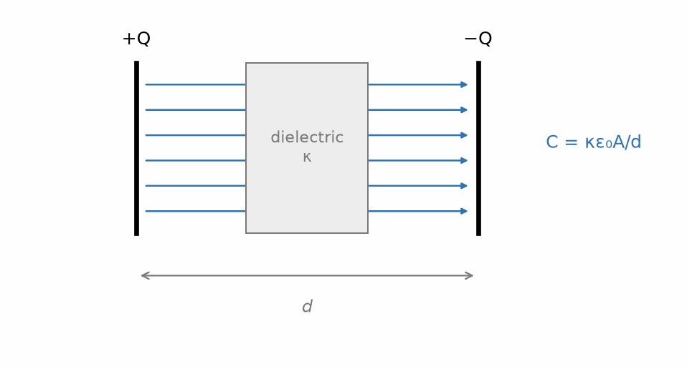
Figure 6.1 — A parallel-plate capacitor with a dielectric filling the gap between the plates.
E = σ / ε₀ = Q / (ε₀A)
Combining this with V = Ed from Chapter 5 and C = Q/V gives:
C = ε₀ A / d
Capacitance increases with plate area (more room to store charge at a given field) and decreases with plate separation. Here is why: for a fixed charge, the field E = σ/ε₀ is unchanged by the gap size (check the formula above), so the voltage V = Ed shrinks right along with d. Dividing the same charge by a shrinking voltage, C = Q/V then increases as d shrinks. This trips up many students on a first pass, precisely because the intuitive-sounding “smaller gap, bigger field” story is not what is actually happening here.

6.4 Dielectrics
Filling the gap between the plates with an insulating material — a dielectric — rather than vacuum increases the capacitance by a factor κ, the dielectric constant (also called relative permittivity), a dimensionless number greater than 1 that depends on the material (roughly 1 for air, about 4–7 for common glass, and well over 1000 for some specialized ceramics used in high-value capacitors):
C = κ ε₀ A / d
The physical mechanism is polarization: the dielectric's own molecules, whether permanently polar or only polarized in response to the applied field, align themselves so that their own small dipole fields (Chapter 3) partially cancel the applied field inside the material. A weaker net field for the same free charge Q means a smaller voltage V = Ed, and since C = Q/V, a smaller V at fixed Q means a larger C. Dielectrics also raise the voltage at which the capacitor breaks down (arcs across), which is often as important in practical component selection as the capacitance value itself, and this maximum safe voltage is what the finished part's datasheet lists as its rated or working voltage. Strictly, that is not quite the same thing as dielectric strength — dielectric strength is a property of the insulating material itself (measured in volts per unit thickness), while the rated voltage is the manufacturer's conservative, thickness-adjusted limit for the finished component, including a safety margin below where breakdown would actually occur.

6.5 Capacitors in Series and Parallel
Just as resistors combine in series and parallel (Chapter 8), so do capacitors, but — reflecting how capacitance is a fundamentally different kind of quantity from resistance — the combination rules come out reversed relative to resistors. Capacitors in parallel (both connected across the same pair of nodes — the junction points in a circuit diagram where two or more wires meet — so both see the same voltage) add:
C_{parallel} = C₁ + C₂ + …
which makes sense physically: connecting capacitors in parallel is equivalent to increasing the effective plate area, and capacitance from Section 6.3 scales directly with area. Capacitors in series (connected end to end, so each carries the same charge Q, with the voltages across each adding to the total) combine by the reciprocal-sum rule instead:
1/C_{series} = 1/C₁ + 1/C₂ + …
which is the same functional form parallel resistors use, not series resistors — a fact worth committing to memory precisely because it is so easy to reach for the wrong rule by pattern-matching on the word “series” alone.
Key Idea
A capacitor stores energy, not only charge. The energy stored is U = ½CV² = ½QV = Q²/(2C). This stored energy is genuinely present in the electric field occupying the space between the plates — not a bookkeeping convenience — a fact that becomes important once you study energy flow in electromagnetic fields more generally.
Worked Example 6.1
Problem: A parallel-plate capacitor has plates of area 2.0 cm² separated by 0.10 mm of air. Find its capacitance, and the capacitance if the gap is instead filled with a dielectric of κ = 5.0.
Solution: Area in SI units: A = 2.0×10⁻⁴ m², d = 1.0×10⁻⁴ m. Air-filled: C = ε₀A/d = (8.85×10⁻¹²)(2.0×10⁻⁴)/(1.0×10⁻⁴) ≈ 17.7 pF. With the dielectric: C = κ × 17.7 pF = 88.5 pF — a fivefold increase, exactly matching κ.
Worked Example 6.2
Problem: A 6.0 µF capacitor and a 3.0 µF capacitor are connected (a) in parallel and (b) in series. Find the equivalent capacitance in each case.
Solution: (a) Parallel: C = 6.0 + 3.0 = 9.0 µF — larger than either individual value, as parallel capacitance always is. (b) Series: 1/C = 1/6.0 + 1/3.0 = 1/6.0 + 2/6.0 = 3/6.0, so C = 2.0 µF — smaller than either individual value, as series capacitance always is. Notice this is exactly the opposite pattern from resistors, where series combinations are always larger and parallel combinations are always smaller than any individual value.
Common Misconception
Because capacitors and resistors are both drawn the same way in a circuit diagram — components in a line are “in series,” components bridging the same two nodes are “in parallel” — it is a very natural mistake to apply the resistor combination formulas to capacitors by habit. Resistance and capacitance are related to voltage and charge in inverted ways (R = V/I versus C = Q/V), which is exactly why their series and parallel rules come out swapped relative to each other. When in doubt, rederive the rule from first principles — same charge for series capacitors, same voltage for parallel ones — rather than trusting memorized pattern-matching alone.
From the Bench
Read the dielectric, not only the value. A 10 µF, 16 V ceramic capacitor with X5R or X7R dielectric may give only a few microfarads with 12 V across it; the datasheet's capacitance-versus-DC-bias curve is the one that matters. These Class 2 ceramics also drift with temperature and age. C0G (NP0) parts are stable, but only come in small values.
On the Job
Hardware engineers who design the board around a chip such as the ESP32-S3 spend real time on this chapter. Their tools are the chip maker's hardware design guidelines and reference schematic, the capacitor makers' online tools that plot capacitance against DC bias and temperature, KiCad or Altium for layout, and a scope with a short ground spring for checking supply ripple. A typical task: choose and place the decoupling capacitors for the module's 3.3 V supply, check that a 10 µF ceramic capacitor still gives enough capacitance at 3.3 V of bias, put the small capacitors closest to the pins, and then measure the supply while Wi-Fi transmits, when the current jumps by hundreds of milliamps.

Practice Problems
- A capacitor has capacitance 4.0 µF and is charged to 12 V. Find the charge stored and the energy stored.
- A parallel-plate capacitor's plate separation is doubled while the charge on it is held fixed. What happens to its capacitance, its voltage, and its stored energy?
- A 10 pF capacitor is filled with a dielectric of κ = 3.5. Find the new capacitance.
- Three capacitors, 2.0 µF, 4.0 µF, and 4.0 µF, are all connected in parallel across a 9.0 V source. Find the total charge supplied by the source.

What You’ll Actually Use
Everyday working tools
- C = Q/V and C = εA/d, for a feel of what makes capacitance larger.
- Stored energy ½CV², which is also why large capacitors bite after power-off.
- Voltage rating and dielectric type when choosing a part.
Mostly for exams and deeper study
- Fields and potentials inside conductors at equilibrium, formally.
- Polarization and bound charge in dielectrics.

Chapter 7 — Electric Current and Resistance
Flip a light switch and the lamp comes on almost instantly, yet the electrons in the wire crawl along at a fraction of a millimeter per second. This chapter sorts out that apparent paradox, and explains why the wire gets warm while it's at it.
Where you meet this: Wire-gauge tables, fuse ratings, PCB trace-width calculators, heating elements, and temperature sensors (RTDs and thermistors) that rely on resistance changing with temperature.

7.1 Current Defined
Count how many cars pass a tollbooth every minute, or how many liters of water flow past a mark on a pipe every second, and you already have the shape of the idea this chapter needs: not how much charge is sitting somewhere, but how much of it goes past a given point, per unit time. Everything so far in this book has concerned static charge — charge sitting still. Electric current asks that same question of charge instead of cars or water: it is defined as the rate at which charge passes a given cross-section of a conductor:
I = dQ/dt
with SI unit the ampere (A), equal to one coulomb per second. By long-standing convention (traceable to Franklin's original, backwards guess mentioned in Chapter 1), current is defined as flowing in the direction positive charge would move — which in an ordinary metal wire is opposite to the actual direction the (negatively charged) conduction electrons travel. This convention is used universally in circuit diagrams and will be used throughout the rest of this series without further comment.

7.2 Current Density and Drift Velocity
It is worth being honest about how slowly electrons in a wire actually move, because the result is famously counterintuitive. Current density J is current per unit cross-sectional area, J = I/A, and it is related to the drift velocity vᴅ of the charge carriers (the average velocity they acquire in the direction opposing the field, superimposed on their much larger random thermal motion) by:
J = n q v_{d}
where n is the number density of charge carriers and q is the carrier's charge. For a typical copper wire carrying a modest current, the drift velocity works out to a small fraction of a millimeter per second — an electron in a typical household wire needs more than an hour to drift one meter, as Worked Example 7.1 shows. What makes a lamp turn on essentially instantly when you flip a switch is not any individual electron racing to the bulb; it is that the electric field itself, and the resulting nudge to every electron already present throughout the wire, propagates at a substantial fraction of the speed of light. The signal is fast; the carriers themselves are almost leisurely.
This distinction between the speed of the signal and the speed of the individual carriers is worth sitting with, because it resolves what otherwise looks like a genuine paradox: a wire a few kilometers long, carrying a current whose individual electrons drift at a fraction of a millimeter per second, will still light a bulb at its far end within a small fraction of a second of the switch closing. Nothing in that observation requires any electron to travel the wire's length quickly — only the field's influence, already present all along the wire, needs to propagate, and that is a wave phenomenon governed by the electromagnetic-wave result of Chapter 12, not by how fast any individual charge carrier happens to be moving.
Worked Example 7.1 — How Slow Is Drift Velocity, Really?
Problem: A copper wire of cross-sectional area 2.0 mm² carries a steady current of 5.0 A. Copper has roughly 8.5 × 10²⁸ free electrons per cubic meter. Estimate the drift velocity of the conduction electrons.
Solution: From J = nqv_d, solve for v_d: v_d = J/(nq) = I/(nqA). Plugging in: v_d = (5.0) / [(8.5×10²⁸)(1.60×10⁻¹⁹)(2.0×10⁻⁶)] ≈ 1.8 × 10⁻⁴ m/s — about 0.18 mm per second. At this rate, an individual electron would take roughly 90 minutes to drift one meter of wire. Every appliance in your home nonetheless responds within a fraction of a second of being switched on, which is only possible because — as this section emphasizes — it is the field's influence propagating through the wire, not the individual electrons' own leisurely progress, that actually carries the “signal.”
Key Idea
The drift velocity of charge carriers and the speed at which an electrical signal propagates are two entirely different things. A typical drift velocity is a fraction of a millimeter per second, yet a lamp switches on essentially instantly — because what reaches the far end of the wire in that instant is not any particular electron, but the electric field's influence on every electron already present throughout the wire, propagating at a substantial fraction of the speed of light. Never confuse how fast the carriers move with how fast the current's effect is felt.
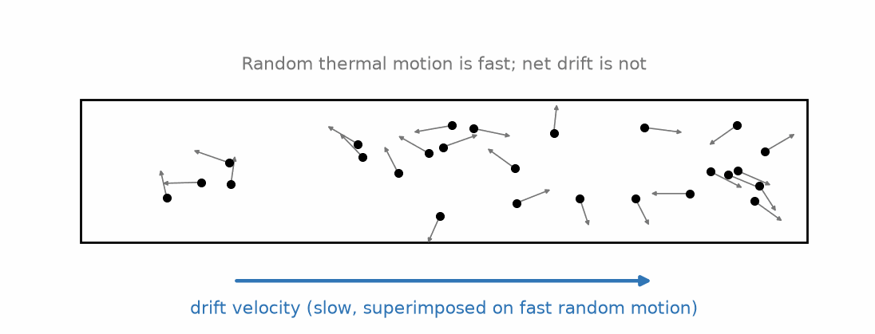
Figure 7.1 — Random thermal motion is fast; the net drift superimposed on it is not.

7.3 Resistance and Resistivity
Push a shopping cart across smooth tile and a small, steady push keeps it gliding along. Push the same cart, same load, across thick carpet instead, and the same steady push barely gets it moving — the floor is fighting back. Drive the same voltage across two different wires, one copper and one some poorer conductor, and something very similar happens: very different currents result, even though the push is identical. Something about the conductor itself, not only the voltage driving the charge, is deciding how much current actually flows.
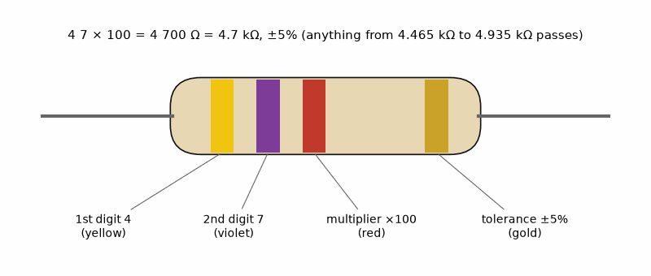
Figure 7.2 — Reading a resistor’s color bands: yellow, violet, red, gold means 4, 7, two zeros and ±5%, so 4.7 kΩ. Start from the end where the bands bunch together; the tolerance band comes last.
Voltage alone can't be the answer, then, since the same voltage can drive wildly different currents through different conductors — the conductor itself is what's deciding the outcome. Ask instead: for this particular conductor, how much voltage does it take to drive a given current through it? Voltage and current on their own do not settle this — a lot of current at a small voltage, or a little current at a large voltage, could each describe the very same wire under different conditions, or entirely different wires under matched conditions. Neither number by itself identifies the conductor.
The way to characterize the conductor itself, independent of whichever voltage happens to be applied at the moment, is once again a ratio: divide the voltage across the conductor by the current actually flowing through it. Try this on one particular conductor at several voltages, and a fixed number falls out. Apply 2.0 V and a current of 0.10 A results; apply 4.0 V and the current is 0.20 A; apply 10 V and the current is 0.50 A. Divide each voltage by its own current, and every pair gives back the same ratio, 20 Ω, regardless of which voltage was actually used.
Most materials resist the flow of current to some degree, converting electrical energy into heat as charge carriers collide with the material's atomic lattice, and that fixed ratio — voltage divided by the current it drives — is the conductor's resistance. For a given conductor, resistance R is defined by how much voltage is required to drive a given current through it, and for many materials over a wide range of conditions, R is very nearly constant — this is Ohm's law, the subject of Chapter 8.
Resistance depends on the conductor's geometry and on an intrinsic material property, resistivity ρ:
R = ρ L / A
where L is the conductor's length and A is its cross-sectional area. Resistance increases with length (more material for carriers to push through) and decreases with cross-sectional area (more parallel paths available). Resistivity is a property of the material alone, independent of shape — copper's resistivity is famously low, which along with its low cost and easy workability is exactly why it dominates wiring; the same reasoning drives the choice of exotic low-resistivity materials like silver in specialized high-frequency applications discussed later in this series.
Conductivity: σ = 1/ρ (units: siemens per meter, S/m)

7.4 Temperature Dependence
Resistivity is temperature dependent, and for most metals it increases with temperature: hotter atoms vibrate more vigorously, scattering conduction electrons more frequently and impeding their drift. Over a modest temperature range, this is well approximated as linear:
ρ(T) ≈ ρ₀ [1 + α(T − T₀)]
where α is the temperature coefficient of resistivity, positive for metals. Semiconductors behave oppositely — their resistivity generally decreases with rising temperature, because additional thermal energy frees more charge carriers to conduct, an effect that dominates over increased scattering. This opposite-sign behavior is one of the first clues, historically, that semiconductors work by a fundamentally different mechanism than metals, a subject developed fully in the semiconductor-physics volume of this series.

7.5 Superconductivity, Briefly
A small number of materials, cooled below a characteristic critical temperature (for many common superconductors, only a few degrees above absolute zero, though so-called high-temperature superconductors reach on the order of a hundred degrees above it), undergo a genuinely abrupt transition to a state of exactly zero resistivity — not merely very low resistivity, but immeasurably, and as far as any experiment has ever detected, exactly zero. A current started in a closed superconducting loop has been observed to persist, undiminished, for years without any external source maintaining it. Superconductivity is a quantum-mechanical phenomenon well beyond this book's scope to explain properly, but it is worth knowing it exists: it demonstrates that the ordinary, temperature-dependent resistivity described above is not some unavoidable law of nature, but a specific consequence of how electrons scatter off a lattice's vibrations and impurities in ordinary conducting materials — a mechanism that a superconductor, below its critical temperature, does not have.
Worked Example 7.2
Problem: A copper wire (ρ = 1.68 × 10⁻⁸ Ω·m) is 2.0 m long with a cross-sectional area of 1.0 mm². Find its resistance.
Solution: R = ρL/A = (1.68×10⁻⁸ Ω·m)(2.0 m) / (1.0×10⁻⁶ m²) = 0.0336 Ω — a small resistance, typical of why short lengths of ordinary hookup wire are treated as essentially resistance-free in introductory circuit problems.
Worked Example 7.3
Problem: A nichrome heating element (used, for example, in a toaster) has a resistivity of 1.10 × 10⁻⁶ Ω·m. Find the length of nichrome wire, with a cross-sectional area of 0.20 mm², needed to make a resistance of 20 Ω, and compare this to the copper wire in the previous example.
Solution: Rearranging R = ρL/A for length: L = RA/ρ = (20)(0.20×10⁻⁶)/(1.10×10⁻⁶) ≈ 3.6 m. Nichrome's resistivity is roughly 65 times larger than copper's, which is exactly why it is chosen for heating elements rather than copper: a practical, compact length of wire can be made to have substantial resistance (and therefore, by the power relations of Chapter 8, to dissipate substantial heat) without needing an impractically long or thin wire the way copper would require for the same resistance.
Common Misconception
It is easy to conflate resistance and resistivity, since both describe a material “resisting” current in some loose sense, and to therefore treat resistivity as if it changed when a wire is cut shorter or drawn thinner. Resistivity is a fixed property of the material itself, at a given temperature — cutting a copper wire in half does not change copper's resistivity at all, though it does change that particular piece of wire's resistance, because resistance depends on geometry (R = ρL/A) while resistivity does not.
From the Bench
Copper's resistance rises about 0.4% per °C, so a winding that measures 1.00 Ω on a cool bench is about 1.24 Ω at 85 °C, with more voltage drop and more heat to match. Size PCB traces with a calculator based on IPC-2152 rather than by eye: a 0.25 mm trace in 1 oz (35 µm) outer-layer copper carries roughly an amp for a modest temperature rise, and nowhere near three.

Practice Problems
- A wire carries a current of 3.0 A. How much charge passes a given point in the wire in 5.0 seconds?
- A conductor's length is tripled while its cross-sectional area is halved. By what factor does its resistance change?
- A resistor has resistance 100 Ω at 20°C and a temperature coefficient of resistivity of 0.004 /°C. Estimate its resistance at 80°C.
- A copper wire and an aluminum wire (resistivity 2.65 × 10⁻⁸ Ω·m) have the same length and the same resistance. Find the ratio of their cross-sectional areas.

What You’ll Actually Use
Everyday working tools
- R = ρL/A to estimate wire and trace resistance.
- Resistor color codes and SMD markings.
- The +0.4%/°C temperature coefficient of copper.
Mostly for exams and deeper study
- Drift velocity and current-density calculations.
- Microscopic models of resistivity, and superconductivity.

Chapter 8 — Ohm's Law and a First Look at Circuits
Plug a bare LED straight into a 5 V USB supply and it may flash once, brilliantly, and never again. One resistor and one line of Ohm's law would have saved it. This chapter is where electronics stops being physics and starts being circuits.
Where you meet this: Every LED indicator, pull-up resistors on buttons and data lines, sensor voltage dividers, and the power rating printed on every resistor.

8.1 Ohm's Law
Georg Ohm found, in 1827, that for a large class of materials (now called ohmic materials, or resistors when packaged as discrete components), the current through the material is directly proportional to the voltage across it, at a fixed temperature:
V = IR
This is not a law of nature in the way Coulomb's law or Gauss's law are — it is an empirical approximation that happens to hold extremely well for metals and for manufactured resistors under normal operating conditions, and it fails outright for many devices you will meet later in this series, including diodes and transistors, whose entire usefulness stems from their current-voltage relationship being deliberately non-Ohmic.
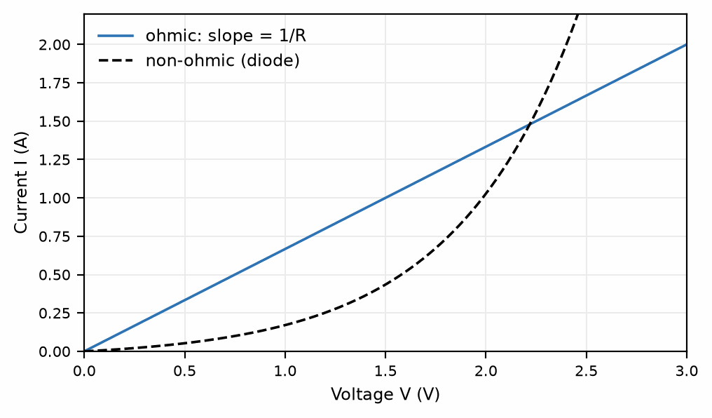
Figure 8.1 — An ohmic device has a straight-line I-V curve; a non-ohmic device (such as a diode) does not.
Key Idea
Ohm's law relates three quantities — memorize the triangle, not only the formula. V = IR, so also I = V/R and R = V/I. Given any two of voltage, current, and resistance, the third follows immediately. This single relationship, together with the two Kirchhoff laws developed in Part III of this book (Chapter 26), is sufficient to analyze any resistive DC circuit, no matter how complex.

8.2 Power in a Resistor
Electrical power is the rate at which electrical energy is delivered or dissipated:
P = IV
Combined with Ohm's law, this yields two equally useful alternate forms:
P = I²R = V²/R
For a resistor, this power is dissipated as heat — this is Joule heating, the same physical mechanism (electrons scattering off the lattice, from Chapter 7) that gives rise to resistance in the first place, now viewed from an energy-accounting perspective rather than a current-impeding one. Every resistor in a real circuit has a maximum power rating, beyond which the resulting heat will damage or destroy it; checking that a resistor's power rating exceeds its expected dissipation is a standard, mandatory step in circuit design that this series will return to repeatedly.

8.3 A First Circuit: Series and Parallel Resistors
Two resistors are in series if the same current must flow through both, one after the other, with no branch point between them. Their combined resistance adds:
R_{series} = R₁ + R₂ + …
Two resistors are in parallel if both are connected across the same pair of nodes, so the same voltage appears across each while the total current splits between them. Their combined resistance follows from the reciprocal sum:
1/R_{parallel} = 1/R₁ + 1/R₂ + …
A useful special case, worth having memorized, is two resistors in parallel:
R_{parallel} = R₁R₂ / (R₁ + R₂)
Series resistance is always larger than the largest individual resistor (more obstacles, end to end); parallel resistance is always smaller than the smallest individual resistor (more parallel paths for current to take, so less overall opposition). This behavior — and the systematic method for analyzing arbitrary networks that do not reduce to simple series/parallel combinations — is developed in full in Part III of this book, which builds directly on the definitions in this chapter.

8.4 A First Look at Voltage Division
One immediate, practical consequence of the series-resistor rule is worth introducing here, ahead of its full treatment in Part III of this book, because it appears so often in practice: two resistors in series across a voltage source V split that voltage between them in direct proportion to their resistances, since the same current I flows through both:
V₁ = V · R₁ / (R₁ + R₂) , V₂ = V · R₂ / (R₁ + R₂)
This voltage divider is one of the single most common sub-circuits in all of electronics, used to derive a smaller reference voltage from a larger supply, and it is worth internalizing this chapter's result now, since it will reappear as a building block almost immediately in Part III of this book (Chapter 27).
Worked Example 8.1
Problem: A 12 V battery is connected across a single 6.0 Ω resistor. Find the current drawn and the power dissipated.
Solution: I = V/R = 12/6.0 = 2.0 A. Power: P = IV = (2.0)(12) = 24 W (equivalently P = I²R = (2.0)²(6.0) = 24 W, a useful cross-check).
Worked Example 8.2
Problem: A 10 Ω resistor and a 30 Ω resistor are connected in series across a 20 V source. Find the current through the circuit and the voltage across each resistor.
Solution: Total series resistance: R = 10 + 30 = 40 Ω. Current: I = V/R = 20/40 = 0.50 A, the same through both resistors since they are in series. Voltage across the 10 Ω resistor: V₁ = IR₁ = (0.50)(10) = 5.0 V. Voltage across the 30 Ω resistor: V₂ = IR₂ = (0.50)(30) = 15 V. Check: 5.0 + 15 = 20 V, matching the source voltage exactly, as it must for a single series loop.
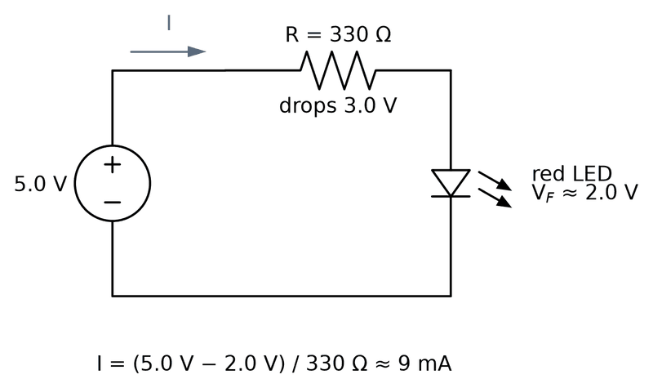
Figure 8.2 — The resistor that saves the LED: it takes the 3 V the LED doesn’t need and sets the current at about 9 mA, plenty for an indicator.
Common Misconception
A frequent error when first combining series and parallel resistors is to add parallel resistances directly, the way series resistances add — forgetting the reciprocal step entirely. Two equal 100 Ω resistors in parallel do not combine to 200 Ω; they combine to 50 Ω, half of either individual value, since two identical parallel paths each carry half the total current at the same voltage, doubling the effective conductance and therefore halving the effective resistance. If a “combined” parallel resistance ever comes out larger than the smallest resistor in the group, the reciprocal step has been dropped somewhere in the calculation.

8.5 Light In and Light Out: The LED and the LDR
Figure 8.2 showed the resistor that sets an LED's current. The same rule works from a microcontroller pin. From the ESP32-S3's 3.3 V output, a red LED with a forward voltage of about 2.0 V and a 220 Ω resistor gets (3.3 − 2.0)/220 ≈ 5.9 mA, bright enough for an indicator and gentle on the pin. A blue or white LED is harder: its forward voltage is about 3.0 V, so only 0.3 V is left for the resistor, and the current then depends on the exact forward voltage, which varies from part to part and with temperature. Designers feed such LEDs from 5 V through a transistor switch (Books 2 and 3), or accept a dim, uncertain glow. An RGB LED is three LEDs in one package, and each color needs its own resistor for the same reason.
The light-dependent resistor (LDR) runs the other way: light in, resistance out. It is a small disc of cadmium sulfide whose resistance falls as light frees more charge carriers. A common part, the GL5528, reads roughly 8 to 20 kΩ at 10 lux (a dim room), at least 1 MΩ in darkness, and falls by a factor of about 10^0.7 ≈ 5 for every tenfold increase in light (its gamma of 0.7). A microcontroller cannot read resistance, only voltage, so the LDR goes into a voltage divider (Section 8.4).
Worked Example 8.3 — A Light Sensor for the Weather Station
Problem: An LDR that reads 15 kΩ at 10 lux, with a gamma of 0.7, forms the top of a divider with a fixed 10 kΩ resistor to ground, powered from 3.3 V. Find the output voltage at 1, 10, and 100 lux, and in darkness (1 MΩ).
Solution: First the resistance at each light level. A gamma of 0.7 means R falls by 10^0.7 ≈ 5.01 per decade of light: about 75 kΩ at 1 lux, 15 kΩ at 10 lux, and 3.0 kΩ at 100 lux. Then the divider, V_out = 3.3 × 10/(10 + R_LDR) with R in kilohms: 1 lux gives 3.3 × 10/85 ≈ 0.39 V; 10 lux gives 3.3 × 10/25 = 1.32 V; 100 lux gives 3.3 × 10/13 ≈ 2.54 V; darkness gives 3.3 × 10/1010 ≈ 0.03 V. The output rises with light and covers most of the 3.3 V range across the dim-to-bright span, because the fixed resistor sits near the middle of the LDR's resistance range (on a logarithmic scale). Check the self-heating at 100 lux: I = 3.3/13 kΩ ≈ 0.25 mA, and P = I²R ≈ 0.19 mW, negligible against the part's 100 mW rating.
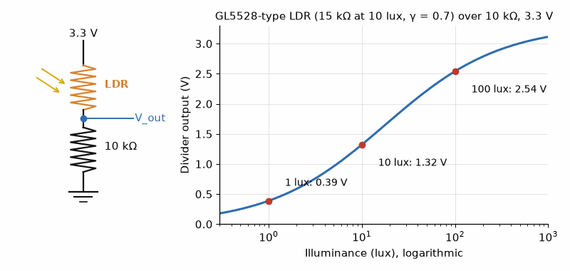
Figure 8.3 — An LDR in a divider turns light into a voltage. With a 10 kΩ fixed resistor, the output climbs from about 0.4 V at 1 lux to 2.5 V at 100 lux, the range from a dim hallway to a bright desk.
An LDR is slow (tens of milliseconds), varies a lot from part to part, and its cadmium is restricted under the EU's RoHS rules for many products. For a measurement in lux, a digital light sensor or a photodiode is the professional choice. For a night light, a display-brightness control, or a first experiment, the LDR and one resistor are hard to beat.
From the Bench
Derate resistors. A 0.25 W resistor dissipating 0.25 W runs hot enough to discolor the board; a common rule is to keep dissipation at or below half the rating. And design with values you can actually buy: 300 Ω isn't in the common E12 series, so you choose 330 Ω and recheck the current.

Practice Problems
- A 9.0 V battery drives a current of 0.30 A through a resistor. Find the resistor's value and the power it dissipates.
- Two resistors, 4.0 Ω and 12 Ω, are connected in parallel. Find the equivalent resistance.
- A resistor rated for a maximum power of 0.25 W is to be used with a 5.0 V source. What is the minimum resistance that keeps it within its rating?
- A voltage divider is built from a 2.0 kΩ resistor and an 8.0 kΩ resistor in series across a 10 V supply. Find the voltage across the 8.0 kΩ resistor.
- A light-dependent resistor reads 30 kΩ in a dim hallway and 3.0 kΩ under a desk lamp. It forms the top of a divider with a fixed 10 kΩ resistor to ground, powered from 3.3 V. Find the output voltage in both cases, and the power in the LDR under the lamp.

What You’ll Actually Use
Everyday working tools
- V = IR and P = VI = I²R = V²/R, many times a day.
- Series resistances add; for two in parallel, product over sum.
- The voltage divider for references and sensor readout.
- A series resistor for any LED from 3.3 V or 5 V, and an LDR divider for light level.
Mostly for exams and deeper study
- The distinction between ohmic and non-ohmic materials, stated formally.
- The history of Ohm's measurements.

Chapter 9 — Magnetism and the Magnetic Field
An old CRT television steered a beam of electrons across its screen with magnetic coils, and holding a strong magnet near the glass smeared the colors (please don't). The same force that bent the beam spins every electric motor. It acts only on moving charge, and always at right angles to the motion.
Where you meet this: Electric motors and loudspeakers, Hall-effect current sensors and phone compasses, mass spectrometers, and the position sensors in brushless-motor drives.

9.1 A Different Kind of Field
Magnetism was known and used — in lodestones and compass needles — for well over a thousand years before anyone connected it to electricity at all. The connection, once made in the early nineteenth century, turned out to run so deep that magnetism and electricity are now understood as two faces of a single phenomenon, electromagnetism, rather than two separate forces that happen to interact. This chapter introduces the magnetic field on its own terms; the following two chapters show where magnetic fields come from and how electricity and magnetism interconvert.
Unlike the electric field, which exerts a force on any charge for being present, the magnetic field exerts a force only on charge that is moving (or, equivalently, on current). A stationary charge sitting in a magnetic field feels nothing at all from that field.

9.2 The Magnetic Force on a Moving Charge
A compass needle sitting on a table, doing nothing but pointing north, is already responding to a magnetic field — but the needle itself is not a moving charge, it is a tiny magnet aligning with the field the way a compass always does. Bring an ordinary charged object near a magnet instead, and hold it perfectly still: nothing happens to it at all. The electric field from Chapter 3 pushes on any charge merely for sitting there; the magnetic field does not.
Set that same charge moving, though, and everything changes. A charge drifting past a magnet feels a real, measurable push — the same effect that channels the charged particles of the solar wind toward Earth's poles, lighting up the sky as the aurora. Whatever this force is, it exists only for charge that is actually moving.
So the question is not “what force does this field exert” in general, but “what force does it exert on a charge moving at a particular speed, in a particular direction”? The honest, slightly unsettling answer is that this force does not point along any of the obvious directions. It does not point along the charge's own direction of travel, and it does not point along the field direction either — unlike gravity, which pulls straight along the line to whatever is doing the pulling, or the electric force, which pushes straight along the line between two charges.
The force instead points off at a right angle to both the charge's velocity and the field, and its strength depends on how those two directions relate: full strength when velocity and field are perpendicular to each other, shrinking as the two line up, and vanishing entirely when velocity and field point along the same line.
A proton moving at 1.0×10⁶ m/s through a 0.10 T field, with its velocity at 90° to the field, feels a force of about 1.6×10⁻¹⁴ N. Angle the proton’s velocity down to 30° from the field instead, everything else unchanged, and the force drops to about 0.80×10⁻¹⁴ N — exactly half, since sin 30° is exactly half of sin 90°. Send the proton moving parallel to the field (0°), and the force drops to zero, no matter how fast the proton is moving or how strong the field is.
That force — perpendicular to both velocity and field, scaled by the sine of the angle between them — is the magnetic force, captured by a vector operation called the cross product. The force on a charge q moving with velocity v through a magnetic field B is given by:
F = q v × B
The × denotes a vector cross product, which is the reason the magnetic force behaves so differently from anything encountered so far in this book: its magnitude is F = qvB sinθ, where θ is the angle between v and B (maximal when velocity and field are perpendicular, zero when they are parallel), and — critically — its direction is always perpendicular to both v and B simultaneously, found using the right-hand rule: point the fingers of your right hand along v, curl them toward B, and your thumb points along v × B (adjust the sign for a negative charge, which experiences a force in the opposite direction).
Key Idea
A magnetic force can never do work on a charge. Because the magnetic force is always perpendicular to the charge's velocity, it can never have a component along the direction of motion, and force perpendicular to displacement does zero work. A magnetic field can change a charge's direction, but never its speed or its kinetic energy. Any speeding up or slowing down of a charged particle in a real device is always due to an electric field, even in devices — like motors — that are popularly described as “magnetic.”

9.3 Circular Motion in a Uniform Field
Because the magnetic force is always perpendicular to velocity and constant in magnitude for a fixed speed, a charged particle moving perpendicular to a uniform magnetic field travels in a perfect circle, with the magnetic force supplying exactly the centripetal force needed — the inward pull toward the center that any object moving along a curved path requires, whatever provides it:
qvB = mv²/r ⟹ r = mv / (qB)
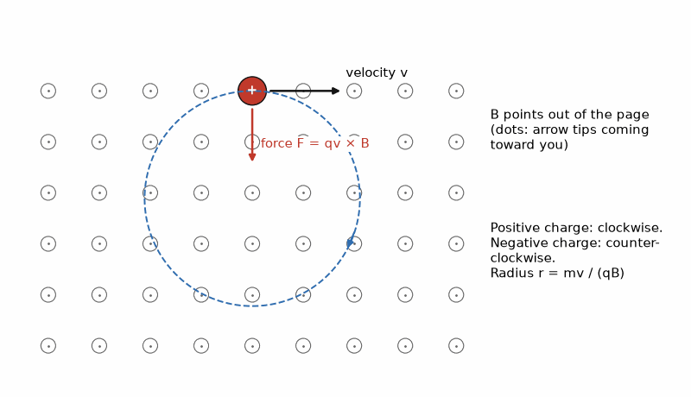
Figure 9.1 — A positive charge in a field pointing out of the page goes round clockwise. The force always points at the center, so it bends the path but never changes the speed.
This relationship is the operating principle behind mass spectrometers, cyclotrons, and — in a more elaborate form — the particle accelerators used in high-energy physics. It also explains why charged particles from the solar wind spiral around Earth's magnetic field lines rather than striking the atmosphere directly, redirected toward the poles where the field lines converge — the mechanism behind the aurora.
If the particle's velocity has a component along the field direction as well as perpendicular to it, the perpendicular component still produces circular motion exactly as described, while the parallel component is entirely unaffected by the field (since v × B vanishes when v is parallel to B). The combined motion is therefore a helix — a circle that also drifts steadily along the field direction — rather than a closed circle. This helical motion is exactly what channels charged particles along Earth's field lines toward the poles, and it is worth being able to picture clearly.

9.4 The Magnetic Force on a Current-Carrying Wire
A current-carrying wire in a magnetic field experiences a force, because the current is nothing more than a great many moving charges, each individually subject to F = qv × B. Summed over a straight wire segment of length L carrying current I in a uniform field B, the total force is:
F = I L × B
with magnitude F = BIL sinθ, where θ is again the angle between the wire (taken in the direction of conventional current flow) and the field. This is the force that turns the rotor of every electric motor: current-carrying wire loops placed in a magnetic field experience a torque that spins the motor's shaft, a device treated in full once this series reaches its power-and-machines material.

9.5 Units
The SI unit of magnetic field is the tesla (T), defined so that a charge of one coulomb moving at one meter per second, perpendicular to a one-tesla field, experiences a force of one newton. A tesla is a substantial field — Earth's own magnetic field at its surface is roughly 0.00005 T (50 µT), a small fridge magnet might reach 0.01 T, and MRI machines operate in the range of 1–3 T. An older, non-SI unit, the gauss (1 T = 10,000 G), still appears frequently in older texts and in some manufacturer datasheets, and is worth recognizing even though this book uses tesla throughout.
Worked Example 9.1
Problem: A proton moves at 2.0 × 10⁶ m/s perpendicular to a 0.50 T magnetic field. Find the magnitude of the magnetic force on it, and the radius of its circular path.
Solution: F = qvB = (1.60×10⁻¹⁹)(2.0×10⁶)(0.50) ≈ 1.6×10⁻¹³ N. Radius: r = mv/(qB) = (1.67×10⁻²⁷ kg)(2.0×10⁶)/[(1.60×10⁻¹⁹)(0.50)] ≈ 0.042 m, about 4.2 cm.
Worked Example 9.2
Problem: A straight horizontal wire 0.80 m long carries a current of 6.0 A due east. Find the magnitude and direction of the magnetic force on the wire if it sits in a uniform 0.40 T field pointing straight down (toward the ground).
Solution: Magnitude: F = BIL sinθ. The wire (east) and the field (down) are perpendicular, so θ = 90° and sinθ = 1: F = (0.40)(6.0)(0.80) = 1.92 N. Direction, by the right-hand rule for I L × B: point your fingers east (current direction), curl them downward (field direction) — your thumb points north. The force on the wire is therefore 1.92 N directed due north.
Common Misconception
Because the magnetic force involves a cross product, its direction is one of the more error-prone parts of introductory electromagnetism, and a common shortcut error is to assume the force points “along” one of the two vectors involved, or splits the difference between them. It does neither: F = qv×B is always exactly perpendicular to both v and B, full stop, regardless of the angle between v and B (as long as that angle is not 0° or 180°, where the cross product vanishes entirely). There is no partial or intermediate direction to reason about — only perpendicular to both, with the right-hand rule fixing which of the two possible perpendicular directions is correct.
From the Bench
Hall-effect sensors are the easy way to measure current without breaking the circuit, and they are what most clamp meters use for DC. They also read any stray field, so a sensor placed beside an inductor or a high-current trace measures that too. Datasheet accuracy figures usually assume no external field.

Practice Problems
- An electron moves at 3.0 × 10⁵ m/s perpendicular to a 0.20 T field. Find the magnetic force on it.
- A straight wire 0.50 m long carries a current of 4.0 A, oriented perpendicular to a 0.30 T field. Find the force on the wire.
- Explain, in one or two sentences, why a magnetic field can change a charged particle's direction of travel but never its speed.
- A proton travels in a circular path of radius 0.10 m in a magnetic field of 0.80 T. Find the proton's speed.

What You’ll Actually Use
Everyday working tools
- F = qvB sin θ and F = BIL sin θ for motor and actuator estimates.
- The right-hand rule for direction.
Mostly for exams and deeper study
- Cyclotron radius and frequency calculations.
- The full vector cross-product treatment.

Chapter 10 — Sources of the Magnetic Field
Run 10 A through a straight wire past a compass and the needle swings. Ørsted noticed the effect in 1820. At a centimeter from the wire the field is about 200 microtesla, four times the Earth's, which is why high-current traces and magnetic sensors should not share a neighborhood.
Where you meet this: Inductors and transformers, relays and solenoids, MRI magnets, and the magnetic coupling between neighboring traces on a board.

10.1 Moving Charge Makes a Field
Chapter 9 described how a magnetic field pushes on moving charge. The complementary fact — and the one that reveals magnetism and electricity as genuinely unified — is that moving charge itself produces a magnetic field. A stationary charge produces only an electric field; the same charge, once set in motion, produces a magnetic field as well, without losing its electric field. Current-carrying wires, not permanent magnets, are the fundamental source of magnetic fields in essentially all of modern electrical engineering; permanent magnets turn out to owe their field to countless aligned electron orbits and spins, which behave, to good approximation, like tiny current loops at the atomic scale.

10.2 The Field of a Long Straight Wire
The magnetic field produced by a long, straight, current-carrying wire circles around the wire, with field lines forming closed circles centered on the wire and lying in planes perpendicular to it. The direction is given by a right-hand rule: point your right thumb in the direction of conventional current, and your curled fingers indicate the field's direction. The field's magnitude at a perpendicular distance r from the wire is:
B = μ₀ I / (2πr)
where μ₀ is the permeability of free space:
μ₀ ≈ 4π × 10⁻⁷ T·m/A
Since the 2019 redefinition of the SI, μ₀ is no longer an exactly defined constant — it is measured, and 4π×10⁻⁷ T·m/A is its familiar introductory approximation, accurate to many more decimal places than any circuit calculation in this book will ever need.
Notice the structural resemblance to the electric field of an infinite line charge from Chapter 4 — both fall off as 1/r rather than the 1/r² of a point source, because both sources are effectively infinite lines rather than points, and the same expanding-geometry argument that gave 1/r for that line charge gives 1/r here as well.
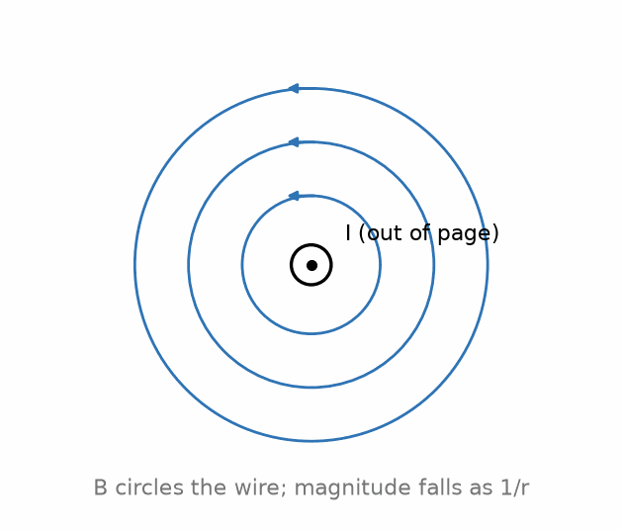
Figure 10.1 — The magnetic field of a long straight wire circles the wire, falling off as 1/r.

10.3 Force Between Two Parallel Wires
Two parallel current-carrying wires each produce a field that exerts a force on the other, via the F = IL × B relation from Chapter 9. Wires carrying current in the same direction attract; wires carrying current in opposite directions repel — a result many students find backward on first encounter, since it is the reverse of the same-charges-repel rule for static charges. This attraction/repulsion between current-carrying wires was, historically, exact enough to measure that it was used for decades to define the ampere itself, before the 2019 SI redefinition tied the ampere to the elementary charge instead.

10.4 Ampere's Law
Just as Gauss's law provides a shortcut to the electric field for sufficiently symmetric charge distributions, Ampere's law provides the analogous shortcut for the magnetic field of sufficiently symmetric current distributions. It states that the line integral of B around any closed path (an “Amperian loop”) equals μ₀ times the net current enclosed by that path:
∮ B · dl = μ₀ I_{enc}
Applied to a circular Amperian loop of radius r centered on a long straight wire, where by symmetry B is constant in magnitude around the loop and everywhere tangent to it, this reduces immediately to B(2πr) = μ₀I, recovering the result of Section 10.2 with almost no work — exactly the payoff Gauss's law provided for the electric field.
Key Idea
Ampere’s law is to the magnetic field exactly what Gauss’s law is to the electric field. Both are always true, but both are only directly solvable for the field when enough symmetry exists to argue the field has constant magnitude around some convenient loop — an infinite straight wire or a solenoid being the standard examples on the magnetic side. Without that symmetry, the law still holds, but finding B from it requires the far more general, and considerably more work-intensive, Biot–Savart approach instead.

10.5 The Field of a Solenoid
A solenoid — a long coil of wire wound in a tight helix — produces, to a good approximation deep inside the coil (away from its ends), a uniform magnetic field parallel to its axis, closely analogous to the uniform field between parallel-plate capacitor plates. Applying Ampere's law to a rectangular loop that runs partly inside and partly outside the solenoid gives:
B = μ₀ n I
where n is the number of turns of wire per unit length along the solenoid's axis. Solenoids are the standard way to produce a strong, uniform, and controllable magnetic field in a compact region, and they form the physical basis of the inductor, a component taken up in the next chapter of this book.
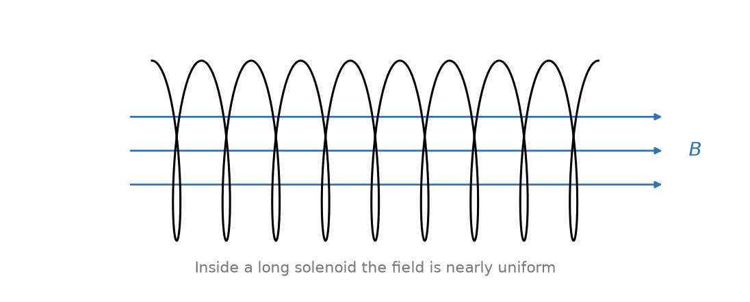
Figure 10.2 — Inside a long solenoid, the magnetic field is nearly uniform.

10.6 Ferromagnetic Materials
Placing a ferromagnetic core — iron being the most familiar example — inside a solenoid dramatically increases the resulting field, often by a factor of several hundred to several thousand, because the core's own atomic-scale magnetic moments (electron orbits and spins) align with the applied field and add their own contribution to it, in direct analogy with how a dielectric's molecular dipoles respond to an applied electric field (Chapter 6). This effect is captured by replacing μ₀ with an effective permeability μ = μᵣμ₀, where the relative permeability μᵣ can be in the thousands for common transformer-grade iron. This is exactly why practical inductors and transformers are wound around iron or ferrite cores rather than left as air-core coils: the same number of turns and the same current produce a vastly stronger field, or equivalently, a much smaller and lighter coil can produce the field a much larger air-core solenoid would need to match.
Worked Example 10.1
Problem: A long straight wire carries a current of 5.0 A. Find the magnetic field at a distance of 2.0 cm from the wire.
Solution: B = μ₀I/(2πr) = (4π×10⁻⁷)(5.0) / [2π(0.020)] = 5.0 × 10⁻⁵ T — exactly the same order of magnitude as Earth's own field, which is why a compass placed near a current-carrying wire is visibly deflected.
Worked Example 10.2
Problem: A solenoid has 800 turns over a length of 20 cm and carries a current of 2.0 A. Find the magnetic field inside it, and find the new field if an iron core with relative permeability 1500 is inserted.
Solution: Turns per unit length: n = 800/0.20 = 4000 turns/m. Air-core field: B = μ₀nI = (4π×10⁻⁷)(4000)(2.0) ≈ 1.0 × 10⁻² T = 10 mT. With the iron core: B = μᵣμ₀nI = 1500 × 10 mT = 15 T — an enormous field, and in practice, iron cores saturate (their internal alignment reaches a maximum) well before reaching such an extreme value, so this idealized result overstates what a real core would achieve at this current; the qualitative point, that the core provides a three-orders-of-magnitude boost, still holds at more realistic operating currents.
Common Misconception
The like-charges-repel, unlike-charges-attract rule from electrostatics is so deeply ingrained by this point in the book that it is tempting to assume current-carrying wires must follow an analogous rule based on current direction. They do not follow the electrostatic pattern at all: parallel currents in the same direction attract, and parallel currents in opposite directions repel — the reverse of the “same repels, opposite attracts” pattern from charge. The two situations are governed by genuinely different force laws (Coulomb's law versus the magnetic force law), and importing intuition from one to the other, without working through the right-hand rule explicitly, reliably produces the wrong sign.
From the Bench
Current loops make magnetic fields, and big loops make big fields. Keep a high-current path and its return close together, as twisted wires or a trace over a solid ground plane, so their fields largely cancel. This single habit fixes a surprising share of noise and EMC problems.

Practice Problems
- Two long parallel wires, 5.0 cm apart, each carry a current of 3.0 A in the same direction. State whether they attract or repel.
- A solenoid has 600 turns over a length of 30 cm and carries a current of 2.0 A. Find the magnetic field inside it (air core).
- At what distance from a wire carrying 10 A does the magnetic field equal 1.0 × 10⁻⁴ T?
- A solenoid produces a field of 8.0 mT with an air core at a given current. Find the field at the same current if a ferrite core of relative permeability 200 is inserted.

What You’ll Actually Use
Everyday working tools
- B = μ₀I/(2πr) near a long wire, and B = μ₀nI inside a solenoid.
- Loop area as the thing to minimize.
Mostly for exams and deeper study
- Biot–Savart integration for arbitrary shapes.
- Ampère's law with carefully chosen paths.

Chapter 11 — Electromagnetic Induction
Wave a magnet through a coil and a voltage appears from nowhere. Faraday found the trick in 1831. It generates nearly all the world's electricity, charges an electric toothbrush through its sealed plastic case, and explains why a relay coil can kick back hard enough to kill the transistor driving it.
Where you meet this: Generators and alternators, transformers and wireless chargers, guitar pickups, induction cooktops, and the inductive kick of every relay and motor.

11.1 Faraday's Discovery
A hand-crank flashlight needs no battery at all. Turn the crank and a magnet inside spins past a coil of wire, and light appears — current flowing through the bulb from nothing but the turning of your own wrist. Every result so far in this book's magnetism chapters has concerned magnets and currents that sit still, producing steady, unchanging fields; nothing in that picture explains where a hand-crank flashlight's current is actually coming from.
Hold that same magnet perfectly still next to the coil, though, and the bulb goes dark immediately, no matter how strong the magnet is. Whatever generates current in the spinning case, a magnet's mere presence is clearly not it.
Nothing encountered so far in this book gives any reason to expect that change itself should matter. A steady magnetic field, however strong, does nothing to a stationary wire loop sitting in it — no current source anywhere in sight, no battery, nothing visibly pushing charge around the loop. Yet the moment that same field starts changing, current appears, as if from nowhere. The field's strength turns out not to be the relevant question at all — what matters is whether the field near this loop is changing, and how quickly.
The one thing that changes is exactly the field-through-a-surface bookkeeping already built in Chapter 4 for electric fields: how much magnetic field is threading through the loop's own area. Track that quantity as a magnet spins nearby, and it rises, falls, and reverses, over and over, even though the wire loop itself never moves. Whatever produces the current, it must be responding to how fast that quantity changes, not to its size at any one instant.
Take a circular loop of radius 10 cm sitting in a field that grows steadily from 0.10 T to 0.40 T over 0.25 s. The loop's area is about 3.14×10⁻² m², so that field-through-the-loop quantity starts at about 3.14×10⁻³, rises to about 7.85×10⁻³ at the midpoint, and reaches about 1.26×10⁻² by the end — a total change of about 9.42×10⁻³ over the 0.25 s it took. Divide that change by the time it took, and the result is about 3.77×10⁻² — a genuine voltage, appearing across the loop with no battery anywhere near it.
That rate of change is exactly what a changing magnetic field, or a changing magnetic flux through a loop of wire more generally, produces: not a new force, but an electromotive force — EMF for short, despite the old-fashioned name nothing more exotic than a voltage the changing flux creates on its own. Michael Faraday discovered this in 1831, and it is, without exaggeration, the single physical fact that makes electric generators, transformers, and power grids possible; without it, essentially all large-scale electricity generation as it currently exists would not work.

11.2 Magnetic Flux
Magnetic flux is defined exactly analogously to electric flux from Chapter 4 — for a flat surface of area A in a uniform field B, oriented so its normal makes angle θ with the field:
Φ_{B} = B A cosθ
with SI unit the weber (Wb), equal to one tesla-meter-squared. It is a change in this quantity — not the field itself, and not even the presence of current — that induction responds to.

11.3 Faraday's Law
Faraday's law states that the induced electromotive force (EMF) around a closed loop equals the negative rate of change of magnetic flux through the loop:
ε = −dΦ_{B}/dt
For a coil of N turns, each threaded by the same changing flux, the induced EMFs from every turn add:
ε = −N dΦ_{B}/dt
Flux can change for several distinct reasons — the field itself changing in time, the loop's area changing, the loop rotating relative to the field, or the loop moving into or out of a field-filled region — and Faraday's law responds identically to all of them, because all of them change the magnetic flux. This is precisely how an electric generator works: a coil is mechanically rotated within a magnetic field, continuously changing the flux as the coil's orientation relative to the field changes, producing an alternating EMF — the direct physical origin of the AC waveform Part II of this book (Chapters 20–23) takes as its starting point.

11.4 Lenz's Law and the Meaning of the Minus Sign
The minus sign in Faraday's law is not a bookkeeping detail — it encodes Lenz's law, one of the more important qualitative facts in this book. Lenz's law states that the induced current always flows in whatever direction opposes the change in flux that produced it. If flux through a loop is increasing, the induced current flows in the direction that would, by the results of Chapter 10, produce a magnetic field opposing that increase; if flux is decreasing, the induced current flows to reinforce it.
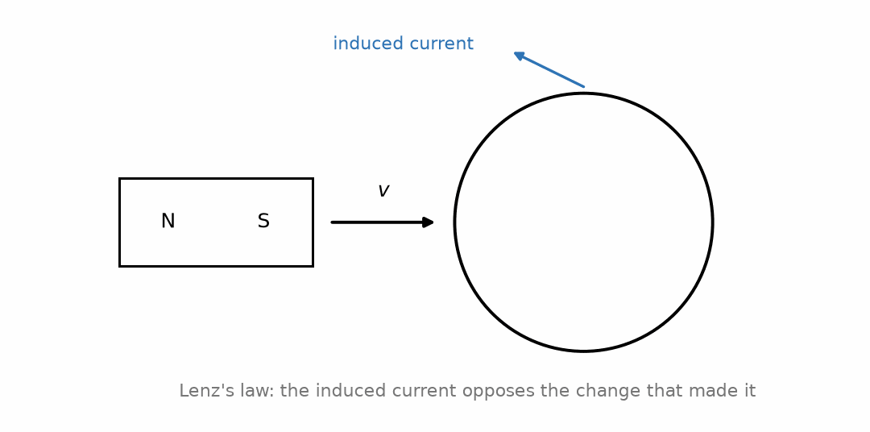
Figure 11.1 — Lenz's law: the induced current opposes the change in flux that produced it.
Key Idea
Lenz's law is a direct consequence of energy conservation. If induced current instead reinforced a changing flux, the effect would build on its own cause without limit, generating energy from nothing. Lenz's law guarantees that any electromagnetic induction always opposes the mechanical or electrical change that created it — which is precisely why turning a generator's shaft takes real mechanical effort: you are always pushing against an induced magnetic braking force, and that mechanical work is exactly what becomes the electrical energy delivered by the generator.

11.5 Motional EMF
A useful special case: a conducting rod of length L, moving with velocity v perpendicular to a magnetic field B, develops an EMF along its length:
ε = BLv
This can be derived directly from the magnetic force on the rod's own free charges (F = qv×B from Chapter 9) without invoking flux at all, and it is reassuring — and a useful check on your understanding — that both approaches, flux-based and force-based, agree exactly. This is the operating principle behind simple linear generators and behind induced voltages in moving conductors more generally, including eddy currents induced in metal moving through a field, which is exploited deliberately in magnetic braking systems.

11.6 Energy Stored in a Magnetic Field: A First Look at Inductance
Just as a capacitor stores energy in the electric field between its plates (Chapter 6), a current-carrying coil stores energy in its own magnetic field. A coil's ability to do this — to build up a magnetic field, store energy in it, and (by Faraday's law, applied to itself) resist any change in the current that produces it — is quantified by its self-inductance L, defined so that the induced EMF opposing a change in the coil's own current is:
ε = −L dI/dt
with SI unit the henry (H). Notice the structural parallel to Ohm's law and to the capacitor relation C = Q/V: three of this book's core circuit elements — resistor, capacitor, inductor — each relate a pair of circuit quantities (voltage and current, charge and voltage, and now voltage and the rate of change of current) through a single characteristic constant of the component. A full treatment of inductors, RL circuits, and the energy U = ½LI² stored in an inductor's magnetic field belongs properly to Part III of this book, which develops all three of these elements — resistor, capacitor, and inductor — together, once the tools for handling time-varying circuits are in place. What matters here is recognizing that Chapter 10's solenoid, once wired into a circuit and thought of as opposing its own changing current via Faraday's law, is exactly what an inductor is.
Worked Example 11.1
Problem: A circular loop of wire, radius 5.0 cm, sits in a magnetic field that increases uniformly from 0.20 T to 0.80 T over 0.30 s, with the field perpendicular to the loop throughout. Find the average induced EMF.
Solution: Loop area: A = πr² = π(0.050)² ≈ 7.85×10⁻³ m². Change in flux: ΔΦ = AΔB = (7.85×10⁻³)(0.80−0.20) = 4.71×10⁻³ Wb. Average EMF: ε = ΔΦ/Δt = 4.71×10⁻³/0.30 ≈ 1.57 × 10⁻² V.
Worked Example 11.2
Problem: A metal rod 0.40 m long slides along a pair of conducting rails, moving at a constant 3.0 m/s, perpendicular to a uniform 0.60 T magnetic field pointing straight into the plane of the rails. Find the motional EMF developed, and state, using Lenz's law, which way current flows in the circuit formed by the rod and rails as the rod moves.
Solution: Motional EMF: ε = BLv = (0.60)(0.40)(3.0) = 0.72 V. To find the current direction with Lenz's law: as the rod slides (say, to the right, into the region enclosed by the rails and rod), the enclosed loop area increases, and since B points into the page, the enclosed flux (into the page) is increasing. The induced current must oppose that increase, meaning it must create its own field pointing out of the page inside the loop — by the right-hand rule for a current loop (Chapter 10), this means the induced current flows counterclockwise as viewed by someone looking at the page, with B pointing away from them into it.
Common Misconception
Faraday's law is sometimes misremembered as responding to the magnetic field itself, so that a strong but constant field is expected to induce a large EMF. It is the rate of change of flux that matters, not the field's absolute size — a room permeated by an enormous, perfectly steady magnetic field induces no EMF in any wire loop sitting motionless within it, no matter how strong that field is, while a comparatively weak field changing quickly can induce a substantial EMF. The relevant question for any induction problem is always “how fast, and in what way, is the flux through this loop changing?” — never “how strong is the field?” by itself.
From the Bench
Put a flyback diode across any relay coil or small DC motor driven by a transistor, cathode to the positive supply. When the transistor turns off, the coil's current has to go somewhere; without the diode it raises the voltage until something breaks down, often the transistor. The diode slows the relay's release a little; a diode plus a Zener speeds it up again if release time matters.

Practice Problems
- A flat coil of 50 turns and area 0.020 m² sits perpendicular to a magnetic field that changes at a rate of 0.50 T/s. Find the induced EMF.
- A conducting rod 0.30 m long moves at 4.0 m/s perpendicular to a 0.50 T field. Find the motional EMF developed along the rod.
- A bar magnet is pushed, north pole first, toward a loop of wire. Using Lenz's law, state the direction of the induced current in the loop (as viewed from the approaching magnet's side) and explain your reasoning.
- An inductor with L = 0.20 H carries a current that is changing at a rate of 5.0 A/s. Find the magnitude of the induced EMF across the inductor.

What You’ll Actually Use
Everyday working tools
- Faraday's law, emf = −dΦ/dt, for estimates.
- v = L di/dt and the inductive kick.
- Lenz's law for the direction of induced current.
Mostly for exams and deeper study
- Motional-emf derivations.
- Mutual inductance from geometry.

Chapter 12 — Toward Maxwell's Equations and the Rest of This Series
Your phone talks to a tower kilometers away without a wire. Maxwell worked out in the 1860s why that is possible: a changing electric field makes a magnetic field, a changing magnetic field makes an electric field, and the pair can leave together at the speed of light.
Where you meet this: Every radio, Wi-Fi router and phone antenna, optical fiber, microwave oven, and the signal-integrity effects of Books 4 and 7.

12.1 Gathering the Pieces
This book has built up electricity and magnetism largely as two separate stories that occasionally touch — first electrostatics (Chapters 1–6), then steady currents and resistance (Chapters 7–8), then magnetostatics (Chapters 9–10), then the one genuine crossover result, electromagnetic induction (Chapter 11). James Clerk Maxwell's achievement, completed in 1865, was to recognize that four equations — two of which you have already met by name — form a complete, self-consistent description of every electric and magnetic phenomenon covered in this book, and a great many that are not.

12.2 Maxwell's Four Equations, Informally Stated
- Gauss's law for electricity (Chapter 4): electric field lines start on positive charge and end on negative charge, or extend to infinity when no opposite charge is present; the total flux through any closed surface measures the net enclosed charge.
- Gauss's law for magnetism (not previously stated by this name, but implicit in every field-line diagram drawn in Chapters 9–10): magnetic field lines never begin or end anywhere — there is no such thing as an isolated magnetic “charge,” or magnetic monopole. Every magnetic field line that leaves a region must loop back into it somewhere.
- Faraday's law (Chapter 11): a changing magnetic flux induces an electric field (which in a conducting loop drives a current, but the induced electric field exists even without a wire present to carry current).
- Ampere's law, with Maxwell's own correction (a term beyond Chapter 10's scope, called the displacement current): a changing electric flux, in addition to actual current, also produces a magnetic field.
It is that final correction — the displacement current, Maxwell's own contribution to a law that already bore Ampere's name — that completes the symmetry between the third and fourth equations and, in doing so, predicts something neither Faraday nor Ampere had any reason to expect: a changing electric field creates a magnetic field, which if itself changing creates an electric field, which if changing creates another magnetic field, and so on indefinitely, each one regenerating the next without needing any charge or current physically present to sustain it.

12.3 Electromagnetic Waves and Light
Maxwell worked out that this self-sustaining oscillation propagates through empty space at a speed determined entirely by ε₀ and μ₀ — the same two constants that appeared, respectively, in Coulomb's law (Chapter 2) and in the field of a straight wire (Chapter 10), each originally measured in completely unrelated laboratory experiments involving static charges and steady currents:
c = 1 / √(ε₀μ₀)
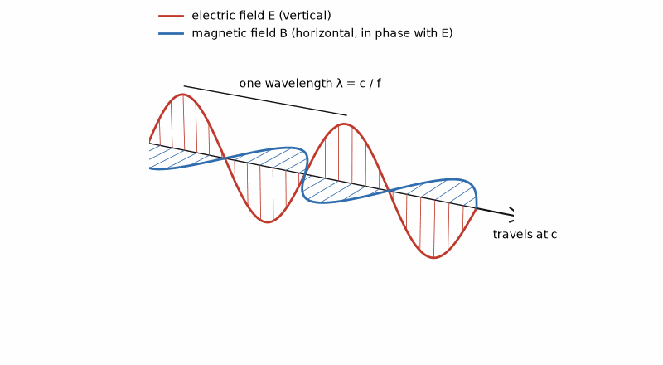
Figure 12.1 — A light or radio wave: the electric field (red) and magnetic field (blue) rise and fall together, at right angles to each other and to the direction of travel.
Plugging in the values from Chapters 2 and 10 gives c ≈ 3.00 × 10⁸ m/s — the measured speed of light, to within experimental precision, computed from two constants that had nothing to do with optics. Maxwell concluded, correctly, that light itself is an electromagnetic wave: a self-propagating oscillation of electric and magnetic fields, and that visible light is merely the narrow band of electromagnetic radiation that happens to be detectable by the human eye. Radio waves, microwaves, infrared, ultraviolet, X-rays, and gamma rays are all the same physical phenomenon at different frequencies — a fact this series returns to in full when it reaches antennas, RF engineering, and wave propagation.
It is worth appreciating how strange this result must have seemed at the time. Nothing about Coulomb's careful measurements of the force between charged pith balls, and nothing about Ampere's measurements of the force between current-carrying wires, had anything ostensibly to do with light. Maxwell's equations were assembled entirely from static- and steady-current experiments, plus Faraday's induction results, and yet the mathematics of that assembled system — quite without being asked to — produced a wave equation whose predicted propagation speed matched light exactly. This is among the most celebrated instances in the history of physics of a purely mathematical consequence of an existing theory turning out to describe something no one had built the theory to explain in the first place, and it is difficult to overstate how strong a piece of evidence this was, historically, that Maxwell's four equations were not merely a convenient summary of known results but a genuinely complete and correct description of electromagnetism.
Key Idea
Every subsequent book in this series is, in a real sense, a set of special cases of Maxwell's four equations. DC circuit theory is Maxwell's equations in the limit where nothing changes in time. AC circuit theory is Maxwell's equations for fields that oscillate slowly enough that a circuit's physical dimensions are much smaller than the wavelength involved. RF and antenna theory is what happens once that assumption stops holding. Semiconductor device physics governs how real materials respond to the fields Maxwell's equations describe. There is, in an important sense, only one subject in this entire series — this book has built it from the ground up.

12.4 A Historical Aside: Waves Need Something to Wave
Nineteenth-century physicists, having only ever encountered waves that traveled through a physical medium — sound through air, ripples through water — found it almost unthinkable that an electromagnetic wave could travel through genuinely empty space with nothing there to do the waving. This led to decades of searching for the “luminiferous aether,” a hypothesized medium presumed to fill all of space specifically so that light would have something to be a wave in. The most famous search for it, the Michelson-Morley experiment of 1887, attempted to detect Earth's motion through this aether by comparing the speed of light in different directions, and found — to the considerable surprise of everyone involved — no difference whatsoever. Einstein's special theory of relativity of 1905 resolved the puzzle by taking the speed of light to be the same for every observer, in every direction; historians still debate how much the Michelson-Morley result itself shaped his thinking. Light needs no medium: it is a self-sustaining disturbance in the electric and magnetic fields themselves, exactly as Maxwell's equations describe. The aether was never found because there was never anything there to find — but the search for it, and its eventual resolution, is a useful reminder that even a spectacularly successful theory (and Maxwell's equations remain, in their domain, exactly correct today) can still coexist for decades with a widely-held, entirely wrong assumption about what that theory actually implies.

12.5 Where This Book Goes Next
Part III of this book, starting at Chapter 26, takes the definitions built here — charge, current, voltage, resistance, capacitance, and (in the closing sections of Part I) inductance and induced EMF — and develops the systematic tools (Kirchhoff's laws, Thevenin and Norton equivalents, phasor analysis for AC) needed to analyze real circuits of arbitrary complexity. From there the series runs through circuits, components, and control (Book 2, including digital logic), semiconductor physics and devices (Book 3), RF, microwave, and transceivers (Book 4), communications, wireless, and SDR (Book 5), power and energy (Book 6), and packaging, layout, EMC, and test (Book 7). Books 8 and 9 then cover firmware and software for electronics, and test and measurement instruments. Together, the nine books map the working vocabulary of a practicing electrical engineer. Every one of those later books assumes the physical vocabulary built in Part I of this one: charge, field, potential, current, resistance, capacitance, magnetic field, and induction. If any of it still feels unfamiliar, this is the section to return to.
A radio signal at 100 MHz has wavelength λ = c/f ≈ (3.00 × 10⁸ m/s)/(1.00 × 10⁸ s⁻¹) = 3.00 m. The units cancel to metres, and the inverse relation means doubling frequency halves wavelength. Books 4 and 5 use that length to reason about antennas and radio links; here it is a first practical payoff from keeping units and powers of ten straight.

Part I Review Problems
- State, in your own words, the physical difference between the electric field and the electric potential at a point in space.
- Explain why Gauss's law and Coulomb's law are considered physically equivalent, even though one is stated as an integral over a closed surface and the other as a force between two points.
- A capacitor and a resistor are both circuit elements that oppose current in some sense. Explain the physical difference between what each one actually does to the energy delivered to it.
- Explain, using Lenz's law, why an electric generator becomes harder to turn by hand as more electrical load (more current draw) is placed on it.
- Using the two constants ε₀ and μ₀, and without looking up the value, explain in words how Maxwell was able to compute the speed of light from experiments that involved neither light nor optics.
- An inductor resists changes in current, much as a capacitor resists changes in voltage. Explain briefly why these two statements are, in a loose sense, mirror images of each other, referring back to how each component is defined.
From the Bench
Wires stop being 'just wires' sooner than you think. Once a trace or cable is longer than about a tenth of a wavelength, or the signal's edge takes a significant fraction of the line length to travel, treat it as a transmission line. On FR-4 circuit board, signals travel at roughly half to 60% of the speed of light, about 15 to 18 cm per nanosecond.

What You’ll Actually Use
Everyday working tools
- c = fλ for wavelength: 2.4 GHz Wi-Fi is about 12.5 cm in air.
- The tenth-of-a-wavelength rule for when layout starts to matter.
Mostly for exams and deeper study
- Maxwell's equations in integral form.
- Deriving the wave speed from ε₀ and μ₀.

Part II — Mathematics and Measurement

Chapter 13 — Quantities, Units, and the SI System
In 1999 NASA lost the Mars Climate Orbiter because one team's software reported thruster impulse in pound-force seconds while the navigation software expected newton-seconds. The spacecraft arrived far too low and was lost in the Martian atmosphere. Nobody had got the physics wrong. They had got the units wrong.
Where you meet this: Datasheets, which mix units freely (mils and millimeters, °F and °C, dBm and watts), and every calculation you hand to someone else.
Every number in engineering is a number of something. This sounds too obvious to state, and yet the single most common source of catastrophic error in engineering calculation is a number that lost track of what it was a number of. This chapter is about keeping that attachment intact.

13.1 Quantity, Numerical Value, and Unit
A physical quantity is written as a numerical value multiplied by a unit. When we write R = 4.7 kΩ, we are making a multiplicative statement: the resistance equals 4.7 times the quantity "one kilohm." The multiplication is real, not notational, and this single realization is what makes unit algebra work.
Because the multiplication is real, units obey ordinary algebraic rules. They multiply, they divide, they cancel. If a current of 2 A flows through a resistance of 3 Ω, then
V = IR = (2 A)(3 Ω) = 6 A·Ω = 6 V
and the last step is not a convention but an identity: the volt is defined so that one ampere times one ohm is one volt. Every derived SI unit works this way. Learning to carry units through a calculation, rather than dropping them and reattaching them at the end, converts a whole class of silent errors into loud ones.
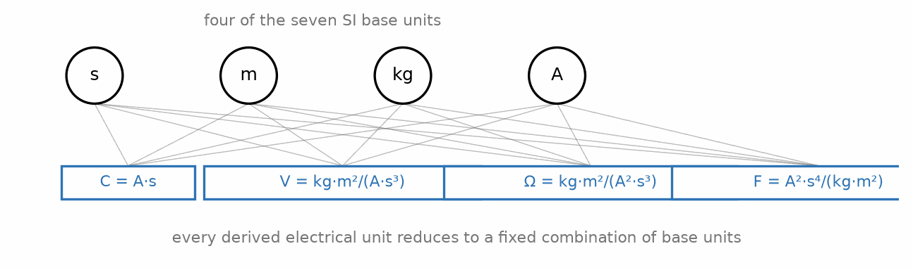
Figure 13.1 — Four SI base units combine to form the derived electrical units.

13.2 The Seven Base Units
The SI system defines seven base quantities and gives each a base unit. Everything else is built from them by multiplication and division.
Quantity — Unit — Symbol
Length
Unit: meter
Symbol: m
Mass
Unit: kilogram
Symbol: kg
Time
Unit: second
Symbol: s
Electric current
Unit: ampere
Symbol: A
Thermodynamic temperature
Unit: kelvin
Symbol: K
Amount of substance
Unit: mole
Symbol: mol
Luminous intensity
Unit: candela
Symbol: cd

Electrical engineering uses four of these constantly — meter, kilogram, second, ampere — and the older name "MKSA system" for that subset still appears in older texts. Note that the base unit of mass is the kilogram, not the gram; the prefix is built into the base unit, which is a historical wrinkle with no deeper meaning and occasionally trips up dimensional bookkeeping.
Since 2019 all seven are defined by fixing the numerical values of seven physical constants — the speed of light, the Planck constant, the elementary charge, and so on — rather than by reference to physical artifacts. The ampere, for instance, is now defined by fixing the elementary charge at exactly 1.602176634 × 10⁻¹⁹ C. This matters philosophically and to national measurement institutes; it changes nothing about how you calculate.

13.3 Derived Units in Electrical Engineering
The units you will actually use every day are derived: each is a specific combination of base units that has been given its own name because the combination occurs so often.
Quantity — Unit — Symbol — In base units
Charge
Unit: coulomb
Symbol: C
In base units: A·s
Voltage
Unit: volt
Symbol: V
In base units: W/A = kg·m²/(A·s³)
Resistance
Unit: ohm
Symbol: Ω
In base units: V/A
Conductance
Unit: siemens
Symbol: S
In base units: A/V
Capacitance
Unit: farad
Symbol: F
In base units: C/V
Inductance
Unit: henry
Symbol: H
In base units: Wb/A
Magnetic flux
Unit: weber
Symbol: Wb
In base units: V·s
Frequency
Unit: hertz
Symbol: Hz
In base units: 1/s
Power
Unit: watt
Symbol: W
In base units: J/s
Energy
Unit: joule
Symbol: J
In base units: W·s

Two entries deserve comment. The hertz is defined as one per second, and so is the becquerel, and so — dimensionally — is the radian per second; they are dimensionally identical and semantically distinct, which is why you cannot cancel Hz against rad/s without thinking. And the siemens is the reciprocal ohm; you will occasionally still meet its charming obsolete name, the mho, written with an upside-down omega.

13.4 Dimensional Analysis as an Error Check
Because units multiply and divide algebraically, any equation you write must balance dimensionally: the units on the left must reduce to the same combination of base units as the units on the right. If they do not, the equation is wrong, and you have found the error without knowing anything about the physics.
This is the cheapest debugging tool in engineering and it is badly underused. Consider the time constant of an RC circuit, τ = RC. Is that dimensionally sensible? Resistance is V/A and capacitance is C/V, so
RC = (V/A)(C/V) = C/A = (A·s)/A = s
which is a time. Good. Had you misremembered the formula as R/C, the same check would have produced units of V²/(A·C) = V²/(A²·s), which is not a time, and the error would have surfaced immediately.
Worked Example 13.1
Verify that the resonant frequency formula f = 1/(2π√(LC)) has units of hertz.
The constant 2π is dimensionless, so we need only the units of 1/√(LC).
Inductance: H = Wb/A = (V·s)/A. Capacitance: F = C/V = (A·s)/V.
Their product: LC = [(V·s)/A]·[(A·s)/V] = s². The volts cancel, the amperes cancel, and we are left with seconds squared.
Therefore √(LC) has units of seconds, and 1/√(LC) has units of 1/s, which is the hertz. The formula is dimensionally sound.
Notice the limit of this check: dimensional analysis confirms the formula's units but cannot verify dimensionless factors. A formula can have the right units and still miss 2π, a common error in resonance calculations.
Key Idea
Carry units through every calculation. Do not strip them at the start and reattach them at the end. Units that fail to cancel correctly are telling you the equation is wrong, and they are telling you before you have wasted an hour on the arithmetic.

13.5 Units That Are Not Really Units
Some quantities are ratios of two quantities with the same units, and therefore dimensionless. Gain, efficiency, power factor, reflection coefficient — how much of a signal bounces back when impedances do not match, made precise in Chapter 37 — and the Q factor of a resonant circuit — a single number describing how sharply it rings, made precise in Chapter 36 — are all pure numbers. They are often given a pseudo-unit anyway — "dB", "%", "dimensionless" — as a reminder of what kind of ratio they are.
The radian is the most important of these. An angle in radians is defined as an arc length divided by a radius: meters over meters, dimensionless. This is precisely why angular frequency ω, measured in radians per second, has base units of 1/s, identical to frequency f in hertz — and precisely why ω = 2πf is not a unit conversion but a genuine numerical relationship between two different quantities that happen to share a dimension.
Common Misconception
It is tempting to treat radians per second and hertz as interchangeable because they share the same base units, and to convert between them by "canceling" the radian. They are not interchangeable. A signal at 1 kHz has ω = 6283 rad/s, not 1000 rad/s. The factor of 2π between them is real and physical: it is the number of radians in one full cycle. The radian being dimensionless means the units cannot catch this error for you — one of the few places where dimensional analysis offers no protection, and correspondingly one of the places where the mistake is most common.
From the Bench
Carry units through every line of a calculation, especially in spreadsheets and scripts, where they silently vanish. Watch the classic traps: PCB dimensions in mils (thousandths of an inch, not millimeters), copper weight in ounces per square foot (1 oz is about 35 µm thick), and wire gauge, where a bigger AWG number means a thinner wire.

Practice Problems
- A capacitor of 100 nF is charged to 12 V. Using C = Q/V, find the stored charge, and express your answer in coulombs and in nanocoulombs.
- Show by dimensional analysis that the quantity L/R has units of time.
- The energy stored in an inductor is given by W = ½LI². Verify that this expression has units of joules.
- A student writes the impedance of a capacitor as Z = ωC. Use dimensional analysis to show this cannot be correct, and determine what the correct expression must look like dimensionally.

What You’ll Actually Use
Everyday working tools
- Dimensional analysis as an error check on every formula.
- Derived units: V = W/A, Ω = V/A, F = C/V, H = V·s/A.
Mostly for exams and deeper study
- The formal definitions of the SI base units.
- Unit systems other than SI.

Chapter 14 — Prefixes, Scientific Notation, and Engineering Notation
A phone's processor juggles capacitances measured in femtofarads while its charger handles watts and the grid behind the wall handles gigawatts. Electronics spans more than twenty powers of ten, and engineering notation is how engineers avoid drowning in zeros.
Where you meet this: Part markings such as 4k7, 2R2 and 104, oscilloscope settings like 2 µs/div and 50 mV/div, and every datasheet table.
Electrical engineering spans an absurd range of magnitudes. The gate capacitance of a modern transistor is measured in femtofarads; the capacitance of a power-factor correction bank is measured in millifarads. That is twelve orders of magnitude, in the same quantity, in the same field. This chapter is about writing such numbers without drowning in zeros.

14.1 The SI Prefixes
A prefix multiplies the unit it is attached to by a power of ten. The prefixes used routinely in electrical engineering are these.
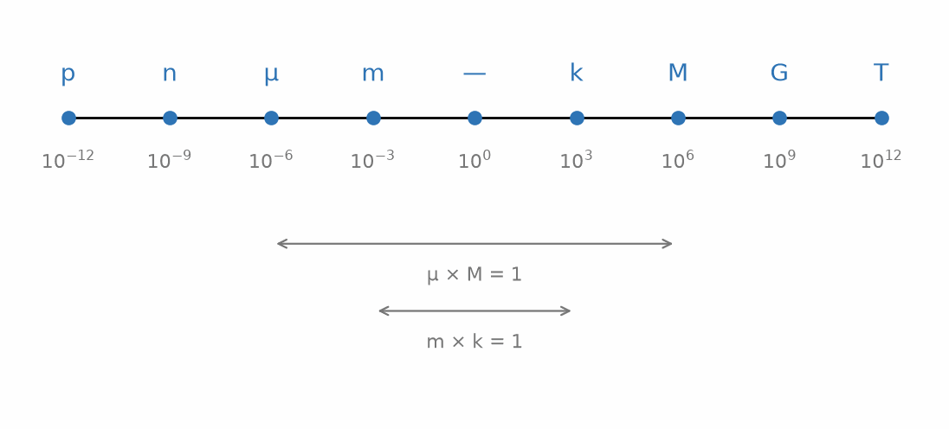
Figure 14.1 — SI prefixes from pico to tera, spaced by their power-of-ten exponent.
Prefix — Symbol — Factor
tera
Symbol: T
Factor: 10¹²
giga
Symbol: G
Factor: 10⁹
mega
Symbol: M
Factor: 10⁶
kilo
Symbol: k
Factor: 10³
(none)
Factor: 10⁰
milli
Symbol: m
Factor: 10⁻³
micro
Symbol: µ
Factor: 10⁻⁶
nano
Symbol: n
Factor: 10⁻⁹
pico
Symbol: p
Factor: 10⁻¹²
femto
Symbol: f
Factor: 10⁻¹⁵

A capital M is mega, a lower-case m is milli, and they differ by a factor of a billion. A capital K is not a valid prefix at all — kilo is always lower-case k — while a capital K is the symbol for the kelvin. In the 5 V, 2 V LED example of Chapter 8, 330 Ω limits current to about 9 mA; reading 330 mΩ instead predicts about 9 A from an ideal source. The notation is small. The consequence is not.
Note also that the prefix binds tighter than the exponent. The expression mm² means (mm)², that is, 10⁻⁶ m², not 10⁻³ m². This catches people constantly in current-density and sheet-resistance calculations.

14.2 Scientific Notation
Scientific notation writes every number as a value between 1 and 10, multiplied by a power of ten: 47000 becomes 4.7 × 10⁴, and 0.00033 becomes 3.3 × 10⁻⁴. The mantissa always has exactly one digit before the decimal point.
Its virtue is unambiguity. The number 4.70 × 10⁴ states plainly that three digits are meaningful, where the plain form 47000 leaves you guessing whether the trailing zeros are measured or merely placeholders — a question Chapter 15 takes up in earnest.

14.3 Engineering Notation
Engineering notation is a variant that restricts the exponent to multiples of three, so that the exponent always corresponds to an SI prefix. Instead of 4.7 × 10⁴ Ω you write 47 × 10³ Ω, and read it directly as 47 kΩ.
This is what practicing engineers actually use, and it is what calculators mean by their "ENG" mode. The reason is entirely practical: component values, datasheet entries, and instrument displays are all expressed with prefixes, so a notation whose exponents map one-to-one onto those prefixes eliminates a translation step, and with it a class of error.
Worked Example 14.1
A current of 0.0000047 A flows through a resistance of 2200000 Ω. Express both in engineering notation, then find the voltage.
The current: 0.0000047 A = 4.7 × 10⁻⁶ A = 4.7 µA.
The resistance: 2200000 Ω = 2.2 × 10⁶ Ω = 2.2 MΩ.
Now the voltage, keeping the powers of ten explicit:
V = IR = (4.7 × 10⁻⁶)(2.2 × 10⁶) = (4.7 × 2.2) × 10⁻⁶⁺⁶ = 10.34 × 10⁰ = 10.34 V.
The exponents canceled exactly, which is the useful thing to notice: micro times mega is unity. Similar pairings are worth committing to memory — milli times kilo is unity, nano times giga is unity, pico times tera is unity. Once you internalize these, a great many circuit calculations can be done in your head, because the prefixes annihilate and you are left with a one-digit multiplication.
Key Idea
Reciprocal prefix pairs cancel. µ×M = 1, m×k = 1, n×G = 1, p×T = 1. A resistance in kilohms times a current in milliamps gives a voltage in volts. A capacitance in microfarads times a resistance in megohms gives a time constant in seconds. Recognizing these pairings is the single biggest speed-up available in routine circuit arithmetic.

14.4 Arithmetic With Powers of Ten
Multiplication adds exponents; division subtracts them. Raising to a power multiplies the exponent. Taking a square root halves it — which is why square roots in engineering notation are awkward, since halving an exponent that is a multiple of three rarely lands on another multiple of three.
Addition and subtraction are the operations that catch people. You cannot add mantissas unless the exponents match. To compute 4.7 × 10³ + 2.2 × 10², first rewrite the second term as 0.22 × 10³, then add mantissas: 4.92 × 10³. Adding 4.7 and 2.2 directly gives 6.9 × 10³, about 40 % too high.
Common Misconception
A frequent error is to assume that because prefixes are convenient, they can be mixed freely inside a single expression. They cannot. Adding 4.7 kΩ to 220 Ω requires converting one to match the other — either 4.7 kΩ + 0.22 kΩ = 4.92 kΩ, or 4700 Ω + 220 Ω = 4920 Ω. Writing "4.7 k + 220" and reading off 4.92 works only because you performed the conversion silently in your head; write it out, because the day you do it silently and get it wrong is the day it costs you.
From the Bench
Learn the component shorthand. On schematics 4k7 means 4.7 kΩ and 2R2 means 2.2 Ω, with the letter standing in for a decimal point that a smudged print might lose. A ceramic capacitor marked 104 is 10 × 10⁴ pF, or 100 nF. And mind the case: 1 mΩ and 1 MΩ differ by a factor of a billion.

Practice Problems
- Express the following in engineering notation with an appropriate prefix: 0.000000015 F, 68000 Ω, 0.0025 A, 1500000000 Hz.
- A 4.7 kΩ resistor carries 3.2 mA. Find the voltage across it and the power dissipated in it, using prefix cancellation rather than long decimals.
- Add the following capacitances, giving the result in nanofarads: 470 pF, 1.2 nF, and 0.01 µF.
- A signal has a period of 20 ns. Find its frequency, and express the answer with an appropriate prefix. Then find the angular frequency ω in rad/s.

What You’ll Actually Use
Everyday working tools
- Engineering notation in steps of 10³.
- Instant fluency with p, n, µ, m, k, M and G.
- Reading part-marking codes.
Mostly for exams and deeper study
- Rarely used prefixes such as zepto and yotta.
- Formal scientific-notation rules for very large calculations.

Chapter 15 — Precision, Significant Figures, and Uncertainty
Your meter says 4.732 V. How many of those digits are true? On an ordinary handheld meter, perhaps three. This chapter is about knowing which digits to believe, and why a resistor marked ±5% can make a four-digit calculation pointless.
Where you meet this: Resistor and capacitor tolerances, meter accuracy specifications, ADC resolution versus accuracy, and production-test limits.
A measurement is not a number; it is a number together with a statement of how well it is known. An oscilloscope that reads 5.02 V is not telling you the voltage is 5.02 V. It is telling you the voltage is near 5.02 V, with a spread that depends on the instrument, the probe, the temperature, and the day. This chapter is about carrying that spread through a calculation honestly.
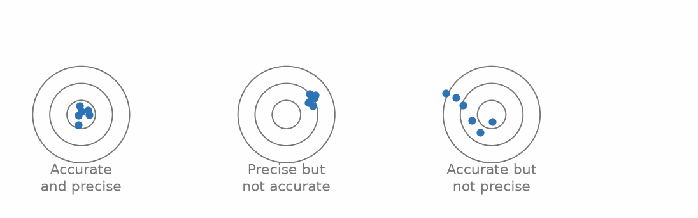
Figure 15.1 — Accuracy and precision are independent: a measurement can have either, both, or neither.

15.1 Significant Figures
The significant figures of a number are the digits that carry real information. The rules are mechanical: all non-zero digits are significant; zeros between non-zero digits are significant; leading zeros are never significant; trailing zeros after a decimal point are significant.
So 0.00470 has three significant figures — the leading zeros are placeholders, the trailing zero is a claim of precision. The genuinely ambiguous case is a whole number ending in zeros: 4700 might have two, three, or four significant figures, and the plain notation cannot tell you which. Scientific notation resolves this completely, which is one of its main practical virtues: 4.7 × 10³ has two, 4.70 × 10³ has three, 4.700 × 10³ has four.

15.2 Propagating Precision Through a Calculation
Two rules cover most cases. For multiplication and division, the result carries as many significant figures as the least precise input. For addition and subtraction, the result carries as many decimal places as the input with the fewest decimal places.
The rules differ because the operations degrade precision differently, and it is worth seeing why rather than memorizing both. Multiplication scales relative error; addition scales absolute error. If you multiply a quantity known to 1% by one known to 10%, the answer is known to roughly 11%, regardless of the units involved. If you add a quantity known to ±0.5 V to one known to ±0.001 V, the sum is known to ±0.5 V — the precise measurement is swamped, and no amount of decimal places in the second number rescues it.
Common Misconception
The most common error with significant figures is rounding at every intermediate step. Do not. Carry full precision through the calculation and round only the final answer. Rounding intermediate values injects error at each step, and those errors accumulate — in a long chain of calculations, aggressive intermediate rounding can easily shift a final answer by more than the measurement uncertainty you were trying to represent. The significant-figure rules describe how to report a result, not how to compute one.

15.3 Absolute and Relative Uncertainty
Absolute uncertainty is expressed in the units of the quantity: 5.02 V ± 0.05 V. Relative uncertainty is the same thing as a fraction or percentage of the value: 5.02 V ± 1%. Converting between them is straightforward, and which one you want depends on the operation you are about to perform.
For products and quotients, relative uncertainties add. If R is known to ±2% and I is known to ±3%, then V = IR is known to roughly ±5%. For sums and differences, absolute uncertainties add. These are conservative, worst-case rules, useful for a quick hand estimate; when independent random uncertainties are treated statistically, standard uncertainties are more commonly combined in quadrature (the square root of the sum of squares), which gives a smaller, more realistic combined uncertainty than simple addition. This is the formal version of the observation in the previous section, and it has a sharp practical consequence.
Worked Example 15.1
Two voltages are measured as V₁ = 10.0 V ± 0.1 V and V₂ = 9.8 V ± 0.1 V. Find the difference and its uncertainty, as an absolute figure and as a percentage.
The difference: V₁ − V₂ = 10.0 − 9.8 = 0.2 V.
The absolute uncertainties add: ±0.1 + ±0.1 = ±0.2 V.
So the difference is 0.2 V ± 0.2 V — a relative uncertainty of 100%.
Each individual measurement was good to 1%. Their difference is good to 100%. Nothing went wrong in the measurement; this is what subtracting two nearly equal numbers does. The signal is the small residue between two large quantities, and the uncertainty of each large quantity survives into that small residue undiminished.
This phenomenon has a name — catastrophic cancellation — and it is a permanent hazard. It is why four-wire (Kelvin) resistance measurement exists, why instrumentation amplifiers are built the way they are, and why a bridge circuit that measures a small imbalance directly will always beat a scheme that measures two large quantities and subtracts them.
Key Idea
Subtracting nearly equal numbers destroys precision. The absolute uncertainty is preserved while the value shrinks, so the relative uncertainty explodes. Whenever a design calls for the small difference between two large measured quantities, look for a way to measure the difference directly instead.

15.4 Accuracy, Precision, and Resolution
These three words are not synonyms, and instrument datasheets depend on the distinction.
- Accuracy is how close a measurement is to the true value. It is limited by calibration, and it drifts with time and temperature.
- Precision (or repeatability) is how close repeated measurements are to each other. An instrument can be precise and inaccurate: reading 4.512 V every time when the true value is 5.000 V.
- Resolution is the smallest change the instrument can display. A six-digit meter has fine resolution, which says nothing whatever about whether those six digits are accurate. Resolution is free; accuracy is expensive.
A typical bench multimeter specification reads something like "±(0.5% of reading + 3 counts)". The first term is a relative error that scales with the measurement; the second is an absolute error, in units of the last displayed digit, that dominates at the low end of a range. This is why measuring 0.1 V on a 1000 V range is a poor idea even though the meter will happily display a number.

15.5 Component Tolerance
Real components differ from their marked values. A resistor marked 4.7 kΩ with a 5% tolerance is guaranteed only to lie between 4.465 kΩ and 4.935 kΩ. This is not a defect; it is the specification, and designs must work across the whole range.
The standard E-series values — E12, E24, E96 — are chosen as geometric progressions so that consecutive values are spaced by roughly the tolerance. E24 steps by about 10%, matching 5% parts, so that the tolerance bands of adjacent values meet without large gaps or heavy overlap. This is why the odd-looking sequence 10, 11, 12, 13, 15, 16, 18, 20, 22, 24, 27, 30, 33, 36, 39, 43, 47, 51, 56, 62, 68, 75, 82, 91 exists: it is a logarithmic ladder, not an arbitrary list, and once you see that, the values stop looking random.
Worst-case analysis assumes every component sits at the tolerance extreme that hurts most. It is pessimistic — the probability of every part being simultaneously worst-case is negligible — but it is the honest way to establish that a design cannot fail, as opposed to establishing that it usually works.

15.6 What an ADC Reading Is Worth
A microcontroller's analog-to-digital converter (ADC) turns a voltage into a whole number. The ESP32-S3's converter gives 12 bits, so its input range is split into 2¹² = 4096 steps; with the input attenuation set for the widest range, Espressif specifies an effective range of about 0 to 2.9 V. One step, the least significant bit (LSB), is therefore 2.9 V/4096 ≈ 0.71 mV. That is the resolution. The accuracy is a different number: Espressif's datasheet gives a total error of about ±50 mV in that range even after calibration, roughly seventy LSBs. A reading printed to four digits deserves trust in only its first two or three until you calibrate against a good multimeter.
Worked Example 15.2 — Reading an 18650 Cell
Problem: The reader lab's 18650 cell (3.0 V empty, 4.2 V full) is monitored by the ESP32-S3 through a divider of two equal 100 kΩ resistors, so the pin sees half the cell voltage. Find the pin voltage at full charge, the cell-voltage change per ADC count, the current the divider draws, and the worst-case error in the cell voltage.
Solution: Pin voltage at 4.2 V: 4.2/2 = 2.10 V, inside the 2.9 V range, as the divider was chosen to ensure. One count is 2.9 V/4096 ≈ 0.708 mV at the pin, so 1.42 mV at the cell. The divider draws 4.2 V/200 kΩ = 21 µA, small next to the board's own consumption. Errors: the ±50 mV converter error at the pin doubles to ±100 mV at the cell. Two 1 % resistors can shift the ratio by up to about 1 % (101/(99 + 101) = 0.505), another ±42 mV at 4.2 V. Worst case, about ±0.14 V, which is more than 10 % of the cell's 1.2 V usable range. The resolution promises millivolts; the accuracy delivers about a tenth of a volt. One calibration point, measured with a multimeter and stored in software, removes most of both errors.
The same thinking applies to distance. The HC-SR04 ranger reports the round-trip time of an ultrasonic pulse, and converting time to distance needs the speed of sound, which depends on air temperature: about v = 331.3 + 0.606T m/s, with T in degrees Celsius.
Worked Example 15.3 — A Robot's Range Finder, Corrected for Temperature
Problem: A robot's HC-SR04 returns an echo pulse 2900 µs long. Find the distance assuming 20 °C, and again for a cold garage at 0 °C. How large is the error if the code assumes 20 °C but the air is at 0 °C, and what does a BME280 reading, accurate to about ±1 °C, buy you?
Solution: The pulse covers the path out and back, so d = vt/2. At 20 °C, v = 331.3 + 0.606 × 20 ≈ 343.4 m/s and d = 343.4 × 0.0029/2 ≈ 0.498 m. At 0 °C, v = 331.3 m/s and d ≈ 0.480 m. Assuming 20 °C in a 0 °C garage overstates the distance by about 1.8 cm, roughly 3.5 %. The datasheet's rule, microseconds divided by 58 gives centimeters, gives 50.0 cm here, because it bakes in about 345 m/s. With the BME280's temperature, the remaining speed error is about 0.6 m/s per degree, roughly 0.2 % per degree of sensor error: two sensors together measure better than either alone.
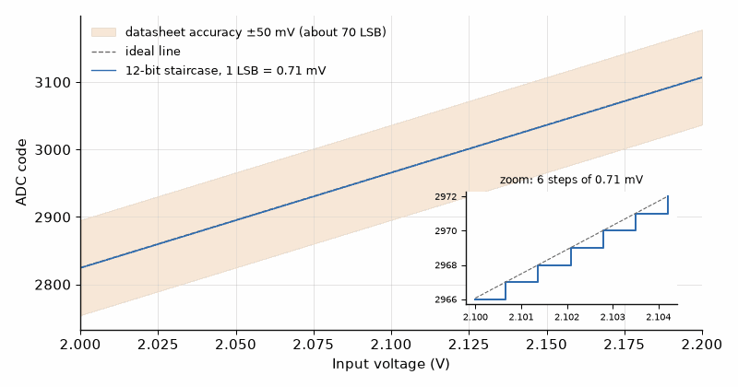
Figure 15.2 — Resolution is not accuracy. Each step of the ESP32-S3's 12-bit converter is about 0.71 mV, but the datasheet's ±50 mV error band is about seventy steps wide. Calibration moves the band; it does not shrink the steps.
From the Bench
Resolution is not accuracy. A meter specified as ±(0.5% of reading + 2 digits), reading 4.732 V on a range whose last digit is 1 mV, could be off by about ±26 mV, so only the first decimal place is fully trustworthy. In worst-case design, tolerances stack: check every part at whichever end of its range hurts most, not only at its nominal value.
On the Job
Test and production engineers live in this chapter. Their tools are calibrated bench instruments (a 6½-digit multimeter, a source-measure unit), test fixtures with spring-loaded pins, Python scripts that drive the instruments, and a calibration certificate for every instrument on the line. A typical task: write the end-of-line test for a smart sensor board, set pass and fail limits for every voltage and current from the component tolerances and the meter's own uncertainty, calibrate each board's ADC against a reference voltage and store the correction in its memory, and then study why 2 % of boards fail one test when the limits said 0.1 % should.

Practice Problems
- State the number of significant figures in each: 0.00250, 1200, 1.200 × 10³, 100.0, 0.0001.
- A resistance of 4.7 kΩ ±5% carries a current of 2.0 mA ±2%. Find the voltage across it and its percentage uncertainty.
- Two lengths are measured as 100.0 mm ± 0.2 mm and 99.5 mm ± 0.2 mm. Find their difference with its absolute and percentage uncertainty, and comment on the result.
- A 4½-digit multimeter with a specification of ±(0.05% of reading + 2 counts) is used on its 20 V range, where the last digit represents 1 mV. Find the total uncertainty when measuring 10.000 V, and again when measuring 0.100 V. Express each as a percentage of the reading.
- A 12-bit ADC with a 0 to 2.9 V input range monitors a 12 V lead-acid battery, which reaches 14.4 V while charging, through a divider of 47 kΩ (top) and 10 kΩ (bottom). Find the pin voltage at 14.4 V, the battery voltage per ADC count, and the battery-voltage error caused by a ±50 mV error at the pin.

What You’ll Actually Use
Everyday working tools
- Reading meter and component tolerance specifications.
- Rounding to what the measurement supports.
- Worst-case thinking about tolerance.
- Resolution versus accuracy for any ADC reading, and a one-point check against a multimeter.
Mostly for exams and deeper study
- Formal propagation of uncertainty in quadrature.
- Statistical definitions such as standard deviation and confidence intervals.

Chapter 16 — Algebra for Circuit Analysis
Most circuit problems are not hard because of physics. They are hard because someone solved for the wrong variable on line two. An engineer who can rearrange a formula quickly and check it with units will beat a slower one with a fancier simulator on most days.
Where you meet this: Choosing a resistor for a target gain, solving a divider for an unknown, picking a time constant, and checking a simulator's output.
Circuit analysis produces equations, and equations must be rearranged. The algebra involved is not difficult, but a few specific manipulations recur so often in electrical engineering that they are worth practicing until they are automatic — because an engineer who has to stop and think about them loses the thread of the circuit while doing so.

16.1 Rearranging for Any Variable
Ohm's law, V = IR, is three formulas in one. Solving for each in turn gives I = V/R and R = V/I. Every constitutive relation in this series works the same way, and you should be able to move between forms without hesitation.
The general procedure is to isolate the target variable by applying inverse operations to both sides, working outward from the target. What makes engineering formulas occasionally awkward is that the target often appears inside a reciprocal, inside a square root, or in more than one place at once.
Worked Example 16.1
The parallel resistance of two resistors is 1/R = 1/R₁ + 1/R₂. Given R and R₁, solve for R₂.
Start by isolating the term containing R₂:
1/R₂ = 1/R − 1/R₁
Combine the right-hand side over a common denominator:
1/R₂ = (R₁ − R)/(R·R₁)
Now invert both sides — and this is the step people rush:
R₂ = (R·R₁)/(R₁ − R)
Inverting both sides of an equation is legitimate provided neither side is zero, but note that you must invert each side as a whole. A frequent error is to invert term by term, turning 1/R − 1/R₁ into R − R₁, which is wrong. The reciprocal of a difference is not the difference of the reciprocals.
Check the result: if R₁ = R, the denominator vanishes and R₂ is infinite, which is correct — if the parallel combination already equals one of the resistors, the other must be an open circuit.
Common Misconception
The reciprocal of a sum is not the sum of the reciprocals. 1/(a + b) ≠ 1/a + 1/b. This is the single most common algebraic error in parallel-impedance work, and it is worth testing yourself on numbers once: 1/(2 + 2) = 0.25, while 1/2 + 1/2 = 1. The two are not close. The parallel-resistance formula is stated as 1/R = 1/R₁ + 1/R₂ precisely because it is the reciprocals that add, not the resistances.

16.2 The Product-Over-Sum Shortcut
For exactly two resistors in parallel, the formula above rearranges to a form worth memorizing:
R = R₁R₂ / (R₁ + R₂)
This is faster than the reciprocal form for hand calculation, and it generalizes to any two impedances in parallel, which is why it recurs constantly in later books. Its limitation is that it applies to exactly two elements. For three or more you must either use the reciprocal form or apply product-over-sum repeatedly, combining two at a time.
Two special cases are worth having at your fingertips. Two equal resistors in parallel give half the value. A resistor in parallel with one ten times larger gives approximately 91% of the smaller value — near enough to the smaller value that in a first-pass estimate the larger one can often be ignored entirely.

16.3 Ratios, Dividers, and Fractions
The voltage divider is the most-used formula in electronics, and it is pure algebra:
V_out = V_in · R₂/(R₁ + R₂)
What makes it worth dwelling on is the structure: the output is the input scaled by a dimensionless ratio between zero and one. Recognizing this shape lets you read a divider off a schematic without writing anything down. If the two resistors are equal, the output is half the input. If R₂ is nine times R₁, the output is nine-tenths of the input.
The current divider has the complementary structure, and the thing to notice is that the resistances swap:
I₁ = I_total · R₂/(R₁ + R₂)
Current through R₁ is proportional to the other resistance. This is not a typographical accident — current preferentially takes the path of lower resistance, so the branch current is larger when its own resistance is smaller, which requires the opposite resistance in the numerator.
Key Idea
Voltage divides in proportion to resistance; current divides in inverse proportion. The voltage-divider numerator is the resistance you are measuring across. The current-divider numerator is the other resistance. Mixing these up is the most common error in first-year circuit analysis, and the check is always the limiting case: as one resistance goes to zero, does the formula give what physics demands?

16.4 Quadratics and Where They Come From
Quadratic equations appear in circuit work whenever power is involved, since power is proportional to the square of voltage or current, and whenever a second-order system's characteristic equation is written down. The solution is the familiar formula:
x = [−b ± √(b² − 4ac)] / 2a
The discriminant b² − 4ac carries the physical meaning. Positive discriminant gives two distinct real roots — in a second-order circuit, the overdamped case. Zero gives one repeated root, the critically damped case. Negative gives two complex conjugate roots, the underdamped case, which oscillates. Chapters 21 and 22 make the last of these tractable; for now, note only that a negative discriminant is not an error but a signal that the system rings.
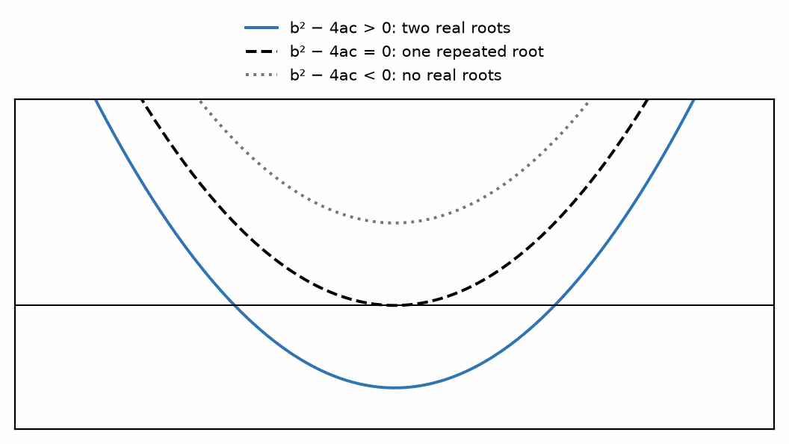
Figure 16.1 — The sign of the discriminant sets the number of real roots of a quadratic.

16.5 Approximations Worth Knowing
Engineers approximate constantly, and two approximations do most of the work. The first is the binomial approximation: for small x,
(1 + x)ⁿ ≈ 1 + nx
So √(1 + x) ≈ 1 + x/2 and 1/(1 + x) ≈ 1 − x when x is small. "Small" here means roughly below 0.1, where the error stays under about 1%.
The second is the observation that when two quantities differ greatly in size, the smaller can often be dropped. In R₁ + R₂ with R₂ a hundred times R₁, dropping R₁ costs 1%. Whether 1% matters depends on the tolerance of the components, which is exactly the kind of judgment Chapter 15 was preparing you to make: there is no point computing to 0.01% with 5% resistors.
From the Bench
Before trusting a rearranged formula, test it with numbers you can do in your head: set R1 = R2 and see whether a divider gives exactly half. Limits are cheap tests too. What happens when a resistor goes to zero, or to infinity? If the answer is absurd, the algebra is wrong.

Practice Problems
- Solve V = IR for R, and evaluate for V = 3.3 V and I = 150 µA.
- Three resistors of 1 kΩ, 2 kΩ, and 3 kΩ are connected in parallel. Find the equivalent resistance, first with the reciprocal formula and then by applying product-over-sum twice, and confirm the two agree.
- A voltage divider must produce 2.5 V from a 9 V supply. If R₂ = 10 kΩ, find R₁.
- Use the binomial approximation to estimate √(1.06) and 1/0.98, then compare each with the exact value and state the percentage error.

What You’ll Actually Use
Everyday working tools
- Rearranging formulas for any variable.
- Checking results with units and limiting cases.
- The quadratic formula, occasionally.
Mostly for exams and deeper study
- Classifying roots by the discriminant.
- Formal proofs of algebraic identities.

Chapter 17 — Systems of Linear Equations
A circuit with three loops hands you three equations in three unknowns, and nature insists that all three hold at once. This chapter is the bookkeeping that makes nodal and mesh analysis mechanical. It is also what circuit simulators do: they solve exactly these systems, only with thousands of unknowns.
Where you meet this: Nodal and mesh analysis (Chapters 28 and 29), SPICE simulators, and calibration routines that fit several unknowns at once.
Nodal and mesh analysis, introduced in Part III, turn any resistive circuit into a system of simultaneous linear equations. The circuit theory is the interesting part; solving the system is mechanical. This chapter supplies the mechanics so that Part III can concentrate on the circuits.

17.1 What a Linear System Is
A linear equation in several unknowns contains those unknowns only to the first power, multiplied by constants and added. No squares, no products of unknowns, no unknowns inside functions. Two equations in two unknowns look like this:
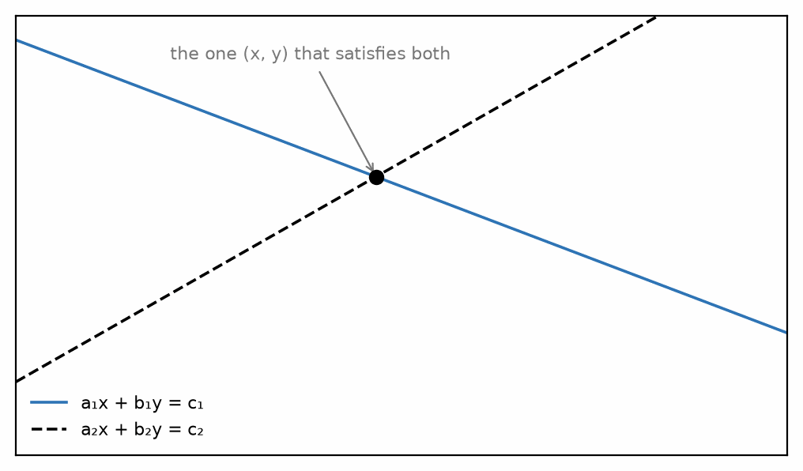
Figure 17.1 — Two linear equations in two unknowns: each is a line, and the solution is where they cross.
a₁x + b₁y = c₁ and a₂x + b₂y = c₂
Circuit equations from Kirchhoff's laws are always of this form when the components are resistors and the sources are independent, which is why the systematic methods work at all. Nonlinear elements — diodes, transistors — break linearity and require entirely different techniques, taken up later in the series.

17.2 Substitution and Elimination
For two equations, substitution is usually quickest: solve one equation for one unknown, put that expression into the other, solve the resulting single-variable equation, then back-substitute.
Elimination scales better. Multiply the equations by whatever constants make the coefficients of one unknown equal in magnitude, then add or subtract to eliminate it. For three or more equations, elimination performed systematically becomes Gaussian elimination, which is what every circuit simulator does internally.
Worked Example 17.1
Solve the system: 3x + 2y = 16 and 5x − y = 9.
Elimination is convenient here because y has a coefficient of −1 in the second equation. Multiply the second equation by 2:
10x − 2y = 18
Add this to the first equation, and the y terms cancel:
(3x + 10x) + (2y − 2y) = 16 + 18, so 13x = 34, giving x = 2.6154.
Back-substitute into the second original equation:
5(2.6154) − y = 9, so 13.0769 − y = 9, giving y = 4.0769.
Always verify in the equation you did not use for back-substitution. First equation: 3(2.6154) + 2(4.0769) = 7.846 + 8.154 = 16.000. Correct.
That verification step costs ten seconds and catches arithmetic slips reliably. In circuit work, where a sign error in one Kirchhoff equation propagates into every node voltage, it is time exceptionally well spent.

17.3 Determinants and Cramer's Rule
For a two-by-two system, the determinant is defined as
D = a₁b₂ − a₂b₁
and Cramer's rule gives the solution directly: x = Dₓ/D and y = D_y/D, where Dₓ is the determinant formed by replacing the x-coefficient column with the constants, and D_y likewise for y.
Cramer's rule is not the fastest method for large systems — its cost grows factorially, which makes it useless beyond about three equations — but for two or three unknowns it is quick, mechanical, and hard to get lost in. Its real value is diagnostic. If D = 0, the system has no unique solution, and in a circuit context that almost always means a modeling error: two ideal voltage sources placed in parallel with different values, an ideal current source left in series with an open circuit, or a floating section with no reference to ground.
Key Idea
A zero determinant is a physics error, not an arithmetic one. When the determinant of a circuit's node equations vanishes, treat it as a warning to examine the circuit model and equations carefully, not only the algebra — the equations may be redundant (as in a genuinely degenerate mathematical system), but in circuit analysis a vanishing determinant is most often a sign of something physically impossible, such as a node with no DC path to the reference node.

17.4 Matrix Form and What Comes Later
Any linear system can be written compactly as a matrix equation. For circuit work the standard arrangement is
G·V = I
where G is the conductance matrix, V is the vector of unknown node voltages, and I is the vector of source currents. This is exactly the form SPICE assembles and solves at every operating point, and recognizing it now will make circuit simulators such as LTspice and ngspice far less mysterious when you meet them.
The conductance matrix has a pleasant structure that makes it easy to write down by inspection: each diagonal entry is the sum of all conductances connected to that node, and each off-diagonal entry is the negative of the conductance directly between the two nodes it indexes. That structure is not a coincidence — it is Kirchhoff's current law, written in matrix form.
From the Bench
For more than three unknowns, let a tool do the arithmetic: a calculator's matrix mode, numpy.linalg.solve in Python, or a SPICE run. Your job is to set up the equations correctly and to check the answer, by substituting it back or by confirming that the currents at one node really do sum to zero.

Practice Problems
- Solve by substitution: 2x + 3y = 12 and x − y = 1.
- Solve by elimination: 4a + 5b = 22 and 3a − 2b = 5.
- Evaluate the determinant of the system 6x + 2y = 10, 3x + y = 5, and explain what your result implies about the solution.
- Two mesh equations for a circuit are 100I₁ − 40I₂ = 5 and −40I₁ + 90I₂ = 0. Solve for both currents using Cramer's rule, and state the physical meaning of the sign of each result.

What You’ll Actually Use
Everyday working tools
- Writing equations from a circuit.
- Solving 2 × 2 and 3 × 3 systems by hand or by calculator.
- Back-substitution as a check.
Mostly for exams and deeper study
- Determinants and Cramer's rule for larger systems by hand.
- The conditions for no solution or infinitely many.

Chapter 18 — Functions, Graphs, and Limiting Behavior
A datasheet's graphs often tell you more than its tables: how a part behaves hot, cold, heavily loaded, or pushed past its limits. Engineers read graphs faster than equations, and this chapter is about reading them well, especially at the ends, where a curve flattens out or runs away.
Where you meet this: Datasheet curves (capacitance against voltage, gain against frequency, efficiency against load), oscilloscope traces, and Bode plots.
Engineers read graphs more often than they read equations. A frequency response, a transfer characteristic, a load line — each is a function drawn rather than written, and the skill being exercised is the ability to extract behavior from shape. This chapter is about that skill.

18.1 Functions as Input-Output Relations
A function assigns exactly one output to each input. In circuit terms, the input is often a frequency or an input voltage, and the output is a gain or an output voltage. The notation H(f) means "the value of H at frequency f" — it is not H multiplied by f, a confusion that causes real difficulty when the same letters are used for both quantities and functions.

18.2 Linear Functions and Straight Lines
A linear function has the form y = mx + c, with m the slope and c the intercept. Ohm's law is linear through the origin, which is why an ohmic resistor plots as a straight line through (0,0) on a current-versus-voltage graph, with slope 1/R.
A load line is the same idea used in reverse. For a source of voltage V_s with internal resistance R_s driving an unknown element, Kirchhoff gives V = V_s − I·R_s: a straight line on the same axes as the device characteristic, with negative slope. Where the two curves cross is the operating point. This graphical technique is how transistor bias points were found before circuit simulators existed, and it remains the clearest way to understand what biasing actually means.

18.3 Asymptotes and Limiting Behavior
The fastest way to understand an unfamiliar transfer function is to ask what it does at the extremes. Consider the response of a simple low-pass filter:
H(f) = 1 / √(1 + (f/f_c)²)
At very low frequency, f/f_c is nearly zero, so the square root is nearly 1 and H ≈ 1: the filter passes the signal untouched. At very high frequency, the 1 becomes negligible next to (f/f_c)², so H ≈ f_c/f: the response falls in inverse proportion to frequency. At f = f_c exactly, H = 1/√2 ≈ 0.707, which is the definition of the corner frequency.
Three numbers — the low-frequency asymptote, the high-frequency asymptote, and the value at the corner — sketch the entire curve to engineering accuracy, without evaluating the function anywhere else. This is the habit worth building: probe the extremes first, fill in the middle only if you need to.
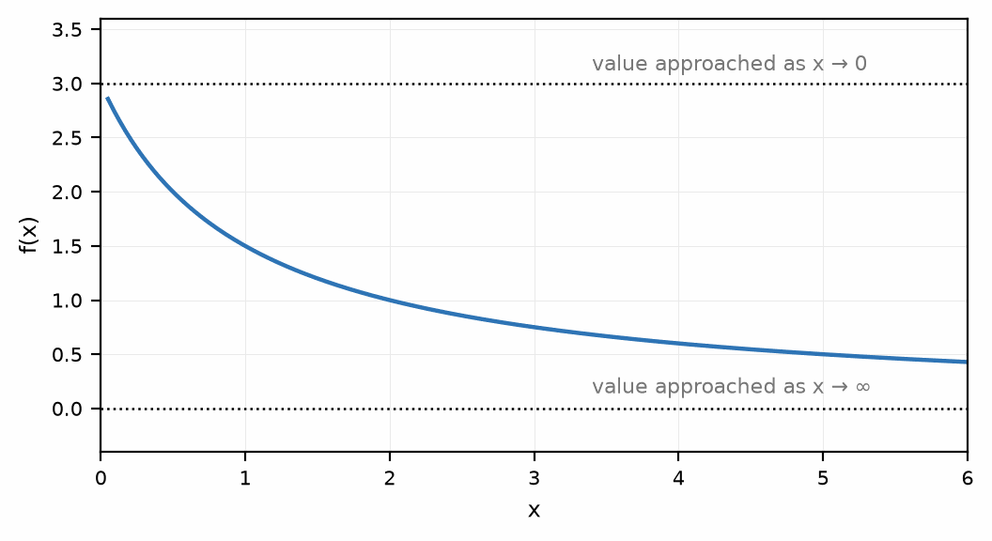
Figure 18.1 — Reading a function's limiting behavior: the value it approaches at each extreme.
Key Idea
Read a transfer function at its limits before you plot it. What happens as the variable goes to zero, and as it goes to infinity? Those two answers plus the behavior at the corner give you the shape. Everything else is detail.
Worked Example 18.1
A high-pass filter has transfer function H(f) = (f/f_c)/√(1+(f/f_c)²), with corner frequency f_c = 1.0 kHz. Find H at f = 100 Hz, f = 1.0 kHz, and f = 10 kHz, and state which asymptote each value sits closest to.
At f = 100 Hz: f/f_c = 0.1, so H = 0.1/√1.01 ≈ 0.0995 — close to the low-frequency asymptote H ≈ 0 (a high-pass filter blocks low frequencies). At f = 1.0 kHz (the corner): H = 1/√2 ≈ 0.707, matching the general −3 dB corner value exactly. At f = 10 kHz: H = 10/√101 ≈ 0.995 — close to the high-frequency asymptote H ≈ 1 (a high-pass filter passes high frequencies essentially unattenuated). The same three numbers — the low-frequency limit, the high-frequency limit, and the corner value — sketch this curve exactly as they did for the low-pass example above, only with the roles of the two asymptotes reversed.

18.4 Logarithmic Axes
Electrical engineering plots almost everything on logarithmic axes, for a reason that follows directly from Chapter 14: the quantities span many orders of magnitude, and a linear axis cannot show a microvolt and a volt on the same picture.
On log axes, a power-law relationship becomes a straight line, and the exponent becomes the slope. The high-frequency asymptote H ≈ f_c/f above is a power law with exponent −1, so on a log-log plot it is a straight line falling at a constant rate — the familiar 20 dB per decade rolloff. A second-order filter falls at exponent −2, giving 40 dB per decade. Reading the slope off a log-log plot tells you the order of the system directly, which is a genuinely useful diagnostic when looking at measured data.
Common Misconception
A logarithmic axis has no zero. It cannot: the logarithm of zero is undefined, tending to negative infinity. This surprises people the first time a plotting program refuses to display their data, or silently drops the DC point. It also means you cannot plot a signal that changes sign on a log axis without taking the magnitude first — which is exactly why frequency responses are conventionally plotted as magnitude and phase separately rather than as a single signed quantity.

18.5 A Straight Line Through Real Data: The Pressure Trend
A weather station's most useful number is not the air pressure but its slope. A falling barometer often means wind and rain are on the way, and the Met Office's shipping forecast puts names on the rate: a fall of 1.6 to 3.5 hPa in three hours is falling, 3.6 to 6.0 hPa is falling quickly, and more than 6.0 hPa is falling very rapidly. The slope of a straight line, Δy/Δx from Section 18.2, is the whole calculation.
Worked Example 18.2 — The Smart Weather Station's Forecast Arrow
Problem: A BME280 on the reader lab's weather station logs 1013.6 hPa at 06:00 and 1010.4 hPa at 09:00. Its absolute accuracy is ±1.0 hPa and its relative accuracy (the error between two readings) is ±0.12 hPa. Find the trend in hPa per hour, its uncertainty, and the shipping-forecast term.
Solution: Slope = Δp/Δt = (1010.4 − 1013.6)/3 = −3.2/3 ≈ −1.07 hPa/h. The absolute error is the same offset in both readings, so it cancels in the difference; only the relative accuracy counts. Two readings each good to ±0.12 hPa make the 3-hour change −3.2 ± 0.24 hPa, so the slope is −1.07 ± 0.08 hPa/h. A fall of 3.2 hPa in three hours is falling, close to the 3.6 hPa threshold of falling quickly; the station shows a down arrow. In practice the firmware fits a line through all 180 one-minute readings instead of using two points, which averages away the sensor's noise.
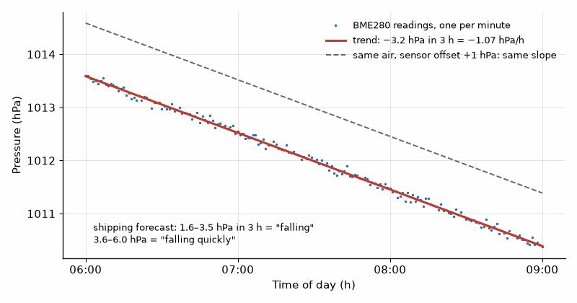
Figure 18.2 — The forecast is a slope. Three hours of readings fall 3.2 hPa, a trend of −1.07 hPa per hour; the sensor's ±1 hPa absolute error shifts the whole line, but only its ±0.12 hPa relative error affects the slope.
From the Bench
Check the axes before the curve. Datasheet plots often use log scales, show a 'typical' part at 25 °C, and hide their test conditions in small print under the title. A part that looks comfortable at the typical point can be marginal at your temperature and supply voltage, which is why you design to the minimum and maximum tables, not to the typical graphs.

Practice Problems
- A resistor obeys Ohm's law. Sketch its current-versus-voltage characteristic for R = 2 kΩ, and state the slope in siemens.
- For the low-pass response H(f) = 1/√(1 + (f/f_c)²) with f_c = 1 kHz, evaluate H at 100 Hz, 1 kHz, and 10 kHz.
- A 12 V source with 50 Ω internal resistance drives a load. Write the load-line equation and find the current when the load voltage is 8 V.
- A measured response falls by a factor of 100 in magnitude when the frequency increases by a factor of 10. What is the slope on a log-log plot, what is the rolloff in dB per decade, and what order of filter does this suggest?
- A weather station logs 1016.4 hPa at 18:00 and 1012.6 hPa at 21:00. Find the slope in hPa per hour, and the worst-case uncertainty in the three-hour change if each reading has a relative accuracy of ±0.12 hPa. Does the sensor's ±1.0 hPa absolute accuracy matter here?

What You’ll Actually Use
Everyday working tools
- Reading linear and logarithmic axes.
- Asymptotes and limiting behavior for quick estimates.
- A slope as a trend: change per hour from readings taken some time apart.
Mostly for exams and deeper study
- Formal limits and continuity.

Chapter 19 — Exponentials, Logarithms, and the Decibel
The power reaching your phone from a cell tower can change by a factor of a million or more as you walk from a window to a basement. A linear scale is not much use over that range, so decibels let engineers add ratios without carrying six extra zeros. The exponential function, the other half of this chapter, describes how every capacitor charges.
Where you meet this: Signal strength in dBm, amplifier gain and filter attenuation in dB, audio levels, RC charging curves, and battery discharge.
The exponential function describes every natural charging and discharging process in electronics, and the logarithm is its inverse. Between them they underpin the decibel, which is the unit electrical engineers use for almost every ratio they care about. This chapter builds all three.

19.1 The Exponential Function
The function eˣ has the defining property that its rate of change equals its own value. Nothing else does this, and that single property is why it appears in every first-order circuit: a capacitor discharging through a resistor loses charge at a rate proportional to the charge remaining, which is precisely the condition that produces an exponential.
The standard forms are decay and growth toward a limit:
v(t) = V₀·e^(−t/τ) and v(t) = V_f·(1 − e^(−t/τ))
where τ is the time constant, equal to RC for a resistor-capacitor pair and L/R for a resistor-inductor pair — both of which you verified dimensionally in Chapter 13.
The numbers worth memorizing are these: after one time constant, a decaying quantity has fallen to 37% of its initial value, and a rising one has reached 63% of its final value. After three time constants, 95%. After five, 99.3%, which is why "five time constants" is the conventional engineering definition of settled. With the 47 kΩ and 10 µF values in Worked Example 19.1, τ is 0.47 s and five τ is 2.35 s. Replacing 47 kΩ with 4.7 kΩ by a prefix slip makes that delay 0.047 s; a debounce or timing circuit would then behave on a different schedule.
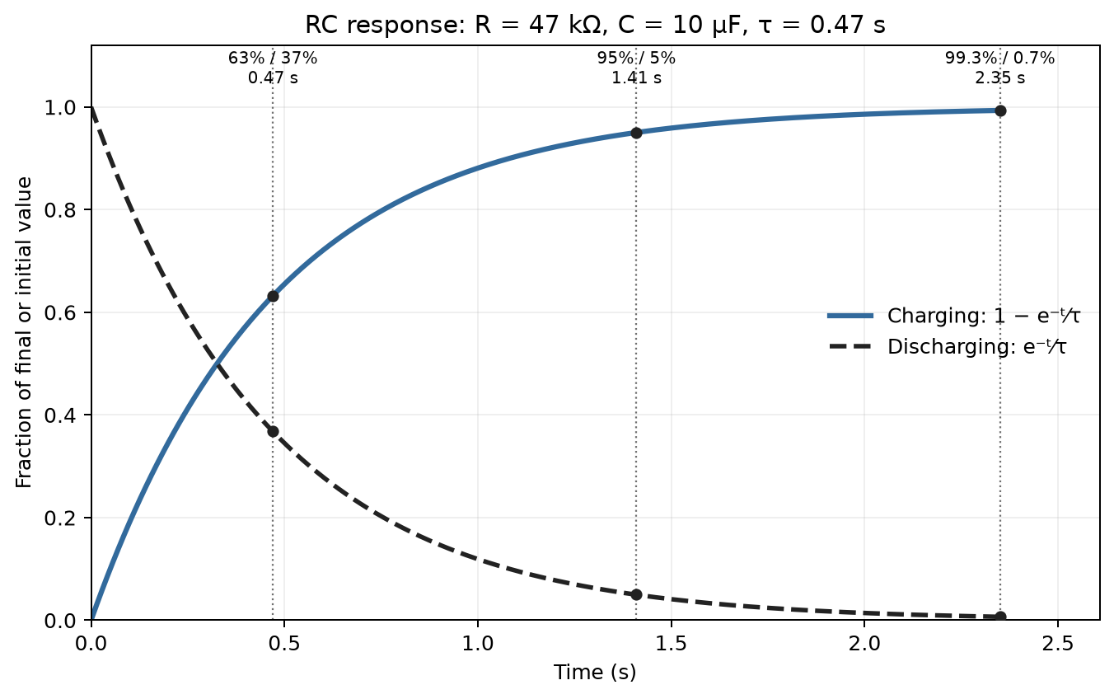
Figure 19.1 — Charging and discharging in the 47 kΩ, 10 µF example (τ = 0.47 s), marked at 0.47 s, 1.41 s, and 2.35 s.
Worked Example 19.1
A 10 µF capacitor charges through a 47 kΩ resistor toward 5 V. How long until it reaches 4 V?
First the time constant: τ = RC = (47 × 10³)(10 × 10⁻⁶) = 0.47 s. Note the prefix cancellation from Chapter 14 — kilo times micro is milli, so 47 × 10 = 470 ms directly.
The charging equation: v(t) = 5(1 − e^(−t/τ)).
Set v = 4 and solve. Divide by 5: 0.8 = 1 − e^(−t/τ), so e^(−t/τ) = 0.2.
Take natural logarithms of both sides: −t/τ = ln(0.2) = −1.609.
So t = 1.609τ = 1.609 × 0.47 = 0.756 s.
Reasonableness check: 4 V is 80% of the final value, which should fall between one time constant (63%) and three (95%), and closer to the lower end. It does — 1.6 time constants. That kind of rough check catches sign errors in the logarithm, which are easy to make and otherwise invisible.

19.2 Logarithms
The logarithm answers the question "to what power?" If 10³ = 1000, then log₁₀(1000) = 3. Two bases matter in engineering: base 10, written log, and base e ≈ 2.71828, written ln. Exponential circuit behavior requires ln; decibels and log-frequency axes use log.
The three properties that do all the work convert multiplication into addition, division into subtraction, and powers into multiplication:
log(ab) = log a + log b; log(a/b) = log a − log b; log(aⁿ) = n·log a
The first of these is the entire reason decibels exist. Cascaded stages multiply their gains; expressed logarithmically, they add. A chain of amplifiers and losses becomes a sum you can do in your head instead of a product you cannot. Chain three amplifier stages with power gains of 5, 8, and 2, and the combination's overall gain is the plain product of the three: 5 × 8 × 2 = 80. Manageable for three stages — but chain together ten, mixing amplifying stages with lossy cables and attenuators whose gains are fractions less than 1, and tracking the running product by hand grows unwieldy and easy to get wrong. Converted to decibels, though, the same three stages become 10 log₁₀(5) ≈ 7 dB, 10 log₁₀(8) ≈ 9 dB, and 10 log₁₀(2) ≈ 3 dB, which add: 7 + 9 + 3 = 19 dB — and 10 log₁₀(80) ≈ 19 dB confirms it.

19.3 The Decibel
The decibel expresses a power ratio logarithmically:
G(dB) = 10·log₁₀(P_out/P_in)
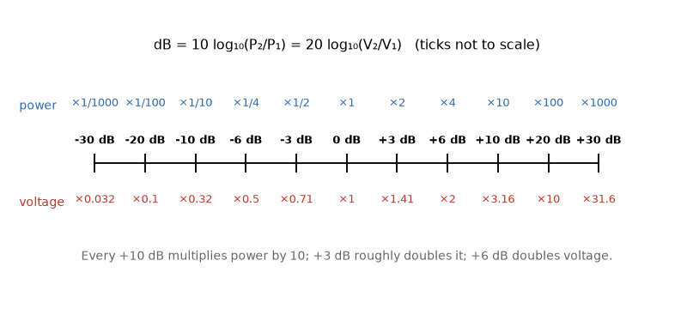
Figure 19.2 — A decibel cheat sheet worth memorizing: +3 dB is about double the power, +10 dB is ten times, and because power goes as voltage squared, +6 dB doubles the voltage.
For voltage or current ratios, the factor is 20 rather than 10, because power is proportional to the square of voltage and the square becomes a factor of two in front of the logarithm — strictly, this equivalence between the voltage-ratio and power-ratio forms of the decibel holds only when input and output are measured across the same impedance, which is the common case this book assumes unless stated otherwise:
G(dB) = 20·log₁₀(V_out/V_in)
The values worth memorizing are few. 3 dB is a factor of 2 in power. 6 dB is a factor of 2 in voltage. 10 dB is a factor of 10 in power. 20 dB is a factor of 10 in voltage. Negative values are the reciprocals: −3 dB is half the power, which is why the corner frequency of a filter — where the response is 1/√2 in voltage, and therefore half in power — is called the 3 dB point.
Key Idea
Use 10·log for power ratios and 20·log for voltage ratios. The factor of two comes from P ∝ V², not from a different definition of the decibel. Applying 20·log to a power ratio, or 10·log to a voltage ratio, produces an answer wrong by a factor of two in dB — which is a factor of two in the exponent, and therefore an enormous error in the underlying quantity.
The decibel is a ratio and therefore dimensionless. To express an absolute quantity, a reference must be specified, and it is written into the unit: dBm is decibels relative to one milliwatt, dBV relative to one volt, dBµV relative to one microvolt. A power of 1 mW is 0 dBm; 1 W is +30 dBm; 1 µW is −30 dBm. These absolute forms are used constantly in RF work, and a later book in this series depends heavily on fluency with them.
Common Misconception
Decibel values add only when they are ratios. You may add gains in dB along a signal chain because the underlying gains multiply. You may not add two dBm values: adding +10 dBm to +10 dBm does not give +20 dBm, because that would be adding absolute powers, not ratios. Two 10 mW signals combine to 20 mW, which is +13 dBm — a 3 dB increase, because doubling power is always 3 dB regardless of the starting level.
From the Bench
Keep dB and dBm apart. A dB value is a ratio; dBm is an absolute power referred to 1 mW, so 0 dBm is 1 mW, +30 dBm is 1 W and −30 dBm is 1 µW. You can add dB to dBm (a 20 dB amplifier turns −40 dBm into −20 dBm), but two dBm values don't add: two uncorrelated −20 dBm signals together make −17 dBm, not −40.

Practice Problems
- A 100 nF capacitor discharges through 22 kΩ from an initial 9 V. Find the time constant, and the voltage after 5 ms.
- Express the following power ratios in dB: 2, 10, 100, 0.5, 1000.
- An amplifier has a voltage gain of 250. Express this in dB. If it is followed by a 6 dB attenuator, what is the overall gain in dB, and as a plain voltage ratio?
- A receiver input is −95 dBm. Convert this to watts. If an antenna and cable together provide a gain of +12 dB, what is the input power in dBm and in watts at the far end?

What You’ll Actually Use
Everyday working tools
- The 3, 6, 10 and 20 dB rules.
- dBm for absolute power.
- Time-constant rules: 63% after one τ, about 99% after five.
Mostly for exams and deeper study
- Change-of-base and other log identities beyond the basics.
- Deriving the exponential from its differential equation.

Chapter 20 — Trigonometry and the Sinusoid
The wall socket delivers a sine wave because a generator turns at constant speed, and a coil rotating in a magnetic field produces a sine, not a square or a triangle. Nearly every signal you will meet can be built from sines, so this chapter is less about triangles than about waves.
Where you meet this: Mains power (60 Hz in North America, 50 Hz in most of the world), audio tones, clock jitter, and every phase measurement on an oscilloscope.
Alternating current is sinusoidal, and Fourier analysis shows that practically every signal an engineer meets, from a square clock to a voice, can be built as a sum of sinusoids; the later books in this series lean on that fact constantly. The sinusoid is therefore not one waveform among many; it is the waveform, and the trigonometry describing it is worth genuine fluency.

20.1 Angles, Degrees, and Radians
An angle in radians is the arc length subtended divided by the radius. A full circle is 2π radians, so 180° = π rad, and the conversion is a simple proportion. Radians are used throughout analysis because the calculus of trigonometric functions is clean only in radians — the derivative of sin x is cos x only when x is in radians, picking up an awkward factor of π/180 otherwise.
Degrees survive in practice because they are convenient for phase, where quarter and half cycles matter and 90° reads more naturally than π/2. Both appear constantly, sometimes in the same equation, and the single most common cause of an inexplicably wrong answer in phase calculations is a calculator left in the wrong angular mode.

20.2 The Sinusoid and Its Parameters
A general sinusoid is written
v(t) = V_m·sin(ωt + φ)
with three independent parameters. V_m is the amplitude, the peak departure from zero. ω is the angular frequency in radians per second, related to ordinary frequency by ω = 2πf and to the period by ω = 2π/T. φ is the phase, which shifts the waveform along the time axis; a positive φ advances the waveform, moving it earlier.
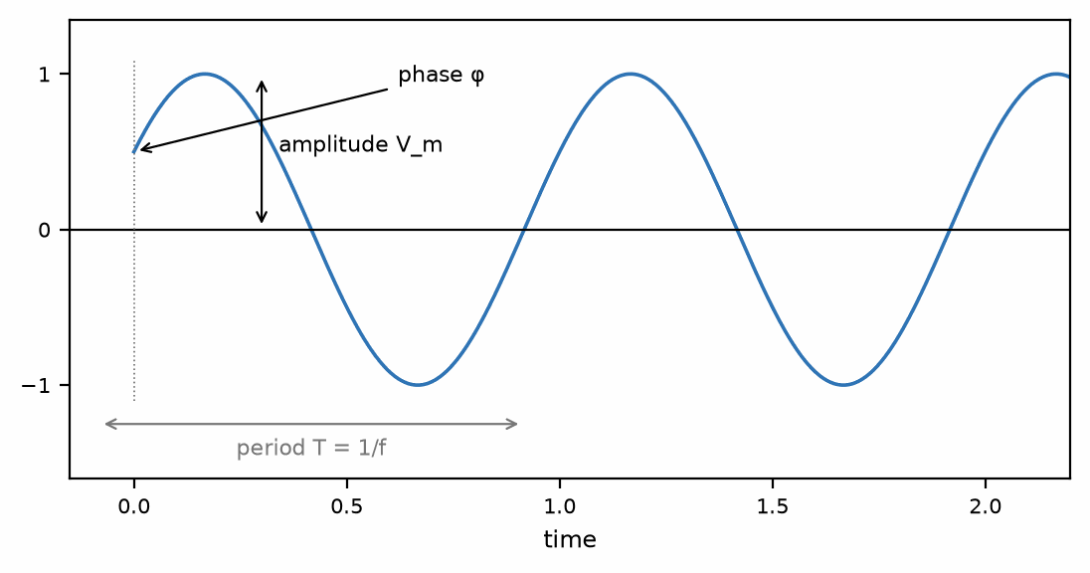
Figure 20.1 — A sinusoid's amplitude, period, and phase, shown on a single cycle.
Only these three numbers are needed. Two sinusoids of the same frequency can differ only in amplitude and phase, and that observation is the seed of the entire phasor method developed in Chapter 23.

20.3 Sine, Cosine, and the Relationship Between Them
Cosine is sine shifted by a quarter cycle: cos θ = sin(θ + 90°). Which one you use as the reference is arbitrary, and different textbooks choose differently, but you must be consistent within a single problem. This series follows the common convention of taking cosine as the reference for phasor work, for reasons that Chapter 22 makes clear.
The identities that earn their keep in circuit analysis are these:
- Pythagorean: sin²θ + cos²θ = 1. This is what turns a resistance and a reactance into a magnitude, and it is why impedance magnitudes involve a square root of a sum of squares.
- Sum of angles: sin(A + B) = sin A cos B + cos A sin B. This is the identity behind mixing and modulation — multiply two sinusoids and you get sum and difference frequencies, which is the foundation of every radio receiver.
- Double angle: sin 2θ = 2 sin θ cos θ, and cos 2θ = 1 − 2sin²θ. The second form explains why the instantaneous power in an AC circuit oscillates at twice the signal frequency.
Worked Example 20.1
A voltage is described by v(t) = 15·sin(377t + 30°). Find the amplitude, angular frequency, ordinary frequency, period, phase, and the instantaneous value at t = 5 ms.
Amplitude: V_m = 15 V. Angular frequency: ω = 377 rad/s.
Frequency: f = ω/2π = 377/6.283 = 60.0 Hz. This is the North American mains frequency, and 377 is a number you will meet often enough to recognize on sight.
Period: T = 1/f = 16.67 ms. Phase: φ = 30°, meaning the waveform leads a pure sine by one-twelfth of a cycle.
At t = 5 ms, the argument is ωt + φ = (377)(0.005) + 30° = 1.885 rad + 30°.
The mixed units must be reconciled. Converting 1.885 rad to degrees: 1.885 × 180/π = 108.0°. So the total argument is 108.0° + 30° = 138.0°.
Therefore v = 15·sin(138.0°) = 15 × 0.669 = 10.0 V.
That reconciliation step is where errors happen. The ωt term is inherently in radians because ω is in radians per second; the phase was given in degrees. One must be converted before they can be added, and no calculator will warn you if you skip it.

20.4 Average and RMS Values
The average value of a sinusoid over a whole number of cycles is zero, since it spends as much time positive as negative. That makes the plain average useless for describing AC magnitude, and something better is needed.
The root-mean-square value is defined as the square root of the mean of the square. Squaring makes everything positive, so nothing cancels, and the definition is chosen so that the RMS value of an AC waveform is exactly the DC value that would dissipate the same power in a resistor. For a sinusoid the result is
V_rms = V_m/√2 ≈ 0.707·V_m
When a supply is described as 230 V AC, that is an RMS figure; its peak is 325 V, and the peak-to-peak swing is 650 V. Insulation must survive the peak while power calculations use the RMS, and confusing the two has consequences at both ends — under-specified insulation on one side, power estimates wrong by a factor of two on the other.
Key Idea
RMS is defined by equal heating, not by averaging. V_rms = V_m/√2 holds for sinusoids only. A square wave has V_rms = V_m; a triangle wave has V_m/√3. Applying the 0.707 factor to a non-sinusoidal waveform is wrong, and the error grows with how far the waveform departs from a sinusoid.
From the Bench
To measure phase on a scope, trigger on one channel, use matched probes and settings on both, and time the gap between zero crossings: phase = 360° × Δt / T. Probe compensation and unequal cable lengths add phase shifts of their own, which matter more as frequency rises.

Practice Problems
- Convert to radians: 45°, 90°, 120°, 270°. Convert to degrees: π/6, 2π/3, 3π/2 rad.
- A current is i(t) = 2.5·sin(2π·1000·t − 45°) A. State its amplitude, frequency, period, and phase, and find its value at t = 0.
- A sinusoidal voltage has a peak-to-peak value of 10 V. Find its amplitude and its RMS value.
- Two sinusoids of the same frequency have amplitudes 3 V and 4 V and are 90° apart in phase. Use the Pythagorean identity to find the amplitude of their sum, and explain why you may not add 3 and 4.

What You’ll Actually Use
Everyday working tools
- Amplitude, frequency, period and phase: v(t) = A sin(ωt + φ).
- ω = 2πf.
- Phase from a measured time delay.
Mostly for exams and deeper study
- Trigonometric identities beyond the basic few.

Chapter 21 — Complex Numbers
Engineers use 'imaginary' numbers to calculate very real things, such as how hot a motor runs or how much current a building's wiring really carries. The trick is that one complex number holds an amplitude and a phase at once, which is exactly what an AC signal needs.
Where you meet this: Impedance, filter design, the Smith chart (Chapter 37), S-parameters, and the I/Q signals of software radio in Book 5.
Two AC voltages of the same frequency — say 5.0 V peak with no phase shift, and 3.0 V peak shifted 90° ahead of it — need to be added together, an entirely ordinary task, since real circuits combine signals like this all the time. Try to add them as plain numbers, though, and you get the wrong answer: the two waveforms peak at different moments, so treating it as “5 plus 3” overstates the combined peak, which actually lands between 5.0 V and 8.0 V (it is 5.83 V). Written out in full using trigonometry, finding exactly where means grinding through a sum-of-cosines identity every single time — slow, easy to fumble, and disproportionate to how ordinary the task feels.
The real difficulty is that a plain number only holds one piece of information, and a sinusoid of fixed frequency carries two: a magnitude and a phase. No single point on an ordinary number line can represent both a size and an angle at once.
The way around it is to stop treating magnitude and phase as two separate numbers to juggle, and instead treat the pair of them as a single object — a point in a flat plane, with one coordinate carrying what an ordinary number would and a second, perpendicular coordinate carrying the rest. Adding two of these objects is then no harder than adding two points: add the corresponding coordinates.
Picture the 5.0 V, no-shift signal as the point (5, 0), and the 3.0 V, 90°-ahead signal as the point (0, 3) — phase 90° landing entirely on the second, perpendicular coordinate. Add the pairs directly, coordinate by coordinate: (5, 0) + (0, 3) = (5, 3). That single addition already contains the answer a page of trigonometry would otherwise be needed to reach — §21.4 below shows exactly how to turn a point like (5, 3) back into the size and angle of the combined signal.
That two-coordinate object, built exactly to make this kind of addition trivial, is what a complex number actually is. Complex numbers have an unfortunate name. There is nothing complicated about them, and nothing imaginary about the imaginary part — both terms are historical accidents from a period when mathematicians distrusted the objects they had newly invented. What a complex number actually is, for our purposes, is a way of carrying two related pieces of information as a single quantity, and then doing arithmetic on the pair at once.
For electrical engineering the two pieces of information are magnitude and phase. Chapter 20 established that two sinusoids of the same frequency can differ only in those two respects. Complex numbers are the tool that lets us manipulate both at once, which is why they took over AC analysis completely and never gave it back.

21.1 Why j and Not i
The imaginary unit is defined by j² = −1. Mathematicians write it i; electrical engineers write j, because i was already taken by current and reusing it would be intolerable. Every textbook in this series uses j. No other difference is implied.
The defining property is worth stating plainly rather than treating as a mystery. There is no real number whose square is negative, so j is not a real number. That is the entire content of the word "imaginary" — it means "not on the real number line," not "fictitious." The number j is exactly as real, in the ordinary sense, as the number 3; it lives in a different direction.

21.2 Rectangular Form
A complex number in rectangular form is written z = a + jb, where a is the real part and b the imaginary part. Both a and b are ordinary real numbers. The whole object can be pictured as a point in a plane, with a measured along the horizontal axis and b along the vertical — the complex plane, or Argand diagram.
That geometric picture is the useful one. A complex number is a point, or equivalently an arrow from the origin to that point. Its length is the magnitude and the angle it makes with the positive real axis is the phase, which connects directly to the sinusoid parameters of Chapter 20.
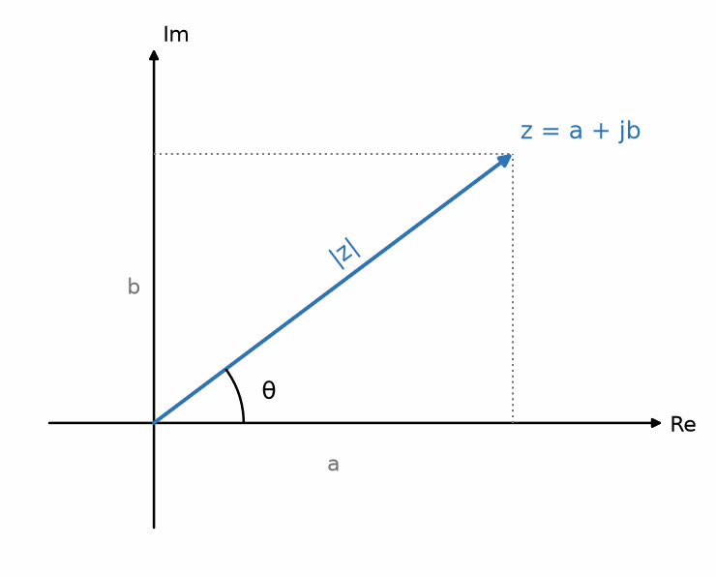
Figure 21.1 — The Argand diagram: a complex number as a point, with magnitude and angle.
Addition and subtraction in rectangular form are componentwise, exactly like adding vectors:
(a + jb) + (c + jd) = (a + c) + j(b + d)
Multiplication follows the ordinary distributive law, with the single extra rule that j² = −1:
(a + jb)(c + jd) = (ac − bd) + j(ad + bc)
The cross terms produce the imaginary part; the j² in the product of the two imaginary parts flips a sign and lands in the real part. There is nothing to memorize here beyond j² = −1 — the rest is expansion of brackets.

21.3 The Complex Conjugate and Division
The conjugate of z = a + jb, written z*, is a − jb: the same number with the sign of the imaginary part flipped, or geometrically, the point reflected across the real axis.
Its usefulness comes from one fact: a number times its conjugate is always real.
z·z* = (a + jb)(a − jb) = a² + b²
This is what makes division possible. To divide by a complex number, multiply top and bottom by the conjugate of the denominator; the denominator becomes real, and the division reduces to dividing by an ordinary number.
Worked Example 21.1
Evaluate (3 + j4)/(1 − j2).
Multiply numerator and denominator by the conjugate of the denominator, which is (1 + j2):
Numerator: (3 + j4)(1 + j2) = 3 + j6 + j4 + j²8 = 3 + j10 − 8 = −5 + j10.
Denominator: (1 − j2)(1 + j2) = 1 + 4 = 5.
So the quotient is (−5 + j10)/5 = −1 + j2.
Check by multiplying back: (−1 + j2)(1 − j2) = −1 + j2 + j2 − j²4 = −1 + j4 + 4 = 3 + j4. Correct.
Note that the denominator became 1² + 2² = 5 without any cross terms — that is the conjugate doing its work, and it always happens. If your denominator still has a j in it after multiplying by the conjugate, you have made an arithmetic error.

21.4 Polar Form
The same number can be described by its magnitude and angle instead of its two components. The magnitude is
|z| = √(a² + b²)
which is the Pythagorean identity from Chapter 20 doing exactly the job advertised, and the angle is
θ = arctan(b/a)
with a crucial caveat: the arctangent function returns values only between −90° and +90°, so it cannot distinguish the second quadrant from the fourth, or the third from the first. You must look at the signs of a and b to place the number in the correct quadrant and adjust by 180° if the real part is negative. Nearly every programming language provides an atan2 function that handles this; hand calculation does not, and this is a reliable source of answers that are exactly 180° wrong.
Conversion back to rectangular form is straightforward trigonometry: a = |z|·cos θ and b = |z|·sin θ.
Common Misconception
Rectangular form is convenient for addition and subtraction; polar form is convenient for multiplication and division. Trying to multiply in rectangular form is possible but tedious, and trying to add in polar form is a genuine mistake — the magnitudes of a sum are not the sum of the magnitudes unless the two numbers happen to have the same angle. Convert to whichever form suits the operation, then convert back. The conversion is cheap; the error from adding polar magnitudes is not.

21.5 Multiplication and Division in Polar Form
In polar form the two operations become remarkably simple. To multiply, multiply the magnitudes and add the angles. To divide, divide the magnitudes and subtract the angles.
|z₁z₂| = |z₁|·|z₂|, ∠(z₁z₂) = ∠z₁ + ∠z₂
This is the property that makes complex numbers indispensable in AC analysis, and it deserves a moment of attention. Multiplying by a complex number scales and rotates. Multiplying by a number of magnitude 1 and angle 90° — which is to say, multiplying by j — rotates by a quarter turn without changing size at all.
Key Idea
Multiplying by j is a 90° rotation. Multiplying by j twice is a 180° rotation, which is multiplication by −1 — and that is exactly the statement j² = −1, seen geometrically. The defining property of j is not an arbitrary rule; it is what a quarter-turn does when you apply it twice.
Once you see multiplication as rotation, the behavior of capacitors and inductors in AC circuits stops being a set of rules to memorize and becomes a single geometric statement, which is where Chapter 23 goes.
From the Bench
Calculators and software disagree about angles. Check whether yours is set to degrees or radians before converting between polar and rectangular form, and use atan2 rather than plain atan, or a vector in the second or third quadrant will come out pointing the wrong way. Many 'impossible' AC results turn out to be quadrant errors.

Practice Problems
- Given z₁ = 4 + j3 and z₂ = 2 − j5, compute z₁ + z₂, z₁ − z₂, and z₁z₂ in rectangular form.
- Convert 5 + j12 to polar form, and convert 10∠−60° to rectangular form.
- Evaluate (2 + j3)/(4 − j) by the conjugate method, and verify your answer by multiplying back.
- Compute j², j³, j⁴, and 1/j. Explain each result as a rotation in the complex plane, and state the general rule for jⁿ.

What You’ll Actually Use
Everyday working tools
- Converting between rectangular and polar form.
- Adding in rectangular form, multiplying and dividing in polar.
Mostly for exams and deeper study
- Roots and powers of complex numbers.

Chapter 22 — Euler's Formula and the Complex Exponential
Some engineers like one equation enough to put it on a mug: e^(jθ) = cos θ + j sin θ. It turns the messy trigonometry of AC circuits into simple multiplication, and it is the whole reason phasors work.
Where you meet this: Phasor analysis, Fourier transforms, digital signal processing, and every I/Q modulator.
This chapter contains one equation. It is arguably the most useful single equation in electrical engineering, and it is the hinge on which the whole of AC analysis turns.

22.1 The Formula
Euler's formula states that
e^(jθ) = cos θ + j·sin θ
The left-hand side is an exponential — the function from Chapter 19 whose rate of change equals its own value. The right-hand side is a pair of sinusoids — the functions from Chapter 20. The formula asserts they are the same thing, provided the exponent is imaginary.
Geometrically the statement is transparent. The right-hand side is a complex number with real part cos θ and imaginary part sin θ, so by the Pythagorean identity its magnitude is √(cos²θ + sin²θ) = 1, and its angle is θ. So e^(jθ) is the point on the unit circle at angle θ. As θ increases steadily, the point travels around the circle at a constant rate.
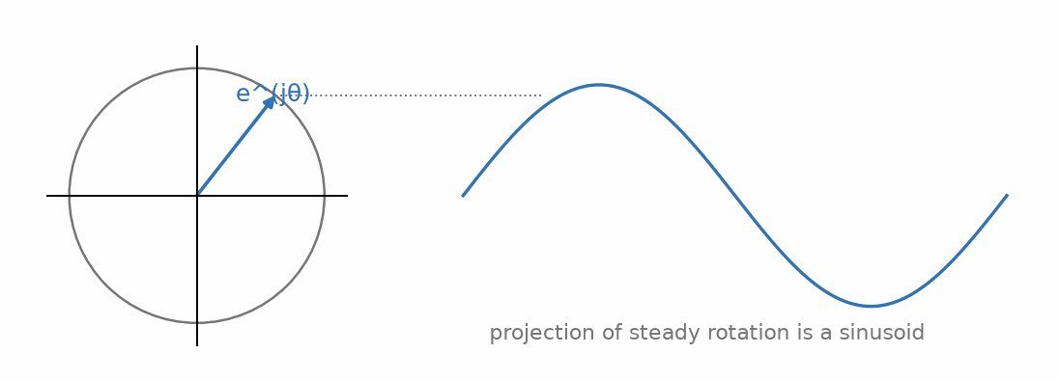
Figure 22.1 — Euler's formula: steady rotation around the unit circle traces out a sinusoid.
That last observation is the whole reason the formula matters to engineers. Steady rotation around a circle, projected onto an axis, is a sinusoid. Euler's formula is the bridge between rotation and oscillation, and AC circuit theory lives on that bridge.
Key Idea
e^(jθ) is a unit-length arrow at angle θ. Nothing more mysterious than that. Multiplying any complex number by e^(jθ) rotates it by θ without changing its length, which is the generalization of "multiplying by j rotates by 90°" from the previous chapter — since j itself is e^(j90°).

22.2 Polar Form, Properly Written
With Euler's formula in hand, the polar form of Chapter 21 can be written as a genuine product rather than as the shorthand angle notation:
z = |z|·e^(jθ)
The engineering shorthand |z|∠θ means exactly this and nothing more. Writing it as an exponential is not mere notation, though — it means the ordinary rules of exponents now apply, and those rules are why multiplication in polar form works the way it does:
|z₁|e^(jθ₁) · |z₂|e^(jθ₂) = |z₁||z₂| · e^(j(θ₁+θ₂))
Magnitudes multiply and angles add, not as a special rule for complex numbers but as the ordinary law that exponents add when you multiply powers of the same base. The polar multiplication rule of Chapter 21 was a consequence of Euler's formula all along.

22.3 Extracting Sine and Cosine
Applying the formula at −θ and using cos(−θ) = cos θ, sin(−θ) = −sin θ gives a companion equation, and adding or subtracting the two isolates the trigonometric functions:
cos θ = (e^(jθ) + e^(−jθ))/2, sin θ = (e^(jθ) − e^(−jθ))/2j
These are worth knowing because they let you replace trigonometric functions with exponentials, and exponentials are far easier to differentiate, integrate, and multiply. A trigonometric identity that takes half a page to prove geometrically often takes two lines in exponential form. The sum-of-angles identity from Chapter 20, for instance, is the statement that exponents add.

22.4 The Rotating Vector
Now let the angle grow with time at a steady rate, θ = ωt, and attach an amplitude:
v(t) = V_m·e^(j(ωt + φ))
This describes an arrow of length V_m rotating counterclockwise at ω radians per second, starting at angle φ. Its projection onto the real axis is V_m·cos(ωt + φ), which is exactly the sinusoid of Chapter 20.
So a real sinusoidal voltage can be regarded as the real part of a rotating complex quantity. Nothing has been lost — the real signal is recoverable at any moment by taking the real part — but a great deal has been gained, because the rotating exponential is far easier to do algebra with than the cosine is.
Common Misconception
Students often ask what the imaginary part of the rotating vector physically is, expecting it to correspond to some measurable quantity. It does not. The imaginary part is mathematical scaffolding: we deliberately added it because the resulting object is easier to compute with, and we discard it at the end by taking the real part. The physical voltage is, and always was, the real part alone. This is not a defect of the method; it is the method.

22.5 Why This Solves AC Circuits
Here is the payoff, stated now and demonstrated in Chapter 23. Differentiating the rotating exponential with respect to time gives
d/dt [V_m·e^(j(ωt+φ))] = jω · V_m·e^(j(ωt+φ))
The function reproduces itself, multiplied by jω. Differentiation — a calculus operation — has become multiplication by a constant. Integration likewise becomes division by jω.
The consequence is enormous. The equations governing capacitors and inductors are differential equations, and differential equations are hard. Written in terms of rotating exponentials, those same equations become algebraic equations in which the derivative has been replaced by the factor jω. An entire class of calculus problems collapses into complex arithmetic of the kind you practiced in Chapter 21.
Worked Example 22.1
Use Euler's formula to prove the identity cos(A + B) = cos A cos B − sin A sin B.
Start from the exponential of the sum, and use the fact that exponents add:
e^(j(A+B)) = e^(jA) · e^(jB)
Expand each factor by Euler's formula:
e^(jA)·e^(jB) = (cos A + j sin A)(cos B + j sin B)
Multiply out, remembering j² = −1:
= cos A cos B + j cos A sin B + j sin A cos B − sin A sin B
= (cos A cos B − sin A sin B) + j(cos A sin B + sin A cos B)
Now apply Euler's formula to the left-hand side: e^(j(A+B)) = cos(A + B) + j sin(A + B).
Two complex numbers are equal only if their real parts match and their imaginary parts match. Equating real parts gives the identity we wanted; equating imaginary parts gives the sine sum identity for free.
Compare this with the geometric proof, which requires a carefully constructed diagram and several similar triangles. The exponential proof is four lines and produces two identities at once. This is representative of what the complex exponential does throughout the subject.
From the Bench
In software, j is usually written 1j (Python) or i (MATLAB and many calculators), and signal-processing functions differ on whether they want frequency in hertz or radians per second. Mixing the two silently gives results that are wrong by a factor of 2π, which is large enough to notice and small enough to explain away if you're tired.

Practice Problems
- Evaluate e^(jπ), e^(jπ/2), and e^(j2π), expressing each as an ordinary complex number.
- Write 3 + j4 in the form |z|e^(jθ), giving θ in both radians and degrees.
- Use the exponential definitions of sine and cosine to show that cos²θ + sin²θ = 1.
- A signal is v(t) = Re{10·e^(j(500t + π/4))}. Write v(t) explicitly as a cosine, state its frequency in hertz, and find its value at t = 2 ms.

What You’ll Actually Use
Everyday working tools
- e^(jθ) as a unit arrow at angle θ.
- Multiplying by e^(jωt) as rotation.
Mostly for exams and deeper study
- Proving Euler's formula from power series.

Chapter 23 — Phasors and Impedance
A phasor is a sort of cheat code. Instead of solving a differential equation for every AC circuit, you freeze the rotation, do ordinary algebra with complex numbers, and switch time back on at the end. It works for any linear circuit at a single frequency, which covers a large share of everyday analysis.
Where you meet this: AC circuit analysis, power systems, filter design, and impedance-versus-frequency curves on component datasheets.
This chapter assembles everything the book has built. Units gave us dimensional discipline, algebra gave us rearrangement, trigonometry gave us the sinusoid, complex numbers gave us two-quantity arithmetic, and Euler's formula connected rotation to oscillation. The phasor is what they combine into, and it is the single most powerful labor-saving device in circuit analysis.

23.1 The Central Observation
Put a resistor and an inductor in series, drive the pair with a sinusoidal voltage source, and every voltage and current anywhere in that little circuit turns out to be a sinusoid too, all at the exact same frequency the source is providing — nothing in an ordinary resistor or inductor can manufacture a new frequency out of nothing. Write out each of those signals in full, though, as an explicit function of time, and the identical oscillating factor — cos(ωt), or its complex cousin e^(jωt) — reappears in the source voltage, the resistor’s voltage, the inductor’s voltage, and the current, term after term, equation after equation, purely because every one of them is being driven at that one shared frequency.
The useful question in a circuit like this is never what the oscillation itself looks like — that part is settled, and identical everywhere in the circuit. It is how each signal’s size and timing compare to the others, once that shared oscillation is set aside. Carrying the same repeated factor through every step of a derivation adds real clutter, and real chances for error, for information that never actually distinguishes one quantity from another.
In a linear circuit driven by a sinusoid at a single frequency, every voltage and every current in the circuit is a sinusoid at that same frequency. The frequency never changes. Only amplitude and phase differ from point to point.
The phasor method stops carrying that shared factor. Agree once, for the whole circuit, on the frequency, set it aside, and track only each signal’s amplitude and phase — which, as Chapter 21 established, is exactly what a complex number is built to hold. Only at the very end, if an explicit time-domain waveform is actually wanted back, is the shared oscillating factor reattached.

23.2 Defining the Phasor
Given a sinusoid v(t) = V_m·cos(ωt + φ), the corresponding phasor is the complex number
V = (V_m/√2)∠φ = (V_m/√2)·e^(jφ)
The time dependence has been dropped entirely. To recover the real signal, multiply by e^(jωt), take the real part, and scale by √2 to undo the RMS normalization: v(t) = √2·Re{V·e^(jωt)}.
Two conventions must be fixed and then adhered to. First, this series uses cosine as the reference — a phasor angle of zero means a cosine, not a sine. A sine must be converted first, using sin θ = cos(θ − 90°). Second, phasor magnitudes in this series are RMS values rather than peak values, since that makes power calculations come out without stray factors of two. Other texts use peak amplitudes; neither is wrong, but mixing them within one problem produces answers off by √2.
Common Misconception
A phasor is not a function of time, and writing V(t) for a phasor is a category error. The whole point of the phasor is that time has been factored out. Nor is a phasor a vector in physical space — the "arrow" of the complex plane points in a mathematical direction, not a spatial one. A phasor diagram showing a current 90° behind a voltage is saying something about timing, not geometry.

23.3 Impedance
With signals represented as phasors, the relationship between voltage and current across any passive component becomes a simple ratio, and that ratio is called impedance:
Z = V/I
Impedance is a complex number measured in ohms. Its real part is resistance, which dissipates power; its imaginary part is reactance, which stores and returns energy without dissipating it. Deriving the three basic impedances is now a short exercise, using the result from Chapter 22 that differentiation becomes multiplication by jω.
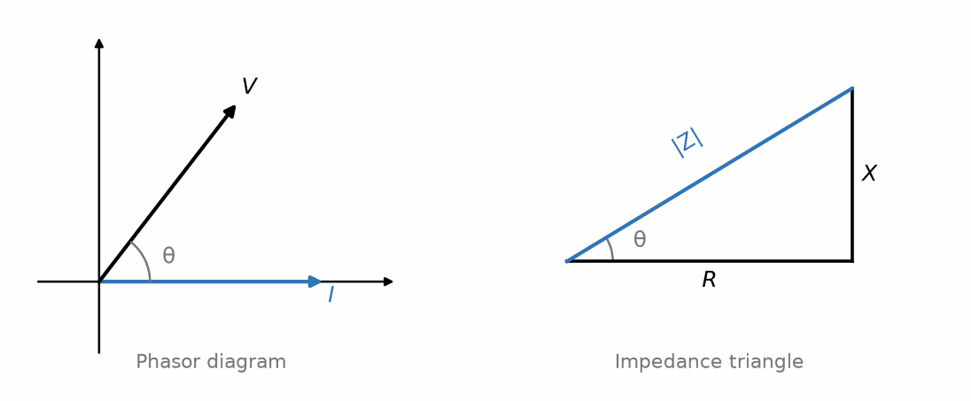
Figure 23.1 — A phasor diagram and its corresponding impedance triangle.
For a resistor, v = iR with no derivative involved, so
Z_R = R
For an inductor, v = L·di/dt. Replacing the derivative with jω gives V = jωL·I, so
Z_L = jωL
For a capacitor, i = C·dv/dt, so I = jωC·V, and inverting,
Z_C = 1/(jωC) = −j/(ωC)
Three differential relationships have become three algebraic ones. Read the signs: inductive reactance is positive imaginary, capacitive reactance is negative imaginary, and the opposite signs are why they cancel at resonance.
Key Idea
Impedance turns AC circuit analysis into DC circuit analysis with complex numbers. Series impedances add. Parallel impedances combine by product-over-sum. Voltage dividers, current dividers, Thevenin equivalents — every technique from resistive circuit analysis carries over unchanged, with R replaced by Z and real arithmetic replaced by complex arithmetic. Nothing new needs to be learned; the old methods work.

23.4 Reading Phase From Impedance
The angle of the impedance is the phase by which voltage leads current. For a pure resistor the impedance is real, its angle is zero, and voltage and current are in phase. For a pure inductor, Z = jωL has angle +90°, so voltage leads current by a quarter cycle. For a pure capacitor, angle −90°, so voltage lags current.
A common mnemonic is ELI for an inductor (L), where voltage E leads current I, and ICE for a capacitor (C), where current I leads voltage E.
Real components are never pure, and the impedance angle tells you how far from ideal a component is. A capacitor whose measured impedance angle is −88° rather than −90° has a small resistive component, and that two-degree discrepancy is precisely the loss mechanism quantified later in the series as equivalent series resistance.
Worked Example 23.1
A 1 kΩ resistor is in series with a 0.1 µF capacitor across a 10 V RMS, 1 kHz supply. Find the total impedance, the current, and the voltage across each component.
First the angular frequency: ω = 2πf = 2π(1000) = 6283 rad/s.
Capacitive impedance: Z_C = −j/(ωC) = −j/(6283 × 0.1 × 10⁻⁶) = −j/(6.283 × 10⁻⁴) = −j1592 Ω.
Total impedance in series is the sum: Z = 1000 − j1592 Ω.
In polar form: |Z| = √(1000² + 1592²) = √(10⁶ + 2.534 × 10⁶) = √(3.534 × 10⁶) = 1880 Ω.
The angle: θ = arctan(−1592/1000) = −57.9°. The real part is positive, so we are in the fourth quadrant and no 180° adjustment is needed.
Current: I = V/Z = 10∠0° / 1880∠−57.9° = 5.32∠+57.9° mA. Dividing means dividing magnitudes and subtracting angles, so the current leads the supply voltage by 57.9° — as expected for a circuit that is predominantly capacitive.
Voltage across the resistor: V_R = I·R = (5.32 mA)(1000 Ω) = 5.32 V, in phase with the current, so at +57.9°.
Voltage across the capacitor: V_C = I·Z_C = (5.32 mA)(1592 Ω) = 8.47 V, at an angle of 57.9° − 90° = −32.1°.
Now the check that catches nearly every error in this kind of problem. The two component voltages are 5.32 V and 8.47 V, which sum arithmetically to 13.79 V — considerably more than the 10 V supply. That is not a violation of Kirchhoff's voltage law. The voltages are 90° apart in phase, so they add as phasors, not as numbers: √(5.32² + 8.47²) = √(28.3 + 71.7) = √100 = 10.0 V. Exactly the supply voltage.
Common Misconception
It looks impossible for the voltages across two series components to exceed the supply voltage, and in a DC circuit it would be. In AC circuits it is routine, because component voltages add as phasors rather than as plain numbers. In a resonant circuit the effect becomes dramatic: the voltage across the inductor and the capacitor individually can exceed the supply by a factor equal to the Q of the circuit, sometimes by hundreds of times. Those voltages are entirely real and will destroy components rated only for the supply voltage. They cancel each other in the sum precisely because they are 180° apart.

23.5 Admittance, and When to Use It
The reciprocal of impedance is admittance, Y = 1/Z, measured in siemens. Its real part is conductance and its imaginary part is susceptance.
Admittance exists for the same reason conductance does: for parallel combinations, admittances add, whereas impedances require the reciprocal formula. In a circuit with many parallel branches, working in admittance turns a nested reciprocal expression into a plain sum. Nodal analysis, which is formulated around parallel connections at each node, is therefore naturally written in admittances — the conductance matrix of Chapter 17 becomes an admittance matrix, and every technique carries straight over.
From the Bench
Real components are never pure. A capacitor has series resistance (ESR) and series inductance (ESL), and above its self-resonant frequency it behaves like an inductor. That is why one large decoupling capacitor does little at hundreds of megahertz, and why datasheets give impedance-versus-frequency curves rather than just a value.

Practice Problems
- Convert to phasor form, using cosine reference and RMS magnitudes: v(t) = 170·cos(377t + 30°) V, and i(t) = 4.24·sin(377t) A.
- Find the impedance of a 22 mH inductor and a 470 nF capacitor, each at 2 kHz. State the magnitude and angle of each.
- A 470 Ω resistor is in series with a 100 mH inductor across a 24 V RMS, 400 Hz supply. Find the total impedance in polar form, the current, and the phase angle between supply voltage and current.
- For the series RC circuit of Worked Example 23.1, find the frequency at which the resistive and capacitive impedance magnitudes are equal. What is the phase angle of the total impedance at that frequency, and what is the ratio of output to input voltage if the output is taken across the resistor?

What You’ll Actually Use
Everyday working tools
- Z_R = R, Z_L = jωL, Z_C = 1/(jωC).
- Phasor in, phasor out, for any linear circuit at one frequency.
Mostly for exams and deeper study
- The formal justification of the phasor transform.

Chapter 24 — Calculus for Electrical Engineering
A capacitor's current depends on how fast its voltage changes, which is why a fast logic edge can draw a surprising spike of current. 'How fast' is a derivative. This chapter keeps calculus to the two ideas engineers use every day, rates and accumulations.
Where you meet this: Capacitor and inductor behavior, amplifier slew rate, energy as the integral of power, and battery fuel gauges that integrate current over time (coulomb counters).
Calculus has a reputation it does not deserve. Stripped of the machinery, it consists of two ideas: a derivative measures how fast something is changing, and an integral measures how much of something has accumulated. Everything else is technique for computing them. This chapter builds both ideas from the circuit behavior that motivates them, and covers the specific results the rest of this series relies on.

24.1 The Derivative as a Rate
The derivative of a quantity with respect to time is its rate of change: how fast it is going up or down at a particular instant. Written dv/dt, it is the slope of the graph of v against t at that moment.
Circuit theory is full of derivatives because two of the three basic components are defined by them. A capacitor's current is proportional to the rate of change of its voltage, and an inductor's voltage is proportional to the rate of change of its current:
i = C·dv/dt and v = L·di/dt
Read these as physical statements rather than formulas. In the ideal model, a capacitor passes current only while its voltage is changing — hold the voltage constant and the current stops, which is why an ideal capacitor blocks DC. An ideal inductor develops voltage only while its current is changing — hold the current constant and the voltage vanishes, which is why an ideal inductor is a short circuit to DC. Real components also have leakage, winding resistance, and other nonideal effects.
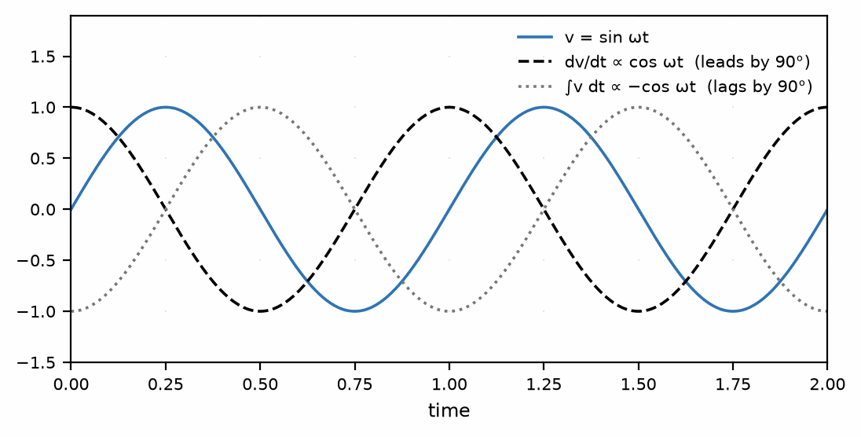
Figure 24.1 — Differentiating a sinusoid shifts its phase by 90 degrees; integrating shifts it by -90 degrees.
The derivatives you need are few:
- A constant has derivative zero. Nothing changing means no rate of change.
- A straight line v = kt has derivative k, the constant slope.
- A power tⁿ has derivative n·t^(n−1).
- The exponential e^(kt) has derivative k·e^(kt) — it reproduces itself, scaled. This is the defining property from Chapter 19.
- Sine and cosine swap: the derivative of sin(ωt) is ω·cos(ωt), and the derivative of cos(ωt) is −ω·sin(ωt). Note that each differentiation brings down a factor of ω and advances the phase by 90°, which is exactly the jω of Chapter 23 seen without complex notation.
Common Misconception
The derivative of sin(ωt) is ω·cos(ωt), not cos(ωt). The factor of ω is dropped constantly and the consequences are severe, because ω is often a large number — at mains frequency it is 377, and in RF work it is in the billions. Omitting it does not make an answer slightly wrong; it makes it wrong by orders of magnitude. The factor appears because of the chain rule: differentiating the inside function ωt gives ω, which multiplies the result.

24.2 The Integral as an Accumulation
Integration is the reverse of differentiation: given a rate, it recovers the total accumulated. Geometrically it is the area under a curve.
Rearranging the capacitor relation shows the accumulation directly. If i = C·dv/dt, then the voltage change from a starting time t₀ to time t is the accumulated current divided by capacitance:
v(t) − v(t₀) = (1/C)·∫[t₀ to t] i(τ) dτ
This says a capacitor's voltage is proportional to the total charge that has flowed into it — the integral of current is charge, which is exactly the statement that a coulomb is an ampere-second. The capacitor is a device that remembers how much current has passed, which is why it is a memory element and why its state must be specified as an initial condition when solving a circuit.
The integrals worth knowing are the derivatives read backwards: the integral of tⁿ is t^(n+1)/(n+1), the integral of e^(kt) is e^(kt)/k, the integral of cos(ωt) is sin(ωt)/ω, and the integral of sin(ωt) is −cos(ωt)/ω. Each integration divides by ω and retards the phase by 90°, which is the 1/jω of capacitive impedance.

24.3 Definite Integrals, Averages, and RMS
A definite integral evaluates the accumulation between two limits, and dividing by the width of the interval gives the average value:
average of f over [a, b] = (1/(b−a))·∫ f dt
This is where the RMS definition of Chapter 20 comes from, and it is worth seeing the calculation once. The mean square of a sinusoid over one period is
mean of V_m²sin²(ωt) = V_m²·(mean of sin²)
and the double-angle identity from Chapter 20 gives sin²θ = (1 − cos 2θ)/2. The cosine term averages to zero over a whole number of cycles, leaving a mean of exactly one half. So the mean square is V_m²/2, and the root mean square is V_m/√2.
That is the entire derivation of the 0.707 factor, and it makes plain why the factor is specific to sinusoids: it came from the average of sin², and a different waveform has a different average of its square.
Worked Example 24.1
A capacitor of 4.7 µF carries a current that rises linearly from 0 to 10 mA over 5 ms, then stops. Find the voltage across it at the end of that interval, assuming it started at 0 V.
The current is i(t) = kt with k chosen so that i = 10 mA at t = 5 ms: k = 0.010/0.005 = 2 A/s.
The voltage is the integral of current divided by capacitance:
v(t) = (1/C)·∫₀^t kt dt = (1/C)·k·t²/2
Evaluating at t = 5 ms:
v = (1/4.7 × 10⁻⁶)(2)(0.005²/2) = (1/4.7 × 10⁻⁶)(2)(1.25 × 10⁻⁵) = (2.5 × 10⁻⁵)/(4.7 × 10⁻⁶) = 5.32 V
A useful cross-check: the average current over the ramp is half the peak, or 5 mA, sustained for 5 ms, giving a total charge of 25 µC. Then v = Q/C = 25 × 10⁻⁶ / 4.7 × 10⁻⁶ = 5.32 V. The two routes agree, and the second is often quicker — for a linear ramp, the area under the curve is a triangle, and you do not need the integral at all.
Key Idea
In sinusoidal steady state, d/dt becomes ×jω and ∫dt becomes ÷jω. This is the whole reason Chapter 23 works. Once you accept it, no differential equation ever needs to be solved to analyze a linear circuit at a single frequency — the calculus has been done in advance, once, and packaged into the factor jω.

24.4 Differential Equations, Briefly
A differential equation relates a quantity to its own derivatives. The RC circuit produces the simplest interesting example. Kirchhoff's voltage law around a charging loop gives
RC·dv/dt + v = V_s
and the solution is the exponential of Chapter 19, v(t) = V_s(1 − e^(−t/RC)). You are not expected to derive that here. What matters is recognizing the pattern: a first-order differential equation produces an exponential response with a single time constant, and a second-order one produces either two exponentials or a damped oscillation, depending on the sign of the discriminant met in Chapter 16.
This is why the phasor method is such a relief. Differential equations must be solved for the complete response, including the transient. But if all you need is the steady state — the behavior after the transients have died away, which is what most AC analysis concerns — the phasor method delivers it algebraically. Transient analysis, where the differential equation genuinely must be solved, is taken up properly in Part III.
From the Bench
Estimate derivatives from what a scope shows you: i = C·Δv/Δt. A 100 pF load swung through 3.3 V in 1 ns draws about 0.33 A during the edge, which is why fast logic needs decoupling capacitors right at its power pins.

Practice Problems
- A capacitor of 1 µF has a voltage rising at a steady 2000 V/s. Find the current through it.
- An inductor of 50 mH carries a current i(t) = 3·sin(1000t) A. Find the voltage across it, including its amplitude and phase relative to the current.
- Find the derivative of v(t) = 10·cos(2000t + 30°) with respect to time, and state the amplitude of the result.
- A current of 5 mA flows into a 10 µF capacitor, initially uncharged, for 200 ms and then stops. Find the final voltage, first by integration and then by the charge method, and confirm the two agree.

What You’ll Actually Use
Everyday working tools
- i = C dv/dt and v = L di/dt, with Δ approximations.
- The area under a curve as accumulated charge or energy.
Mostly for exams and deeper study
- Formal differentiation and integration rules.
- Analytic solutions of differential equations.

Chapter 25 — Where This Book Leads Next
Every toolbox needs a label on the lid. Before the circuits start, this short chapter says which Part II tools you will reach for constantly and which can stay in the drawer for a while.
Where you meet this: Part III of this book, and Books 2, 4 and 5 of the series.
The mathematics is now in place. It is worth a short chapter to say explicitly where each piece gets used, both so the effort feels justified and so you know where to return when a later book assumes something you have half-forgotten.

25.1 Immediately: Part III, Circuit Theory
Part III opens with Kirchhoff's laws and resistive networks, which need only Chapters 16 and 17 — rearrangement and simultaneous equations. It then introduces capacitors and inductors, at which point Chapter 24's derivatives become necessary to state what those components do. First-order transients use the exponentials of Chapter 19 directly, including the 63% and five-time-constant rules.
The second half of Part III is sinusoidal steady-state analysis, and it uses Chapters 20 through 23 continuously and without further explanation. The phasor and impedance material of Chapter 23 is assumed knowledge from the moment AC appears. If one chapter of this book is worth revisiting before starting Part III, it is that one.
A concrete hand-off: a low-impedance sensor can produce 5.4 V, while the ESP32-S3 ADC range in Chapter 15 ends at about 2.9 V. Two nominal 10 kΩ resistors halve the signal to 2.70 V and draw 0.27 mA. With both resistors at ±1%, the largest divider ratio is 10.1/(9.9 + 10.1) = 0.505, so the output is about 2.73 V. Part III supplies the node-voltage method for checking the divider, its loading, and its margin before a pin is connected.

25.2 Soon: Filters, Frequency Response, and Bode Plots
Frequency response is the impedance of Chapter 23 evaluated across a range of frequencies rather than at one. The asymptotic reading of transfer functions and logarithmic axes from Chapter 18, combined with the decibels of Chapter 19, is precisely the skill set the Bode plot demands. An engineer fluent in those two chapters can sketch the response of a filter from its component values in a few seconds, without computing a single point.

25.3 Later: RF, Noise, and Communications
The RF books lean on this material harder than any others. The Smith chart is a conformal map of the complex plane, and it is unusable without genuine comfort with complex arithmetic. S-parameters are complex ratios, quoted in magnitude and phase. Link budgets are sums of decibel quantities, and the dBm conventions of Chapter 19 are used on every page. Noise figure is a ratio of ratios, expressed logarithmically, and the uncertainty reasoning of Chapter 15 governs how precisely any of it can be measured.
Modulation theory rests on the sum-of-angles identity from Chapter 20 — multiplying two sinusoids produces sum and difference frequencies, which is what a mixer does and what every superheterodyne receiver is built around.

25.4 Eventually: Transforms
The Fourier and Laplace transforms, which arrive later in the series, are direct generalizations of what you have already done. The phasor represents a signal at one frequency; the Fourier transform represents a signal as a continuous superposition of all frequencies at once. The jω of Chapter 23 becomes the more general complex variable s = σ + jω of the Laplace transform, where the real part σ describes growth or decay and the imaginary part describes oscillation.
Both transforms turn differential equations into algebraic ones, exactly as the phasor method did — they are the same trick, applied more broadly. Having understood why jω works, you will find the transforms considerably less alien than students who meet them without this grounding.
Key Idea
Nothing later in this series depends on a fundamentally unfamiliar mathematical foundation. Later books extend these tools — complex arithmetic, logarithms, sinusoids, first-order calculus — and combine them in more demanding ways, and some topics (Fourier and Laplace transforms, probability and noise, feedback and control) can genuinely feel harder in their own right. But none of it requires a fundamentally different mathematical starting point than what this book has already built. If this book is solid, the rest of the series is about applying that foundation, not relearning it.

What You’ll Actually Use
Everyday working tools
- Algebra, linear equations, decibels, complex numbers and phasors, constantly.
Mostly for exams and deeper study
- Calculus beyond simple derivatives and integrals, mostly in later and more theoretical work.

Part III — DC and AC Circuit Theory

Chapter 26 — Circuit Elements and Kirchhoff's Laws
Every circuit, from a flashlight to a server motherboard, obeys two rules. Current flowing into a junction must flow out, and the voltages around any closed loop add to zero. The rules are compact; the sign mistakes are not.
Where you meet this: Every debugging session, current-sense measurements, power budgets, and the equations inside every circuit simulator.

26.1 From Physics to Circuit Theory
Part I defined voltage, current, resistance, capacitance, and inductance from first physical principles. Circuit theory takes those definitions as given and asks a more restricted, more tractable question: if you know how each individual element in a network behaves — a resistor obeying V = IR, a capacitor obeying C = Q/V, an inductor obeying ε = −L dI/dt, and a source supplying a fixed voltage or current — what can you say about the voltages and currents everywhere in an arbitrary network built by wiring many such elements together?
This restriction is not a retreat from physics; it is what makes circuit analysis tractable at all. A real circuit board can have hundreds or thousands of components. Nothing about Coulomb's law or Gauss's law, applied directly, scales to a problem of that size — but the two laws introduced in this chapter, which are themselves direct consequences of charge conservation and energy conservation, scale perfectly well, because they let you reason about a circuit's topology (how things are connected) independently of the messy details of the fields inside any one component.

26.2 Nodes, Branches, and Loops
A node is any point in a circuit where two or more elements connect — physically, an entire stretch of ideal (zero-resistance) wire between components counts as a single node, since every point along it is at the same potential. A branch is a single path between two nodes, generally containing one circuit element. A loop is any closed path through the circuit that starts and ends at the same node without repeating any other node along the way.
These three words — node, branch, loop — are the vocabulary the rest of this chapter, and much of this book, is built from, and it is worth being able to identify all three correctly on a circuit diagram before proceeding, since misidentifying a node (for instance, treating two separate points joined by a plain wire as two different nodes) is one of the most common sources of error in an otherwise correct circuit analysis.

26.3 Kirchhoff's Current Law (KCL)
Picture a T-junction in a water pipe: one pipe flows in, two flow out. Whatever volume of water enters that junction every second has to leave it too, split between the two outgoing pipes in whatever proportion — water does not pile up and vanish inside a junction. An ideal node in a lumped circuit model behaves the same way for charge: whatever current flows in is balanced by current flowing out, because the model assigns no charge storage to the node itself. A physical junction can have parasitic capacitance, but when that matters it must be represented in the model rather than ignored. A node with 4.0 A flowing in from one branch and 7.0 A flowing in from a second must have exactly 11.0 A flowing out overall, however that 11.0 A is then divided among whatever branches leave the node.
This is Kirchhoff's current law: the sum of currents entering any node equals the sum of currents leaving it — equivalently, the algebraic sum of all currents at a node, with currents entering counted as positive and currents leaving as negative (or any other single consistent convention), is always zero:
Σ I_{in} = Σ I_{out} (equivalently: Σ I_{node} = 0)
KCL is charge conservation (Chapter 1) applied to an ideal node in a lumped circuit model. At such a node, the algebraic sum of branch currents is zero at each instant, including during transients. If appreciable charge accumulates on a physical node, that storage must be represented by an explicit capacitance or another field-based model; it cannot be ignored while claiming the ideal-node equation is exact for the physical junction.

26.4 Kirchhoff's Voltage Law (KVL)
Kirchhoff's voltage law states that the algebraic sum of all voltage rises and drops around any closed loop is zero:
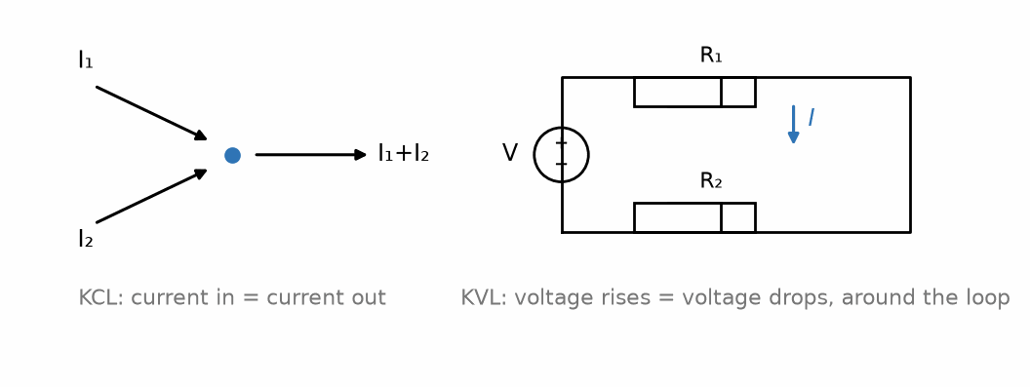
Figure 26.1 — KCL at a node and KVL around a loop, the two laws every circuit-analysis method rests on.
Σ V_{loop} = 0
KVL follows from the fact that electric potential (Chapter 5) is a well-defined function of position — travel around any closed loop, back to your starting point, and the net change in potential must be zero, since potential does not depend on the path taken between two points, only on the two points themselves. Practically, this means: pick a direction to traverse a loop, add up every voltage drop you encounter in that direction (a drop across a resistor in the direction of assumed current flow, for instance) and subtract every voltage rise (crossing a source from − to +, for instance), and the total must equal zero. This reasoning holds for the lumped-circuit approximation used throughout this book, where any changing magnetic flux linking a loop is represented explicitly as its own circuit source — an induced EMF, as in Chapter 11 — rather than left as a distributed effect. In full electromagnetic theory, a changing magnetic flux produces a genuinely non-conservative electric field (Faraday's law, Chapter 11), and outside the lumped approximation KVL as stated here no longer holds exactly.
Key Idea
KCL is about nodes; KVL is about loops. KCL enforces charge conservation at every point where branches meet. KVL enforces that potential is a well-defined, single-valued quantity around any closed path. Together with the individual V-I relationship for each element (Ohm's law, for a resistor), applied systematically, they are sufficient to solve any resistive circuit — nothing more is needed beyond those element laws and careful bookkeeping of these two.

26.5 Sign Conventions and the Passive Sign Convention
Before applying either law, every branch needs an assumed current direction and every element needs a labeled voltage polarity. The passive sign convention, used throughout this book and throughout the rest of this series, assigns the voltage polarity across a passive element (a resistor, capacitor, or inductor) so that the assumed current enters at the + terminal — under this convention, a positive value of P = VI means the element is absorbing power, and a negative value means it is delivering power, which is otherwise unusual for a passive element and typically signals either a sign error or a source hiding somewhere in what was assumed to be a passive branch.
It does not matter, in principle, which direction you assume for a branch current before solving a circuit — if you guess the wrong direction, the algebra will return a negative value for that current, correctly telling you the actual current flows opposite to your assumed direction. What matters is consistency: once a direction and polarity are assigned to a branch, every equation involving that branch must use them consistently throughout the entire solution.
Worked Example 26.1
Problem: A single loop contains a 12 V battery in series with a 4.0 Ω resistor and an 8.0 Ω resistor. Using KVL, find the current in the loop.
Solution: Assume current I flows clockwise, out of the battery's + terminal. Traversing the loop clockwise starting at the battery's − terminal: rise of 12 V crossing the battery, then a drop of I(4.0) across the first resistor, then a drop of I(8.0) across the second. KVL: 12 − 4.0I − 8.0I = 0, so 12 = 12I, giving I = 1.0 A.
Worked Example 26.2
Problem: At a node, three branches meet. Branch A carries 3.0 A into the node. Branch B carries 5.0 A into the node. Branch C leaves the node. Find the current in branch C.
Solution: By KCL, total current in equals total current out: 3.0 + 5.0 = I_C, so I_C = 8.0 A, leaving the node.
Common Misconception
A very common early error is applying KVL correctly in form but inconsistently in sign — for instance, treating a resistor's voltage as a drop when traversing it in one direction during one part of a solution, and quietly treating the same resistor's voltage as a rise later in the same solution, usually because the assumed current direction was forgotten partway through. Before writing down a KVL equation, it helps to mark every assumed current direction and every resulting + / − polarity directly on the circuit diagram first, and then read the diagram rather than trying to hold the whole sign convention in your head while writing the equation. In a feedback circuit, reversing the sign in the model can turn negative feedback into positive feedback; the output then runs to a supply rail instead of settling at the intended operating point, as Book 2 shows.
From the Bench
KVL is your best debugging tool. Measure the voltages around a loop with a meter; if the drops don't add up to the supply, there is a resistance you didn't plan for, usually a poor solder joint, a tired connector or an undersized trace. Measuring the voltage along a few centimeters of supply trace under load is a cheap way to find one.

Practice Problems
- At a node, currents of 2.0 A and 6.0 A flow in, and a single branch carries current out. Find that branch's current.
- A single loop has a 9.0 V source in series with three resistors: 2.0 Ω, 3.0 Ω, and 4.0 Ω. Find the loop current.
- In the circuit of the previous problem, find the voltage across the 4.0 Ω resistor.
- Explain, in terms of charge conservation, why KCL would be violated if current could accumulate indefinitely at an ordinary circuit node.

What You’ll Actually Use
Everyday working tools
- KCL and KVL for every quick check.
- The passive sign convention.
Mostly for exams and deeper study
- Formal derivations from conservation of charge and energy.

Chapter 27 — Equivalent Resistance and Dividers
A thermostat, a potentiometer volume knob and the feedback network of a phone charger's regulator all use the same trick: two resistances in series, with the output taken from the middle. This chapter makes series, parallel and dividers second nature.
Where you meet this: Sensor interfaces (thermistors, potentiometers), the feedback networks that set a regulator's output voltage, attenuators, and scaling signals for ADC inputs.

27.1 Series and Parallel, Revisited
Part I introduced the series and parallel combination rules for resistors: resistances add directly in series, and combine by reciprocal sum in parallel. This chapter treats those rules as tools for simplifying entire networks, not only pairs of resistors, and develops the two divider circuits — voltage and current — that follow directly from them and that appear, in some form, inside an enormous fraction of practical circuits.
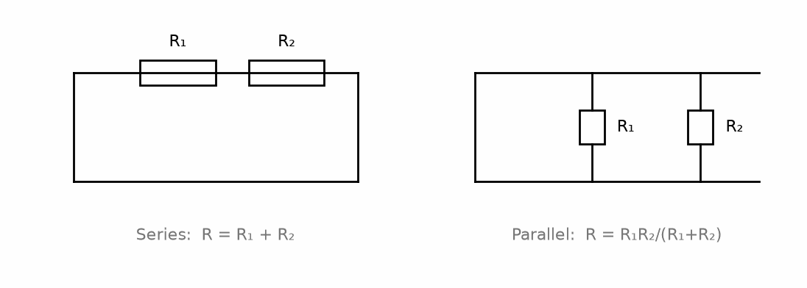
Figure 27.1 — Series and parallel resistor combinations, with their equivalent-resistance formulas.
R_{series} = R₁ + R₂ + … , 1/R_{parallel} = 1/R₁ + 1/R₂ + …

27.2 Reducing a Network by Combination
Many practical circuits, though they may look complicated at first glance, can be fully solved by repeatedly identifying resistors that are purely in series or purely in parallel, combining them into a single equivalent resistor, and redrawing the (now simpler) circuit — repeating until only a single equivalent resistance remains between the source terminals. This is not a universal method (Chapters 28 and 29 introduce the systematic techniques needed once a network cannot be reduced this way, typically because of a “bridge” configuration with no purely series or parallel path), but it is the fastest method whenever it applies, and recognizing when it applies is itself a skill worth developing before reaching for heavier machinery.

27.3 The Voltage Divider
Two resistors in series across a voltage source V split that voltage in direct proportion to their resistances, since the same current flows through both:
V₁ = V · R₁ / (R₁ + R₂) , V₂ = V · R₂ / (R₁ + R₂)
The voltage divider generalizes immediately to any number of series resistors: the voltage across any one of them is the source voltage times that resistor's share of the total series resistance. It is worth noting explicitly what the voltage divider assumes: that whatever draws off the divided voltage (a downstream load) draws negligible current compared to the current already flowing through the divider itself. If that assumption fails — if the load draws a comparable or larger current — the simple divider formula no longer gives the correct output voltage, and the load's own resistance must be folded into the calculation as a resistor in parallel with whichever divider resistor it is connected across.
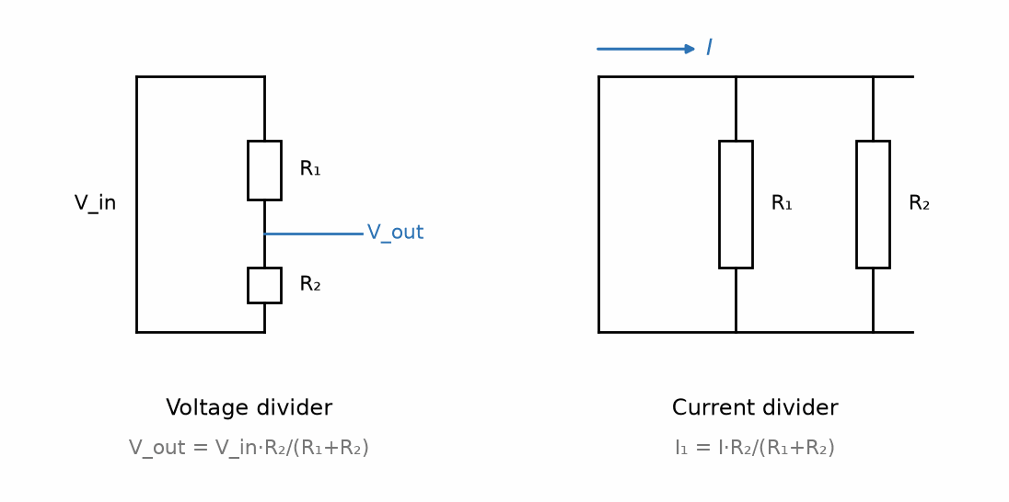
Figure 27.2 — Voltage and current dividers, with their governing formulas.

27.4 The Current Divider
Two resistors in parallel across a current source (or a branch carrying a known total current) split that current inversely in proportion to their resistances — the larger resistor carries the smaller share, since current preferentially takes the path of least resistance:
I₁ = I · R₂ / (R₁ + R₂) , I₂ = I · R₁ / (R₁ + R₂)
Notice that each resistor's current formula uses the other resistor's value in the numerator — the reverse of the voltage divider's pattern, where each resistor's voltage formula uses its own value in the numerator. This inversion is easy to state and easy to forget under exam pressure; rederiving it once from Ohm's law and KCL (each resistor sees the same voltage V = IR_parallel, so I₁ = V/R₁ and I₂ = V/R₂, and substituting R_parallel confirms the pattern above) is a more reliable way to keep it straight than memorizing it as an isolated fact.
Key Idea
Voltage dividers use each resistor's own value; current dividers use the other resistor's value. This asymmetry falls directly out of Ohm's law applied to series versus parallel configurations, and rederiving it once is more durable than memorizing the two formulas as unrelated facts.
Worked Example 27.1
Problem: A 15 V source drives a series combination of a 5.0 kΩ and a 10 kΩ resistor. Find the voltage across the 10 kΩ resistor.
Solution: V₁₀ₖ = 15 × 10/(5.0+10) = 15 × 10/15 = 10 V.
Worked Example 27.2
Problem: A current source supplies 12 mA to a parallel combination of a 2.0 kΩ and a 6.0 kΩ resistor. Find the current through the 2.0 kΩ resistor.
Solution: Using the current-divider formula (note the other resistor's value appears in the numerator): I₂ₖ = I × R₆ₖ/(R₂ₖ+R₆ₖ) = 12 × 6.0/(2.0+6.0) = 12 × 0.75 = 9.0 mA. Check: the smaller resistor should carry the larger share of the current, and 9.0 mA out of 12 mA total is indeed the larger share, confirming the arithmetic direction is right.
Common Misconception
It is a common shortcut error, once a network contains more than two resistors, to attempt to identify series and parallel groupings by eye without carefully tracing which nodes each resistor actually connects — two resistors that merely look adjacent on a drawn diagram are not necessarily in series or parallel with each other in the sense these rules require. A resistor is in series with another only if they share exactly one node with nothing else connected there (so the same current is forced through both), and two resistors are in parallel only if both of their endpoints connect to the same pair of nodes. When a network's diagram is drawn with resistors at odd angles or overlapping, redrawing it schematically, node by node, before attempting any combination is far more reliable than trying to judge series/parallel relationships from the picture's layout alone.

27.5 Resistive Sensors: The Divider Interface
Resistive sensors are often the simplest to interface: thermistors sense temperature, LDRs light (Section 8.5), strain gauges force and weight, and potentiometers position. Their resistance changes with the physical input, and a divider turns that change into a voltage an ADC can sample. Other transducers include capacitive touch and humidity sensors, inductive metal and position sensors, and optical or electrochemical devices; their front ends depend on the sensor. This section focuses on resistive sensors and the divider of Section 27.3; later books return to capacitive and inductive sensing.
The Reader Lab includes both bare sensing elements and integrated modules; the word sensor does not imply a resistor connected directly to an ADC. A thermistor or LDR may use a divider, while a load cell uses a bridge. A microphone or photodiode needs a suitable analog front end; an integrated sensor may convert its signal and report digital values over I2C, SPI, or UART. A camera sends image data. Check the device interface before choosing a divider, bridge, or ADC; later books develop these other transducers and data paths.
A negative-temperature-coefficient (NTC) thermistor is a ceramic bead whose resistance falls steeply as it warms. Its data sheet gives two numbers: R₂₅, the resistance at 25 °C, and B, a constant in kelvin. Between those, the B-equation R(T) = R₂₅ e^(B(1/T − 1/T₂₅)), with T in kelvin, describes the curve well over a few tens of degrees. The common 10 kΩ, B = 3950 K part (MF52-type beads) changes by about 4.4 % per degree near room temperature, ten times more than a copper wire.
Worked Example 27.3 — The Thermistor Divider, Analog First
Problem: A 10 kΩ NTC (B = 3950 K) forms the bottom of a divider with a fixed 10 kΩ resistor on top, powered from 3.3 V. Find the output at 0, 25, and 50 °C, the sensitivity near 25 °C in mV per degree, what one count of the ESP32-S3's ADC means in degrees, and how much the thermistor heats itself.
Solution: The B-equation gives 33.6 kΩ at 0 °C (273.15 K), 10.0 kΩ at 25 °C, and 3.59 kΩ at 50 °C. (The maker's table says 32.1 kΩ at 0 °C: the B-equation is a model, good near its two reference temperatures and a few percent off far from them; the three-constant Steinhart-Hart equation does better.) The divider gives V_out = 3.3 × R/(10 k + R): 2.54 V at 0 °C, 1.65 V at 25 °C, and 0.87 V at 50 °C. Sensitivity near 25 °C: dR/dT = −BR/T² = −3950 × 10 kΩ/298.15² ≈ −444 Ω/K, and the divider's slope there is 3.3 × 10 k/(20 k)² = 82.5 µV/Ω, so the output moves about −36.7 mV per degree. One ADC count (0.71 mV) is then about 0.02 °C, far finer than the converter accuracy. Espressif reports a calibrated total-error limit of ±50 mV at the widest-range ATTEN3 setting (0-2.9 V); at this slope that corresponds to about ±1.4 °C. The limit was measured with a DC input, a 100 nF input capacitor, Wi-Fi disabled, and 25 °C ambient; board noise and thermistor, resistor, and reference tolerances add error. Calibrate the assembled channel against a reference thermometer if better accuracy is needed. Self-heating: at 25 °C the thermistor dissipates (1.65 V)²/10 kΩ ≈ 0.27 mW, and with a dissipation constant of about 2 mW/°C it runs about 0.14 °C warm. Choosing the fixed resistor equal to the thermistor's resistance at the temperature you care about most puts the steepest part of the curve there.
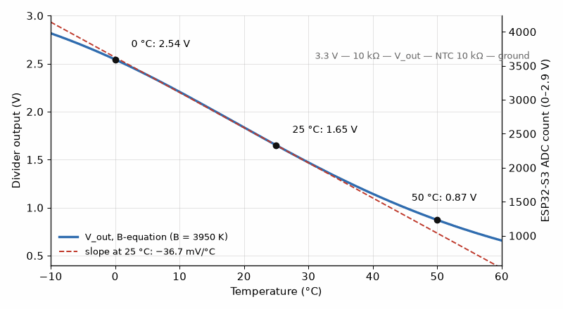
Figure 27.3 — A 10 kΩ NTC thermistor under a 10 kΩ resistor. The output falls from 2.54 V at 0 °C to 0.87 V at 50 °C and is steepest, about −37 mV per degree, around 25 °C, where the thermistor matches the fixed resistor.

27.6 The Wheatstone Bridge
A divider's output sits on top of a large fixed voltage: 1.65 V, changing by tens of millivolts. To see a tiny change, build two dividers side by side and measure between their outputs. That is the Wheatstone bridge. If both dividers have the same ratio, the bridge is balanced and its output is zero; a small change in one arm gives a small output that is now all signal, ready to be amplified or compared. With a supply V_s, one divider of R₁ over R₂ and the other of R₃ over R₄ (each measured to the bottom), V_out = V_s[R₂/(R₁ + R₂) − R₄/(R₃ + R₄)], and balance means R₁/R₂ = R₃/R₄.
Worked Example 27.4 — A Thermostat With No Code
Problem: A bridge from 3.3 V has a fixed 10 kΩ over the NTC of Worked Example 27.3 on one side, and a fixed 10 kΩ over a set-point potentiometer on the other. The potentiometer is set to the thermistor's resistance at 20 °C. A comparator (an LM393, say) switches the heater on when the thermistor side is the higher of the two. Find the potentiometer setting and the bridge output at 18 °C and 22 °C.
Solution: At 20 °C (293.15 K), the B-equation gives R = 10 kΩ × e^(3950(1/293.15 − 1/298.15)) ≈ 12.54 kΩ, so the potentiometer is set to 12.54 kΩ, and its side sits at 3.3 × 12.54/22.54 ≈ 1.836 V. At 18 °C the thermistor is 13.75 kΩ and its side sits at 3.3 × 13.75/23.75 ≈ 1.911 V: the output is +75 mV and the comparator turns the heater on. At 22 °C the output is about −75 mV and the heater turns off. The whole thermostat is two resistors, a thermistor, a potentiometer, and a comparator, with no software to crash. A real one adds a little positive feedback around the comparator (hysteresis, Book 2) so that it does not chatter on and off at exactly 20 °C.
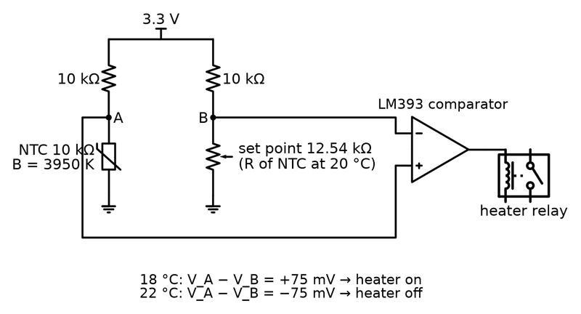
Figure 27.4 — The analog-first thermostat: a Wheatstone bridge compares the thermistor with a set-point potentiometer, and a comparator turns the bridge's few tens of millivolts into a clean on or off for the heater.
Now the same job in about twenty lines on the ESP32-S3: read the divider of Worked Example 27.3 with the ADC, convert the voltage to resistance and the resistance to temperature with the B-equation, compare with a set point that has a degree of hysteresis, and drive the relay from a pin. The code version can also show the temperature on the OLED, follow a weekly schedule, and report over Wi-Fi. The analog version keeps working if the firmware hangs. That is why real thermostats and appliances often keep a simple hardware cut-out, a thermal fuse or a comparator, beside the microcontroller: the code handles comfort and the hardware handles safety. The same pattern appears in every later book.
Bridges are also how scales weigh. A load cell is a metal bar with four strain gauges glued to it, wired as a full bridge, so that bending the bar unbalances all four arms at once. Its data sheet gives the output at full load per volt of supply. Every scale you have stood on contains one, and so does the reader lab's Smart Refrigerator Monitor.
Worked Example 27.5 — Weighing the Milk
Problem: The Smart Refrigerator Monitor puts a 5 kg load cell (rated output 1.0 mV/V, such as a TAL220) under the milk shelf, excited from 5 V and read by an HX711, a 24-bit converter made for bridges, whose gain-128 input spans ±20 mV. Find the full-scale output, the output for a 1 L carton of milk (1.03 kg), and the fraction of the HX711's range in use. A thermistor divider like Worked Example 27.3 watches the fridge temperature beside it.
Solution: Full-scale output = 1.0 mV/V × 5 V = 5.0 mV at 5 kg, so the cell gives 1.0 mV per kilogram, and the carton produces about 1.03 mV. The HX711's ±20 mV input is four times larger than the cell's 5 mV full scale, so a quarter of its range is in use, and its 24 bits leave ample resolution. The bridge's zero is not perfect (the data sheet allows ±0.1 % of full scale, ±5 µV here), so the firmware stores the empty-shelf reading and subtracts it, the tare. When the reading drops below about 0.2 mV, less than a fifth of a carton, the monitor sends a shopping reminder. Learn it here, buy the IC at work: the HX711 is the bridge-plus-amplifier-plus-converter of this section in one small package.

27.7 Between 5 V and 3.3 V: A Divider as a Level Shifter
Older parts and many hobby modules use 5 V logic; the ESP32-S3 uses 3.3 V, and its pins are not designed to accept 5 V. A 5 V output connected straight to a 3.3 V input pushes current through the input's protection diodes into the supply and can damage the chip. For a slow signal going down from 5 V to 3.3 V, a divider is enough. Going up from 3.3 V to 5 V often needs nothing: a 5 V TTL-style input sees anything above about 2.0 V as high. Fast or two-way buses such as I²C use a small transistor level-shifter module instead.
Worked Example 27.6 — The Ultrasonic Echo Pin
Problem: The HC-SR04's echo output swings to 5.0 V. The ESP32-S3 input needs at least 0.75 × 3.3 = 2.475 V to read a 1 and must not see more than 3.6 V. Choose a divider.
Solution: Try 2.2 kΩ on top and 3.3 kΩ below: V = 5.0 × 3.3/(2.2 + 3.3) = 3.0 V. That clears the 2.475 V threshold by about 0.5 V and stays 0.6 V below the limit. The divider draws 5.0/5.5 kΩ ≈ 0.91 mA while the echo is high, which the module drives easily. Its Thevenin resistance, 2.2 ∥ 3.3 ≈ 1.3 kΩ, with a few picofarads of pin capacitance gives a time constant of a few nanoseconds, nothing next to an echo pulse hundreds of microseconds long. The trigger needs no divider: the ESP32-S3's high output, close to 3.3 V, is above the module's TTL-level threshold (2.0 to 2.4 V, depending on the data sheet).
From the Bench
A divider only divides properly when its load draws much less current than the divider does. A 100 kΩ/100 kΩ divider feeding a 100 kΩ input gives one-third, not one-half. Rule of thumb: make the load at least ten times the divider's output resistance (the two resistors in parallel), or buffer the output with an op-amp.
On the Job
Smart-thermostat teams show where this chapter goes. A commercial smart thermostat's sensing layer is a temperature sensor, a humidity sensor, a motion or proximity sensor to know whether anyone is home, and an ambient-light sensor for the display, all feeding a microcontroller that switches the heating and cooling through relays or solid-state switches on the 24 V AC control wires of a North American heating system. Hardware engineers there use thermal chambers, reference thermometers, SPICE, and long logging runs. A typical task: the thermostat reads 1.5 °C too warm because the display, the processor, and the Wi-Fi radio heat the case. The engineer moves the sensor to the bottom edge, cuts slots in the board around it so heat cannot flow in through the copper, and adds a firmware correction based on how hard the electronics are working, then proves it in the chamber over a week of simulated days.

Practice Problems
- A 20 V source drives a series combination of a 3.0 kΩ, 5.0 kΩ, and 2.0 kΩ resistor. Find the voltage across the 5.0 kΩ resistor.
- A current source supplies 30 mA to two parallel resistors, 4.0 kΩ and 12 kΩ. Find the current through each.
- Reduce the following network to a single equivalent resistance: a 6.0 Ω resistor in series with the parallel combination of a 4.0 Ω and a 12 Ω resistor.
- A voltage divider built from a 1.0 kΩ and a 9.0 kΩ resistor across a 10 V supply is loaded by a 9.0 kΩ resistor connected across the 9.0 kΩ divider resistor. Find the actual output voltage, and compare it to the unloaded divider prediction.
- A 10 kΩ NTC thermistor with B = 3950 K forms the bottom of a divider, with a fixed 10 kΩ resistor on top and 3.3 V across the pair. Using the B-equation, find the output voltage at 25 °C and at 40 °C.
- An ultrasonic sensor's 5.0 V echo output must drive a 3.3 V input whose high threshold is 2.475 V and whose absolute maximum is 3.6 V. Check a divider of 1.0 kΩ (top) over 2.0 kΩ, and one of 2.2 kΩ over 3.3 kΩ, and choose one.

What You’ll Actually Use
Everyday working tools
- Series and parallel combination.
- Voltage and current dividers, and the loading rule.
- Thermistor dividers with the B-equation, bridges for small changes, and a divider that brings a 5 V signal down to 3.3 V.
Mostly for exams and deeper study
- Long ladder networks reduced by hand.

Chapter 28 — Nodal Analysis
Faced with a tangle of resistors and sources, nodal analysis gives you a recipe that always works: label the node voltages, write KCL at each node, solve. It is also, in essence, what a SPICE simulator does, so knowing it tells you when a simulation has been set up wrong.
Where you meet this: Circuit simulators (which use modified nodal analysis), op-amp circuit analysis, and bias calculations.

28.1 The Idea Behind Nodal Analysis
Series/parallel reduction (Chapter 27) fails when a circuit contains a configuration where no two resistors are purely in series or purely in parallel with each other — a bridge circuit is the classic example. Nodal analysis is a systematic method for resistive circuits of any topology. Mesh analysis (Chapter 29) provides a second method for planar circuits. Both turn the network into simultaneous algebraic equations solved together rather than reduced step by step.
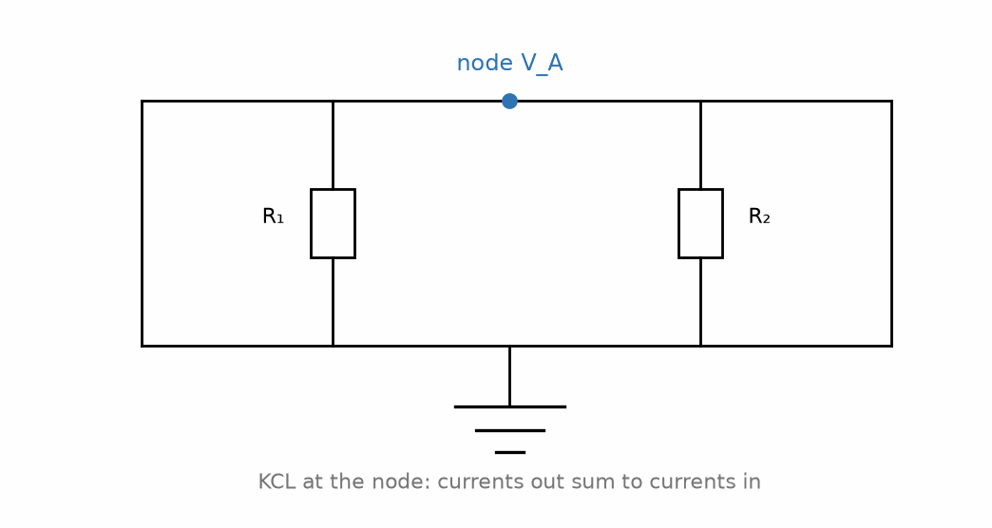
Figure 28.1 — A node voltage and the branch currents leaving it: KCL sets currents out equal to currents in.
The method treats every node's voltage (relative to a chosen reference node) as an unknown, writes one KCL equation per non-reference node, and solves the resulting system.

28.2 Choosing a Reference Node
Since only voltage differences are ever physically meaningful (Chapter 5), one node in the circuit is designated the reference node, arbitrarily assigned a voltage of exactly 0 V, usually chosen to be the node with the most connections (often literally labeled “ground” on a circuit diagram). Every other node's voltage is then understood to mean its voltage relative to this reference.

28.3 Writing the Node Equations
At every non-reference node, KCL is applied by expressing every branch current leaving that node in terms of the node voltages at its two ends and the resistance of that branch (using Ohm's law, I = V/R, applied across each resistor), and setting the sum of these outgoing currents equal to any current injected into the node by an independent source — one whose value is fixed from outside the circuit, not controlled by anything elsewhere in it:
Σ (V_{node} − V_{neighbor}) / R_{branch} = I_{injected}
Repeating this for every non-reference node produces a system of linear equations — one equation per unknown node voltage — solvable by substitution, elimination, or matrix methods for larger networks.

28.4 Handling Voltage Sources: The Supernode
An independent voltage source connected directly between two non-reference nodes complicates the ordinary node equation, since the current through a voltage source cannot be written directly in terms of a single resistance the way a resistor's current can. The standard technique is the supernode: the two nodes on either side of such a source are combined into a single “supernode,” for which one KCL equation is written treating the combined current leaving both nodes together, supplemented by a second equation stating the known voltage difference enforced by the source itself. This pair of equations — one KCL equation for the supernode as a whole, one constraint equation from the source — replaces the two individual node equations that would otherwise be needed.
Key Idea
Nodal analysis produces exactly one equation per unknown node voltage — except at a supernode, which still produces exactly two equations for its two node voltages, though not in the ordinary single-node form. Getting the equation count right before attempting to solve is the fastest way to catch a setup error before it propagates into a wrong final answer.
Worked Example 28.1
Problem: A circuit has two non-reference nodes, A and B. A 10 A current source injects current into node A. A 2.0 Ω resistor connects node A to ground. A 4.0 Ω resistor connects node A to node B. A 5.0 Ω resistor connects node B to ground. Find V_A and V_B.
Solution: Node A: current in (10 A) equals current out through the two resistors leaving A: 10 = V_A/2.0 + (V_A − V_B)/4.0. Node B: current leaving B through its two resistors sums to zero (no source directly at B): (V_B − V_A)/4.0 + V_B/5.0 = 0. Multiplying the first equation by 4.0: 40 = 2V_A + (V_A − V_B), so 40 = 3V_A − V_B. Multiplying the second by 20: 5(V_B − V_A) + 4V_B = 0, so 9V_B = 5V_A, giving V_B = (5/9)V_A. Substituting: 40 = 3V_A − (5/9)V_A = (22/9)V_A, so V_A = 360/22 ≈ 16.36 V, and V_B = (5/9)(16.36) ≈ 9.09 V.

28.5 Nodal Analysis for Larger Networks
For a network with many non-reference nodes, writing and solving the system of node equations by hand becomes impractical past three or four unknowns, and in practice the equations are instead assembled into a matrix equation, GV = I, where G is a conductance matrix built directly from the branch conductances (1/R for each resistor), V is the vector of unknown node voltages, and I is a vector of known injected currents. This matrix, for networks without supernodes, has a simple, mechanical construction rule: each diagonal entry is the sum of conductances connected to that node, and each off-diagonal entry is the negative of the conductance directly connecting the two corresponding nodes. Software tools used throughout the rest of this series (and throughout real engineering practice) build and solve exactly this matrix automatically for networks with hundreds or thousands of nodes — but the underlying equations being solved are never anything more than the same KCL statement introduced in this chapter, applied node by node.
Worked Example 28.2
Problem: A single non-reference node has two resistors, 4.0 Ω and 8.0 Ω, both connecting it to ground, and a 12 A current source injecting current into it. A third resistor, 2.0 Ω, connects this node to a second non-reference node, which itself has only a 6.0 Ω resistor to ground (no other connections). Find both node voltages.
Solution: Let node A be the first node and node B the second. Node A: 12 = V_A/4.0 + V_A/8.0 + (V_A − V_B)/2.0. Node B: (V_B − V_A)/2.0 + V_B/6.0 = 0. Multiplying the node A equation by 8.0: 96 = 2V_A + V_A + 4(V_A − V_B) = 7V_A − 4V_B. Multiplying the node B equation by 6.0: 3(V_B − V_A) + V_B = 0, so 4V_B = 3V_A, giving V_B = 0.75V_A. Substituting: 96 = 7V_A − 4(0.75V_A) = 7V_A − 3V_A = 4V_A, so V_A = 24 V, and V_B = 0.75(24) = 18 V.
Common Misconception
A frequent setup error is writing a node's KCL equation with inconsistent current directions — for instance, treating (V_A − V_B)/R as current leaving node A toward B in one term, while elsewhere in the same equation treating current from a neighboring node as if it were also automatically leaving A. The safest habit is to fix, once and for all before writing anything down, the convention that all resistor currents at a node are written as leaving that node (using the node's own voltage minus its neighbor's, divided by the connecting resistance), with any current source term signed according to whether it injects into or draws out of the node — and then to apply that same convention uniformly to every node equation in the circuit.
From the Bench
Choose the reference node sensibly: the node with the most connections, usually the negative supply or the board's 0 V. On the bench, every 'voltage at node X' is relative to wherever your black lead sits, so make your measurement reference the same as your analysis reference.
Worked Example 28.3 — A Voltage Source Between Two Unknown Nodes
A 12 V source has its positive terminal at node A and negative terminal at node B. A 6.0 Ω resistor connects A to ground; a 3.0 Ω resistor connects B to ground. Find both node voltages using a supernode.
Idea: Treat A and B as one supernode. KCL for the combined boundary is V_A/6.0 + V_B/3.0 = 0; the source supplies the second equation, V_A − V_B = 12 V.
From the source constraint, V_A = V_B + 12. Substitution gives (V_B + 12)/6 + V_B/3 = 0, so V_B = −4.0 V and V_A = 8.0 V. The negative node voltage means the actual polarity is below ground, not that the solution has failed.
Check: V_A/6 + V_B/3 = 8/6 − 4/3 = 0, and V_A − V_B = 8 − (−4) = 12 V. Both defining equations hold.
Usual mistake: Writing ordinary KCL at A and B without accounting for the unknown current through the ideal voltage source leaves an unsolved variable. The source current is not given; its voltage constraint is.

Practice Problems
- A single non-reference node has a 6 A current source injecting current into it, and two resistors — 3.0 Ω and 6.0 Ω — connecting it to ground. Find the node voltage.
- Write and solve the node equations for a circuit with three non-reference nodes, where node 1 has a 2 A source injected, a 4.0 Ω resistor to ground, and a 2.0 Ω resistor to node 2; node 2 has a 5.0 Ω resistor to ground and a 3.0 Ω resistor to node 3; node 3 has an 8.0 Ω resistor to ground.
- Explain, in your own words, why an independent voltage source connected between two non-reference nodes requires the supernode technique rather than an ordinary node equation.

What You’ll Actually Use
Everyday working tools
- Node voltages as unknowns, with KCL at each node.
- Supernodes when a voltage source joins two nodes.
Mostly for exams and deeper study
- Large circuits with dependent sources solved by hand.

Chapter 29 — Mesh Analysis
Mesh analysis is nodal analysis's twin. Instead of node voltages, you give each window of the circuit its own circulating current. For circuits with many nodes and few loops, it's the shorter road.
Where you meet this: Analysis of planar circuits, loop-current thinking about power paths, and ground-loop reasoning in EMC work.

29.1 The Idea Behind Mesh Analysis
Mesh analysis is nodal analysis's mirror image: rather than treating node voltages as the unknowns and applying KCL, it treats loop (“mesh”) currents as the unknowns and applies KVL around each mesh. A mesh, specifically, is a loop that contains no other loop within it — the smallest possible closed paths in a planar circuit diagram, which is why mesh analysis, unlike nodal analysis, applies only to planar circuits (those that can be drawn on a flat page with no branches crossing over one another).

29.2 Assigning Mesh Currents
Each mesh is assigned its own circulating current, conventionally taken clockwise (though any consistent choice works), understood as a fictitious current that flows only around that one mesh's own loop. Where two meshes share a branch, the actual physical current in that shared branch is the difference (or sum, depending on the relative directions) of the two meshes' currents — this is the key bookkeeping idea that makes mesh analysis work, and it is worth drawing out explicitly on a diagram before writing any KVL equation.

29.3 Writing the Mesh Equations
For each mesh, KVL is applied by traversing that mesh's loop in the assumed direction and summing the voltage drops across every element encountered, expressing each resistor's voltage drop in terms of the net current actually flowing through it (which may involve a neighboring mesh's current, for a shared branch), and setting independent sources' contributions on the other side of the equation:
Σ (I_{mesh} − I_{neighbor}) R_{shared} + Σ I_{mesh} R_{own} = Σ V_{sources}
As with nodal analysis, a current source shared between two meshes complicates the ordinary equation — the analogous fix here is the supermesh: the two meshes on either side of a shared current source are combined into a single supermesh, treated with one KVL equation around the combined outer loop, supplemented by a constraint equation stating the known current relationship the source enforces between the two mesh currents.
Key Idea
Nodal analysis and mesh analysis are dual methods. Nodal analysis is usually the more efficient choice when a circuit has fewer nodes than meshes (and is especially natural when current sources are involved, since they slot directly into KCL); mesh analysis is usually more efficient when a circuit has fewer meshes than nodes (and is especially natural when voltage sources dominate, since they slot directly into KVL). Both methods, correctly applied, must produce the same final answer for any quantity computed both ways — this agreement is one of the most useful checks available for catching an arithmetic or setup error.
Worked Example 29.1
Problem: A circuit has two meshes. Mesh 1 (current I₁, clockwise) contains a 10 V source and a 2.0 Ω resistor, and shares a 4.0 Ω resistor with mesh 2. Mesh 2 (current I₂, clockwise) contains the shared 4.0 Ω resistor and its own 6.0 Ω resistor, with no independent source. Find I₁ and I₂.
Solution: Mesh 1 KVL (traversing clockwise, starting right after the source): 10 = 2.0I₁ + 4.0(I₁ − I₂), giving 10 = 6.0I₁ − 4.0I₂. Mesh 2 KVL: the shared resistor's drop, from mesh 2's perspective, is 4.0(I₂ − I₁), plus the 6.0 Ω resistor's own drop 6.0I₂, with no source: 0 = 4.0(I₂ − I₁) + 6.0I₂, giving 0 = −4.0I₁ + 10I₂, so I₂ = 0.4I₁. Substituting into the first equation: 10 = 6.0I₁ − 4.0(0.4I₁) = 6.0I₁ − 1.6I₁ = 4.4I₁, giving I₁ ≈ 2.27 A, and I₂ = 0.4(2.27) ≈ 0.91 A. The actual current through the shared 4.0 Ω resistor is I₁ − I₂ ≈ 1.36 A.
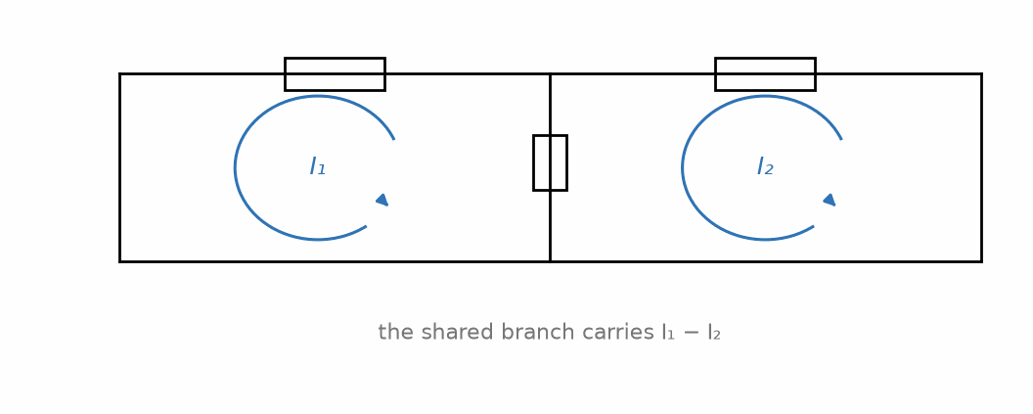
Figure 29.1 — Two mesh currents sharing a branch: the branch carries their difference.

29.4 Source Transformations
A practical bridge between nodal and mesh analysis, worth knowing independently of either: any real voltage source in series with a resistance can be replaced by an equivalent current source in parallel with the same resistance, and vice versa, without changing anything about how the rest of the circuit responds — this is exactly the same Thevenin/Norton relationship developed fully in Chapter 30, applied here as a mid-analysis simplification tool. A source transformation can convert a voltage source awkwardly placed for mesh analysis into a current source that slots naturally into a nodal analysis instead (or the reverse), and it is often faster, for a circuit with a mix of source types, to transform every source to whichever type matches the analysis method you intend to use, before writing a single equation.
Worked Example 29.2
Problem: A single mesh contains a 15 V source in series with a 3.0 Ω resistor, forming one branch, connected across a second branch in which a 5.0 Ω resistor and a 2.0 A current source sit in parallel with each other; the current source and the voltage source both drive current into the top node. Use a source transformation on the voltage source and its series resistor to simplify the circuit before analyzing it.
Solution: The 15 V source in series with 3.0 Ω transforms to an equivalent current source of 15/3.0 = 5.0 A in parallel with the same 3.0 Ω resistor. The circuit is now two current sources (5.0 A and 2.0 A) with two parallel resistors (3.0 Ω and 5.0 Ω). Taking both current sources as flowing into the same node (as the problem states), they add: 5.0 + 2.0 = 7.0 A total. The parallel resistors combine as (3.0)(5.0)/(3.0+5.0) = 1.875 Ω, so the node voltage is V = (7.0)(1.875) ≈ 13.1 V — reached entirely by simple parallel-circuit reasoning, without ever writing a mesh equation.
Common Misconception
Students who have just learned mesh analysis sometimes forget that a resistor shared between two meshes appears in both mesh equations, each time using the difference of the two meshes' currents (with the sign of that difference flipped between the two equations, since each mesh views the same physical current from the opposite side). Omitting the neighboring mesh's contribution to a shared resistor's voltage drop — treating it as if it belonged to only one mesh — is one of the most common setup errors in an otherwise correctly structured mesh analysis, and it is worth double-checking every shared branch specifically for this before solving the resulting system.
From the Bench
Thinking in loops pays off far beyond homework. Every current returns to its source, and the loop it takes sets both its magnetic field and its noise pickup. When a measurement is noisy, ask what loop the current is flowing in, and how big that loop is.

Practice Problems
- A single-mesh circuit contains a 20 V source, a 3.0 Ω resistor, and a 7.0 Ω resistor, all in series. Find the mesh current.
- Two meshes share a 5.0 Ω resistor. Mesh 1 has its own 3.0 Ω resistor and an 8.0 V source; mesh 2 has its own 2.0 Ω resistor and no source. Write the two mesh equations and solve them for both mesh currents.
- Explain why mesh analysis, unlike nodal analysis, cannot be applied directly to a non-planar circuit.

What You’ll Actually Use
Everyday working tools
- Mesh currents for circuits with few loops.
- Loop-area thinking for layout and noise.
Mostly for exams and deeper study
- Supermeshes, and the limits of mesh analysis for non-planar circuits.

Chapter 30 — Thevenin and Norton Equivalents
Why do a car's headlights dim when the starter cranks? Because the battery isn't an ideal source. It has internal resistance, and the starter's large current drops voltage across it. Thevenin's theorem says every linear source looks like that from the outside: an ideal voltage behind a resistance.
Where you meet this: Battery internal resistance, the 50 Ω output of signal generators, sensor interfacing, and maximum power transfer in RF (Chapter 37).

30.1 Why Equivalent Circuits Matter
Plug a phone charger, a lamp, and a speaker into the same wall outlet, one after another, and none of them need to know anything about the power plant, the transformers, or the miles of wiring standing behind that outlet — each device only cares about two things: the voltage available, and how much that voltage sags once real current is actually drawn. A small hobby battery and a car battery can both be rated at the same voltage, yet behave very differently once a real load is attached — the car battery barely sags, the small one drops noticeably — so a source is not fully described by its open-circuit voltage alone; something else about it matters too, once current actually flows.
What actually matters, for anything you plan to plug into a complicated network of sources and resistors, is not the full internal circuit at all — it's the minimum information needed to predict exactly how that network will behave, for any load you might attach. A genuinely complicated network could have dozens of resistors and sources tangled together, and re-solving that entire internal system from scratch every time a different load — a different speaker, a different sensor — gets connected would be an enormous, and largely wasted, amount of repeated work, when only the load itself actually changed.
Thevenin's theorem makes a remarkable promise: no matter how complicated a linear network behind two terminals actually is, it behaves — as far as anything connected to those two terminals can tell — exactly like a single ideal voltage source in series with a single resistor. Reduce it to those two numbers once, and every future load calculation becomes almost trivial.

30.2 The Thevenin Equivalent
The Thevenin equivalent of a network, as seen from a pair of terminals, consists of a voltage source V_Th in series with a resistance R_Th, found as follows:
- V_Th is the open-circuit voltage at the terminals — the voltage you would measure across them with nothing connected (an open circuit), found using any of the analysis techniques from Chapters 26–29.
- R_Th is the equivalent resistance seen looking back into the terminals with every independent source deactivated — voltage sources replaced by short circuits (0 V, since an ideal voltage source has zero internal resistance and forces its terminal voltage regardless of current), and current sources replaced by open circuits (since an ideal current source forces its current regardless of voltage, which an open circuit — infinite resistance — trivially satisfies at zero current).
Once V_Th and R_Th are known, any load connected to the original terminals sees exactly the same voltage and current it would see connected to this much simpler two-element equivalent — a fact that is not obvious on its own terms, but follows rigorously from the superposition property of linear circuits (developed fully in Chapter 31).
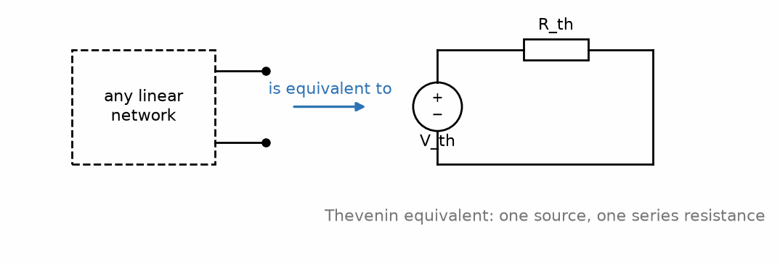
Figure 30.1 — Any linear network, viewed from a pair of terminals, is equivalent to one source and one series resistance.

30.3 The Norton Equivalent
The Norton equivalent is the source-transformed twin of the Thevenin equivalent: a current source I_N in parallel with the same resistance R_Th (often written R_N, though it is numerically identical to R_Th for the same network). I_N is the short-circuit current — the current that would flow if the two terminals were directly connected together — and it relates to the Thevenin quantities by Ohm's law applied to the equivalent circuit itself:
I_{N} = V_{Th} / R_{Th}
Thevenin and Norton equivalents are always interchangeable via this relationship, and which one is more convenient to compute or to use downstream depends entirely on the specific problem — a network dominated by voltage sources often yields V_Th more directly; a network dominated by current sources often yields I_N more directly.
Key Idea
R_Th is always found the same way, regardless of which equivalent you ultimately want: deactivate every independent source (short voltage sources, open current sources) and find the resulting resistance looking into the terminals. This single resistance value serves both the Thevenin and Norton equivalents identically.

30.4 Maximum Power Transfer
A Thevenin equivalent makes a classical and practically important question easy to answer: given a fixed source with Thevenin resistance R_Th, what load resistance R_L draws the maximum possible power from it? The answer, the maximum power transfer theorem, is R_L = R_Th — the load resistance is matched exactly to the source's internal (Thevenin) resistance. At this matched condition, exactly half the total power generated by the source is delivered to the load, and the other half is dissipated internally within R_Th; this 50% efficiency ceiling is the price of maximizing delivered power rather than maximizing efficiency, and real power-delivery systems (where efficiency, not raw power transfer, is usually the goal) deliberately avoid matched-impedance operation for exactly this reason — a distinction worth keeping in mind once this series reaches power systems, where the two goals genuinely diverge.
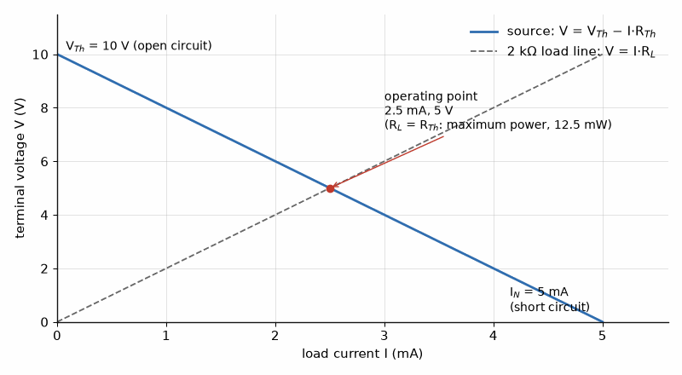
Figure 30.2 — A real source on one graph: open-circuit voltage at the top, short-circuit current at the right, and a straight line between them. A load equal to R_Th (here 2 kΩ) gets the most power out, at the price of wasting as much again inside the source.
Worked Example 30.1
Problem: A network, viewed from terminals A-B, has an open-circuit voltage of 9.0 V and a short-circuit current of 3.0 A. Find its Thevenin and Norton equivalents, and the load resistance that draws maximum power.
Solution: V_Th = 9.0 V (given directly as the open-circuit voltage). R_Th = V_Th/I_N = 9.0/3.0 = 3.0 Ω (from the relationship between the open-circuit and short-circuit conditions). Norton equivalent: I_N = 3.0 A in parallel with R_N = 3.0 Ω. Maximum power transfer occurs when R_L = R_Th = 3.0 Ω, at which point the load voltage is exactly half of V_Th (by the voltage-divider relationship between R_Th and a matched R_L), i.e., 4.5 V, delivering P = V²/R_L = (4.5)²/3.0 = 6.75 W to the load.

30.5 Practical Measurement of Thevenin Parameters
The derivation above assumes you already know the network's internal composition well enough to compute V_Th and R_Th directly. In practice — testing an unfamiliar circuit board, or characterizing a physical device such as a battery or a sensor — both quantities can be measured directly, without any knowledge of what is inside the black box. V_Th is the open-circuit voltage at the terminals of interest, read using a voltmeter (whose own internal resistance is, ideally, so large that it draws negligible current and does not disturb the measurement). R_Th can then be found either from a separate short-circuit current measurement, via R_Th = V_Th/I_N as in Section 30.3, or — often more safely, since deliberately short-circuiting a real device can be risky — by connecting a known load resistance, measuring the resulting terminal voltage, and solving the resulting voltage-divider relationship for R_Th. This experimental determination of a network's Thevenin equivalent is exactly how a real battery's internal resistance is characterized in practice, and it is why a battery's terminal voltage sags under heavy load: the load resistance and the battery's own (generally small, but nonzero) internal resistance form exactly the voltage-divider situation this book has already developed the tools to analyze.
Worked Example 30.2
Problem: A battery has an open-circuit terminal voltage of 9.0 V. When a 20 Ω load is connected, the terminal voltage drops to 8.0 V. Find the battery's internal (Thevenin) resistance.
Solution: The load and the battery's internal resistance form a voltage divider: V_load = V_Th × R_load/(R_load + R_Th). Substituting known values: 8.0 = 9.0 × 20/(20 + R_Th). Solving: (20 + R_Th) = 9.0 × 20/8.0 = 22.5, so R_Th = 2.5 Ω — a small but nonzero internal resistance, entirely typical of a real battery, and the direct physical reason its terminal voltage sags noticeably under a heavy enough load.
Common Misconception
It is tempting to think maximum power transfer (R_L = R_Th) is always the design goal, since “maximum power” sounds unambiguously desirable. In most real power-delivery contexts it is the opposite of what you want: at the matched condition, the source itself dissipates exactly as much power internally as the load receives, a 50% efficiency ceiling that would be unacceptable for a power grid (where R_Th is deliberately kept as small as possible relative to the load, so that nearly all delivered power reaches the load rather than being wasted as heat inside the source). Maximum power transfer matters most in signal and communication contexts — antenna matching, for instance — where the absolute power levels are small and efficiency is a secondary concern to getting as strong a signal through as possible.
From the Bench
Most function generators assume a 50 Ω load. Set one to 1 V, connect it to a high-impedance input, and you'll see about 2 V, because the generator's own 50 Ω no longer drops half the voltage. Check the generator's load or output-impedance setting before you doubt the circuit.

Practice Problems
- A network has V_Th = 12 V and R_Th = 4.0 Ω. Find its Norton equivalent.
- A network has a Norton equivalent of I_N = 2.0 A in parallel with R_N = 6.0 Ω. Find its open-circuit voltage.
- For the network in the previous problem, find the load resistance for maximum power transfer, and the power delivered to that load.
- Explain briefly why deactivating an independent voltage source means replacing it with a short circuit, referring to what an ideal voltage source's own defining behavior is.

What You’ll Actually Use
Everyday working tools
- Measuring V_Th (open circuit) and R_Th (with a known load).
- Thinking of every source and load as an impedance.
Mostly for exams and deeper study
- The formal proof of Thevenin's theorem.
- Norton conversions with dependent sources.

Chapter 31 — Superposition and Linearity
Plug a guitar into an amplifier while the fridge compressor kicks in and you hear the music and a hum together. In a linear system, each cause produces its own effect and the effects add. That is superposition, and it is why the signal and the noise can be analyzed separately.
Where you meet this: Treating DC bias and AC signal separately, noise analysis, and any circuit with more than one source.

31.1 Linear Circuits
A circuit is linear if it is built entirely from linear elements: resistors (V = IR), capacitors and inductors (whose defining relationships, from Part I, are likewise linear), and independent sources. Diodes, transistors, and other devices met later in this series are generally not linear, and none of the techniques in this chapter apply to them directly without first restricting attention to a small enough operating range that their behavior can be approximated as linear — a technique this series returns to explicitly once those devices are introduced.

31.2 The Superposition Theorem
A resistor sits in a circuit fed by two separate sources at once — say a 10 V voltage source and a 4 A current source, both pushing current through the same resistor. Solving for the actual current through that resistor, with both sources active together, generally means setting up the full circuit and solving it as one system.
There is a shortcut, though, and it looks almost too good to be true. Turn off the 4 A source (replace it with an open circuit) and solve for the current from the 10 V source alone — say this comes out to 2.0 A. Turn the 10 V source back off instead (replace it with a short circuit) and solve for the current from the 4 A source alone — say this comes out to 1.5 A. Add those two separately-computed numbers together, 2.0 + 1.5 = 3.5 A, and — remarkably — that is the correct current through the resistor with both sources active simultaneously, exactly as if each source's contribution did not care that the other one was also present.
This should feel a little suspicious. Two sources acting on the same resistor at the same time could easily interact in complicated ways, one source's presence changing how the circuit responds to the other. Whether adding two separately-computed answers together like this actually gives the right total is not something to take for granted only because it worked once.
It works here for a specific reason: every equation used to solve this circuit — Ohm's law, KCL, KVL — is linear, meaning doubling a source doubles its effect, and the response to two sources acting together is exactly the sum of their individual effects. This is exactly the same reason forces and fields from multiple charges added back in Chapters 2 and 3 — a mathematical property of linear systems generally, not a coincidence specific to this one resistor.
This is the superposition theorem, stated formally: in any linear circuit containing multiple independent sources, the voltage or current at any point can be found by considering each independent source separately — deactivating all other independent sources exactly as in the Thevenin-equivalent method of Chapter 30 (voltage sources shorted, current sources opened) — solving the resulting simpler circuit for the contribution of that one source alone, and then algebraically summing the individual contributions from every source to get the total.
Key Idea
Superposition applies to voltages and currents, never to power. Power depends on voltage and current multiplied together (P = IV or P = I²R), and squaring or multiplying is not a linear operation — the power delivered by two sources acting together is generally not the sum of the powers each would deliver acting alone. Superposition is a technique for finding voltages and currents; power in a multi-source circuit must always be computed afterward, from the correctly superposed total voltage or current, never by adding individually-computed powers.

31.3 Why Superposition Works
Superposition is not a special trick specific to circuits — it is the same principle already met twice in this series: as the statement that Coulomb forces and electric fields from multiple charges add (Chapters 2 and 3), and it holds here for exactly the same underlying reason. Every equation used to solve a linear circuit — Ohm's law, KCL, KVL, the nodal and mesh equations built from them — is linear in the sources appearing in it, meaning if you scale every source by some factor, every resulting voltage and current scales by that same factor, and if you have two separate sets of sources active simultaneously, the resulting voltages and currents are exactly the sum of what each set would produce acting alone. This is a mathematical property of linear systems in general, and circuit theory is one particular, especially useful, arena in which it applies.

31.4 When Superposition Is (and Is Not) Worth Using
Superposition is rarely the fastest method for finding a single specific quantity in a circuit with many sources — nodal or mesh analysis, solved once for the whole circuit, is usually less work than solving the circuit repeatedly, once per source. Superposition earns its keep in two other situations: when you specifically want to know each source's individual contribution to some quantity (useful for understanding which source dominates a circuit's behavior, or for noise analysis later in this series, where different sources of unwanted signal need to be tracked separately), and as a conceptual tool for proving other results — the Thevenin equivalent's validity, for instance, rests directly on superposition.
Worked Example 31.1
Problem: A resistor R carries current contributed by two independent sources. Acting alone (with the other source deactivated), a 10 V source produces 2.0 A through R. Acting alone, a 4 A current source produces 1.5 A through R in the same direction. Find the total current through R with both sources active.
Solution: By superposition, the total current is the sum of the two individual contributions (since both were found to flow in the same direction): I_total = 2.0 + 1.5 = 3.5 A. Had the two contributions been found to flow in opposite directions, they would instead have been subtracted, with the sign of each contribution (relative to a chosen reference direction) tracked explicitly throughout.
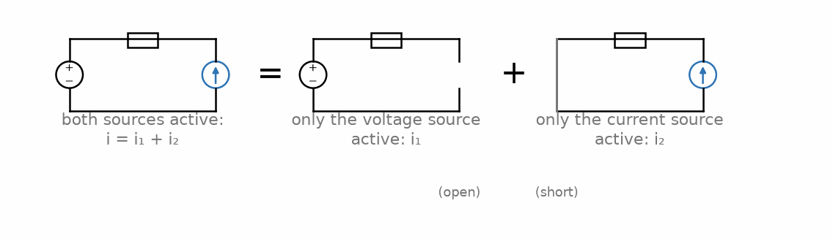
Figure 31.1 — Superposition: the response with both sources active equals the sum of each source acting alone.

31.5 Dependent Sources and Superposition
This book has, so far, only used independent sources — voltage or current sources whose value is fixed, set from outside the circuit. Many practical circuits, and essentially every transistor small-signal model this series will introduce in its semiconductor-devices volume, also contain dependent (controlled) sources, whose value is instead proportional to some other voltage or current elsewhere in the same circuit. Superposition's deactivation rule applies only to independent sources — a dependent source must never be deactivated when superposing, since doing so would discard the very relationship (to whatever voltage or current controls it) that defines it, and that relationship generally still involves contributions from every independent source active in the problem. In practice, this means a circuit with dependent sources is solved by superposing over the independent sources only, while the dependent source's own defining equation is carried through, unmodified, in every one of the individual sub-problems.
Worked Example 31.2
Problem: Acting alone, a 5.0 V independent source produces a current of 1.0 A through a resistor R, and this same current, through a dependent source's controlling relationship, produces a dependent voltage of 2.0 V elsewhere in the circuit (dependent source value = 2× the controlling current, in volts per ampere). A second independent source, a 2.0 A current source, acting alone (with the dependent source's relationship still active, only the independent 5.0 V source deactivated), produces 0.4 A through the same resistor R. Find the total current through R with both independent sources active, and the resulting dependent source value.
Solution: Superposing over the two independent sources only (the dependent source itself is never deactivated in either sub-problem): total current through R = 1.0 + 0.4 = 1.4 A, giving the dependent source's value as 2 × 1.4 = 2.8 V. Because that source's gain is linear and it stays active throughout, its own contributions would superpose too — 2×1.0 = 2.0 V from the first sub-problem and 2×0.4 = 0.8 V from the second, summing to the same 2.8 V — but summing the controlling current first, as above, is the more direct route.
Common Misconception
Because superposition works cleanly for voltage and current, it is a natural (but incorrect) next guess that it should also work for power — that the total power dissipated in a resistor, with multiple sources active, is the sum of the powers each source would cause individually. It is not: power is proportional to the square of voltage or current, and (a + b)² ≠ a² + b² in general (there is a cross term, 2ab, left over). The correct procedure is always to superpose the voltages or currents first, add them algebraically to get the total, and only then compute power from that final total value — never to compute power source-by-source and add the results. In Worked Example 31.1, 2.0 A and 1.5 A through a 4.0 Ω resistor would dissipate 16 W and 9 W separately. Together they make 3.5 A and 49 W, not 25 W. A resistor sized from the sum of the separate powers would be underspecified by almost a factor of two.
From the Bench
Superposition only holds while the circuit stays linear. An amplifier near clipping, a diode switching on or an op-amp at its supply rail breaks it, and two signals that each look fine alone can intermodulate when applied together. If adding a second signal changes the first, you've left linear territory.

Practice Problems
- Acting alone, a voltage source produces 3.0 V across a resistor. Acting alone, a current source produces −1.0 V across the same resistor (opposite polarity). Find the total voltage with both sources active.
- Take Worked Example 31.1's two contributions (2.0 A and 1.5 A, in the same direction) and let R = 4.0 Ω. Show that adding the power each source would deliver alone gives the wrong total power, and find the size of the error.
- A linear circuit contains three independent sources. How many simplified circuits must be solved to apply superposition fully?

What You’ll Actually Use
Everyday working tools
- DC and AC analysis done separately.
- Switching sources off: voltage sources shorted, current sources opened.
Mostly for exams and deeper study
- Formal proofs of additivity and homogeneity.

Chapter 32 — Capacitors and Inductors as Circuit Elements
Unplug an old television or a camera flash, and some of the capacitors inside can still hold a dangerous charge minutes later. Capacitors and inductors store energy, and they resist sudden change: a capacitor's voltage cannot jump, and neither can an inductor's current.
Where you meet this: Decoupling and bulk capacitors, power-supply inductors, timing circuits, filters, and motor and relay coils.

32.1 The v-i Relationships, Restated for Circuit Use
Part I defined capacitance and inductance from field physics. For circuit analysis, what matters is each element's voltage-current (v-i) relationship, restated here in the form used throughout the rest of this book:
Capacitor: i = C dv/dt Inductor: v = L di/dt
Both relationships are fundamentally different in character from a resistor's V = IR: a resistor's voltage and current are related instantaneously and algebraically, while a capacitor's current and an inductor's voltage depend on the rate of change of the other quantity, making both elements inherently dynamic — their behavior depends on the circuit's history, not only its instantaneous state, which is precisely why they are called dynamic or energy-storage elements, in contrast to a resistor's purely dissipative behavior.

32.2 Continuity Conditions
Two facts follow directly from the v-i relationships above and are used constantly in transient analysis (Chapter 33): a capacitor's voltage cannot change instantaneously (an instantaneous voltage change would require i = C dv/dt to be infinite, which no real source can supply), and an inductor's current cannot change instantaneously (for the parallel reason that an instantaneous current change would require v = L di/dt to be infinite).
Key Idea
Capacitor voltage and inductor current are the two quantities that must remain continuous across any switching event. Everything else in a circuit — resistor voltages and currents, capacitor current, inductor voltage — can and generally does change abruptly the instant a switch operates. This single fact is the starting point for every transient-analysis problem in the next chapter.

32.3 Energy Storage, Revisited
Part I established that a capacitor stores energy U = ½Cv² and, in its closing chapters, that an inductor stores energy U = ½Li². Both expressions reappear constantly in circuit-level energy accounting, and both make explicit, in circuit terms, why the two continuity conditions above must hold: an instantaneous jump in capacitor voltage or inductor current would correspond to an instantaneous jump in stored energy, which would require an infinite instantaneous power delivery — physically impossible for any real, finite source.
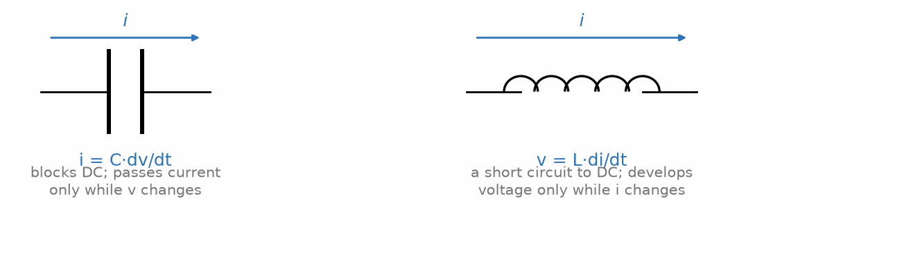
Figure 32.1 — The defining v-i relationships for a capacitor and an inductor.

32.4 Series and Parallel Combinations, Revisited
Part I introduced the capacitor combination rules (parallel adds, series reciprocal-sums) alongside the parallel-plate capacitor derivation. Inductors, it is worth noting explicitly here, combine exactly like resistors rather than like capacitors — series inductances add directly, and parallel inductances combine by reciprocal sum:
L_{series} = L₁ + L₂ + … , 1/L_{parallel} = 1/L₁ + 1/L₂ + …
This gives a useful, if slightly untidy, memory anchor across all three passive elements: resistors and inductors share one combination pattern (series adds, parallel reciprocal-sums), while capacitors follow the opposite pattern — a fact traceable, in each case, back to whether the element's defining relationship involves current or its time-integral (charge) on one side.
Worked Example 32.1
Problem: A 10 µF capacitor's voltage is changing at a rate of 500 V/s. Find the current through it.
Solution: i = C dv/dt = (10×10⁻⁶)(500) = 5.0×10⁻³ A = 5.0 mA.
Worked Example 32.2
Problem: A 3.0 H inductor and a 6.0 H inductor are connected (a) in series and (b) in parallel. Find the equivalent inductance in each case.
Solution: (a) Series: L = 3.0 + 6.0 = 9.0 H. (b) Parallel: 1/L = 1/3.0 + 1/6.0 = 2/6.0 + 1/6.0 = 3/6.0, so L = 2.0 H — following exactly the same combination pattern as resistors, not capacitors.
Common Misconception
Because a resistor's power is always positive (dissipated as heat, regardless of current direction, since P = I²R involves a squared term), it is easy to assume the same must be true of a capacitor's or inductor's instantaneous power. It is not: a capacitor or inductor's instantaneous power, p(t) = v(t)i(t), is regularly negative — precisely during the portion of a cycle when the element is returning previously-stored energy back to the rest of the circuit rather than absorbing more of it. Averaged over a full cycle of steady sinusoidal operation, an ideal capacitor or inductor's net energy exchange is exactly zero (all the energy it absorbs during part of the cycle, it returns during another part), which is the seed of the “reactive power” concept developed fully in Chapter 35 — reactive power is, in a real sense, this back-and-forth energy exchange, tallied up and given its own name and unit.
From the Bench
Discharge large capacitors before touching them, through a resistor rather than a screwdriver, and confirm with a meter. For inductors, check the saturation current: beyond it the core saturates, the inductance collapses and the current can spike. A '10 µH' inductor is only 10 µH below its rated current.

Practice Problems
- A capacitor's voltage changes at a constant rate of 200 V/s, producing a current of 4.0 mA through it. Find its capacitance.
- An inductor carries a current changing at 10 A/s, producing a voltage of 2.0 V across it. Find its inductance.
- Two inductors, 4.0 H and 4.0 H, are connected in parallel. Find the equivalent inductance.
- Explain briefly why an inductor's current, unlike a resistor's, cannot change instantaneously when a switch in its circuit is closed.

What You’ll Actually Use
Everyday working tools
- Capacitor voltage and inductor current are continuous.
- Stored energy ½CV² and ½LI².
- Combination rules, which for capacitors are the reverse of resistors.
Mostly for exams and deeper study
- The formal duality between capacitors and inductors.

Chapter 33 — First-Order Transients: RC and RL Circuits
Why does the indicator LED on a power strip fade slowly after you switch it off? The supply's capacitor is discharging through the LED and its resistor, along an exponential set by a single number, the time constant τ = RC.
Where you meet this: Power-on reset circuits, switch debouncing, RC timers, the rise time of signals on cables, and inrush current at power-up.

33.1 What a Transient Is
A transient is the temporary response of a circuit as it moves from one steady condition to another, following a sudden change such as a switch closing or opening. The preceding chapters established the tools for steady-state resistive circuit analysis; this chapter is the first to ask what happens during the interval of change itself, and it is where the dynamic elements introduced in Chapter 32 — capacitors and inductors — finally do something a purely resistive circuit cannot: respond gradually, over time, rather than instantaneously.

33.2 The RC Circuit — Discharging
Consider a capacitor, initially charged to voltage V₀, connected at time t = 0 across a resistor R (with no source), allowing it to discharge. Applying KVL and the capacitor's defining relationship i = C dv/dt leads to a first-order differential equation whose solution is an exponential decay:
v(t) = V₀ e^{−t/RC}
The quantity τ = RC, called the time constant, has units of time (seconds, when R is in ohms and C in farads) and sets the natural timescale of the decay: after one time constant, the voltage has fallen to about 37% (1/e) of its initial value; after five time constants, it has fallen below 1% and is conventionally treated as having reached its final (here, zero) value for most practical purposes.

33.3 The RC Circuit — Charging
If instead an initially uncharged capacitor is connected, at t = 0, in series with a resistor R across a DC source of voltage V_s, the capacitor voltage rises according to:
v(t) = V_{s} (1 − e^{−t/RC})
approaching V_s asymptotically, with the same time constant τ = RC governing how quickly it gets there: after one time constant, the capacitor has charged to about 63% of V_s; after five time constants, it is within about 1% of fully charged.
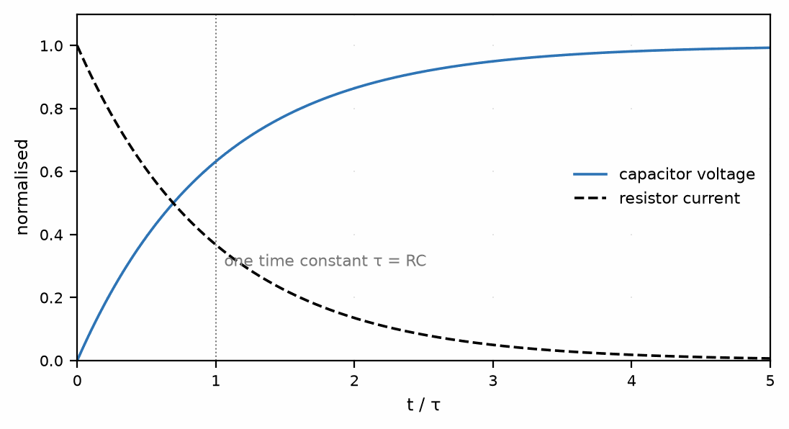
Figure 33.1 — Capacitor voltage and resistor current during RC charging, in units of the time constant.

33.4 The RL Circuit
An RL circuit behaves as the direct dual of the RC circuit, with the inductor's current — not a capacitor's voltage — being the quantity that cannot change instantaneously and that follows the exponential time course. For a series RL circuit switched onto a DC source V_s at t = 0, with the inductor initially carrying no current:
i(t) = (V_{s}/R) (1 − e^{−tR/L})
with time constant τ = L/R (units of seconds, when L is in henries and R in ohms) playing exactly the same role here that RC played for the capacitor circuit.
Key Idea
Every first-order transient follows the same universal template. Whatever the quantity of interest — capacitor voltage, inductor current, or any other voltage or current in a single-time-constant circuit — it can always be written as x(t) = x_final + (x_initial − x_final) e^(−t/τ), where x_initial and x_final are the quantity's values immediately after the switching event and infinitely long afterward, respectively, and τ is RC for a capacitive circuit or L/R for an inductive one. Memorizing this one general template is more useful than memorizing the charging and discharging formulas separately, since every specific case in this chapter is this template with the appropriate initial value, final value, and time constant substituted in.
Worked Example 33.1
Problem: A 100 µF capacitor, charged to 20 V, is discharged through a 5.0 kΩ resistor starting at t = 0. Find the capacitor voltage at t = 0.50 s.
Solution: τ = RC = (5.0×10³)(100×10⁻⁶) = 0.50 s. v(t) = V₀e^(−t/τ) = 20e^(−0.50/0.50) = 20e⁻¹ ≈ 7.36 V — exactly the “37% of initial value” benchmark, since the elapsed time here happens to equal exactly one time constant.
Worked Example 33.2
Problem: A series RL circuit with R = 10 Ω and L = 2.0 H is connected to a 20 V source at t = 0, with the inductor initially carrying no current. Find the current at t = 0.10 s, and the final steady-state current.
Solution: τ = L/R = 2.0/10 = 0.20 s. Final current (steady state, once di/dt = 0 so the inductor's voltage drop vanishes and it behaves like a plain wire): I_final = V_s/R = 20/10 = 2.0 A. At t = 0.10 s: i(t) = I_final(1 − e^(−t/τ)) = 2.0(1 − e^(−0.10/0.20)) = 2.0(1 − e^(−0.5)) ≈ 2.0(1 − 0.607) ≈ 0.79 A.

33.5 A Note on Second-Order Circuits
This chapter has deliberately restricted itself to first-order circuits — those containing exactly one energy-storage element (one capacitor or one inductor, possibly combined with any number of resistors that can all be reduced, by the equivalent-resistance methods of Chapter 27, to a single effective R). A circuit containing both a capacitor and an inductor together (an RLC circuit) is second-order, governed by a second-order differential equation whose solution can take three qualitatively different forms — overdamped (a sluggish, non-oscillating return to steady state, similar in character to the first-order case but slower), underdamped (an oscillating, gradually decaying return, ringing back and forth around the final value before settling), or critically damped (the fastest possible return without any oscillation, sitting exactly at the boundary between the other two behaviors). Working through the general second-order case properly requires machinery — characteristic equations, damping ratios, natural frequencies — that this book has not yet built, and it is deferred deliberately rather than treated in an abbreviated, unsatisfying way here.
What this book has built, however, is not wasted: Chapter 36's resonant frequency ω₀ = 1/√(LC) is exactly the undamped natural frequency of the very same second-order RLC system being described here, found by an entirely different (sinusoidal-steady-state) route — a second confirmation, alongside the small-signal preview in Chapter 38, that the specific tools built in this book keep resurfacing, largely unchanged, in contexts this book itself does not fully develop.
Common Misconception
It is tempting to assume an inductor “blocks” current indefinitely, by loose analogy with how a capacitor blocks DC current once fully charged. In steady state (once enough time constants have elapsed that transients have died out), an inductor behaves like a plain wire — zero voltage drop, since v = L di/dt vanishes once current is no longer changing — allowing DC current through it completely unimpeded. It is only during the transient itself, while current is actively changing, that the inductor's back-EMF has any effect; a capacitor, by contrast, does genuinely block steady DC current in its final, fully-charged steady state, the opposite long-term behavior from an inductor's.

33.6 Transients in the Reader Lab: Buttons and the I²C Bus
A push button does not close cleanly. Its metal contacts bounce for a millisecond or more, so a single press can look like several presses to a fast input. An RC filter with a time constant longer than the bounce smooths it out, and a Schmitt-trigger input (one with two thresholds, Book 2) turns the slow edge back into a clean one. The same exponential from Section 33.3 sets how fast any open-drain bus can run: on I²C, the bus the BME280 and the OLED share, the chips only pull the lines low, and a pull-up resistor charges the wiring's capacitance back up, an RC charging curve at every rising edge.
Worked Example 33.3 — Debouncing a Button
Problem: A button connects an input to ground; a 10 kΩ pull-up to 3.3 V and a 100 nF capacitor from the input to ground form the filter. When the button is released, how long does the input take to reach a high threshold of 0.75 × 3.3 V?
Solution: τ = RC = 10 kΩ × 100 nF = 1.0 ms. Charging from 0 V, v = 3.3(1 − e^(−t/τ)), and reaching 75 % needs e^(−t/τ) = 0.25, so t = τ ln 4 ≈ 1.39 ms. Short bounces during release barely move the slow voltage, so the input sees one clean change about 1.4 ms after the release. When pressed, the switch discharges the capacitor almost at once; a 100 Ω to 1 kΩ resistor in series with the switch limits that discharge current. Firmware can do the same job by ignoring changes for 10 to 20 ms; many designs use both.
Worked Example 33.4 — Pull-Ups for the BME280 and the OLED
Problem: The BME280 and OLED modules share an I²C bus with about 100 pF of capacitance, counting both modules and 20 cm of jumper wire. In this kit the BME280 module carries 10 kΩ pull-ups and the OLED module 4.7 kΩ, which end up in parallel (check your own modules: many carry pull-ups). The I²C specification measures rise time from 30 % to 70 % of the supply and allows 1000 ns at 100 kHz and 300 ns at 400 kHz. Does the bus work at both speeds? What if only the 10 kΩ pull-ups were fitted?
Solution: Rise time from 30 % to 70 %: from v = V(1 − e^(−t/RC)), t = RC ln(0.7/0.3) = 0.8473RC. The pull-ups in parallel give 10 ∥ 4.7 ≈ 3.2 kΩ, so t_r = 0.8473 × 3.2 kΩ × 100 pF ≈ 271 ns: inside both limits, with little margin at 400 kHz. With only 10 kΩ, t_r ≈ 847 ns: fine at 100 kHz, too slow at 400 kHz. The other limit: the chips must pull the line below 0.4 V while sinking at most 3 mA, so R ≥ (3.3 − 0.4)/3 mA ≈ 967 Ω. Adding modules adds pull-ups in parallel and capacitance at the same time, which is why a bus that worked with two modules can fail with five.
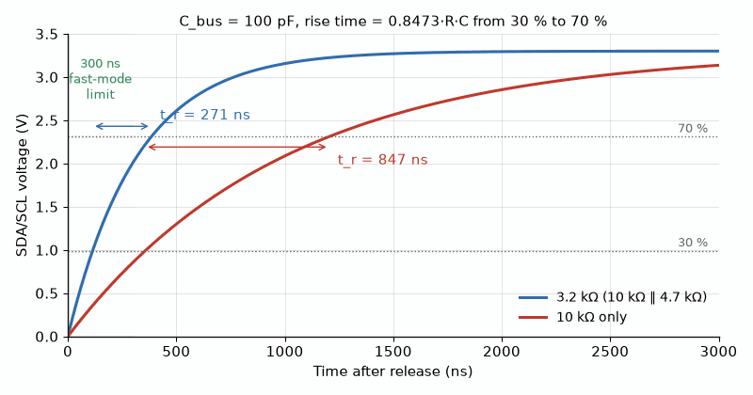
Figure 33.2 — Every rising edge on I²C is an RC charging curve. With 3.2 kΩ and 100 pF the 30 to 70 % rise takes 271 ns, inside the 300 ns fast-mode limit; with 10 kΩ it takes 847 ns, too slow for 400 kHz.
From the Bench
Rise time and bandwidth are linked. For a single RC pole, the 10–90% rise time is about 2.2τ, or roughly 0.35 divided by the −3 dB bandwidth. The same rule applies to your oscilloscope: a 100 MHz scope can't show a rise much faster than about 3.5 ns, so a 'beautiful 2 ns edge' on it is mostly the scope's own response.

Practice Problems
- A 50 µF capacitor is charged through a 2.0 kΩ resistor from a 12 V source. Find the time constant and the capacitor voltage after one time constant has elapsed.
- An RL circuit has R = 20 Ω and L = 4.0 H. Find its time constant.
- For the circuit in the previous problem, connected to a 10 V source at t = 0 with zero initial current, find the current after two time constants have elapsed.
- Explain briefly why an inductor behaves like a plain wire (zero voltage drop) once a circuit reaches DC steady state.
- An I²C bus has 150 pF of capacitance. Find the largest pull-up resistor that meets the 300 ns rise-time limit of 400 kHz fast mode, and the smallest one allowed at 3.3 V if the drivers can sink 3 mA while holding 0.4 V. Pick a standard value and find its rise time.

What You’ll Actually Use
Everyday working tools
- τ = RC and τ = L/R.
- 63% after one τ, about 99% after five.
- Rise time ≈ 2.2τ ≈ 0.35 / bandwidth.
- RC debouncing for buttons, and the I²C pull-up rule t_r ≈ 0.85·Rp·Cb.
Mostly for exams and deeper study
- Solving the first-order differential equation formally.

Chapter 34 — Sinusoidal Steady-State Analysis
Plug in a motor and the current it draws peaks a little after the voltage does. Nothing is wrong. That's an inductive load, and phasor analysis predicts exactly how far behind the current runs. This chapter applies every DC technique to AC, with complex numbers doing the extra work.
Where you meet this: AC mains circuits, audio crossover networks, filter design, and RF impedance work.

34.1 Solving AC Circuits with Phasors
With impedance defined (Chapter 23), an AC circuit at a single fixed frequency is analyzed exactly like a DC resistive circuit, with three substitutions: every resistor, capacitor, and inductor is replaced by its impedance; every sinusoidal source is replaced by its phasor; and every resulting voltage or current in the solution is itself a phasor, convertible back to a time-domain sinusoid only at the very end, using the source's known frequency ω.

34.2 Series and Parallel Impedance Combination
Impedances combine exactly like resistances — series impedances add, parallel impedances combine by reciprocal sum — with the arithmetic now performed on complex numbers rather than real ones:
Z_{series} = Z₁ + Z₂ + … , 1/Z_{parallel} = 1/Z₁ + 1/Z₂ + …
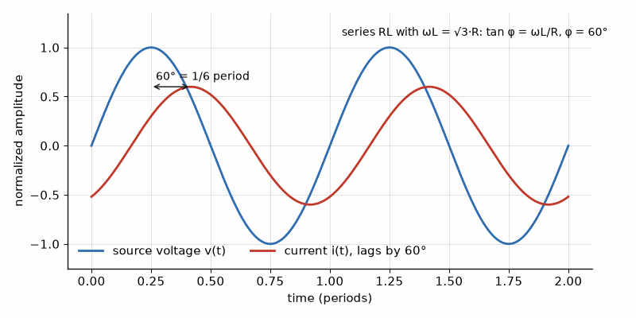
Figure 34.1 — In a series RL circuit the current lags the voltage. With ωL = √3·R the lag is exactly 60°, one sixth of a period, and a two-channel scope shows it directly.
The voltage and current dividers from Chapter 27 likewise carry over unchanged in form, with impedances substituted for resistances:
V₁ = V · Z₁/(Z₁+Z₂) , I₁ = I · Z₂/(Z₁+Z₂)

34.3 Nodal, Mesh, Thevenin, and Superposition in the Phasor Domain
Nodal analysis, mesh analysis, Thevenin and Norton equivalents, and superposition (Chapters 28 through 31) all carry over to phasor circuits exactly as stated, with resistances replaced by impedances throughout — the underlying laws (KCL, KVL) are statements about instantaneous charge and energy conservation that hold regardless of whether the circuit's quantities happen to be constant, transient, or sinusoidally oscillating, so nothing about the reasoning behind any of those five techniques actually depended on the circuit being purely resistive DC in the first place. This is the single biggest practical payoff of the phasor method: an engineer who has mastered Chapters 26 through 31 has, without additional conceptual work, already mastered the corresponding AC techniques — only the arithmetic (complex rather than real) is new.
Key Idea
Every systematic technique from Chapters 26–31 applies unchanged to phasor circuits. Replace every resistance with the corresponding impedance, every source with its phasor, solve using ordinary complex-number algebra, and convert the final phasor answer back to a time-domain sinusoid only as the last step.

34.4 RMS Values
A note on convention: this book's phasors carry RMS magnitude by default (Chapter 23), not peak amplitude — chosen because most AC quantities, including household mains voltage ratings, are themselves quoted as RMS values, defined so that an RMS voltage delivers the same average power to a resistor as a DC voltage of the same numeric value would. Occasionally, though, it is the peak amplitude V_m that is actually given or wanted. For a sinusoid, RMS and peak amplitude relate simply:
V_{rms} = V_{m} / √2 ≈ 0.707 V_{m}
A “120 V” household outlet in the United States, for instance, is a 120 V RMS rating, corresponding to a peak voltage of about 170 V — the actual voltage waveform swings between +170 V and −170 V every cycle, even though the quoted, practically relevant number is 120 V. Power calculations (Chapter 35) are almost always done using RMS values directly, specifically so that AC power formulas take the same simple form as their DC counterparts. Treating 120 V RMS as though it were 120 V peak would halve the calculated heating in a resistor: 100 Ω would be assigned 72 W instead of 144 W. In a power design, that is a thermal-rating error, not a notation preference.
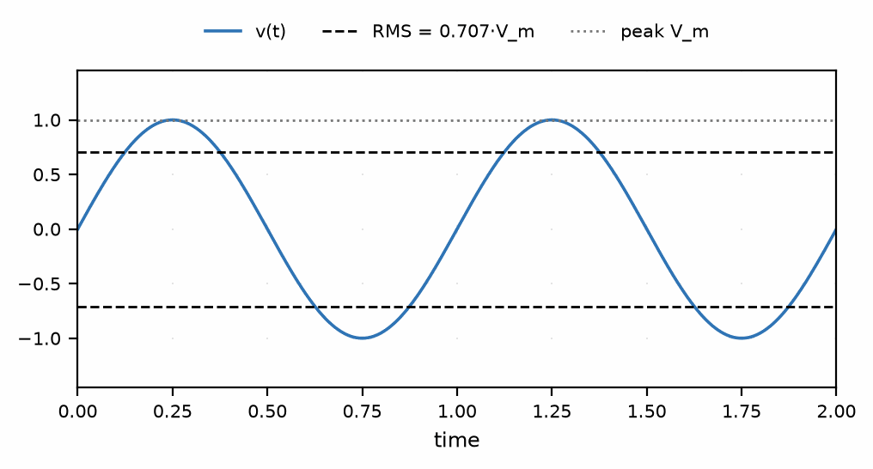
Figure 34.2 — A sinusoid's peak and RMS values.
Worked Example 34.1
Problem: A 100∠0° V phasor source (RMS magnitude, per this book's convention, at some frequency ω) drives a series combination of a 30 Ω resistor and an inductor with impedance j40 Ω. Find the current phasor and the phasor voltage across the inductor.
Solution: Total impedance: Z = 30 + j40 = 50∠53.1° Ω (magnitude √(30²+40²) = 50, angle arctan(40/30) ≈ 53.1°). Current: I = V/Z = 100∠0° / 50∠53.1° = 2.0∠−53.1° A. Voltage across the inductor: V_L = I × Z_L = (2.0∠−53.1°)(40∠90°) = 80∠36.9° V (multiplying polar-form complex numbers: multiply magnitudes, add angles).
Worked Example 34.2
Problem: A sinusoidal source has a peak voltage of 170 V. Find its RMS voltage, and identify the familiar household voltage rating this corresponds to.
Solution: V_rms = V_m/√2 = 170/1.414 ≈ 120 V — the standard nominal household voltage rating in North America, confirming that the “120 V” outlet rating is indeed an RMS value, not the actual peak voltage present on the line.
Common Misconception
Because impedance combines exactly like resistance, it is easy to slip into treating impedance magnitudes as if they combined the same simple way — for instance, assuming two impedances in series always add to give a larger magnitude in a straightforward way. Impedances are complex numbers, and complex addition does not add magnitudes (except in the special case where both impedances happen to have the same angle); a 30 Ω resistor in series with a j40 Ω inductor's impedance, for instance, gives a combined magnitude of 50 Ω (via the Pythagorean-style calculation in Worked Example 34.1), not 30 + 40 = 70 Ω. Always add impedances in rectangular form, term by term, and only convert to polar form (magnitude and angle) afterward, once the addition itself is complete.
From the Bench
RMS is what meters and ratings mean, but only a true-RMS meter measures it correctly for waveforms that aren't sine waves. An average-responding meter is calibrated for sines and can read well low on the peaky current of a switching supply or a lamp dimmer. If the waveform isn't a clean sine, use a true-RMS meter or compute RMS from the scope.

Practice Problems
- A 50∠0° V source drives a series RC circuit with R = 30 Ω and Z_C = −j40 Ω. Find the total impedance in polar form.
- Using the impedance found in the previous problem, find the current phasor.
- A sinusoidal voltage has an RMS value of 240 V. Find its peak amplitude.
- Two impedances, 20∠0° Ω and 20∠90° Ω, are in series. Find the combined impedance in both rectangular and polar form.

What You’ll Actually Use
Everyday working tools
- Impedance combination and phasor nodal and mesh analysis.
- RMS: V_rms = V_peak/√2 for a sine.
Mostly for exams and deeper study
- Large AC networks solved fully by hand.

Chapter 35 — AC Power and Power Factor
Your electricity meter charges for watts, but the utility has to build wires and transformers for volt-amperes. When a load's current is out of step with its voltage, the two differ, and somebody pays for the difference. That difference is what power factor measures.
Where you meet this: Motors and lighting, the power-factor-correction stage in laptop and server supplies, UPS ratings in VA and W, and utility tariffs for large customers.

35.1 Instantaneous and Average Power
Push down hard on a bicycle pedal at the exact top of its stroke, when it is momentarily motionless, and you can push as hard as you like — none of that force turns into useful pedaling, because at that instant your push and the pedal's own motion are at right angles to each other. Push the same pedal, the same force, once it has swept around to the side and is actually moving beneath your foot, and nearly all of that same push converts into forward motion. Your effort was identical in both cases; only the alignment between the push and the motion decided how much of it did anything useful.
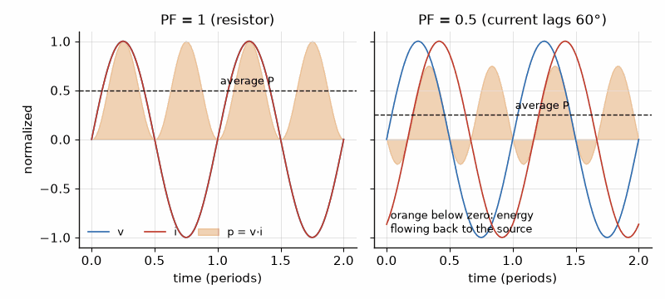
Figure 35.1 — Power as it actually flows. With a resistor (left) the product v·i never goes negative. With the current lagging by 60° (right) part of every cycle sends energy back to the source, and the average power halves.
So how hard you push, multiplied by how fast the pedal is moving, does not by itself say how much of that effort actually goes into forward motion — alignment matters enormously, and a badly aligned push can involve as much raw effort while accomplishing almost nothing. AC circuits split the same way. A load draws 8.0 A (RMS) from a 100 V (RMS) source, with the current arriving 53.1° out of step with the voltage. Multiply voltage by current directly, ignoring the misalignment, and the result is 100 × 8.0 = 800 — the total back-and-forth exchange between source and load, every cycle. Only part of that 800 is properly aligned and actually does useful work — 480, it turns out — and because the aligned and misaligned parts combine like two sides of a right triangle rather than by simple subtraction, recovering that 480 from the 800 takes the Pythagorean relationship developed below, not ordinary arithmetic.
That total back-and-forth exchange is called apparent power; the portion actually delivered is real power; and the portion that sloshes back and forth without net transfer is reactive power. For a sinusoidal voltage v(t) = V_m cos(ωt) across an element carrying current i(t) = I_m cos(ωt − θ) (where θ is the phase angle by which current lags voltage, positive for an inductive load), the instantaneous power p(t) = v(t)i(t) oscillates in a generally complicated way, but its time-average — the quantity that actually matters for billing, heating, and most practical purposes — reduces to a clean, simple result:
P_{avg} = V_{rms} I_{rms} cosθ
The factor cosθ is called the power factor, and it is the single most important new concept this chapter introduces: it measures what fraction of the product of RMS voltage and RMS current is actually converted to real, usable average power, as opposed to being exchanged back and forth between source and load without net transfer.

35.2 Real, Reactive, and Apparent Power
Three related power quantities are used throughout AC power engineering, and this series returns to all three, in far greater depth, in its dedicated power-systems volume:
- Real power (P), measured in watts (W): the average power actually delivered to and consumed by the load — the only one of the three that corresponds to real, billable energy consumption or genuine heating/mechanical work.
- Reactive power (Q), measured in volt-amperes reactive (VAR): power that is exchanged back and forth between source and load each cycle (stored temporarily in an inductor's magnetic field or a capacitor's electric field, then returned), with zero net transfer averaged over a full cycle.
- Apparent power (S), measured in volt-amperes (VA): the product V_rms I_rms, with no cosθ factor at all — the total power a source must be capable of supplying, real and reactive combined, even though only the real portion does useful work.
These three quantities relate through a right triangle (the “power triangle”), with apparent power as the hypotenuse:
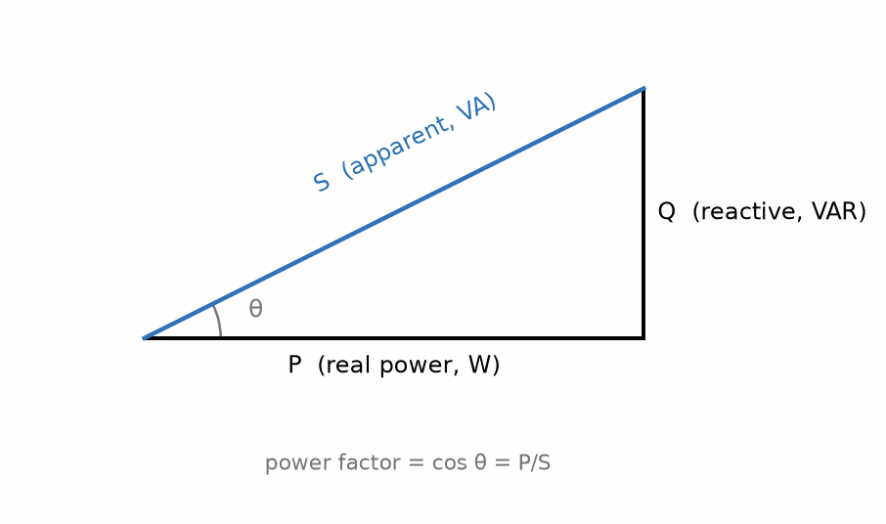
Figure 35.2 — The power triangle: real, reactive, and apparent power, related through the power-factor angle.
S = √(P² + Q²) , P = S cosθ , Q = S sinθ

35.3 Why Power Factor Matters
A load with a low power factor (cosθ well below 1, typical of large motors and other strongly inductive loads) draws a large current for a given amount of real power delivered, since P = V_rms I_rms cosθ means I_rms must be correspondingly larger to compensate for a small cosθ at fixed P and V_rms. That larger current causes larger resistive (I²R) losses in the wiring and generating equipment supplying the load, even though those losses correspond to no additional useful work being done — which is exactly why electric utilities charge industrial customers a power-factor penalty, and why power-factor correction (typically, adding capacitors in parallel with an inductive load to cancel some of its reactive power) is standard practice in industrial electrical systems, a topic developed fully in this series' power-systems volume.
Key Idea
Power factor is the cosine of the phase angle between voltage and current, and it directly measures how much of a load's apparent power is actually useful. A purely resistive load has power factor 1 (voltage and current in phase, all apparent power is real power); a purely reactive load (an ideal inductor or capacitor alone) has power factor 0 (voltage and current 90° out of phase, all apparent power is reactive, zero real power delivered on average).
Worked Example 35.1
Problem: A load draws an RMS current of 10 A from a 120 V RMS source, with the current lagging the voltage by 36.9°. Find the real power, reactive power, and apparent power delivered to the load.
Solution: Apparent power: S = V_rms I_rms = (120)(10) = 1200 VA. Real power: P = S cosθ = 1200 cos(36.9°) ≈ 1200(0.80) = 960 W. Reactive power: Q = S sinθ = 1200 sin(36.9°) ≈ 1200(0.60) = 720 VAR. Check: √(P² + Q²) = √(960² + 720²) = √(921,600 + 518,400) = √1,440,000 = 1200 VA, matching S exactly, as the power-triangle relationship requires.

35.4 Power Factor Correction
Since a low power factor arises from a load's net reactance — the imaginary part of its impedance, made precise in Chapter 36 — most commonly inductive, as in motors and transformers, which draw lagging current — the standard remedy is to add capacitors in parallel with the load, specifically sized so that the capacitor's own reactive power partially or fully cancels the load's inductive reactive power. Because reactive power, unlike real power, is not consumed but merely exchanged back and forth each cycle, a capacitor's leading reactive contribution and an inductor's lagging reactive contribution genuinely cancel in the net reactive-power total seen by the source, reducing S (and hence the current the source and wiring must supply) for the same real power P actually being delivered to the load — without needing to modify the load itself in any way, since the correcting capacitors are added entirely separately, typically right at the point where power enters an industrial facility.
Worked Example 35.2
Problem: A factory load draws 100 kW of real power at a power factor of 0.70 lagging, from a 480 V RMS supply. Find the apparent power and the reactive power drawn, and state qualitatively what adding power-factor-correcting capacitors would do to the current the supply must provide for the same 100 kW of real power delivered.
Solution: Apparent power: S = P/cosθ = 100/0.70 ≈ 142.9 kVA. Reactive power: since cosθ = 0.70 corresponds to sinθ ≈ 0.714 (from cos²θ + sin²θ = 1), Q = S sinθ ≈ 142.9 × 0.714 ≈ 102 kVAR. Adding capacitors sized to supply some or all of this 102 kVAR locally means the source itself no longer needs to supply that reactive power — S decreases toward P (the power factor rises toward 1.0), and since S = V_rms I_rms at fixed V_rms, the current I_rms the supply must provide decreases correspondingly, even though the same 100 kW of real power is still being delivered to the factory's actual equipment.
Common Misconception
It is easy to read “apparent power” as a less-accurate or approximate version of real power, since the everyday word “apparent” often means “seeming, but not actually true.” In this context the two quantities are not competing estimates of the same thing — apparent power (S = V_rms I_rms) is a genuinely different physical quantity from real power (P = S cosθ), representing the full electrical burden a source and its wiring must be sized to handle, of which only the real-power portion does useful work. A generator, transformer, or set of wires must be rated for apparent power, in VA, not for real power alone in W, precisely because the reactive component still demands current-carrying capacity even though it delivers no net energy.

35.5 The Home Energy Dashboard
A home energy dashboard answers one question: what does each appliance cost to run? The answer is energy, real power multiplied by time, priced in kilowatt-hours. Two traps wait. Many appliances cycle on and off, so the power on the label is not the average. And motors and compressors draw lagging current, so multiplying RMS volts by RMS amps gives apparent power, not the real power the meter bills. Book 6 builds the current sensor; here are the numbers it feeds.
Worked Example 35.3 — What Does the Fridge Cost?
Problem: A refrigerator's compressor draws 120 W of real power at a power factor of 0.60 from a 120 V outlet, and runs 40 % of the time. Find the average power, the energy per day and per year, and the cost at an example rate of $0.30 per kWh. What would a dashboard that multiplied RMS volts by RMS amps report while the compressor runs?
Solution: Average power: 120 W × 0.40 = 48 W. Energy: 48 W × 24 h = 1.152 kWh per day, about 420 kWh per year. Cost: 1.152 kWh × $0.30 ≈ $0.35 per day, about $126 per year. While running, the compressor's apparent power is S = P/PF = 120/0.60 = 200 VA, and its current is 200/120 ≈ 1.67 A. A dashboard that multiplied volts by amps would show 200 W, two-thirds too high. Real power needs the product of voltage and current sampled together, averaged over each cycle, which is exactly the integral of Section 35.1 and what energy-monitor chips compute.
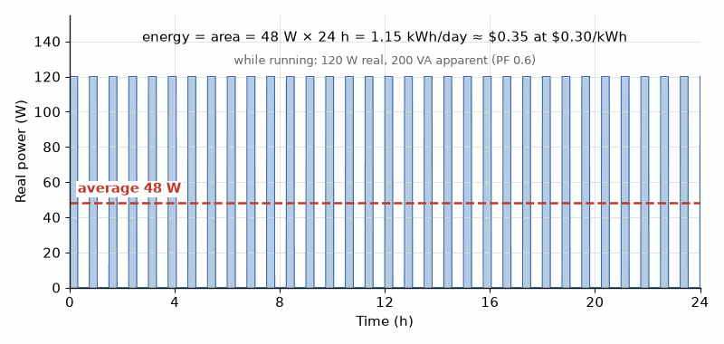
Figure 35.3 — A refrigerator's power over a day: 120 W while the compressor runs, almost nothing between cycles, 48 W on average. The energy is the area under the curve, 1.15 kWh, about $0.35 at $0.30 per kWh.
From the Bench
Read both ratings on a UPS or generator: a 1500 VA / 900 W unit is limited by whichever you reach first. Most modern switching supplies above a few tens of watts use active power-factor correction and reach 0.9 or better, but older and cheaper ones draw peaky current with a poor power factor and plenty of harmonics.

Practice Problems
- A load has a power factor of 0.90 and draws 1500 W of real power at 240 V RMS. Find the RMS current.
- A load draws 15 A RMS from a 100 V RMS source at a power factor of 0.60 (current lagging). Find the real, reactive, and apparent power.
- Explain briefly why a purely inductive load (power factor 0) delivers zero average real power despite drawing nonzero current.
- A dehumidifier draws 2.5 A RMS from a 120 V RMS outlet at a power factor of 0.85 and runs 10 hours a day. Find its real power, its energy use in a 30-day month, and the monthly cost at $0.25 per kWh.

What You’ll Actually Use
Everyday working tools
- P = V_rms·I_rms·cos φ.
- Watts, volt-amperes and vars, and which one sizes the wiring.
- Energy cost: average real power × hours × price per kWh.
Mostly for exams and deeper study
- Complex power S = VI* and its derivations.

Chapter 36 — Resonance, Frequency Response, and Transformers
An old radio picked one station out of dozens with a single knob: a coil and a variable capacitor resonating at one frequency and ignoring the rest. Your phone still does a version of the same thing, and the charger on your desk relies on the transformer that closes this chapter.
Where you meet this: Radio tuning and filters, LC and crystal oscillators, wireless-charging coils tuned to resonance, and the transformers in chargers and power supplies.

36.1 The Series RLC Circuit
Push a playground swing at random moments and it barely moves, no matter how hard you push — sometimes a push fights the swing's own motion, sometimes it helps, and the two roughly cancel out over time. Push it instead at exactly the swing's own natural rhythm, small push after small push, each one perfectly timed, and the swing climbs higher and higher, far beyond what any single push could produce alone. An RLC circuit has a natural rhythm of its own too, set by its inductor and capacitor, and driving it at exactly that frequency produces the same kind of buildup — not in how high something swings, but in how large a voltage appears across the inductor or capacitor individually, compared to the source driving the whole circuit.
A series combination of a resistor, inductor, and capacitor, driven by a sinusoidal source, has total impedance:
Z = R + jωL + 1/(jωC) = R + j(ωL − 1/(ωC))
The imaginary part — the net reactance — depends on frequency in an interesting way: the inductor's reactance ωL grows with frequency while the capacitor's reactance 1/(ωC) shrinks with frequency, so at one particular frequency, the resonant frequency, the two exactly cancel, leaving a purely real impedance equal to R alone.

36.2 Resonant Frequency
Setting ωL = 1/(ωC) and solving for ω gives the resonant angular frequency:
ω₀ = 1/√(LC)
At resonance, a series RLC circuit's impedance is at its minimum possible value (equal to R alone, with the reactive parts canceling), so current is at its maximum for a given source voltage, and — since the inductor's and capacitor's voltages are equal in magnitude but opposite in phase at this exact frequency — the voltage across either one individually can substantially exceed the source voltage itself, an effect exploited deliberately in radio tuning circuits, where a resonant circuit is used to select one specific broadcast frequency out of many present simultaneously on an antenna. Worked Example 36.2 makes the size concrete: with R = 5.0 Ω, L = 10 mH, C = 100 nF, and a 1.0 V RMS source at resonance, Q ≈ 63.2, so the ideal inductor and capacitor voltages are each about 63 V RMS, equal and opposite. Component voltage can exceed the source without violating KVL; the two reactive phasors cancel.
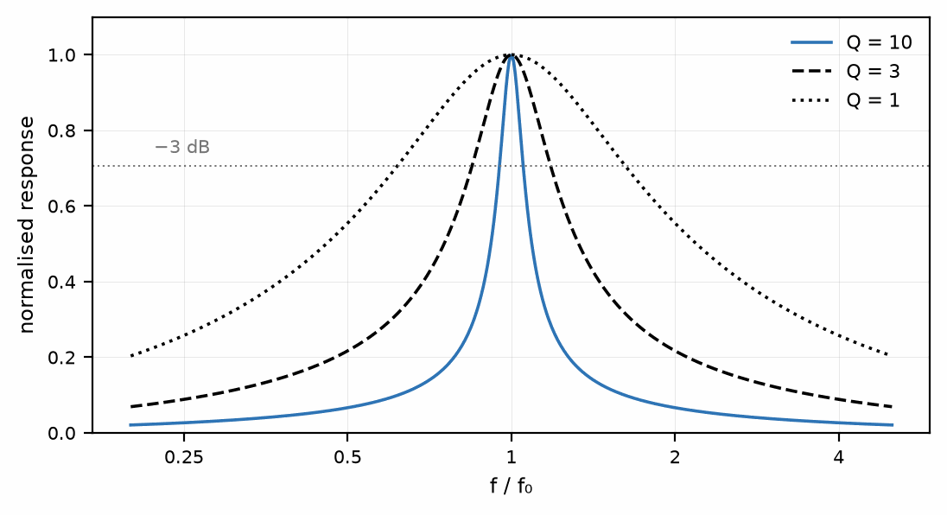
Figure 36.1 — Resonance curves at three values of Q, the quality factor defined in §36.3: a higher Q gives a sharper, narrower peak.
Key Idea
Resonance is the frequency at which inductive and capacitive reactance precisely cancel. Below resonance, a series RLC circuit's net reactance is capacitive (current leads voltage); above resonance, it is inductive (current lags voltage); exactly at resonance, the circuit is purely resistive, current and voltage are in phase, and the power factor is 1.

36.3 Bandwidth and Quality Factor
A resonant circuit does not respond only at exactly ω₀ — it responds over a range of frequencies around ω₀, with the response falling off on either side. The bandwidth (the width of the frequency range over which the circuit's response stays within a standard threshold of its peak value) and the quality factor Q, which measures how sharply peaked the resonance is (a high-Q circuit has a narrow, sharply peaked response; a low-Q circuit has a broad, gentle one), are related by:
Q = ω₀L / R = 1 / (ω₀RC) , Bandwidth = ω₀/Q
A high-Q circuit — achieved with a small resistance relative to the inductor's reactance at resonance — is desirable in a radio tuner precisely because it rejects nearby, unwanted frequencies sharply while passing the desired station strongly; the same quality factor, and much of this same frequency-response machinery, reappears throughout this series' RF and microwave volumes, where filters and resonant cavities are central design elements rather than incidental circuit behaviors.
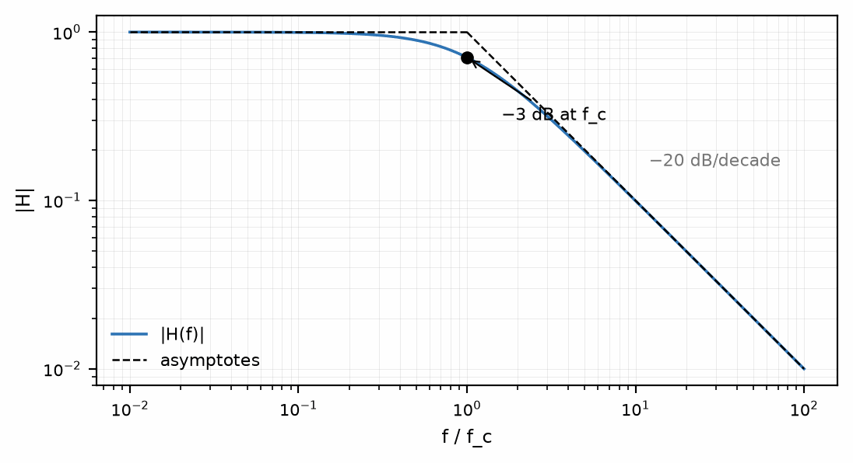
Figure 36.2 — A first-order low-pass response: flat below the corner (cutoff) frequency, falling at -20 dB/decade above it — a standard measure of how steeply the response drops per tenfold rise in frequency.

36.4 Mutual Inductance and the Transformer
Two coils placed near each other share magnetic flux, so that a changing current in one coil (Chapter 11) induces a voltage in the other. This coupling is quantified by the mutual inductance M, defined so that a changing current in one coil induces an EMF in the other, ε2 = −M dI1/dt (and, symmetrically, ε1 = −M dI2/dt), measured, like self-inductance, in henries (H). Mutual inductance is the physical basis of the transformer, one of the most important devices in all of electrical power engineering. An ideal transformer, with N₁ turns on its primary winding and N₂ turns on its secondary, relates the two windings' voltages and currents by the turns ratio:
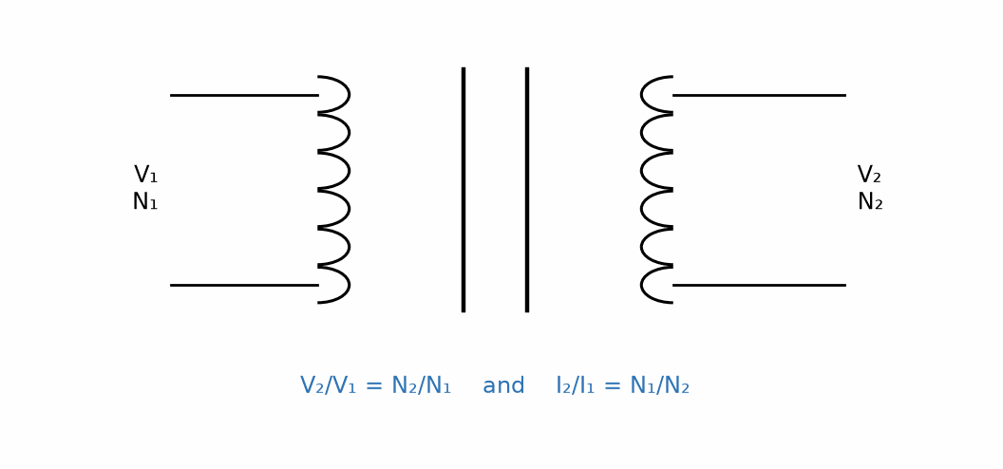
Figure 36.3 — An ideal transformer: voltage and current scale with the turns ratio, in opposite directions.
V₂/V₁ = N₂/N₁ , I₂/I₁ = N₁/N₂
Notice that voltage and current transform in opposite ratios — a step-up transformer (more secondary turns than primary) increases voltage but correspondingly decreases current by the same factor, and vice versa for a step-down transformer, so that an ideal transformer's input and output apparent power (Chapter 35) are exactly equal: transformers change the voltage-to-current ratio of the power delivered, but (idealized, with no internal losses) never change the total power itself. This single fact — trading voltage for current, or current for voltage, at essentially no cost — is the entire reason long-distance power transmission is done at very high voltage (minimizing current, and therefore minimizing I²R transmission losses over the wires) before being stepped back down to safer, more usable voltages near the point of consumption, a subject this series returns to fully in its power-systems volume.

36.5 Simple Filters: Low-Pass and High-Pass RC Circuits
A single resistor and capacitor, arranged one way, form the simplest possible low-pass filter; arranged the other way, they form the simplest possible high-pass filter — and both are a direct, practical application of the frequency-dependent impedance introduced in Chapter 23. Take a series RC circuit driven by a sinusoidal source, and consider the output taken across the capacitor. By the voltage-divider relationship (Chapter 34, generalized to impedances):
V_{out}/V_{in} = Z_{C}/(R + Z_{C}) = 1/(1 + jωRC)
At low frequencies (ω small), Z_C = 1/(jωC) is large compared to R, so nearly all the input voltage appears across the capacitor — the circuit passes low frequencies through to the output largely unattenuated. At high frequencies, Z_C shrinks toward zero, and the output voltage shrinks with it — high frequencies are attenuated. This is a low-pass filter, and the frequency at which the output has fallen to 1/√2 (about 70.7%) of the input — the conventional definition of a filter's cutoff frequency — occurs exactly where |Z_C| = R, which works out to:
ω_{c} = 1/(RC) (equivalently f_{c} = 1/(2πRC))
Taking the output across the resistor instead of the capacitor, in the same series RC circuit, gives the complementary behavior: at low frequencies, nearly all the voltage drops across the now-large capacitor impedance, leaving little across the resistor; at high frequencies, the capacitor's impedance shrinks and the resistor's share of the voltage grows toward the full input. This is a high-pass filter, with exactly the same cutoff frequency ω_c = 1/(RC), measured across the other element.
Key Idea
The same RC circuit is a low-pass or a high-pass filter depending only on which element's voltage you take as the output. Both share the identical cutoff frequency ω_c = 1/(RC) — the same time constant from Chapter 33's transient analysis reappears here as a frequency-domain quantity, which is not a coincidence: a circuit's time-domain settling behavior and its frequency-domain filtering behavior are two views of the exact same underlying impedance relationships.
Worked Example 36.1
Problem: A low-pass RC filter is built with R = 1.0 kΩ and C = 100 nF. Find its cutoff frequency in Hz, and determine whether a 500 Hz signal is passed or substantially attenuated.
Solution: ω_c = 1/(RC) = 1/[(1.0×10³)(100×10⁻⁹)] = 1/(1.0×10⁻⁴) = 1.0×10⁴ rad/s. Converting: f_c = ω_c/(2π) ≈ 1592 Hz, about 1.6 kHz. Since 500 Hz is well below this cutoff frequency, it falls within the filter's passband and is passed through with little attenuation — only frequencies well above roughly 1.6 kHz would be substantially attenuated by this particular filter.
Worked Example 36.2
Problem: A series RLC circuit has L = 10 mH, C = 100 nF, and R = 5.0 Ω. Find the resonant frequency (in Hz) and the quality factor.
Solution: ω₀ = 1/√(LC) = 1/√[(10×10⁻³)(100×10⁻⁹)] = 1/√(1.0×10⁻⁹) = 1/(3.1623×10⁻⁵) ≈ 3.1623×10⁴ rad/s. Converting to ordinary frequency: f₀ = ω₀/(2π) ≈ 5033 Hz, about 5.0 kHz. Quality factor: Q = ω₀L/R = (3.16×10⁴)(10×10⁻³)/5.0 ≈ 63.2 — a fairly high-Q, sharply resonant circuit.
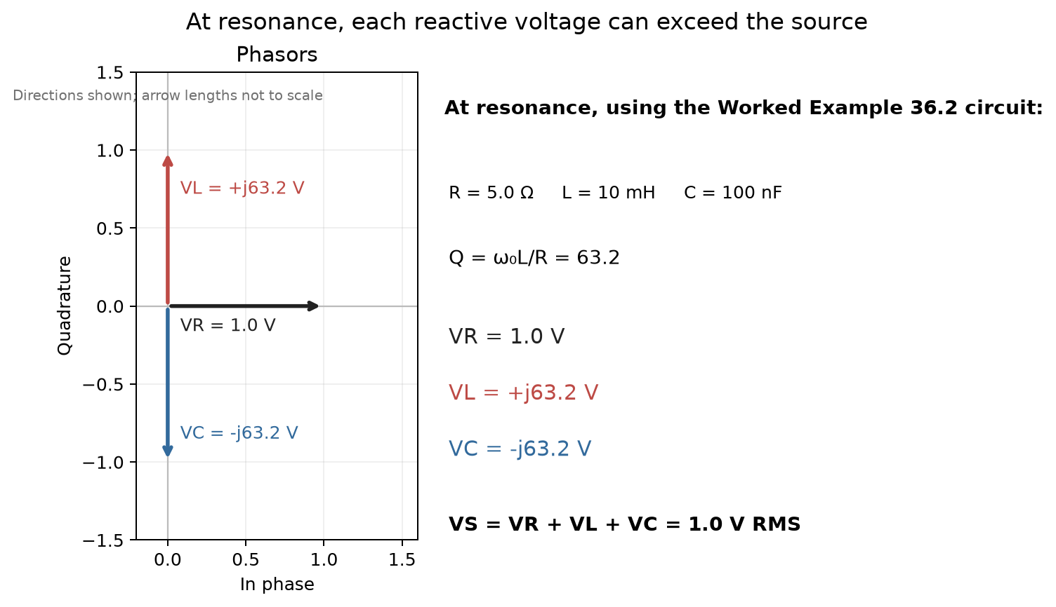
Figure 36.4 — At resonance, equal and opposite reactive voltages can each exceed the 1.0 V RMS source; the phasor sum remains 1.0 V RMS.
Worked Example 36.3
Problem: An ideal transformer has 1000 turns on its primary and 100 turns on its secondary, with 240 V RMS applied to the primary, delivering 5.0 A RMS to a load on the secondary. Find the secondary voltage and the primary current.
Solution: Turns ratio N₂/N₁ = 100/1000 = 0.10, a step-down transformer. Secondary voltage: V₂ = V₁ × (N₂/N₁) = 240 × 0.10 = 24 V. For the current, the ratio inverts: I₁ = I₂ × (N₂/N₁) = 5.0 × 0.10 = 0.50 A. Check via apparent power: primary S = V₁I₁ = 240 × 0.50 = 120 VA; secondary S = V₂I₂ = 24 × 5.0 = 120 VA — equal, as required for an ideal (lossless) transformer.
Common Misconception
It is a common first-pass error to assume a step-down transformer, since it reduces voltage, must therefore also reduce the power available — as though “stepping down” meant losing capability. An ideal transformer changes voltage and current in exactly inverse proportion and delivers the same apparent power out as goes in; a step-down transformer trades a smaller voltage for a larger available current at the same total power, which is exactly the behavior wanted at the receiving end of a power line, where a lower, safer voltage is needed but the same total power must still be delivered to the load.
From the Bench
High-Q resonant circuits are touchy. Component tolerance moves the resonant frequency (a 5% change in capacitance shifts f₀ by about 2.5%), and even the 10 pF or so of a standard 10× scope probe can detune a small LC tank. Measure resonant circuits with low-capacitance probes, or couple to them loosely.

Practice Problems
- A series RLC circuit has L = 5.0 mH and C = 20 nF. Find its resonant frequency in Hz.
- For the circuit in the previous problem, if R = 2.0 Ω, find the quality factor Q.
- An ideal transformer steps 480 V RMS down to 120 V RMS. If the secondary delivers 20 A RMS to a load, find the primary current.
- Explain briefly why long-distance power transmission is done at very high voltage rather than at the voltage ultimately used by consumers.
- A high-pass RC filter uses R = 2.2 kΩ and C = 47 nF. Find its cutoff frequency in Hz.

What You’ll Actually Use
Everyday working tools
- f₀ = 1/(2π√(LC)).
- Q as the sharpness of a resonance.
- Transformer ratios: voltage scales with turns, current inversely.
Mostly for exams and deeper study
- Bandwidth derivations for series and parallel RLC circuits.

Chapter 37 — The Smith Chart, Impedance Matching, and Bias Networks
A Wi-Fi router's radio chip, the cable and the antenna all have to agree on an impedance, usually 50 Ω, or part of the signal bounces back instead of radiating. The Smith chart is the map engineers use to make them agree. Phillip Smith published it in 1939, and it remains a common display on vector network analyzers.
Where you meet this: Antenna matching, RF amplifier design, vector network analyzer displays, and the matching networks between a phone's power amplifier and its antenna (Book 4).
This chapter is a preview of where the mathematics of complex impedance leads once RF engineering takes it over — not a transmission-line design course compressed into a foundations book. You will come away able to design a basic single-frequency L-network by hand, using the reasoning below; the deeper skills — bandwidth, multi-section networks, and real component non-idealities — are what this series' dedicated RF and microwave volume builds on top of this foundation.

37.1 Why Matching Matters: The Conjugate-Match Condition
Chapter 23 introduced impedance and showed that a linear circuit's behavior at one frequency is fully captured by a complex number. A question follows immediately once any real source feeds any real load: how much of the available power actually reaches the load, and what can be done about it if the answer is “not much”? Chapter 30 answered this for purely resistive networks — maximum power transfer requires R_load = R_source. The complex generalization, needed the moment either side has any reactance, is the conjugate-match condition:
Z_{load} = Z_{source}*
That is, the load impedance must equal the complex conjugate of the source impedance — same resistance, equal and opposite reactance. A source with impedance 50 + j30 Ω delivers maximum available power to a load of exactly 50 − j30 Ω, because the load's negative reactance exactly cancels the source's positive reactance (leaving a purely resistive series combination), while the matched resistances split available power exactly as the DC theorem already established. A matching network is nothing more than a lossless circuit — built from reactive elements, which absorb no real power themselves — inserted between an arbitrary source and load specifically to present this conjugate-matched impedance to each side.

37.2 The Reflection Coefficient
Working directly with impedance is awkward once transmission lines enter the picture, because impedance transforms in a complicated way along a line. The reflection coefficient Γ, defined relative to a reference impedance Z₀ (almost always 50 Ω in RF work), is better behaved:
Γ = (Z − Z₀) / (Z + Z₀)
Equivalently, working with the normalized impedance z = Z/Z₀: Γ = (z − 1)/(z + 1). Γ = 0 means a perfect match (all power delivered, nothing reflected); |Γ| = 1 means total reflection (an open circuit, a short circuit, or any purely reactive load). For any passive load, |Γ| ≤ 1 always.

37.3 The Smith Chart
The Smith chart is a graphical picture of the relationship between Γ and z, plotted on the complex Γ-plane, restricted to the unit disk (since |Γ| ≤ 1 for passive loads). Overlaid on that disk are two families of curves: circles of constant normalized resistance r, and arcs of constant normalized reactance x. Every point inside the chart corresponds to exactly one normalized impedance z = r + jx, and reading r and x directly off the chart — rather than doing the complex algebra of the Γ ↔ z conversion by hand every time — is the entire practical value of the chart.
The constant-r circles all pass through the point Γ = 1 (the open-circuit point, z → ∞), with the r = 0 circle being the chart's own outer boundary (the case of a purely reactive load, |Γ| = 1). The constant-x arcs are centered off-chart, above the real axis for inductive reactance (positive x) and below it for capacitive reactance (negative x), with the entire real axis itself forming the x = 0 line — purely resistive impedances.
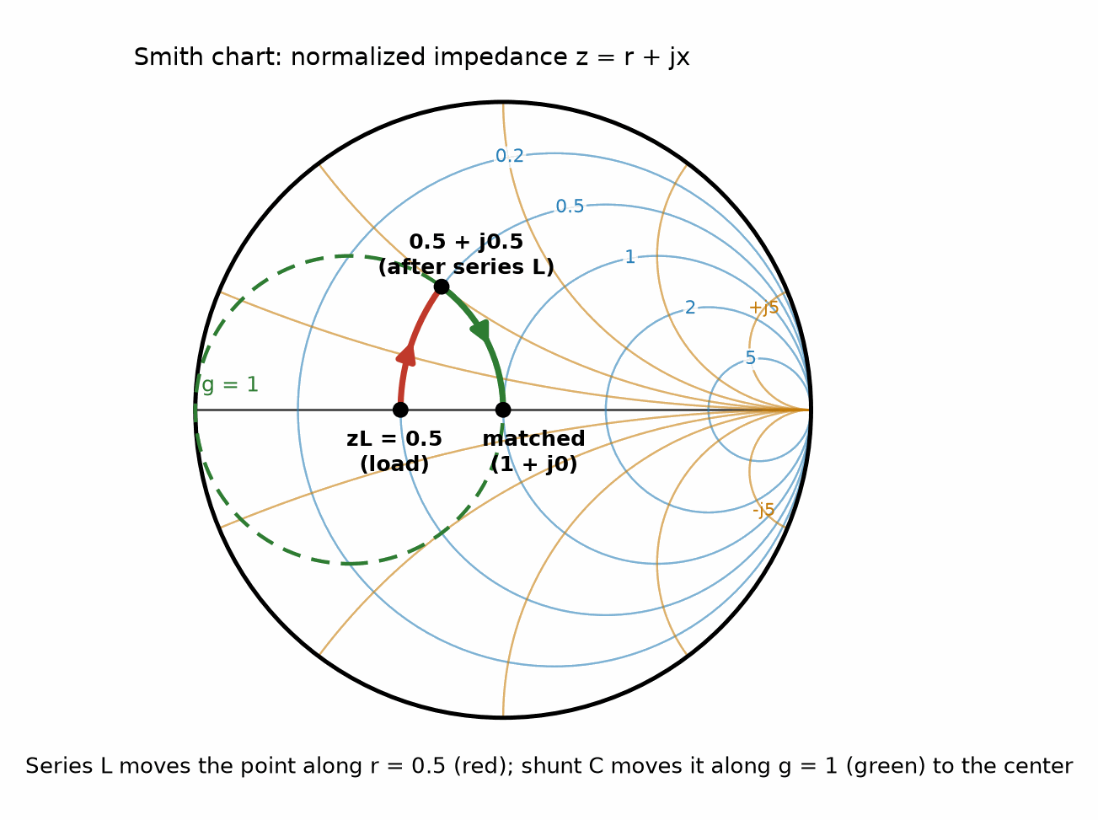
Figure 37.1 — The Smith chart, with a two-element matching path plotted (Worked Examples 37.1 and 37.2).

37.4 VSWR and Return Loss
Two practical numbers are computed directly from |Γ| and appear on every piece of RF test equipment. The voltage standing wave ratio:
VSWR = (1 + |Γ|) / (1 − |Γ|)
runs from 1 (perfect match) to infinity (total reflection), and is the ratio most commonly quoted for antennas and RF connectors. Return loss, expressed in decibels, is the other common figure of merit:
Return Loss (dB) = −20 log₁₀|Γ|
with a larger return loss (in dB) meaning a better match — the opposite sense from VSWR, which is worth keeping straight, since both numbers describe exactly the same underlying |Γ|.

37.5 Moving on the Chart: Series and Shunt Elements
Adding a series reactance to a load moves its point along a constant-r circle — a series element changes only x, leaving r (and hence the circle it sits on) unchanged, whether the added reactance is inductive (moving clockwise, toward more positive x) or capacitive (moving counterclockwise). Adding a shunt element — one placed in parallel, rather than in series — is most naturally described in admittance terms: y = 1/z = g + jb, where a shunt reactance changes only b, moving the point along a constant-g circle. The admittance grid is the impedance grid rotated 180° about the chart's center (since y = 1/z corresponds to Γ → −Γ), so the same physical chart serves both purposes — a shunt element moves a point along whichever constant-g circle is the point-reflection, through the center, of the corresponding constant-r circle.
Key Idea
Series elements move you along a constant-r circle; shunt elements move you along a constant-g circle. A two-element L-network match is nothing more than finding one circle of each kind that intersect — one step to reach the intersection, one more to reach the center (the matched point, Γ = 0).

37.6 Lumped-Element (L-Network) Matching
The simplest matching network — an L-network — uses exactly two reactive elements, one in series and one in shunt, arranged so the load's impedance is transformed to Z₀. Given the discussion above, the design procedure is direct: pick whichever element (series or shunt) moves the load's own r-circle (or g-circle) so that it crosses the g = 1 circle (or r = 1 circle), then pick the second element to complete the trip to the center.
Worked Example 37.1
Match a purely resistive load R_L = 25 Ω to a Z₀ = 50 Ω system at f = 1.0 GHz using an L-network.
Normalized load: z_L = 25/50 = 0.5. Since R_L < Z₀, add a series reactance first. Solving for the series reactance X_s that lands exactly on the g = 1 circle (algebraically, X_s² = R_L(Z₀ − R_L) = 25(50 − 25) = 625, so X_s = 25 Ω): the point moves from z = 0.5 to z = 0.5 + j0.5 — and a direct check confirms this normalized admittance is y = 1 − j1, i.e., g = 1 exactly, as required.
A series inductor supplies this positive reactance: L = X_s/ω = 25/(2π×10⁹) ≈ 3.98 nH. The load's residual susceptance of −1 (normalized) is canceled by a shunt capacitor supplying b = +1 (normalized) = 0.02 S (actual): C = 0.02/ω ≈ 3.18 pF. With both elements in place, the load presents precisely 50 + j0 Ω to the source.
Worked Example 37.2
A load impedance of Z_L = 25 + j25 Ω (not purely resistive) is to be matched to the same 50 Ω system, also at 1.0 GHz. How many elements are needed?
Normalized: z_L = 0.5 + j0.5 — which is exactly the intermediate point reached in Worked Example 37.1 after its series inductor was added. This load's own reactance already does the job a series element would otherwise have to do. Only the shunt capacitor is needed: C ≈ 3.18 pF, exactly as before, bringing the load to a perfect match with a single component.
Common Misconception
It is tempting to assume an L-network always needs exactly one inductor and one capacitor. It needs one series and one shunt reactance, of whichever sign the specific match requires — Worked Example 37.1 happened to need a series L and a shunt C, but the dual solution (series C, shunt L) is equally valid for a resistive load, and which pair of element types is actually needed depends on the load's own reactance, exactly as Worked Example 37.2 shows: a load with the right amount of its own series reactance already present needs only a single shunt element to finish the job.

37.7 Distributed Matching: Microstrip Lines and Stubs
At the frequencies where microstrip circuit boards operate, a short length of transmission line is often a more practical matching element than a discrete inductor, especially once the frequency is high enough that a lumped component's own parasitic behavior becomes significant. The single-stub tuning technique replicates the L-network idea using distributed elements: a length d of line (of the board's own characteristic impedance Z₀) is inserted between the load and a shunt stub, chosen so that at distance d from the load, the line's input admittance has real part exactly Y₀ = 1/Z₀ — placing the point on the g = 1 circle, exactly as a series lumped element did in Section 37.6. A stub of length l, then, cancels the remaining susceptance, exactly as the shunt capacitor did.
Worked Example 37.3
A purely resistive load Z_L = 100 Ω is to be matched to a Z₀ = 50 Ω microstrip line using a single short-circuited shunt stub. Find the required distance d from the load to the stub, and the stub length l, both as fractions of a wavelength.
Normalized load: z_L = 2.0. Solving the standard single-stub distance equation for a real load gives two valid solutions within one half-wavelength; the shorter one works out to d ≈ 0.152λ. At that point, the line's input impedance is Z_in ≈ 33.3 − j23.6 Ω, so its admittance is Y_in ≈ 0.020 + j0.0141 S — the real part matches Y₀ = 1/50 = 0.020 S exactly, confirming the point sits on the g = 1 circle as intended.
A short-circuited stub of length l presents an input susceptance of −Y₀cot(βl); setting this equal to −0.0141 S (to cancel the remaining +j0.0141 S) gives βl ≈ 54.7°, or l ≈ 0.152λ. The second valid solution, d ≈ 0.348λ with a stub of l ≈ 0.348λ, is equally correct — in practice, whichever pair gives the more convenient physical length on the actual board is used.
An open-circuited stub can be used in place of a short-circuited one — often preferred in microstrip specifically because an open stub needs no via to ground, which a short-circuited stub does — at the cost of a generally different (and here, longer) required stub length for the same match, since an open stub's input susceptance is +Y₀tan(βl) rather than −Y₀cot(βl).

37.8 Fine-Tuning a Match with SMD Components
A matching network built from fixed-value components — whether lumped or microstrip — rarely lands exactly on the intended match once real component tolerances, board parasitics, and assembly variation are accounted for. A small additional shunt capacitance, realized as a surface-mount trimmer or a selectable small SMD pad, is the standard way to correct a small residual mismatch after assembly, precisely because shunt capacitive susceptances add: adding a second capacitor in parallel with the first increases the total susceptance by exactly ωΔC, with no interaction between the two.
Worked Example 37.4
A matching network designed for a perfect match at 1.0 GHz is measured, after assembly, to present an input admittance of Y_in = 0.020 − j0.0010 S (the real part is correct; a small residual inductive-looking susceptance remains, most likely from stray inductance in the shunt capacitor's own PCB pad). Find the additional SMD shunt capacitance needed to null out this residual susceptance.
The residual susceptance to cancel is +0.0010 S (a shunt capacitor's susceptance is positive, ωC, so it can only add positive susceptance — exactly what is needed here to cancel a negative residual). ΔC = 0.0010/ω = 0.0010/(2π×10⁹) ≈ 0.159 pF — a genuinely tiny trim capacitance, which is why practical RF fine-tuning uses sub-picofarad SMD padders rather than trying to hit the ideal value on the first try with the primary matching components alone.

37.9 Bias Networks: RF Chokes and High-Ohmic Resistors
A practical amplifier stage needs DC bias delivered to its active device without disturbing the RF matching networks built around it — the bias network must be effectively invisible to the signal at the operating frequency, while still providing whatever DC path the device actually needs.
At an output node (a bipolar transistor's collector, or a FET's drain — the output terminals of the two main transistor families, covered properly later in this series), meaningful DC current must flow, so an RF choke — an inductor sized so its reactance ωL is large compared to the system impedance at the operating frequency — is the standard solution: it looks like a low-resistance DC path (an inductor has zero DC resistance, ideally) while presenting a high impedance, close to an open circuit, to the RF signal, leaving the surrounding matching network's design essentially undisturbed. A common rule of thumb sizes the choke's reactance to at least 5-10 times the system impedance at the design frequency.
At an input node (a FET's gate, in particular), the DC current required is essentially zero — an ideal FET gate draws no DC current at all — so a simple high-value resistor works as well as a choke, and is simpler and cheaper to implement. A large resistor barely loads the RF path (since it sits in parallel with a much smaller system impedance) and needs to carry essentially no current, so the power dissipated in it is negligible regardless of its value being “too large” by ordinary circuit-design standards.
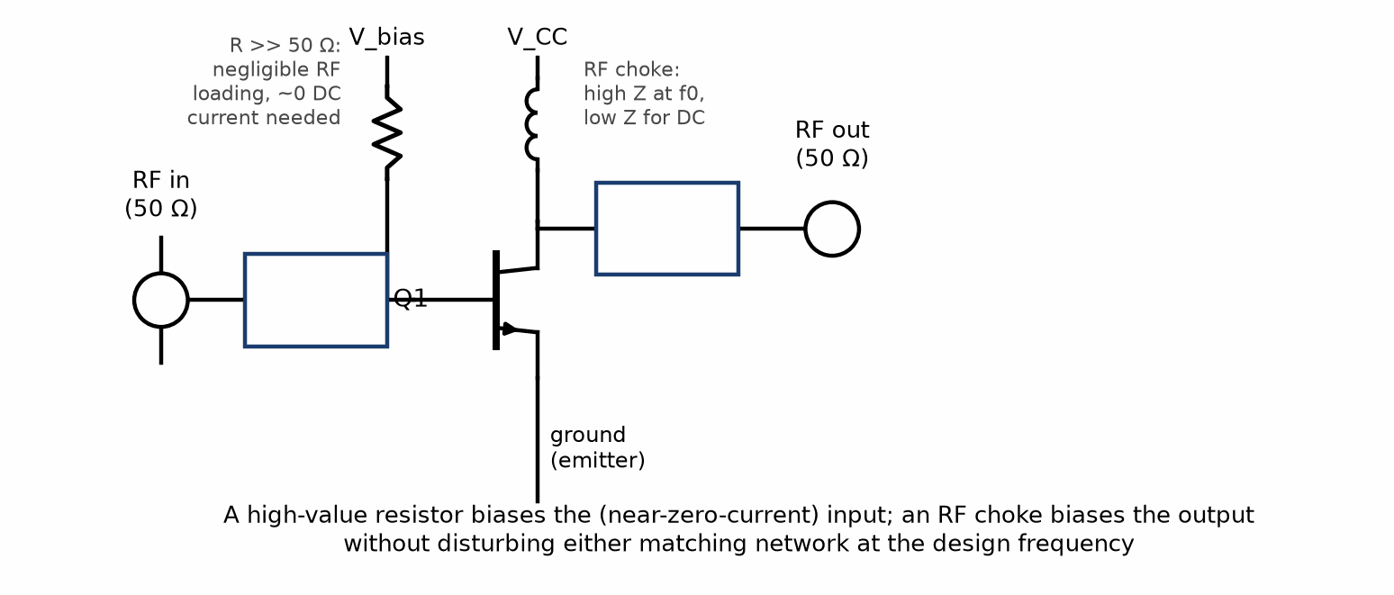
Figure 37.2 — A single-stage amplifier: a high-value resistor biases the input, an RF choke biases the output, and neither disturbs its adjacent matching network at the design frequency.
Worked Example 37.5
An amplifier operating at f = 2.4 GHz uses a 50 Ω matching network at its output. Using a rule-of-thumb factor of 10, find the minimum RF choke inductance for output biasing. Separately, verify that a 10 kΩ gate-bias resistor barely disturbs a 50 Ω input match.
Choke: required reactance X_L ≥ 10 × 50 = 500 Ω. L_min = X_L/ω = 500/(2π×2.4×10⁹) ≈ 33.2 nH — any inductor of this value or larger keeps the choke's loading on the RF path below the 10% level implied by the rule of thumb.
Bias resistor: a 10 kΩ resistor in parallel with a 50 Ω system impedance combines to (50 × 10,000)/(50 + 10,000) ≈ 49.75 Ω — a deviation of about 0.5% from the unloaded 50 Ω, negligible for essentially any practical purpose, and confirming that a high-ohmic resistor is an entirely adequate choice for a near-zero-current input bias point.
From the Bench
Real matching networks never land exactly where the chart says, because pad capacitance, trace inductance and part tolerance all count at RF. Leave footprints on the board for a three-element pi network (one series part and two shunt pads) so the match can be tuned later on a network analyzer; unused positions get a 0 Ω link or stay empty, which costs almost nothing.
On the Job
RF engineers on consumer products match antennas for a living. Their tools are a vector network analyzer, a box of 0402 inductors and capacitors, a fine-tipped soldering iron, and a Smith chart on the analyzer's screen. A typical task: a Wi-Fi and Bluetooth LE product's 2.4 GHz antenna, matched perfectly on the bare board, detunes once the plastic case and the battery are fitted. The engineer measures it in the finished product, picks a new two-element match from the chart, solders it into the pi-pad footprint the layout left for that purpose, and checks the radiated power in a test chamber before the design is released.

Practice Problems
- A 50 Ω system has a load impedance of 30 + j40 Ω. Find the normalized impedance and the reflection coefficient Γ (in polar form).
- For a load with |Γ| = 0.5, find the VSWR and the return loss in dB.
- Design an L-network to match a purely resistive load of 20 Ω to a 50 Ω system at 500 MHz. Find the series inductance and shunt capacitance required.
- An RF choke must present a reactance of at least 8 times the system impedance of 75 Ω at 900 MHz. Find the minimum required inductance.

What You’ll Actually Use
Everyday working tools
- Reading Γ, VSWR and return loss.
- Two-element L-network matching.
- Bias tees and RF chokes.
Mostly for exams and deeper study
- Constructing constant-r and constant-x circles mathematically.
- Stub matching on transmission lines by hand.

Chapter 38 — Where This Series Goes Next
You now have the physics, the mathematics and the circuit theory. The rest of the series is what engineers build with them: amplifiers, chips, radios, power supplies and finished products. This short chapter is the map.

38.1 What This Book Has Built
This book took the physical definitions from Part I — voltage, current, resistance, capacitance, inductance — and built the systematic machinery needed to analyze linear circuit models made from them: Kirchhoff's two laws as the foundation; series/parallel reduction and dividers as the fastest tool when it applies; nodal analysis for resistive networks of any topology and mesh analysis for planar networks; Thevenin and Norton equivalents for reasoning about a network's behavior independent of whatever load is eventually attached to it; superposition as both a practical technique and a conceptual justification for several of the results around it; first-order transients as the first genuinely time-dependent behavior in the book; and finally phasors and impedance, which extend every one of the DC techniques to sinusoidal steady-state AC circuits with only a change from real to complex arithmetic.

38.2 A Preview: Linearizing a Nonlinear Device
It is worth seeing, briefly and concretely, how a central technique of Book 3, Semiconductor Physics and Devices, connects to this one, rather than taking the connection entirely on faith. A diode's actual current-voltage relationship is strongly nonlinear — current grows roughly exponentially with voltage once the diode is forward-biased past a threshold, nothing like a resistor's straight-line V = IR. And yet, once a diode is biased at some fixed operating point (a fixed DC voltage and current, set by the rest of the circuit) and only a small additional signal is applied on top of that bias, the diode's response to that small extra signal is, to good approximation, linear — behaving, for that small signal only, exactly like an ordinary resistor whose value (called the diode's small-signal or dynamic resistance) depends on where along its curve the bias point happens to sit.
Concretely: if a diode's bias point sits at a current I_D, its small-signal resistance works out (from the exponential diode equation, derived properly in Book 3) to r_d ≈ V_T/I_D, where V_T is a small, roughly fixed voltage (about 26 mV at room temperature). A small AC signal riding on top of the DC bias sees the diode as nothing more than this resistance r_d — and once that substitution is made, the entire nonlinear device has been replaced, for purposes of analyzing the small signal, by an ordinary linear resistor, dropped into an otherwise perfectly ordinary circuit built from the same resistors, capacitors, and sources Part III has spent twelve chapters learning to handle. Nodal analysis, Thevenin equivalents, phasors for an AC signal riding on the bias — every technique in this book applies directly to that small-signal picture, exactly as advertised.
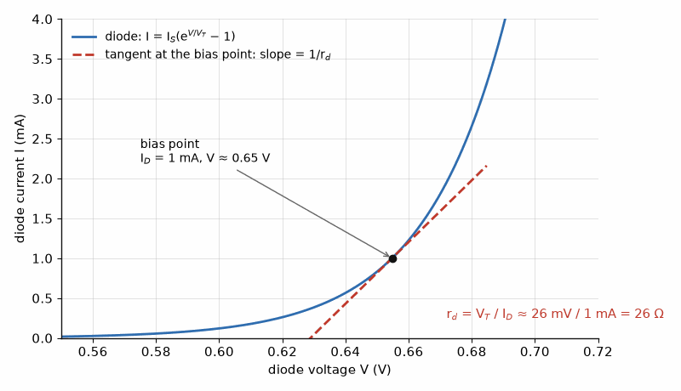
Figure 38.1 — The trick behind Book 3: zoom in far enough on any smooth curve and it looks straight. Near its 1 mA bias point this diode behaves like a 26 Ω resistor for small signals.
Worked Example 38.1 — A Genuine Preview
Problem: A diode is biased at a DC current of 1.0 mA, giving it a small-signal resistance of r_d = V_T/I_D = 0.026/0.001 = 26 Ω. This diode's small-signal model (a 26 Ω resistor) is placed in series with a 1.0 kΩ resistor across a small 10 mV AC signal source. Find the AC voltage appearing across the diode's small-signal resistance.
Solution: This is nothing more than a voltage divider (Chapter 27), applied to the diode's linearized small-signal model exactly as if it were any other resistor: V_diode = V_signal × r_d/(r_d + R) = 10 mV × 26/(26+1000) ≈ 10 × 0.0253 ≈ 0.25 mV. Every step here — identifying the divider, applying the ratio, computing the numeric answer — is drawn directly and without modification from Chapter 27 of this book. The only genuinely new idea, contributed by Book 3, was finding that 26 Ω small-signal resistance value in the first place, from the diode's underlying (and quite different-looking) nonlinear physics.

38.3 A Deliberate Limitation, and Why It Is Temporary
The systematic circuit-analysis problems in this book use a linear model: resistors, capacitors, inductors, independent sources, and (in Chapter 36) ideal transformers, with no thresholds or saturation. Some Reader Lab and application examples mention nonlinear devices such as LEDs and comparators, but treat them at the interface level rather than analyzing their nonlinear behavior. Real electronic circuits also use diodes and transistors, whose response depends on operating point and signal size. The linear methods in this book apply to those devices only after an appropriate model or local linearization has been chosen.
This boundary leads directly to Books 2 and 3. Book 2 puts diodes, transistors, and op-amps to work as building blocks; Book 3 develops semiconductor physics and devices from the ground up. Some devices have a smooth response around a stable operating point, where a sufficiently small signal can be modeled by a linear circuit. For example, a forward-biased diode has a small-signal resistance of approximately V_T/I_D. The approximation is local: it becomes inaccurate when the signal is large enough to move the device far from its bias point, and it does not replace the nonlinear model needed to find that operating point. Once the small-signal model is appropriate, this book's nodal analysis, Thevenin equivalents, and phasor methods can analyze the resulting linear network.
Key Idea
A small-signal model is valid only near its stated operating point and within the signal range for which the linear approximation holds. Find the operating point first; then use the linear-circuit tools from this book on the model. Outside that range, return to the device's nonlinear behavior.

End-of-Book Review Problems
- State, in your own words, why KCL is a direct consequence of charge conservation while KVL is a direct consequence of potential being a well-defined function of position.
- Explain the practical difference between choosing nodal analysis and choosing mesh analysis for a given circuit, and identify one circuit feature that would make one method preferable to the other.
- A Thevenin equivalent circuit is connected to a variable load resistor. Describe qualitatively how the load voltage and load current each change as the load resistance is increased from zero to a very large value, and identify the load resistance at which power delivered to the load is maximized.
- Explain why superposition can be used to find a voltage or current in a multi-source linear circuit, but cannot be used the same way to find power.
- A series RLC circuit is driven at a frequency well below its resonant frequency. State, with brief reasoning, whether the circuit's net reactance is inductive or capacitive at this frequency.
- Explain briefly why an ideal transformer's turns ratio affects voltage and current in inverse proportion to each other, referring to the requirement that input and output apparent power must be equal.

What You’ll Actually Use
Everyday working tools
- KCL and KVL, Ohm's law, dividers, Thevenin equivalents, phasors and decibels: the tools you will use in every later book.
Mostly for exams and deeper study
- Most derivations in Parts I and II, which matter for understanding and exams more than for daily design work.

Appendix A — Formula Reference

Part I — The Physics of Electricity and Magnetism

SI Prefixes
These prefixes recur throughout this book and throughout the rest of this series, and it is worth having the full range fixed firmly in mind rather than only the two or three you happen to use most often — a stray factor of a thousand, misread from an unfamiliar prefix, is one of the most common sources of an answer that is wrong by several orders of magnitude despite every other step being correct.
Prefix — Symbol — Factor
tera
Symbol: T
Factor: 10¹²
giga
Symbol: G
Factor: 10⁹
mega
Symbol: M
Factor: 10⁶
kilo
Symbol: k
Factor: 10³
(none)
Symbol: —
Factor: 10⁰
milli
Symbol: m
Factor: 10⁻³
micro
Symbol: µ
Factor: 10⁻⁶
nano
Symbol: n
Factor: 10⁻⁹
pico
Symbol: p
Factor: 10⁻¹²
femto
Symbol: f
Factor: 10⁻¹⁵

Electrostatics
Quantity — Formula
Coulomb's law — F = kq₁q₂/r² , k = 8.99×10⁹ N·m²/C²
Electric field (point charge) — E = kq/r²
Electric field, force — E = F/q₀
Gauss's law — Φᴇ = Qₑₙᴄ/ε₀
Field, infinite sheet — E = σ/(2ε₀)
Field, infinite line — E = λ/(2πε₀r)
Potential (point charge) — V = kq/r
Potential energy (pair) — U = kqQ/r
Field ↔ potential (uniform) — E = ΔV/d

Capacitance
Quantity — Formula
Capacitance — C = Q/V
Parallel plate — C = ε₀A/d (with dielectric: κε₀A/d)
Energy stored — U = ½CV² = ½QV = Q²/(2C)
Capacitors in parallel — Cₚ = C₁ + C₂ + …
Capacitors in series — 1/Cₛ = 1/C₁ + 1/C₂ + …

Current, Resistance, and Circuits
Quantity — Formula
Current — I = dQ/dt
Current density, drift velocity — J = I/A = nqv_d
Resistance — R = ρL/A
Ohm's law — V = IR
Power — P = IV = I²R = V²/R
Series resistors — Rₛ = R₁ + R₂ + …
Parallel resistors — 1/Rₚ = 1/R₁ + 1/R₂ + …

Magnetism
Quantity — Formula
Magnetic force on charge — F = qv×B , F = qvB sinθ
Force on current-carrying wire — F = IL×B , F = BIL sinθ
Radius of circular motion — r = mv/(qB)
Field of a long straight wire — B = μ₀I/(2πr) , μ₀ = 4π×10⁻⁷ T·m/A
Field inside a solenoid — B = μ₀nI (with core: μᵣμ₀nI)
Ampere's law — ∮ B·dl = μ₀Iₑₙᴄ

Induction
Quantity — Formula
Magnetic flux — Φʙ = BA cosθ
Faraday's law — ε = −N dΦʙ/dt
Motional EMF — ε = BLv
Self-inductance — ε = −L dI/dt
Speed of light — c = 1/√(ε₀μ₀) ≈ 3.00×10⁸ m/s

Part II — Mathematics and Measurement

Units and Measurement
Prefix pairs that cancel: µ×M = m×k = n×G = p×T = 1
Relative uncertainty of a product: add the relative uncertainties
Absolute uncertainty of a sum or difference: add the absolute uncertainties

Circuit Algebra
Series resistance: R = R₁ + R₂ + …
Parallel resistance: 1/R = 1/R₁ + 1/R₂ + …, and for two, R = R₁R₂/(R₁ + R₂)
Voltage divider: V_out = V_in·R₂/(R₁ + R₂)
Current divider: I₁ = I_total·R₂/(R₁ + R₂)
Quadratic roots: x = [−b ± √(b² − 4ac)]/2a
Binomial approximation, small x: (1 + x)ⁿ ≈ 1 + nx
Two-by-two determinant: D = a₁b₂ − a₂b₁

Exponentials, Logarithms, Decibels
Decay: v(t) = V₀·e^(−t/τ); Rise: v(t) = V_f(1 − e^(−t/τ))
Time constants: τ = RC and τ = L/R
Settling: 63% at 1τ, 86% at 2τ, 95% at 3τ, 99.3% at 5τ
Log laws: log(ab) = log a + log b; log(a/b) = log a − log b; log(aⁿ) = n log a
Power ratio: G(dB) = 10·log₁₀(P₂/P₁); Voltage ratio: G(dB) = 20·log₁₀(V₂/V₁)
Key values: 3 dB = ×2 power; 6 dB = ×2 voltage; 10 dB = ×10 power; 20 dB = ×10 voltage
Absolute: 0 dBm = 1 mW; +30 dBm = 1 W; −30 dBm = 1 µW

Trigonometry and Sinusoids
General sinusoid: v(t) = V_m·sin(ωt + φ), with ω = 2πf = 2π/T
Pythagorean: sin²θ + cos²θ = 1
Sum of angles: sin(A+B) = sin A cos B + cos A sin B; cos(A+B) = cos A cos B − sin A sin B
Double angle: sin 2θ = 2 sin θ cos θ; cos 2θ = 1 − 2sin²θ
RMS of a sinusoid: V_rms = V_m/√2 ≈ 0.707 V_m (square wave: V_m; triangle: V_m/√3)

Complex Numbers
Rectangular: z = a + jb, with j² = −1
Magnitude: |z| = √(a² + b²); Angle: θ = arctan(b/a), adjusted for quadrant
Conjugate: z* = a − jb, and z·z* = a² + b²
Polar product: magnitudes multiply, angles add
Euler: e^(jθ) = cos θ + j sin θ; cos θ = (e^(jθ) + e^(−jθ))/2; sin θ = (e^(jθ) − e^(−jθ))/2j

Phasors and Impedance
Phasor of V_m·cos(ωt + φ): V = (V_m/√2)∠φ using RMS convention
Impedances: Z_R = R; Z_L = jωL; Z_C = 1/(jωC) = −j/(ωC)
Series impedance adds; parallel impedance by product-over-sum; admittance Y = 1/Z adds in parallel
Impedance angle = phase by which voltage leads current

Calculus
Component laws: i = C·dv/dt; v = L·di/dt
d/dt of e^(kt) = k·e^(kt); of sin(ωt) = ω cos(ωt); of cos(ωt) = −ω sin(ωt); of tⁿ = n·t^(n−1)
∫e^(kt) dt = e^(kt)/k; ∫cos(ωt) dt = sin(ωt)/ω; ∫tⁿ dt = t^(n+1)/(n+1)
In sinusoidal steady state: d/dt → ×jω, and ∫dt → ÷jω

Part III — DC and AC Circuit Theory

Kirchhoff's Laws and Basic Relations
Quantity — Formula
Kirchhoff's Current Law — Σ Iin = Σ Iout at any node
Kirchhoff's Voltage Law — Σ V = 0 around any closed loop
Voltage divider — V₁ = V·R₁/(R₁+R₂)
Current divider — I₁ = I·R₂/(R₁+R₂)

Equivalent Circuits
Quantity — Formula
Thevenin resistance — R_Th: sources deactivated, look into terminals
Thevenin voltage — V_Th = open-circuit voltage
Norton current — I_N = short-circuit current = V_Th/R_Th
Maximum power transfer — R_L = R_Th ; P_max = V_Th²/(4R_Th)

Dynamic Elements and Transients
Quantity — Formula
Capacitor v-i relation — i = C dv/dt
Inductor v-i relation — v = L di/dt
Inductors in series/parallel — Ls = L1+L2+… ; 1/Lp = 1/L1+1/L2+…
RC time constant — τ = RC
RL time constant — τ = L/R
General transient form — x(t) = x_final + (x_initial − x_final)e^(−t/τ)

Phasors and Impedance
Quantity — Formula
Impedance, resistor — Z_R = R
Impedance, inductor — Z_L = jωL
Impedance, capacitor — Z_C = 1/(jωC) = −j/(ωC)
RMS from peak — V_rms = V_m/√2

AC Power
Quantity — Formula
Real power — P = V_rms I_rms cosθ (W)
Reactive power — Q = V_rms I_rms sinθ (VAR)
Apparent power — S = V_rms I_rms (VA) ; S = √(P²+Q²)
Power factor — cosθ = P/S

Resonance and Transformers
Quantity — Formula
Resonant angular frequency — ω₀ = 1/√(LC)
Quality factor (series RLC) — Q = ω₀L/R
Bandwidth — = ω₀/Q
Ideal transformer — V₂/V₁ = N₂/N₁ ; I₂/I₁ = N₁/N₂

Smith Chart and Impedance Matching
Quantity — Formula
Reflection coefficient — Γ = (Z − Z₀)/(Z + Z₀) = (z − 1)/(z + 1)
VSWR — VSWR = (1 + |Γ|)/(1 − |Γ|)
Return loss — RL (dB) = −20log₁₀|Γ|
L-network series reactance (R_L < Z₀) — X_s = √[R_L(Z₀ − R_L)]
L-network shunt susceptance — B_p = X_s/(R_L² + X_s²)
Short-circuited stub susceptance — B = −Y₀cot(βl)
Open-circuited stub susceptance — B = +Y₀tan(βl)
RF choke sizing (rule of thumb) — X_L ≥ (5 to 10)×Z₀

Sensors and Interfaces (Chapters 8, 15, 27, 33)
Quantity — Formula
ADC step (resolution) — LSB = full-scale range/2ᴺ
NTC thermistor, B-equation — R(T) = R₂₅ e^(B(1/T − 1/T₂₅)), T in kelvin
Thermistor sensitivity — dR/dT = −BR/T²
Wheatstone bridge output — V_out = V_s[R₂/(R₁ + R₂) − R₄/(R₃ + R₄)]
Load-cell output — V_out = (rated output in mV/V) × V_excitation × load/capacity
Speed of sound in air — v ≈ 331.3 + 0.606T m/s, T in °C
RC rise time, 30 % to 70 % (I²C) — t_r = 0.8473RC
Energy cost — cost = P × hours/1000 × price per kWh

Appendix B — Practice Problem Solutions
Every practice problem in the book is worked here in full, chapter by chapter: the idea, the formula, the numbers, and a check. Attempt each problem before you read its solution; the Preface explains why that matters more than it seems.

Chapter 1 Solutions
1. The charge is a whole number of electron charges, so divide the total by e. |q| = 8.0 nC = 8.0×10⁻⁹ C, and n = |q|/e = (8.0×10⁻⁹ C)/(1.602×10⁻¹⁹ C) ≈ 5.0×10¹⁰ electrons. Check the sign: the rod is negative, so these are excess electrons, not missing ones. Fifty billion sounds like a lot, yet it is only about one extra electron for every 10¹³ atoms in a small rod.
2. Charge is conserved and identical spheres share it equally. Total before contact: (+6.0 nC) + (−2.0 nC) = +4.0 nC. After touching, each sphere carries half: +2.0 nC. Check: 2.0 + 2.0 = 4.0 nC, the same total as before. The usual mistake is to split 6.0 and 2.0 separately or to forget the sign of the negative charge.
3. Current is charge per second, so Q = IΔt = (2.0 A)(60 s) = 120 C. The number of elementary charges is n = Q/e = 120/(1.602×10⁻¹⁹) ≈ 7.5×10²⁰. Check the order of magnitude: one coulomb is about 6.24×10¹⁸ charges, and 120 × 6.24×10¹⁸ ≈ 7.5×10²⁰.
4. Work one contact at a time, conserving charge and splitting equally each time. First contact: the neutral sphere (0) touches +9.0 nC; the total +9.0 nC splits into +4.5 nC each. Second contact: the same sphere (+4.5 nC) touches −3.0 nC; the total +1.5 nC splits into +0.75 nC each. Final charges: the first sphere +4.5 nC, the travelling sphere +0.75 nC, the third sphere +0.75 nC. Check: 4.5 + 0.75 + 0.75 = 6.0 nC, equal to the starting total 9.0 − 3.0 = 6.0 nC.

Chapter 2 Solutions
1. Use Coulomb's law with magnitudes, then decide the direction from the signs. F = k|q₁q₂|/r² = (8.99×10⁹)(4.0×10⁻⁶)(6.0×10⁻⁶)/(0.30)² = 0.2158/0.090 ≈ 2.4 N. The charges have opposite signs, so the force is attractive: each charge is pulled toward the other along the line joining them. Newton's third law gives the same 2.4 N on both.
2. Rearrange Coulomb's law for the distance: r = √(kq²/F) = √[(8.99×10⁹)(1.0×10⁻⁶)²/1.0] = √(8.99×10⁻³) ≈ 0.095 m, about 9.5 cm. Check: at 9.5 cm, F = (8.99×10⁹)(10⁻¹²)/(0.095)² ≈ 1.0 N. A microcoulomb is a large charge for everyday objects; two of them push hard even at ten centimeters.
3. Find each force on the middle charge separately, give it a direction, then add as vectors along the line. From +2.0 µC at x = 0 (10 cm away): attractive, so it pulls the −3.0 µC charge toward x = 0, with F₁ = (8.99×10⁹)(2.0×10⁻⁶)(3.0×10⁻⁶)/(0.10)² ≈ 5.39 N. From +1.0 µC at x = 20 cm (10 cm away): also attractive, pulling toward x = 20 cm, with F₂ = (8.99×10⁹)(1.0×10⁻⁶)(3.0×10⁻⁶)/(0.10)² ≈ 2.70 N. They point in opposite directions, so the net force is 5.39 − 2.70 ≈ 2.7 N toward x = 0. The usual mistake is to add the magnitudes (8.1 N) without drawing the arrows.
4. Draw one sphere: gravity mg acts down, the string tension T acts along the string, 10° from vertical, and the Coulomb repulsion F acts horizontally, away from the other sphere. In equilibrium, vertical: T cos 10° = mg; horizontal: T sin 10° = F. Dividing eliminates T: F = mg tan 10° = (1.0×10⁻³ kg)(9.81 m/s²)(0.1763) ≈ 1.73×10⁻³ N. The geometry gives the separation: each sphere hangs L sin 10° = (0.50 m)(0.1736) = 0.0868 m from the vertical, so r = 2L sin 10° ≈ 0.174 m. Now Coulomb's law: kq²/r² = F, so q = r√(F/k) = (0.174)√(1.73×10⁻³/8.99×10⁹) ≈ 7.6×10⁻⁸ C, about 76 nC on each sphere. Check: the tension is mg/cos 10° ≈ 9.96×10⁻³ N, a little more than the weight, as it must be when the string also supplies the sideways force.

Chapter 3 Solutions
1. The field of a point charge is E = k|q|/r² = (8.99×10⁹)(12×10⁻⁹)/(0.10)² ≈ 1.08×10⁴ N/C. Direction: field lines end on negative charge, so at the point the field points radially inward, toward the charge. Check the units: N·m²/C² × C / m² = N/C.
2. Each charge is 2.0 cm from the midpoint, so each contributes E = kq/r² = (8.99×10⁹)(5.0×10⁻⁹)/(0.020)² ≈ 1.12×10⁵ N/C. At the midpoint, the field of +q points away from +q, toward −q, and the field of −q points toward −q as well, so the two add instead of cancelling: E ≈ 2.25×10⁵ N/C, directed from the positive charge toward the negative one. The usual mistake is to assume that equal and opposite charges cancel at the midpoint; that happens with two equal charges of the same sign.
3. F = qE, with q = −e for the electron. The magnitude is (1.602×10⁻¹⁹ C)(500 N/C) ≈ 8.0×10⁻¹⁷ N. Because the charge is negative, the force points opposite to the field: in the −x direction. Check: field arrows show the push on a positive test charge, so an electron always goes against them.
4. τ = pE sin θ = (2.0×10⁻²⁹ C·m)(3.0×10⁵ N/C) sin 90° = 6.0×10⁻²⁴ N·m. Perpendicular is the orientation of maximum torque; at 0° or 180° the torque would be zero. The torque turns the dipole until p lines up with E.

Chapter 4 Solutions
1. Gauss's law: Φ = Q_enc/ε₀ = (2.0×10⁻⁹ C)/(8.85×10⁻¹² C²/N·m²) ≈ 226 N·m²/C. The 3.0 cm radius never enters: the flux through a closed surface depends only on the charge inside, not on the size or shape of the surface. Check with a direct calculation: E = kQ/r² at r = 0.030 m is 2.0×10⁴ N/C, and E × 4πr² = 2.0×10⁴ × 0.01131 ≈ 226 N·m²/C.
2. For an infinite sheet, E = σ/(2ε₀) = (4.0×10⁻⁶ C/m²)/[2(8.85×10⁻¹² C²/N·m²)] ≈ 2.26×10⁵ N/C, pointing away from the positively charged sheet on both sides. The 2.0 cm is a distractor: an ideal infinite sheet gives the same field at every distance, because its field lines are parallel and never spread out. A real sheet behaves this way only at distances small compared with its size.
3. Suppose the field immediately outside the surface had a component along the surface. That component would push the free charges sideways along the surface, and they would move. In electrostatic equilibrium nothing moves, so the charges keep rearranging until the sideways component is zero. What remains is a field perpendicular to the surface. Gauss's law then fixes its size: a small pillbox straddling the surface gives E = σ/ε₀ immediately outside, and zero inside the metal.
4. For a long line of charge, E = λ/(2πε₀r) = (5.0×10⁻⁹ C/m)/[2π(8.85×10⁻¹² C²/N·m²)(0.040 m)] ≈ 2.25×10³ N/C, directed radially away from the wire. Note the 1/r fall-off, slower than a point charge's 1/r², because the field lines spread in two dimensions instead of three.

Chapter 5 Solutions
1. V = kq/r = (8.99×10⁹)(3.0×10⁻⁹)/(0.15) ≈ 180 V. Potential is a scalar, so there is no direction to state; it is positive because the charge is positive and the reference is zero at infinity.
2. The work needed equals the potential energy at the end, since U = 0 at infinity: W = kqQ/r = (8.99×10⁹)(2.0×10⁻⁹)(5.0×10⁻⁹)/(0.10) ≈ 9.0×10⁻⁷ J. It is positive because like charges repel and you must push. Check: the same answer comes from W = qV, with V = kQ/r = 449.5 V from the fixed charge: (2.0×10⁻⁹)(449.5) ≈ 9.0×10⁻⁷ J.
3. In a uniform field, ΔV = Ed = (2.0×10⁴ V/m)(5.0×10⁻³ m) = 100 V. Check the units: V/m × m = V.
4. Energy first: the electron gains KE = |q|ΔV = (1.602×10⁻¹⁹ C)(500 V) ≈ 8.0×10⁻¹⁷ J, which is 500 eV. Then speed from KE = ½mv²: v = √(2KE/m) = √[2(8.0×10⁻¹⁷)/(9.11×10⁻³¹)] ≈ 1.33×10⁷ m/s, about 4.4 % of the speed of light. Is the non-relativistic formula good enough? The relativistic correction scales with KE/(mc²) = 500 eV/511 keV ≈ 0.001, so the classical answer is off by only about 0.1 %. Above about 10 keV, as in an old CRT or an X-ray tube, you would need the relativistic formula.

Chapter 6 Solutions
1. Q = CV = (4.0×10⁻⁶ F)(12 V) = 4.8×10⁻⁵ C = 48 µC. Energy: U = ½CV² = ½(4.0×10⁻⁶)(12)² ≈ 2.9×10⁻⁴ J, which is 0.29 mJ. Check with the other form: U = ½QV = ½(48 µC)(12 V) = 288 µJ.
2. With C = ε₀A/d, doubling d halves C. The charge is fixed (the capacitor is isolated), so V = Q/C doubles. The energy U = Q²/(2C) also doubles. Where did the extra energy come from? The plates attract each other, and you did work pulling them apart; that work is now stored in the field, which fills twice the volume at the same field strength (E = σ/ε₀ does not change with Q fixed).
3. A dielectric multiplies the capacitance by κ: C = κC₀ = 3.5 × 10 pF = 35 pF. The dielectric's molecules polarize and partly cancel the field, so the same charge produces a smaller voltage, and C = Q/V rises.
4. Capacitors in parallel add: C = 2.0 + 4.0 + 4.0 = 10.0 µF. The source charges this total: Q = CV = (10.0×10⁻⁶ F)(9.0 V) = 9.0×10⁻⁵ C = 90 µC. Check by parts: 18 µC + 36 µC + 36 µC = 90 µC, since every capacitor sees the full 9.0 V.

Chapter 7 Solutions
1. Q = IΔt = (3.0 A)(5.0 s) = 15 C. Check the units: an ampere is a coulomb per second, so A × s = C.
2. R = ρL/A. Tripling L multiplies R by 3; halving A multiplies R by 2, because R ∝ 1/A. Together R rises by 3 × 2 = 6. This is what happens when a wire is stretched: it gets longer and thinner at the same time.
3. Use the linear model R(T) = R₀[1 + α(T − T₀)]. Here ΔT = 80 − 20 = 60 °C, so R = 100[1 + (0.004)(60)] = 100 × 1.24 = 124 Ω. A 24 % change from a 60 °C rise is why copper windings and PCB traces run noticeably more resistive when hot.
4. Equal length and equal resistance means ρ_Cu L/A_Cu = ρ_Al L/A_Al, so A_Cu/A_Al = ρ_Cu/ρ_Al = (1.68×10⁻⁸)/(2.65×10⁻⁸) ≈ 0.634. The copper wire needs only about 63 % of the aluminum wire's cross-section. Aluminum still wins on overhead power lines because it is about a third as dense, so the thicker aluminum wire is roughly half the weight of the copper one.

Chapter 8 Solutions
1. Ohm's law: R = V/I = 9.0 V/0.30 A = 30 Ω. Power: P = VI = (9.0)(0.30) = 2.7 W. Check: I²R = (0.30)²(30) = 2.7 W. A 2.7 W resistor is a large part; a common 0.25 W resistor would burn.
2. Product over sum: R = R₁R₂/(R₁ + R₂) = (4.0)(12)/(4.0 + 12) = 48/16 = 3.0 Ω. Check: the parallel result must be smaller than the smaller resistor, and 3.0 Ω < 4.0 Ω.
3. From P = V²/R, R = V²/P = (5.0)²/0.25 = 100 Ω. This is a minimum: a smaller resistor would draw more current and dissipate more than 0.25 W. Following this chapter's bench note, a designer would derate to half power and choose about 200 Ω, or a 0.5 W part.
4. The divider rule: V₈ₖ = V × R₈ₖ/(R₂ₖ + R₈ₖ) = 10 × 8.0/(2.0 + 8.0) = 8.0 V. Check: the current is 10 V/10 kΩ = 1.0 mA, and (1.0 mA)(8.0 kΩ) = 8.0 V; the other 2.0 V falls across the 2.0 kΩ.
5. This is the divider rule with the LDR on top: V_out = 3.3 × 10/(10 + R_LDR), with resistances in kilohms. Dim hallway: V_out = 3.3 × 10/40 ≈ 0.83 V. Desk lamp: V_out = 3.3 × 10/13 ≈ 2.54 V. More light gives a higher voltage, which is what a night light or a display-brightness control wants. Power in the LDR under the lamp: I = 3.3/13 kΩ ≈ 0.254 mA, and P = I²R = (0.254×10⁻³)²(3000) ≈ 0.19 mW, far below a GL5528-type cell's 100 mW rating.

Chapter 9 Solutions
1. F = |q|vB sin 90° = (1.602×10⁻¹⁹ C)(3.0×10⁵ m/s)(0.20 T) ≈ 9.6×10⁻¹⁵ N. The direction follows from F = qv × B with the electron's negative sign, so it is opposite to what the right-hand rule gives for a positive charge.
2. F = BIL = (0.30 T)(4.0 A)(0.50 m) = 0.60 N, perpendicular to both the wire and the field. This is the force that turns every electric motor.
3. The magnetic force F = qv × B is always perpendicular to the velocity. A force at right angles to the motion does no work (W = F·d = 0), so the kinetic energy and the speed cannot change; only the direction can. That is why a charge in a uniform field moves in a circle at constant speed.
4. From r = mv/(qB): v = rqB/m = (0.10 m)(1.602×10⁻¹⁹ C)(0.80 T)/(1.67×10⁻²⁷ kg) ≈ 7.7×10⁶ m/s. Check: that is 2.6 % of the speed of light, so the non-relativistic formula is fine.

Chapter 10 Solutions
1. Parallel wires with currents in the same direction attract; opposite currents repel. Here they attract, with a force per meter of F/L = μ₀I₁I₂/(2πd) = (2×10⁻⁷)(3.0)(3.0)/(0.050) ≈ 3.6×10⁻⁵ N/m, about the weight of a few milligrams per meter. The usual mistake is to borrow the charge rule (like repels like); for currents it is the other way round.
2. Turns per meter: n = N/ℓ = 600/0.30 m = 2000 turns/m. Field inside: B = μ₀nI = (4π×10⁻⁷)(2000)(2.0) ≈ 5.0×10⁻³ T = 5.0 mT. Check: about a hundred times Earth's field, typical for a small air-core coil.
3. From B = μ₀I/(2πr): r = μ₀I/(2πB) = (4π×10⁻⁷)(10)/[2π(1.0×10⁻⁴)] = 0.020 m = 2.0 cm. For comparison, Earth's field is about 5×10⁻⁵ T, so within a few centimeters of a 10 A cable a compass is unreliable.
4. With the same current and turns, B scales with the relative permeability: B = 200 × 8.0 mT = 1.6 T. In practice a ferrite saturates at roughly 0.3 to 0.5 T, so a real ferrite core would not reach 1.6 T; the linear scaling holds only below saturation, as Worked Example 10.2 warns.

Chapter 11 Solutions
1. Faraday's law for N turns: |ε| = N A dB/dt = (50)(0.020 m²)(0.50 T/s) = 0.50 V. Check the units: T·m²/s = Wb/s = V.
2. Motional EMF: ε = BLv = (0.50 T)(0.30 m)(4.0 m/s) = 0.60 V. The rod sweeps out 1.2 m² of area per second, so the flux through the circuit changes at 0.50 × 1.2 = 0.60 Wb/s, the same answer from Faraday's law.
3. As the north pole approaches, the flux through the loop, pointing away from the magnet, increases. Lenz's law says the induced current opposes the change, so it makes a field pointing back toward the magnet: the near face of the loop becomes a north pole, which repels the approaching magnet. By the right-hand rule, a north face toward you means the current circulates counterclockwise as seen from the magnet's side. Check with energy: if the loop attracted the magnet instead, the magnet would speed up and the current would grow with no energy input, which is impossible.
4. |ε| = L|dI/dt| = (0.20 H)(5.0 A/s) = 1.0 V. Check the units: H × A/s = (V·s/A)(A/s) = V.

Chapter 12 Solutions
1. The field E at a point is the force per unit charge a test charge would feel there: a vector, with a size and a direction, in N/C or V/m. The potential V is the potential energy per unit charge a test charge would have there: a scalar, in volts, defined relative to a reference point. Field tells you which way a charge is pushed; potential tells you how much energy each coulomb gains or loses moving between two points. They are linked: the field points from high potential to low, and its size is the rate at which the potential falls with distance.
2. They describe the same fact, that a static charge produces a field whose strength falls as 1/r² and whose lines start and end on charges. Coulomb's law states it as a force between two point charges; Gauss's law states it as a total flux through a closed surface. Section 4.3 shows that applying Gauss's law to a sphere around a point charge gives Coulomb's law back. The surface form is more convenient for symmetric charge distributions, and it is the form that survives into Maxwell's equations.
3. A resistor turns the energy delivered to it into heat, which leaves the circuit for good. An ideal capacitor stores the energy in its electric field, ½CV², and can return all of it to the circuit later. Both limit current in some sense, but only the resistor dissipates; the capacitor only borrows.
4. Turning the coil through the magnetic field induces a current when a load is connected. That current, by Lenz's law, produces a force that opposes the motion causing it, a braking torque. More load means more current and a stronger braking torque, so whoever turns the crank must push harder. This is energy conservation: every watt delivered to the load is a watt of mechanical work at the shaft.
5. ε₀ comes from electrostatics, from the force between charges (Coulomb's law). μ₀ comes from magnetism, from the force between current-carrying wires. Maxwell's equations predict waves of linked electric and magnetic fields travelling at c = 1/√(ε₀μ₀). Putting in the two measured constants gives about 3.00×10⁸ m/s, which matched the measured speed of light. No optical measurement went into the calculation, so the match told Maxwell that light is an electromagnetic wave.
6. A capacitor is defined by Q = CV, so its current is i = C dv/dt: a fast change of voltage needs a large current, and the capacitor resists sudden voltage changes. An inductor is defined by Φ = LI, so its voltage is v = L di/dt: a fast change of current needs a large voltage, and the inductor resists sudden current changes. Swap voltage and current, and capacitance and inductance, and one statement turns into the other. That duality returns in Chapter 32 and in every AC circuit in Part III.

Chapter 13 Solutions
1. Q = CV = (100×10⁻⁹ F)(12 V) = 1.2×10⁻⁶ C. In nanocoulombs that is 1200 nC, or 1.2 µC. Check with prefixes: 100 n × 12 = 1200 n.
2. Write each unit in base units. A henry is V·s/A (from v = L di/dt) and an ohm is V/A. So H/Ω = (V·s/A)/(V/A) = s. L/R is a time; it is the time constant of an RL circuit, as Chapter 33 shows.
3. H·A² = (V·s/A)(A²) = V·A·s. A volt times an ampere is a watt, and a watt times a second is a joule. The ½ is a pure number and does not change the units, so W = ½LI² is an energy, as required.
4. ω has units 1/s and a farad is A·s/V (from C = Q/V), so ωC has units (1/s)(A·s/V) = A/V. That is siemens, a conductance, not an impedance. Impedance must be V/A, so ωC must sit in the denominator: Z = 1/(ωC), or Z = 1/(jωC) once the phase is included. Check with intuition: a capacitor should pass high frequencies more easily, so its impedance must fall as ω rises, which 1/(ωC) does and ωC does not.

Chapter 14 Solutions
1. Move the decimal point in steps of three and pick the matching prefix. 0.000000015 F = 15×10⁻⁹ F = 15 nF. 68000 Ω = 68×10³ Ω = 68 kΩ. 0.0025 A = 2.5×10⁻³ A = 2.5 mA. 1500000000 Hz = 1.5×10⁹ Hz = 1.5 GHz.
2. V = IR = (4.7 kΩ)(3.2 mA) = 15.04 V, because kilo × milli = 10³ × 10⁻³ = 1. P = VI = (15.04 V)(3.2 mA) ≈ 48.1 mW. Check: I²R = (3.2 mA)²(4.7 kΩ) = 10.24×10⁻⁶ × 4.7×10³ ≈ 48.1×10⁻³ W.
3. Put everything in nanofarads first: 470 pF = 0.47 nF, 1.2 nF stays, and 0.01 µF = 10 nF. Total: 0.47 + 1.2 + 10 = 11.67 nF, about 11.7 nF. The usual mistake is adding 470 + 1.2 + 0.01 as if the prefixes were the same.
4. f = 1/T = 1/(20×10⁻⁹ s) = 50×10⁶ Hz = 50 MHz. ω = 2πf = 2π(50×10⁶) ≈ 3.14×10⁸ rad/s. Check: 1/(20 n) = 0.05 G = 50 M.

Chapter 15 Solutions
1. Leading zeros never count; trailing zeros count when there is a decimal point. 0.00250 has three (2, 5 and the trailing 0). 1200 is ambiguous: two, three, or four, depending on what the writer meant, which is why scientific notation exists. 1.200×10³ has four. 100.0 has four. 0.0001 has one.
2. V = IR = (4.7 kΩ)(2.0 mA) = 9.4 V. For a product, relative uncertainties add (worst case): 5 % + 2 % = 7 %. So V = 9.4 V ± 7 % = 9.4 V ± 0.66 V, roughly 8.7 V to 10.1 V. Check by extremes: (4.935 kΩ)(2.04 mA) ≈ 10.07 V and (4.465 kΩ)(1.96 mA) ≈ 8.75 V.
3. Difference: 100.0 − 99.5 = 0.5 mm. For a difference, absolute uncertainties add: 0.2 + 0.2 = ±0.4 mm. Relative to the result that is 0.4/0.5 = 80 %. Each measurement was good to 0.2 %, yet their difference is known only to 80 %. Subtracting two nearly equal measurements destroys precision; measure the difference directly instead, for example with a differential measurement or a bridge (Chapter 27).
4. Add the two parts of the specification. At 10.000 V: 0.05 % of reading = 5 mV, plus 2 counts = 2 mV, total ±7 mV, which is 0.07 % of reading. At 0.100 V: 0.05 % of reading = 0.05 mV, plus the same 2 mV, total ±2.05 mV, which is 2.05 % of reading, about thirty times worse. The fixed count term dominates small readings, so switch to a lower range (here a 200 mV range) for small voltages.
5. Pin voltage at 14.4 V: the divider ratio is 10/(47 + 10) = 0.1754, so V_pin = 14.4 × 0.1754 ≈ 2.53 V, inside the 2.9 V range with some margin. One count at the pin is 2.9 V/4096 ≈ 0.708 mV; at the battery that is 0.708 mV/0.1754 ≈ 4.0 mV per count. A ±50 mV error at the pin becomes ±50/0.1754 ≈ ±0.29 V at the battery. The resolution is a few millivolts, but the accuracy is about a third of a volt, too coarse to tell a half-charged lead-acid battery from a full one without calibrating against a meter.

Chapter 16 Solutions
1. Divide both sides by I: R = V/I = 3.3 V/150 µA = 3.3/(150×10⁻⁶) = 22×10³ Ω = 22 kΩ. Check: 22 kΩ is a standard E12 value, a hint that the numbers came from a real design.
2. Reciprocal formula: 1/R = 1/1000 + 1/2000 + 1/3000 = (6 + 3 + 2)/6000 = 11/6000, so R = 6000/11 ≈ 545.5 Ω. Product over sum twice: 1 kΩ ∥ 2 kΩ = (1000)(2000)/3000 ≈ 666.7 Ω; then 666.7 ∥ 3000 = (666.7)(3000)/3666.7 ≈ 545.5 Ω. The two agree, and the result is below the smallest resistor, as any parallel combination must be.
3. Divider: V_out = V_in R₂/(R₁ + R₂), so 2.5 = 9 × 10k/(R₁ + 10k). Rearranged: R₁ + 10k = 9 × 10k/2.5 = 36 kΩ, so R₁ = 26 kΩ. Check: 9 × 10/36 = 2.5 V. In practice you would pick a 27 kΩ standard value and get 9 × 10/37 ≈ 2.43 V.
4. The binomial approximation (1 + x)ⁿ ≈ 1 + nx for small x. √1.06 = (1 + 0.06)^½ ≈ 1 + 0.03 = 1.030; the exact value is 1.02956, so the error is +0.04 %. 1/0.98 = (1 − 0.02)⁻¹ ≈ 1 + 0.02 = 1.020; the exact value is 1.02041, so the error is −0.04 %. Both errors are of order x², which is why the approximation is so good for a few percent.

Chapter 17 Solutions
1. From the second equation, x = y + 1. Substitute into the first: 2(y + 1) + 3y = 12, so 5y + 2 = 12, y = 2, and x = 3. Check in both equations: 2(3) + 3(2) = 12 and 3 − 2 = 1.
2. Make the b coefficients cancel: multiply the first equation by 2 and the second by 5, giving 8a + 10b = 44 and 15a − 10b = 25. Adding: 23a = 69, so a = 3. Back-substitute: 4(3) + 5b = 22, so b = 2. Check: 3(3) − 2(2) = 5.
3. D = (6)(1) − (3)(2) = 0. A zero determinant means there is no unique solution. Here the first equation is exactly twice the second (6x + 2y = 10 is 2 × (3x + y = 5)), so the two lines coincide and there are infinitely many solutions. In a circuit, a zero determinant usually means you wrote the same equation twice, for example a KCL equation at every node including the reference.
4. Cramer's rule. D = (100)(90) − (−40)(−40) = 9000 − 1600 = 7400. D₁ replaces the first column by the sources: (5)(90) − (−40)(0) = 450, so I₁ = 450/7400 ≈ 0.0608 A = 60.8 mA. D₂ replaces the second column: (100)(0) − (5)(−40) = 200, so I₂ = 200/7400 ≈ 0.0270 A = 27.0 mA. Both are positive, so both mesh currents flow in the directions you assumed when writing the equations. Check: 100(0.0608) − 40(0.0270) = 6.08 − 1.08 = 5.0.

Chapter 18 Solutions
1. Ohm's law gives I = V/R = (1/R)V, a straight line through the origin. With R = 2 kΩ the slope is 1/R = 0.5 mS: 1 mA at 2 V, 2 mA at 4 V, −1 mA at −2 V. The steeper the line, the smaller the resistance.
2. H(100 Hz) = 1/√(1 + 0.1²) = 1/√1.01 ≈ 0.995. H(1 kHz) = 1/√2 ≈ 0.707. H(10 kHz) = 1/√(1 + 10²) = 1/√101 ≈ 0.0995. A decade below the corner the filter barely touches the signal; at the corner it is down to 0.707 (−3 dB); a decade above it passes about a tenth.
3. The source drops 50I across its internal resistance, so V = 12 − 50I. Setting V = 8 V: 50I = 4 V, so I = 0.080 A = 80 mA. Check the end points of the load line: open circuit 12 V at 0 A, short circuit 0 V at 12/50 = 240 mA.
4. On log-log axes the slope is Δlog|H|/Δlog f = log(1/100)/log(10) = −2. In decibels a factor of 100 in magnitude is 20 log 100 = 40 dB, so the rolloff is 40 dB per decade. Each pole contributes 20 dB per decade, so this suggests a second-order response.
5. Slope = Δp/Δt = (1012.6 − 1016.4) hPa/3 h = −3.8/3 ≈ −1.27 hPa/h. Each reading has a relative error of ±0.12 hPa, so the 3-hour change is known to about ±0.24 hPa (worst case), and the slope to about ±0.08 hPa/h. The ±1.0 hPa absolute accuracy does not matter here: it is the same offset in both readings and cancels in the difference. A 3.8 hPa fall in three hours is what the Met Office's shipping forecast calls falling quickly.

Chapter 19 Solutions
1. τ = RC = (22×10³ Ω)(100×10⁻⁹ F) = 2.2×10⁻³ s = 2.2 ms. After 5 ms: v = 9 e^(−5/2.2) = 9 e^(−2.27) ≈ 9 × 0.103 ≈ 0.93 V. Check: 5 ms is a little more than two time constants, and e⁻² ≈ 0.135, so the answer should be somewhat below 9 × 0.135 = 1.2 V.
2. dB = 10 log₁₀(ratio). 2 → 3.01 dB; 10 → 10 dB; 100 → 20 dB; 0.5 → −3.01 dB; 1000 → 30 dB. Every factor of 10 adds 10 dB; halving subtracts 3 dB.
3. Voltage gain in dB is 20 log₁₀(250) ≈ 47.96 dB, about 48 dB. The attenuator subtracts 6 dB: 41.96 dB overall. As a voltage ratio, 10^(41.96/20) ≈ 125. Check: 6 dB is a voltage factor of 1.995, close to 2, and 250/2 = 125.
4. dBm is decibels relative to 1 mW: P = 1 mW × 10^(−95/10) = 10^(−9.5) mW ≈ 3.16×10⁻¹⁰ mW = 3.16×10⁻¹³ W. With +12 dB of gain, −95 + 12 = −83 dBm, which is 10^(−8.3) mW ≈ 5.01×10⁻⁹ mW = 5.01×10⁻¹² W. Check: 12 dB is a factor of 15.8, and 3.16×10⁻¹³ × 15.8 ≈ 5.0×10⁻¹² W. Adding decibels is much easier than multiplying these tiny numbers, which is why radio engineers live in dBm.

Chapter 20 Solutions
1. Multiply degrees by π/180. 45° = π/4 ≈ 0.785 rad; 90° = π/2 ≈ 1.571 rad; 120° = 2π/3 ≈ 2.094 rad; 270° = 3π/2 ≈ 4.712 rad. Going back, multiply radians by 180/π: π/6 = 30°, 2π/3 = 120°, 3π/2 = 270°.
2. Compare with A sin(2πft + φ): amplitude 2.5 A, frequency 1000 Hz, period T = 1/f = 1 ms, phase −45° (the wave lags a plain sine by an eighth of a cycle). At t = 0: i = 2.5 sin(−45°) = 2.5 × (−0.707) ≈ −1.77 A.
3. The amplitude (peak) is half the peak-to-peak: 10/2 = 5 V. For a sinusoid, RMS = peak/√2 = 5/1.414 ≈ 3.54 V. A meter on AC reads this RMS value.
4. Write the sum as 3 cos ωt + 4 sin ωt. It equals A cos(ωt − φ) with A cos φ = 3 and A sin φ = 4. Squaring and adding, and using cos²φ + sin²φ = 1: A² = 9 + 16 = 25, so A = 5 V. You cannot add 3 and 4 because the two waves never peak at the same instant: when one is at its maximum the other is at zero. Only waves exactly in phase add their amplitudes directly.

Chapter 21 Solutions
1. Add and subtract real and imaginary parts separately: z₁ + z₂ = (4 + 2) + j(3 − 5) = 6 − j2; z₁ − z₂ = (4 − 2) + j(3 + 5) = 2 + j8. Multiply out and use j² = −1: (4 + j3)(2 − j5) = 8 − j20 + j6 − j²15 = 8 + 15 − j14 = 23 − j14.
2. Magnitude: |5 + j12| = √(25 + 144) = 13; angle: arctan(12/5) ≈ 67.4°, in the first quadrant since both parts are positive. So 5 + j12 = 13∠67.4°. Back to rectangular: 10∠−60° = 10 cos(−60°) + j10 sin(−60°) = 5 − j8.66.
3. Multiply numerator and denominator by the conjugate of the denominator, 4 + j: numerator (2 + j3)(4 + j) = 8 + j2 + j12 + j²3 = 5 + j14; denominator (4 − j)(4 + j) = 16 + 1 = 17. Result: 5/17 + j14/17 ≈ 0.294 + j0.824. Check by multiplying back: (0.294 + j0.824)(4 − j) = 1.176 + 0.824 + j(3.296 − 0.294) = 2.00 + j3.00.
4. Multiplying by j rotates by 90°. j² = −1 (two quarter-turns, a half-turn). j³ = −j (three quarter-turns). j⁴ = 1 (a full turn, back to the start). 1/j = −j (a quarter-turn backwards), which you can check: j × (−j) = −j² = 1. In general jⁿ repeats every four steps, so jⁿ depends only on the remainder of n divided by 4.

Chapter 22 Solutions
1. Use e^(jθ) = cos θ + j sin θ. e^(jπ) = cos π + j sin π = −1. e^(jπ/2) = 0 + j1 = j. e^(j2π) = 1 + j0 = 1. On the unit circle these are a half-turn, a quarter-turn, and a full turn.
2. |3 + j4| = √(9 + 16) = 5, and θ = arctan(4/3) ≈ 0.927 rad ≈ 53.13°. So 3 + j4 = 5e^(j0.927). Check: 5 cos 0.927 ≈ 3.00 and 5 sin 0.927 ≈ 4.00.
3. cos θ = (e^(jθ) + e^(−jθ))/2 and sin θ = (e^(jθ) − e^(−jθ))/(2j). Square the cosine: (e^(2jθ) + 2 + e^(−2jθ))/4. Square the sine, using (2j)² = −4: −(e^(2jθ) − 2 + e^(−2jθ))/4. Add them: the e^(2jθ) and e^(−2jθ) terms cancel, and the constants give (2 + 2)/4 = 1. So cos²θ + sin²θ = 1.
4. Re{10e^(j(500t + π/4))} = 10 cos(500t + π/4) V. The angular frequency is ω = 500 rad/s, so f = 500/(2π) ≈ 79.6 Hz. At t = 2 ms the angle is 500 × 0.002 + 0.785 = 1.785 rad, and cos(1.785) ≈ −0.213, so v ≈ −2.13 V. The usual mistake is to evaluate the cosine with the calculator in degree mode.

Chapter 23 Solutions
1. A phasor holds the RMS magnitude and the phase of a cosine. Voltage: 170 cos(377t + 30°) is already a cosine, and its RMS value is 170/√2 ≈ 120.2 V, so V = 120.2∠30° V (the US mains voltage, 120 V RMS at 60 Hz). Current: sin(377t) = cos(377t − 90°), and 4.24/√2 ≈ 3.00 A, so I = 3.00∠−90° A.
2. At 2 kHz, ω = 2π(2000) ≈ 12 566 rad/s. Inductor: Z_L = jωL = j(12 566)(0.022) ≈ j276 Ω, or 276∠90° Ω. Capacitor: Z_C = 1/(jωC) = −j/(12 566 × 470×10⁻⁹) ≈ −j169 Ω, or 169∠−90° Ω. Check the trend: double the frequency and Z_L doubles while Z_C halves.
3. ω = 2π(400) ≈ 2513 rad/s, so Z_L = jωL = j251 Ω and Z = 470 + j251 Ω. Polar: |Z| = √(470² + 251²) ≈ 533 Ω, angle arctan(251/470) ≈ +28.1°. Current: I = V/Z = 24∠0°/533∠28.1° ≈ 45.0∠−28.1° mA. The current lags the voltage by 28.1°, as it must in an inductive circuit.
4. Worked Example 23.1 uses R = 1 kΩ and C = 0.1 µF. Equal magnitudes need R = 1/(ωC), so ω = 1/(RC) = 1/(1000 × 10⁻⁷) = 10⁴ rad/s, and f = 10⁴/(2π) ≈ 1592 Hz. There Z = 1000 − j1000 Ω, with |Z| ≈ 1414 Ω and angle −45°. The output across R is R/|Z| = 1000/1414 ≈ 0.707 of the input: the −3 dB point. This frequency, 1/(2πRC), is the corner frequency of the RC filter in Chapter 36.

Chapter 24 Solutions
1. i = C dv/dt = (1×10⁻⁶ F)(2000 V/s) = 2×10⁻³ A = 2 mA. A constant slope of voltage means a constant current, which is how a current source charging a capacitor makes a linear ramp.
2. v = L di/dt = (0.050 H) × d/dt[3 sin(1000t)] = (0.050)(3)(1000) cos(1000t) = 150 cos(1000t) V. Amplitude: 150 V. Phase: cosine leads sine by 90°, so the voltage leads the current by 90°, as it must for an inductor. Check: ωLI = (1000)(0.050)(3) = 150 V.
3. Chain rule: dv/dt = −10 × 2000 × sin(2000t + 30°) = −20 000 sin(2000t + 30°) V/s. Amplitude: 20 000 V/s, which is ω times the original amplitude. Differentiating a sinusoid multiplies it by ω and shifts it 90° ahead.
4. By integration: v = (1/C)∫i dt = (1/10×10⁻⁶)(5×10⁻³ A)(0.200 s) = (10⁵)(10⁻³) = 100 V. By charge: Q = It = (5 mA)(200 ms) = 1 mC, and v = Q/C = 10⁻³/10⁻⁵ = 100 V. The two agree, because integrating a constant current is the same as multiplying it by time.

Chapter 26 Solutions
1. KCL: what flows in flows out. 2.0 A + 6.0 A = I_out, so I_out = 8.0 A, leaving the node.
2. In a single loop the same current flows through every element, and series resistances add: R = 2.0 + 3.0 + 4.0 = 9.0 Ω. I = V/R = 9.0 V/9.0 Ω = 1.0 A. Check with KVL: 2.0 + 3.0 + 4.0 = 9.0 V of drops, equal to the source.
3. V = IR = (1.0 A)(4.0 Ω) = 4.0 V. Check with the divider rule: 9.0 × 4.0/9.0 = 4.0 V.
4. If more current flowed into a node than out, charge would pile up there without limit. An ordinary node is a junction of wires with no place to store charge (unlike a capacitor plate), and charge cannot be created or destroyed (Chapter 1). So every coulomb that arrives must leave in the same instant, and the currents into a node must sum to zero. That statement is KCL.

Chapter 27 Solutions
1. Series resistances add: 3.0 + 5.0 + 2.0 = 10 kΩ. Divider rule: V₅ₖ = 20 × 5.0/10 = 10 V. Check: the current is 20 V/10 kΩ = 2.0 mA, and (2.0 mA)(5.0 kΩ) = 10 V.
2. Current divider: each branch takes a share inversely proportional to its resistance. I₄ₖ = 30 × 12/(4.0 + 12) = 22.5 mA; I₁₂ₖ = 30 × 4.0/16 = 7.5 mA. Check: 22.5 + 7.5 = 30 mA, and both branches see the same voltage, (22.5 mA)(4.0 kΩ) = 90 V = (7.5 mA)(12 kΩ).
3. Work from the inside out. 4.0 Ω ∥ 12 Ω = (4.0)(12)/(16) = 3.0 Ω. Add the series 6.0 Ω: R = 9.0 Ω.
4. Unloaded: V_out = 10 × 9.0/(1.0 + 9.0) = 9.0 V. Loaded: the 9.0 kΩ load in parallel with the 9.0 kΩ lower resistor gives 4.5 kΩ, so V_out = 10 × 4.5/(1.0 + 4.5) ≈ 8.18 V, about 9 % low. The divider formula assumes no load current; keep the load at least ten times the lower resistor, or buffer the output (Book 2).
5. Use the B-equation R = R₂₅ e^(B(1/T − 1/T₂₅)), with temperatures in kelvin. At 25 °C, R = 10 kΩ, so V_out = 3.3 × 10/(10 + 10) = 1.65 V. At 40 °C (313.15 K): R = 10 kΩ × e^(3950(1/313.15 − 1/298.15)) = 10 kΩ × e^(−0.635) ≈ 5.30 kΩ, so V_out = 3.3 × 5.30/(10 + 5.30) ≈ 1.14 V. A 15 °C rise lowers the output by about 0.51 V, roughly 34 mV per degree. The output falls as the temperature rises because the NTC sits at the bottom of the divider.
6. Divider output: V = 5.0 × R_bottom/(R_top + R_bottom). With 1.0 kΩ over 2.0 kΩ: 5.0 × 2/3 ≈ 3.33 V. That is above the 2.475 V high threshold, so it reads as a 1, and below the 3.6 V maximum, but with only about 0.27 V of margin; a 5.25 V supply would give 3.5 V. With 2.2 kΩ over 3.3 kΩ: 5.0 × 3.3/5.5 = 3.0 V, which clears the threshold by 0.5 V and stays 0.6 V below the maximum. The second divider is the better choice, and it draws 5.0 V/5.5 kΩ ≈ 0.91 mA.

Chapter 28 Solutions
1. KCL at the node: the source current equals the current leaving through both resistors. 6 = V/3.0 + V/6.0 = V(0.333 + 0.167) = 0.5V, so V = 12 V. Check: 12/3 + 12/6 = 4 + 2 = 6 A.
2. Write KCL at each node, currents leaving on the left and sources on the right. Node 1: V₁/4.0 + (V₁ − V₂)/2.0 = 2. Node 2: (V₂ − V₁)/2.0 + V₂/5.0 + (V₂ − V₃)/3.0 = 0. Node 3: (V₃ − V₂)/3.0 + V₃/8.0 = 0. In matrix form the coefficients are [0.75, −0.5, 0; −0.5, 1.0333, −0.3333; 0, −0.3333, 0.4583], and the solution is V₁ ≈ 4.61 V, V₂ ≈ 2.91 V, V₃ ≈ 2.12 V. Check node 1: 4.61/4 + (4.61 − 2.91)/2 = 1.152 + 0.848 = 2.00 A. The matrix is symmetric, as it always is for a circuit with only resistors and independent current sources.
3. An ordinary node equation needs every branch current written as a voltage difference divided by a resistance. A voltage source has no resistance, so its current can be anything; it is set by the rest of the circuit. A supernode draws one boundary around both nodes and the source. The unknown source current leaves one node and enters the other, so it cancels from the combined KCL equation. The source itself supplies the missing second equation: V_a − V_b = V_s.

Chapter 29 Solutions
1. One mesh, one current: I = V/R_total = 20/(3.0 + 7.0) = 2.0 A. Check: drops of 6.0 V and 14.0 V add to 20 V.
2. Take both mesh currents clockwise, with the 8.0 V source driving I₁. KVL around mesh 1: 8.0 = 3.0I₁ + 5.0(I₁ − I₂), which is 8.0I₁ − 5.0I₂ = 8.0. KVL around mesh 2: 0 = 5.0(I₂ − I₁) + 2.0I₂, which is −5.0I₁ + 7.0I₂ = 0. From the second equation, I₂ = (5/7)I₁. Substituting: 8I₁ − (25/7)I₁ = 8, so (31/7)I₁ = 8 and I₁ = 56/31 ≈ 1.81 A, I₂ = 40/31 ≈ 1.29 A. The shared 5.0 Ω resistor carries I₁ − I₂ ≈ 0.52 A. Check mesh 2: 5.0 × (−0.52) + 2.0 × 1.29 ≈ 0.
3. Mesh analysis assigns one current to each window of a circuit drawn flat on the page. In a non-planar circuit at least one branch must cross another without connecting, so the windows are not defined and the meshes overlap in ways that make the KVL bookkeeping ambiguous. Nodal analysis only needs nodes and branches, which every circuit has, so it works for any circuit.

Chapter 30 Solutions
1. Norton current: I_N = V_Th/R_Th = 12 V/4.0 Ω = 3.0 A. The resistance is unchanged: R_N = R_Th = 4.0 Ω, in parallel with the current source. Check: the open-circuit voltage of the Norton form is (3.0 A)(4.0 Ω) = 12 V.
2. With nothing connected, all of the Norton current flows through R_N: V_oc = I_N R_N = (2.0 A)(6.0 Ω) = 12 V. This is the Thevenin voltage.
3. Maximum power transfer: R_L = R_Th = 6.0 Ω. The load then sees half the Thevenin voltage, 6.0 V, so P = V²/R = 36/6.0 = 6.0 W; equivalently P = V_Th²/(4R_Th) = 144/24 = 6.0 W. The same 6.0 W is lost inside the source, so the efficiency is only 50 %.
4. An ideal voltage source holds its terminal voltage fixed whatever the current. Setting it to zero means it holds zero volts whatever the current, and an element with zero volts across it at any current is a short circuit, 0 Ω. (An ideal current source set to zero carries zero current at any voltage, an open circuit.)

Chapter 31 Solutions
1. Superposition adds the contributions with their signs: 3.0 V + (−1.0 V) = 2.0 V, with the polarity of the voltage source's contribution.
2. With R = 4.0 Ω and both sources active, the current is 2.0 + 1.5 = 3.5 A, so the true power is P = I²R = (3.5)²(4.0) = 49 W. Adding the powers of each source alone gives (2.0)²(4.0) + (1.5)²(4.0) = 16 + 9 = 25 W, almost half too small. The missing 24 W is the cross term 2I₁I₂R = 2(2.0)(1.5)(4.0) = 24 W, since (I₁ + I₂)² = I₁² + 2I₁I₂ + I₂². Power is not linear in current, so superpose currents and voltages first, then compute power once.
3. One simplified circuit per independent source: three circuits, each with one source active and the other two set to zero (voltage sources shorted, current sources opened). Dependent sources stay in every circuit.

Chapter 32 Solutions
1. i = C dv/dt, so C = i/(dv/dt) = (4.0×10⁻³ A)/(200 V/s) = 2.0×10⁻⁵ F = 20 µF.
2. v = L di/dt, so L = v/(di/dt) = 2.0 V/(10 A/s) = 0.20 H.
3. Inductors in parallel combine like resistors in parallel: 1/L = 1/4.0 + 1/4.0 = 0.5, so L = 2.0 H. Two equal parts in parallel give half of one, as with resistors (ignoring any magnetic coupling between them).
4. v = L di/dt. A sudden jump in current would make di/dt infinite and so need an infinite voltage, which no circuit can supply. So the current changes smoothly, starting from whatever value it had, and the inductor's voltage jumps instead. The same fact explains the spark when an inductive circuit is opened: the current tries to keep flowing, and the voltage rises until something breaks down.

Chapter 33 Solutions
1. τ = RC = (2.0×10³ Ω)(50×10⁻⁶ F) = 0.10 s. After one time constant: v = V_s(1 − e⁻¹) = 12(1 − 0.368) ≈ 7.6 V, which is 63 % of the final 12 V.
2. τ = L/R = 4.0 H/20 Ω = 0.20 s.
3. Final current: I_f = V/R = 10/20 = 0.50 A. After two time constants: i = 0.50(1 − e⁻²) = 0.50(1 − 0.135) ≈ 0.43 A, which is 86 % of the final value, reached at t = 0.40 s.
4. In DC steady state nothing changes, so di/dt = 0 for every inductor. Since v = L di/dt, the voltage across each inductor is zero whatever current it carries, and an element with zero volts at any current behaves like a wire. A real inductor keeps the small resistance of its winding.
5. Rise time between 30 % and 70 %: from v = V(1 − e^(−t/τ)), t₃₀ = −τ ln 0.7 and t₇₀ = −τ ln 0.3, so t_r = τ ln(0.7/0.3) = 0.8473RC. Largest pull-up: R_max = t_r/(0.8473C) = 300 ns/(0.8473 × 150 pF) ≈ 2.36 kΩ. Smallest pull-up, set by the 3 mA the drivers can sink while holding 0.4 V: R_min = (3.3 − 0.4)/3 mA ≈ 967 Ω. A 2.2 kΩ resistor fits, with t_r = 0.8473 × 2.2 kΩ × 150 pF ≈ 280 ns.

Chapter 34 Solutions
1. Z = R + Z_C = 30 − j40 Ω. Magnitude √(30² + 40²) = 50 Ω; angle arctan(−40/30) ≈ −53.1°. So Z = 50∠−53.1° Ω, a 3-4-5 triangle.
2. I = V/Z = 50∠0°/50∠−53.1° = 1.0∠53.1° A. The current leads the voltage by 53.1°, as in any capacitive circuit.
3. For a sinusoid, V_peak = √2 V_rms = 1.414 × 240 ≈ 339 V. Insulation and component ratings must survive this peak, not the 240 V RMS figure.
4. Rectangular: 20∠0° = 20 + j0 and 20∠90° = 0 + j20, so the sum is 20 + j20 Ω. Polar: |Z| = √(20² + 20²) = 20√2 ≈ 28.3 Ω at 45°, so Z ≈ 28.3∠45° Ω. Impedances add in rectangular form; adding the magnitudes (40 Ω) would be wrong.

Chapter 35 Solutions
1. P = V_rms I_rms cos θ, so I_rms = P/(V_rms cos θ) = 1500/(240 × 0.90) ≈ 6.94 A. At unity power factor the same 1500 W would need only 6.25 A; the extra current heats the wiring without doing useful work.
2. Apparent power: S = V_rms I_rms = (100)(15) = 1500 VA. Real power: P = S cos θ = 1500 × 0.60 = 900 W. With cos θ = 0.60, sin θ = 0.80 (a 3-4-5 triangle), so the reactive power is Q = S sin θ = 1500 × 0.80 = 1200 var, positive because the current lags. Check: √(900² + 1200²) = 1500 VA.
3. In a pure inductance the current lags the voltage by exactly 90°, so cos θ = 0 and P = V_rms I_rms cos θ = 0. Current flows, but for half of each cycle the inductor stores energy in its field and for the other half it returns it to the source. The net energy per cycle is zero; only the wiring's resistance turns some of the circulating current into heat.
4. Real power: P = V_rms I_rms × PF = 120 × 2.5 × 0.85 = 255 W. Energy per day: 0.255 kW × 10 h = 2.55 kWh; per 30-day month, 76.5 kWh. Cost: 76.5 kWh × $0.25/kWh ≈ $19.13 per month. A dashboard that multiplied RMS volts by RMS amps would report 300 VA and overstate the bill by about 18 %.

Chapter 36 Solutions
1. ω₀ = 1/√(LC) = 1/√[(5.0×10⁻³)(20×10⁻⁹)] = 1/√(1.0×10⁻¹⁰) = 1.0×10⁵ rad/s. f₀ = ω₀/(2π) ≈ 15 915 Hz, about 15.9 kHz.
2. For a series RLC circuit, Q = ω₀L/R = (1.0×10⁵)(5.0×10⁻³)/2.0 = 500/2.0 = 250. That is a very sharp resonance: the bandwidth is f₀/Q ≈ 64 Hz.
3. The turns ratio is N₂/N₁ = 120/480 = 0.25. An ideal transformer conserves power, so V₁I₁ = V₂I₂ and I₁ = I₂(N₂/N₁) = 20 × 0.25 = 5.0 A. Check: 480 × 5.0 = 2400 VA = 120 × 20.
4. For a given power P = VI, a higher voltage needs less current, and the loss in the line is I²R. Raising the voltage tenfold cuts the current tenfold and the line loss a hundredfold. Transformers make the trade cheap: step up at the power station, transmit at hundreds of kilovolts, and step down in stages near the consumer.
5. f_c = 1/(2πRC) = 1/[2π(2.2×10³)(47×10⁻⁹)] ≈ 1539 Hz, about 1.54 kHz. The same formula holds for low-pass and high-pass; only which element the output is taken across changes.

Chapter 37 Solutions
1. Normalize: z = Z_L/Z₀ = (30 + j40)/50 = 0.6 + j0.8. Then Γ = (z − 1)/(z + 1) = (−0.4 + j0.8)/(1.6 + j0.8). Multiply above and below by the conjugate 1.6 − j0.8: the numerator becomes (−0.4)(1.6) + 0.64 + j(1.28 + 0.32) = j1.6, and the denominator 1.6² + 0.8² = 3.2. So Γ = j0.5 = 0.5∠90°. Check: |Γ| < 1, as it must be for a passive load.
2. VSWR = (1 + |Γ|)/(1 − |Γ|) = 1.5/0.5 = 3.0. Return loss = −20 log₁₀|Γ| = −20 log₁₀ 0.5 ≈ 6.0 dB. A quarter of the power is reflected (|Γ|² = 0.25), so about 1.25 dB is lost at this mismatch.
3. R_L = 20 Ω is below 50 Ω, so put the series element next to the load and the shunt element on the 50 Ω side. Q = √(50/20 − 1) = √1.5 ≈ 1.225. Series reactance: X_s = QR_L ≈ 24.5 Ω, an inductor of L = X_s/ω = 24.5/(2π × 5×10⁸) ≈ 7.80 nH. Shunt reactance: X_p = R_s/Q = 50/1.225 ≈ 40.8 Ω, a capacitor of C = 1/(ωX_p) ≈ 7.80 pF. Check: 20 + j24.5 Ω has admittance 0.02 − j0.0245 S; the capacitor adds +j0.0245 S, leaving 0.02 S, which is 50 Ω.
4. X_L ≥ 8 × 75 = 600 Ω. L = X_L/ω = 600/(2π × 9×10⁸) ≈ 1.06×10⁻⁷ H, about 106 nH. Choose the next standard value up, 120 nH, and check its self-resonant frequency is well above 900 MHz.

Chapter 38 Solutions
1. KCL says the currents into a node sum to zero. A node stores no charge, and charge is conserved, so whatever flows in must flow out at the same instant. KVL says the voltages around a closed loop sum to zero. Potential is a property of position, like height on a map: walk any loop back to where you started and you are at the same potential, so the rises and drops must cancel.
2. Count the equations. Nodal analysis needs one per node minus the reference; mesh analysis needs one per mesh. Choose the method with fewer. Current sources favor nodal analysis, because they drop straight into a KCL equation; voltage sources favor mesh analysis, because they drop straight into a KVL equation. A non-planar circuit rules out mesh analysis.
3. At R_L = 0 the load voltage is zero and the current is at its maximum, V_Th/R_Th. As R_L rises, the voltage rises toward V_Th and the current falls toward zero. Power, the product of the two, is zero at both ends and peaks between them, at R_L = R_Th, where the load gets V_Th²/(4R_Th).
4. Superposition works because voltages and currents depend linearly on the sources: double a source and its contribution doubles. Power depends on the square of current (or the product of voltage and current), and (a + b)² ≠ a² + b²; the cross term 2ab is missing from the sum of the separate powers. So superpose voltages and currents, then compute power from the totals.
5. Below resonance, ωL is smaller than 1/(ωC): the inductive reactance has fallen with frequency and the capacitive reactance has risen. The net reactance ωL − 1/(ωC) is negative, so the circuit is capacitive and the current leads the voltage.
6. An ideal transformer neither stores nor dissipates energy, so the power into the primary equals the power out of the secondary: V₁I₁ = V₂I₂. The voltages follow the turns ratio, V₂/V₁ = N₂/N₁. For the products to stay equal, the currents must follow the inverse ratio, I₂/I₁ = N₁/N₂. Step the voltage up tenfold and the current steps down tenfold.

Appendix C — Glossary
Accuracy — closeness of a measurement to the true value. Distinct from precision and from resolution.
ADC (analog-to-digital converter) — a circuit that turns a voltage into a number; an N-bit ADC splits its range into 2ᴺ steps.
Admittance — the reciprocal of impedance, Y = 1/Z, in siemens. Adds for parallel branches.
Ampere (A) — SI unit of electric current; one coulomb per second.
Ampere's law — Relates the circulation of the magnetic field around a closed loop to the current enclosed by that loop.
Amplitude — the peak departure of a sinusoid from zero, written V_m. Not the same as the RMS value.
Apparent power (S) — The product of RMS voltage and RMS current, measured in volt-amperes (VA), combining real and reactive power.
Argand diagram — the complex plane, with real part plotted horizontally and imaginary part vertically.
Branch — A single path between two nodes in a circuit, generally containing one circuit element.
Capacitance (C) — The ratio of charge stored to voltage applied across a pair of conductors; measured in farads.
Conductor — A material in which charge (typically electrons) moves freely in response to an electric field.
Conjugate — the complex number with the sign of its imaginary part reversed, written z*. Used to make denominators real.
Coulomb (C) — SI unit of electric charge.
Coulomb's law — The force between two point charges is proportional to the product of the charges and inversely proportional to the square of their separation.
Decibel — a logarithmic ratio. 10·log₁₀ for power ratios, 20·log₁₀ for voltage ratios. Dimensionless unless a reference is stated, as in dBm.
Derivative — the instantaneous rate of change of a quantity, written dv/dt.
Determinant — a scalar computed from a square matrix. A zero determinant signals that a system has no unique solution.
Dielectric — An insulating material placed between a capacitor's plates to increase its capacitance.
Dimensional analysis — checking that both sides of an equation reduce to the same combination of base units. It cannot detect missing dimensionless factors.
Drift velocity — The average velocity of charge carriers in the direction of current flow, superimposed on much larger random thermal motion.
Electric field (E) — Force per unit charge at a point in space; the physical condition set up by charge that a second charge responds to.
Electric flux — A measure of the electric field passing through a given surface.
Electric potential (V) — Potential energy per unit charge; commonly called voltage.
Electromotive force (EMF) — The energy per unit charge supplied by a source (battery, generator, or induction) that drives current around a circuit.
Elementary charge (e) — The smallest unit of free charge, carried by the proton (+e) and the electron (−e).
Engineering notation — scientific notation restricted to exponents that are multiples of three, so each maps onto an SI prefix.
Equipotential surface — A surface on which every point is at the same electric potential; always perpendicular to the local electric field.
Euler's formula — e^(jθ) = cos θ + j sin θ. The link between exponentials and sinusoids, and the foundation of phasor analysis.
Faraday's law — A changing magnetic flux through a loop induces an electromotive force around that loop.
Ferromagnetic material — A material (such as iron) whose internal atomic-scale current loops align strongly with an applied magnetic field, greatly amplifying it.
Gauss's law — The total electric flux through a closed surface is proportional to the net charge enclosed.
Hysteresis — two switching thresholds instead of one, so that a slowly changing or noisy input causes one clean change of state instead of chatter.
Impedance (Z) — The complex-number generalization of resistance, relating voltage and current phasors: V = IZ.
Inductance (L) — A coil's characteristic constant relating the induced EMF opposing a change in its own current to the rate of that current's change.
Insulator — A material in which electrons remain bound to individual atoms and do not conduct appreciable current under ordinary fields.
Integral — the accumulated total of a quantity, equivalently the area under its curve.
I²C — a two-wire bus (clock and data) on which chips only pull the lines low and pull-up resistors return them high.
j — the imaginary unit, defined by j² = −1. Written i by mathematicians; electrical engineers use j because i denotes current.
Kirchhoff's Current Law (KCL) — The sum of currents entering any node equals the sum of currents leaving it.
Kirchhoff's Voltage Law (KVL) — The sum of voltage rises and drops around any closed loop is zero.
LDR (light-dependent resistor) — a photoresistor whose resistance falls as the light on it increases.
Lenz's law — The direction of an induced current always opposes the change in magnetic flux that produced it.
Level shifting — converting a logic signal between two supply voltages, such as 5 V and 3.3 V.
Load cell — a metal element carrying strain gauges wired as a bridge, whose output is proportional to the force or weight on it.
LSB (least significant bit) — the smallest step an ADC can resolve: its full-scale range divided by 2ᴺ.
Magnetic field (B) — The field that exerts a force on moving charge; measured in tesla.
Magnetic flux — A measure of the magnetic field passing through a given surface; measured in webers.
Mesh — A loop in a planar circuit that contains no other loop within it.
Mesh analysis — A systematic circuit-analysis method using loop (mesh) currents as unknowns, governed by KVL.
Mutual inductance (M) — A measure of the coupling between two coils, by which a changing current in one induces a voltage in the other.
Nodal analysis — A systematic circuit-analysis method using node voltages as unknowns, governed by KCL.
Node — A point in a circuit where two or more elements connect, all at the same potential.
Norton equivalent — A simplified representation of a linear network as a current source in parallel with a resistance.
Ohm's law — For an ohmic material, voltage across it is proportional to the current through it: V = IR.
Passive sign convention — The convention assigning a passive element's voltage polarity so assumed current enters at its + terminal.
Permeability of free space (μ₀) — The constant relating magnetic field to the current that produces it in vacuum.
Permittivity of free space (ε₀) — The constant relating electric field to the charge that produces it in vacuum.
Phase — the angular offset of a sinusoid from a reference, in degrees or radians.
Phasor — a complex number encoding the RMS magnitude and phase of a sinusoid, with the time dependence factored out.
Power factor — The cosine of the phase angle between voltage and current; the fraction of apparent power that is real power.
Precision — the repeatability of a measurement. An instrument can be precise and inaccurate simultaneously.
Pull-up resistor — a resistor from a signal line to the supply that holds the line high unless something pulls it low.
Quality factor (Q) — A measure of how sharply peaked a resonant circuit's response is.
Reactance — the imaginary part of impedance. Positive for inductors, negative for capacitors. Stores energy rather than dissipating it.
Reactive power (Q) — Power exchanged between source and load each cycle with zero net average transfer, measured in VAR.
Real power (P) — The average power actually delivered to and consumed by a load, measured in watts.
Resistance (R) — The opposition a conductor presents to current flow; measured in ohms.
Resistivity (ρ) — An intrinsic material property describing how strongly a material resists current flow, independent of its shape.
Resolution — the smallest change an instrument can display. Independent of accuracy.
Resonant frequency — The frequency at which a circuit's inductive and capacitive reactance exactly cancel.
RMS (root-mean-square) — The value of a sinusoid that delivers the same average power to a resistor as a DC value of the same number.
Significant figures — the digits of a number that carry real information about its precision.
Superconductivity — A state, reached below a critical temperature in certain materials, of exactly zero electrical resistivity.
Supermesh — A combined mesh technique used when a current source is shared between two meshes.
Supernode — A combined node technique used when a voltage source connects two non-reference nodes.
Superposition — The principle that the net force, field, voltage, or current from multiple linear sources equals the sum of the contributions from each source acting alone, with all other independent sources deactivated in turn.
Tesla (T) — SI unit of magnetic field.
Thermistor — a resistor made to change strongly with temperature; an NTC type's resistance falls as it warms.
Thevenin equivalent — A simplified representation of a linear network as a voltage source in series with a resistance.
Time constant (τ) — The characteristic timescale of a first-order transient, equal to RC or L/R.
Tolerance — the guaranteed range within which a component value lies, usually a percentage of the marked value.
Transformer — A device using mutual inductance between two windings to change voltage and current by a fixed turns ratio.
Transient — The temporary response of a circuit as it moves from one steady condition to another.
Volt (V) — SI unit of electric potential; one joule per coulomb.
Voltage divider — A pair of series resistors that splits an applied voltage between them in proportion to their resistances.
Wheatstone bridge — two voltage dividers side by side with the output taken between their midpoints, zero when balanced.
Worst-case analysis — evaluating a design with every component at its least favorable tolerance extreme simultaneously.

Appendix D — Chapter Summaries
The following summaries are meant for review after finishing the book, not as a substitute for reading each chapter in full — they compress each chapter to its central thread, deliberately leaving out the worked examples, misconceptions, and much of the connective reasoning that make the ideas stick on a first read. Use them the way you would use a set of flashcards: to check, a week or a month after finishing a chapter, whether its core idea has actually stayed with you, and to see at a glance how the thirty-eight chapters connect into a single, continuous argument rather than a list of unrelated topics.

Chapter 1 — Electric Charge
Charge is a fundamental property of matter, quantized in units of the elementary charge e, and always conserved. Objects become charged not by creating charge but by moving electrons between materials — by friction, by contact, or by induction. Conductors allow their electrons to move freely; insulators do not. This distinction, purely a matter of how tightly electrons are bound, is the seed from which the entire rest of electrical engineering grows: every subsequent chapter is, in one way or another, a study of what charge does once it is free to move, or of what happens when a field acts on charge that cannot move.

Chapter 2 — Coulomb's Law and the Electric Force
Coulomb's law quantifies the force between two point charges: proportional to the product of the charges, inversely proportional to the square of their separation. The inverse-square form reflects the geometry of a spreading sphere and reappears throughout physics. Superposition — that forces from multiple sources add as vectors — is what makes any charge configuration, however complex, tractable in principle, even though the bookkeeping quickly becomes the practical bottleneck rather than the physics itself.

Chapter 3 — The Electric Field
Rather than charges acting on each other directly across empty space, each charge sets up a field that fills the surrounding space, and a second charge responds only to the local field at its own position. This reframing — force as a two-step process, source to field to second charge — resolves the “action at a distance” puzzle and sets up field lines as a way of visualizing both direction (the tangent to the line) and strength (how closely lines are spaced) at a glance.

Chapter 4 — Electric Flux and Gauss's Law
Gauss's law relates the total electric flux through any closed surface to the net charge enclosed, and is exactly equivalent to Coulomb's law — but for symmetric charge distributions (spheres, infinite lines, infinite sheets), it turns what would be a difficult integral into simple algebra by letting you choose a Gaussian surface that matches the distribution's own symmetry. Applied to a conductor, it explains why excess charge sits only on the outer surface and why the field inside a conductor in equilibrium is always exactly zero.

Chapter 5 — Electric Potential Energy and Voltage
Electric potential — voltage — is potential energy per unit charge, a scalar quantity that is almost always more convenient to work with than the field directly, since it adds algebraically with no direction to track. Field and potential are two views of the same physics: the field points in the direction potential falls off fastest, and for a uniform field this reduces to the simple, practically important relation E = ΔV/d. Only potential differences, never an absolute potential, are ever physically meaningful.

Chapter 6 — Conductors, Capacitance, and Dielectrics
A capacitor is any pair of conductors that stores equal and opposite charge at some voltage between them, with capacitance C = Q/V depending only on geometry. The parallel-plate formula C = ε₀A/d (or κε₀A/d with a dielectric) is derived directly from the field of a charged sheet and the field-to-voltage relation of the previous chapter. Capacitors store real energy in their electric field, and — in a rule that inverts the resistor pattern from the next chapter — combine in parallel by simple addition and in series by reciprocal sum.

Chapter 7 — Electric Current and Resistance
Current is the rate at which charge moves past a point, conventionally taken in the direction positive charge would flow, even though in metals it is electrons moving the opposite way. Individual charge carriers drift remarkably slowly; what makes a circuit respond quickly is the field's own rapid propagation, not the carriers' speed. Resistance, R = ρL/A, depends on both geometry and an intrinsic material property, resistivity, which itself depends on temperature — increasing for metals, decreasing for semiconductors, a contrast that hints at the very different physics underlying each.

Chapter 8 — Ohm's Law and a First Look at Circuits
Ohm's law, V = IR, is an empirical rule (not a fundamental law) that holds well for metals and manufactured resistors, though it fails deliberately for diodes and transistors later in this series. Power dissipated in a resistor, P = IV = I²R = V²/R, is converted irreversibly to heat. Resistors combine by direct addition in series and reciprocal sum in parallel — the opposite pattern from capacitors — and a series pair forms a voltage divider, one of the most common sub-circuits in all of electronics. The LED's series resistor works from a 3.3 V microcontroller pin too, and a light-dependent resistor in a divider turns light into a voltage.

Chapter 9 — Magnetism and the Magnetic Field
Unlike the electric field, the magnetic field exerts a force only on moving charge, given by F = qv×B: always perpendicular to both velocity and field, and therefore never capable of doing work or changing a particle's speed — only its direction. A charge moving perpendicular to a uniform field travels in a circle; a current-carrying wire, being a great many moving charges together, feels a corresponding force F = IL×B, the mechanism behind every electric motor.

Chapter 10 — Sources of the Magnetic Field
Moving charge does not only respond to magnetic fields — it produces them, unifying electricity and magnetism into a single phenomenon. A long straight wire produces a field falling off as 1/r; two such wires attract if their currents run the same direction and repel if opposite, the reverse of the static-charge rule. Ampere's law provides the same kind of symmetry-exploiting shortcut for magnetic fields that Gauss's law provides for electric fields, most usefully in deriving the uniform field inside a solenoid, whose strength can be amplified enormously by a ferromagnetic core.

Chapter 11 — Electromagnetic Induction
A changing magnetic flux through a loop induces an electromotive force, by Faraday's law, ε = −N dΦʙ/dt — the single fact underlying every electric generator and transformer. Lenz's law, encoded in that minus sign, guarantees the induced current always opposes the change that produced it, a direct consequence of energy conservation. A coil's own self-inductance, quantifying its resistance to changes in its own current, is the first hint of the inductor as a third fundamental circuit element, alongside the resistor and capacitor.

Chapter 12 — Toward Maxwell's Equations
Maxwell's four equations — two versions of Gauss's law, Faraday's law, and a corrected Ampere's law — unify everything in this book into one self-consistent system. Maxwell's own addition, the displacement current, completes a symmetry that predicts self-sustaining electromagnetic waves, propagating at a speed computable from ε₀ and μ₀ alone, that turns out to match the measured speed of light exactly — revealing light itself as an electromagnetic wave, and setting up every later book in this series as, in one way or another, a special case of these same four equations.

Chapter 13 — Quantities, Units, and the SI System
A quantity is a number times a unit, and the multiplication is real, so units obey algebra. Seven SI base units; the electrical derived units are built from four of them. Dimensional analysis catches structural errors for free but cannot detect a missing dimensionless factor such as 2π, which distinguishes hertz from radians per second.

Chapter 14 — Prefixes, Scientific Notation, and Engineering Notation
Prefixes multiply by powers of ten and case is significant. Engineering notation restricts exponents to multiples of three so they map onto prefixes. Reciprocal prefix pairs cancel: micro times mega is one, milli times kilo is one. Exponents must match before mantissas can be added.

Chapter 15 — Precision, Significant Figures, and Uncertainty
A measurement includes its uncertainty. Significant figures describe how to report a result, not how to compute one, so do not round intermediate steps. Relative uncertainties add for products; absolute uncertainties add for sums. Subtracting nearly equal numbers destroys precision. Accuracy, precision, and resolution are three different things. An ADC's resolution (0.71 mV per count on the ESP32-S3) is not its accuracy (about ±50 mV), and a sensor reading is only as good as the constants behind it, such as the temperature-dependent speed of sound.

Chapter 16 — Algebra for Circuit Analysis
The reciprocal of a sum is not the sum of the reciprocals. Product-over-sum handles exactly two parallel elements. Voltage divides in proportion to resistance, current in inverse proportion. The discriminant of a quadratic tells you whether a second-order circuit is overdamped, critically damped, or oscillatory.

Chapter 17 — Systems of Linear Equations
Circuit equations from Kirchhoff's laws are linear, so systematic solution methods apply. Elimination scales better than substitution. A zero determinant indicates the system has no unique solution — either redundant equations or, less often, a physically inconsistent circuit — not an arithmetic mistake. The matrix form G·V = I is what simulators actually solve.

Chapter 18 — Functions, Graphs, and Limiting Behavior
Read a transfer function at its limits before plotting it: low-frequency asymptote, high-frequency asymptote, and behavior at the corner give the shape. Log axes turn power laws into straight lines whose slope reveals the order of the system. A logarithmic axis has no zero. A trend is a slope: the weather station's pressure change per hour, where a constant offset cancels and only the relative accuracy matters.

Chapter 19 — Exponentials, Logarithms, and the Decibel
The exponential is the function whose rate of change equals itself, which is why it governs every first-order circuit. Logarithms convert multiplication to addition, which is the entire reason decibels exist. Use 10·log for power and 20·log for voltage. dB values add along a chain; dBm values do not.

Chapter 20 — Trigonometry and the Sinusoid
A sinusoid is fixed by three numbers: amplitude, angular frequency, and phase. Radians are required for calculus; degrees are convenient for phase. The Pythagorean identity produces impedance magnitudes and the sum-of-angles identity produces mixing. RMS is defined by equal heating, and the 0.707 factor applies only to sinusoids.

Chapter 21 — Complex Numbers
A complex number carries two quantities at once, which for engineers means magnitude and phase. Rectangular form suits addition; polar form suits multiplication. The conjugate makes denominators real. Multiplying by j is a 90° rotation, and j² = −1 is that fact applied twice.

Chapter 22 — Euler's Formula and the Complex Exponential
Euler's formula identifies e^(jθ) with a unit arrow at angle θ, bridging rotation and oscillation. A real sinusoid is the real part of a rotating complex exponential. Differentiating that exponential multiplies it by jω, which converts calculus into arithmetic.

Chapter 23 — Phasors and Impedance
In a linear circuit at one frequency, only amplitude and phase vary, so the frequency can be factored out into a phasor. Impedance is the resulting complex voltage-to-current ratio: R, jωL, and 1/(jωC). Every DC circuit technique carries over with R replaced by Z. Component voltages add as phasors, so they may exceed the supply voltage.

Chapter 24 — Calculus for Electrical Engineering
A derivative is a rate and an integral is an accumulation. Capacitors and inductors are defined by derivatives, which is why a capacitor blocks DC and an inductor passes it. Differentiating a sinusoid brings down a factor of ω and advances the phase by 90°, which is exactly the jω of phasor analysis.

Chapter 25 — Where This Book Leads Next
Part III uses Chapters 16, 17, 19, and 24 for transients and Chapters 20 to 23 continuously for AC, with the Smith chart of Chapter 37 as the RF extension. Filters use Chapters 18 and 19. RF work leans on complex arithmetic and decibels throughout. The Fourier and Laplace transforms generalize the phasor idea, and nothing later in the series depends on a fundamentally unfamiliar mathematical foundation, even though later material builds on these tools in more demanding ways.

Chapter 26 — Circuit Elements and Kirchhoff's Laws
KCL (charge conservation at a node) and KVL (potential as a well-defined function of position, applied around a loop) are the two laws sufficient, together with each element's own v-i relationship, to solve any circuit. The passive sign convention fixes voltage polarity relative to assumed current direction so that power calculations come out with a consistent, interpretable sign.

Chapter 27 — Equivalent Resistance and Dividers
Series/parallel reduction, whenever it applies, is the fastest path to a solution. The voltage divider splits voltage in proportion to each resistor's own value; the current divider splits current in proportion to the other resistor's value — an inversion worth rederiving rather than memorizing. A common sensor interface is a divider: a thermistor or LDR changes resistance, and the divider turns that change into a voltage. A Wheatstone bridge removes the large common voltage so a small change can be compared or amplified, which is how an analog thermostat and a load cell work, and a divider also brings a 5 V signal safely down to 3.3 V.

Chapter 28 — Nodal Analysis
Treating node voltages as unknowns and applying KCL at each non-reference node produces a system solvable for any resistive network, planar or not. Voltage sources between two non-reference nodes require the supernode technique.

Chapter 29 — Mesh Analysis
Treating mesh currents as unknowns and applying KVL around each mesh is nodal analysis's dual, applicable only to planar circuits. Current sources shared between meshes require the supermesh technique. Choosing between nodal and mesh analysis is a practical efficiency decision, not a question of correctness — both, done right, agree.

Chapter 30 — Thevenin and Norton Equivalents
Any linear network, viewed from two terminals, reduces to a single source and a single resistance — a voltage source in series (Thevenin) or a current source in parallel (Norton), related by I_N = V_Th/R_Th. Maximum power transfer to a load occurs when the load resistance matches R_Th, at a cost of only 50% efficiency.

Chapter 31 — Superposition and Linearity
In a linear circuit with multiple sources, each source's individual contribution to a voltage or current can be found separately and summed — a direct consequence of the linearity of Ohm's law, KCL, and KVL. Superposition does not extend to power, since power depends nonlinearly (via squaring or multiplication) on voltage and current.

Chapter 32 — Capacitors and Inductors as Circuit Elements
A capacitor's current and an inductor's voltage depend on the rate of change of the other quantity, making both elements dynamic rather than instantaneous like a resistor. Capacitor voltage and inductor current cannot change instantaneously — the starting point for transient analysis. Inductors combine like resistors (series adds, parallel reciprocal-sums); capacitors combine the opposite way.

Chapter 33 — First-Order Transients
RC and RL circuits, following a switching event, relax exponentially toward a new steady state, governed by the time constant τ = RC or τ = L/R. Every such transient follows the same general form, x(t) = x_final + (x_initial − x_final)e^(−t/τ), regardless of which specific quantity or circuit is involved. The same exponential sets how long a debounced button takes to settle and how fast an I²C bus can run: t_r = 0.8473RC from 30 % to 70 %.

Chapter 34 — Sinusoidal Steady-State Analysis
With impedance defined, every DC technique from Chapters 26–31 — KVL/KCL, series/parallel combination, dividers, nodal and mesh analysis, Thevenin/Norton, superposition — applies unchanged to AC circuits, using complex impedances in place of real resistances. RMS values, not peak amplitudes, are the practical standard for quoting AC voltages and currents.

Chapter 35 — AC Power and Power Factor
Average AC power is P = V_rms I_rms cosθ, where cosθ, the power factor, measures what fraction of the apparent power (S = V_rms I_rms) is real, useful power (P) rather than reactive power (Q) that is exchanged but not net-delivered. Low power factor means larger current for the same real power, and correspondingly larger transmission losses — the practical reason power factor correction matters. An energy dashboard multiplies real power by time; cycling appliances need their average power, and multiplying RMS volts by RMS amps overstates the cost of motor loads.

Chapter 36 — Resonance, Frequency Response, and Transformers
A series RLC circuit's inductive and capacitive reactances cancel exactly at the resonant frequency ω₀ = 1/√(LC), leaving a purely resistive, current-maximizing impedance; the quality factor Q measures how sharply peaked this resonance is. An ideal transformer trades voltage for current (or vice versa) in exact proportion to its turns ratio, keeping apparent power unchanged — the basis of high-voltage long-distance power transmission.

Chapter 37 — The Smith Chart, Impedance Matching, and Bias Networks
Matching a complex load to a real system impedance requires a conjugate match, not merely equal resistances. The Smith chart plots the reflection coefficient Γ over a grid of constant-resistance circles and constant-reactance arcs, letting an L-network or a microstrip stub be designed graphically: series elements move a point along a circle of constant r, shunt elements along a circle of constant g. RF chokes and high-value resistors bias a stage without disturbing its matching networks, because one presents a high reactance and the other draws negligible current, at the frequency that actually matters.

Chapter 38 — Where This Series Goes Next
Every technique in this book applies only to linear circuits. Books 2 and 3 introduce the nonlinear semiconductor devices — diodes, transistors — that make up the bulk of real electronics, and Book 3 shows how their small-signal, linearized behavior around a fixed operating point reduces, once again, to exactly the linear circuit analysis this book has built.

Appendix E — A Practical Circuit-Analysis Checklist
This appendix collects, in one place, the habits this book has recommended chapter by chapter — not new material, but a single reference to run through when a solution comes out wrong, or before trusting one that came out right.

Before Writing Any Equations
- Identify every node, and confirm you have not accidentally split a single node (joined by plain wire) into two, or merged two genuinely distinct nodes into one.
- Assign a current direction and voltage polarity to every branch, using the passive sign convention, and mark them directly on the diagram rather than trying to hold them in your head.
- For nodal analysis, choose a reference node — usually the one with the most connections — and set it to 0 V.
- For mesh analysis, confirm the circuit is planar before proceeding; if it is not, nodal analysis is the only systematic option available.
- Check for supernodes (a voltage source directly between two non-reference nodes) or supermeshes (a current source shared between two meshes) before writing ordinary node or mesh equations.

While Solving
- Count your equations against your unknowns before solving — one KCL equation per non-reference node (or one combined equation per supernode), or one KVL equation per mesh (or one per supermesh, plus its constraint equation).
- For AC (phasor) problems, confirm every impedance is written correctly — R for a resistor, jωL for an inductor, 1/(jωC) or −j/(ωC) for a capacitor — and that ω has been computed correctly from the source frequency before any impedance is evaluated numerically.
- Add and subtract complex numbers in rectangular form; multiply and divide them in polar form. Converting to the wrong form for a given operation is one of the most common sources of arithmetic error in phasor problems.

After Solving
- If a branch current came out negative, that is not necessarily an error — it means the actual current flows opposite to your originally assumed direction, and the magnitude is still correct.
- Check KCL and KVL directly against your final answer: plug the solved voltages and currents back into the original node and loop equations and confirm they balance, rather than trusting the algebra that produced them.
- Where two independent methods are available for the same quantity (for instance, nodal analysis and a direct Thevenin-equivalent reduction), solving the same problem both ways is one of the most reliable checks available — genuine agreement between two structurally different methods is strong evidence against a hidden error in either one.
- For power calculations in multi-source circuits, confirm you superposed voltages/currents first and computed power only once, from the final total — never by summing individually-computed powers from each source.
- For transient problems, confirm the initial and final conditions separately before writing the general exponential solution — an error in either endpoint propagates through the entire time-domain answer even if the time constant itself is correct.

A Final Habit Worth Keeping
Every method in this book — nodal analysis, mesh analysis, Thevenin equivalents, superposition, phasor analysis — is built on the same two laws from Chapter 26. When a solution feels uncertain, the most reliable recovery is rarely to search for a more advanced technique; it is to return to KCL and KVL directly, applied carefully and patiently to the specific circuit in front of you, and to let the rest of the book's machinery earn back your trust one correctly-checked step at a time.

Appendix F — Further Reading
This book derives and verifies every result it uses from first principles, so none of the following is required to read it. They are listed for readers who want to go beyond a single introductory chapter in a given area — organized by part, with a dedicated list for Chapter 37's specialized topic, impedance matching and the Smith chart, which draws on a body of RF and microwave engineering well beyond this book's scope.

Part I — The Physics of Electricity and Magnetism
David J. Griffiths, Introduction to Electrodynamics — the standard next step in rigor beyond this book's algebra-based treatment, developing Maxwell's equations in their full vector-calculus form.
Daniel Fleisch, A Student's Guide to Maxwell's Equations — a friendlier companion to Griffiths, walking through each of the four equations term by term — arguably the better next step for a reader who liked this book's approachable style specifically.
David Halliday, Robert Resnick, and Jearl Walker, Fundamentals of Physics — a broader general-physics reference, useful if you want more worked problems at this same introductory level across all of physics, not only electricity and magnetism.

Part II — Mathematics and Measurement
Erwin Kreyszig, Advanced Engineering Mathematics — the standard engineering-mathematics reference; it covers every topic in this part in more depth and continues into differential equations, transforms, and vector calculus.
K. A. Stroud (with Dexter J. Booth), Engineering Mathematics — a gentler, more example-driven companion if Kreyszig's pace feels too fast.
Fluke, Fluke 117 Electrician’s Multimeter specifications — DC-voltage accuracy specification used in Section 15.7.
Tektronix, How Oscilloscope Probes Affect Your Measurement — probe resistance, capacitance, and circuit loading.
Espressif Systems, "ESP32-S3 Series Datasheet," section 5.5 (ADC Characteristics), and ESP-IDF "ADC Calibration Driver" guide: primary references for the input range, calibrated error limit, and correction method used in Chapters 15 and 27.

Part III — DC and AC Circuit Theory
Charles K. Alexander and Matthew N. O. Sadiku, Fundamentals of Electric Circuits — the standard next-level circuits textbook, with far more worked problems and a treatment of Laplace-domain circuit analysis that this book only opens the door to in Chapter 25.
Paul Horowitz and Winfield Hill, The Art of Electronics — not a substitute for a formal circuits course, but the standard reference for the practical, component-level electronics that the next book in this series builds on.

For Chapter 37 — The Smith Chart, Impedance Matching, and Bias Networks
David M. Pozar, Microwave Engineering — the standard graduate-level microwave engineering textbook; its treatment of the Smith chart, impedance matching, and microstrip design is the most complete and rigorous available, and the single source this chapter leaned on most heavily.
Phillip H. Smith, Electronic Applications of the Smith Chart — written by the chart's originator, often referred to as the Smith Chart Handbook; the most thorough single-topic treatment of the chart itself and its graphical constructions.
Chris Bowick, RF Circuit Design — a shorter, design-oriented companion, strong on practical lumped-element matching networks and filter design.
Guillermo Gonzalez, Microwave Transistor Amplifiers: Analysis and Design — extends this chapter's bias-network treatment into full small-signal amplifier design.
Ulrich L. Rohde and David P. Newkirk, RF/Microwave Circuit Design for Wireless Applications — a further, more advanced treatment of matching networks and RF circuit design in a systems context.

If this book gave you something, a laugh, an idea, or a better question, I'd love to hear about it. A short review on Amazon, even a sentence or two, helps other curious readers find it, and I read every one.

About the Author
Lothar J. Musiol is a graduate of Munich University of Applied Sciences who spent more than forty years in the semiconductor industry, first at Germany's largest company in the field, then at a string of American start-ups. He studied physics alongside all of it, seriously enough to know exactly how much he is simplifying. Dual citizenship, put to its most sensible use, lets him split his time between San Clemente, California, and Passau, Bavaria, where Austria begins at the garden fence. The household includes one married daughter, one grumpy Teacup Pomeranian named Gucci, and eleven chickens, listed in order of seniority rather than volume.
He writes to make complex ideas clearer and more engaging than most treatments manage, without ever pretending they are simpler than they actually are.

Also by Lothar J. Musiol
Physics, Actually
Physics, Actually, Volume 1: Motion, Forces, Time, and Relativity
Physics, Actually, Volume 2: Gravity, Cosmology, and the Limits of Spacetime
Physics, Actually, Volume 3: The Standard Model, Chaos, and the Edge of Knowledge
Life, Actually: From the First Cell to the Edited Genome and the Search for Life Elsewhere
More Actually Books
Gravity, Actually: Einstein’s Relativity in Plain Words: Falling, Time, Black Holes, and the Waves We Finally Heard
The Universe, Actually: What Humanity Currently Understands About Reality
Math, Actually
Math, Actually, Volume 1: From Arithmetic to Calculus
Math, Actually, Volume 2: From Multivariable Calculus to Set Theory & Logic
Math, Actually, Volume 3: From Differential Equations to Abstract Algebra
Math, Actually, Volume 4: From Category Theory to the Frontier
Quantum, Actually
Quantum, Actually, Volume 1: Questions and Answers from the Double Slit to the Superconducting Wire
Quantum, Actually, Volume 2: A QED Course
Science Sparks
Science Sparks: Physics, Life, and Mathematics — The Same Few Rules, Told in Highlights
Look First
Look First, Volume 1: The Universe Has No Now
Look First, Volume 2: A Trip Is Not a New Life
Electrical Engineering Series
Circuits, Components, and Control (Book 2)
Semiconductor Physics and Devices (Book 3)
RF, Microwave, and Transceivers (Book 4)
Communications, Wireless, and SDR (Book 5)
Power and Energy (Book 6)
Packaging, Layout, EMC, and Test (Book 7)
Firmware and Software for Electronics (Book 8)
Test and Measurement Instruments (Book 9)
History
The Dolphins’ View of History
Fiction
The Murder That Hadn’t Happened Yet (The Relativistic Investigation Bureau, Book 1), Lothar J. Musiol writing as Spezala Genara Relavi (S.G.R.)
The Warning That Was Sent Too Late (The Relativistic Investigation Bureau, Book 2), Lothar J. Musiol writing as Spezala Genara Relavi (S.G.R.)
Schrödinger’s Paperwork (Lolly Wren’s Curious Science Adventures, Book 1), Lothar J. Musiol writing as Quentin Edmund Darling (Q.E.D.)
The Permitted Options (Lolly Wren’s Curious Science Adventures, Book 2), Lothar J. Musiol writing as Quentin Edmund Darling (Q.E.D.)
Protocol Flamingo (The Invasion Storybooks, Book 1), Lothar J. Musiol writing as George Herbert Fontaine
In Love with Murder, Actually: A Derailed Mystery in Provence, Lothar J. Musiol writing as Romuald Livingston
In German
Auswandern – Ab in die USA, Kanada, Australien oder Neuseeland?

